Perform moving of an image from one place to another.
import cv2
import numpy as np
img = cv2.imread(r"C:\Users\kalpa\Downloads\parrot.jpg")
img = cv2.resize(img, (600, 400))
tx = 30 # move right
ty = 20 # move down
matrix = np.float32([[1, 0, tx],
[0, 1, ty]])
translated = cv2.warpAffine(img, matrix, (600, 400))
cv2.imshow("Original Image", img)
cv2.imshow("Translated Image", translated)
cv2.waitKey(0)
cv2.destroyAllWindows()

INPUT:
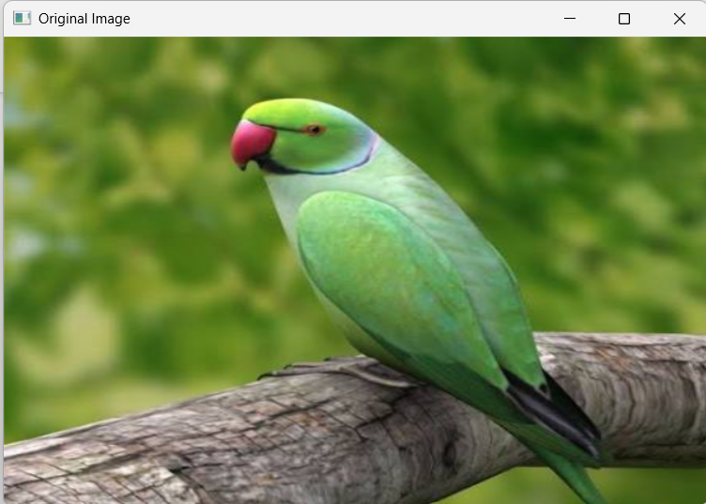
OUTPUT:
