Convert an Image to show outline using Canny function.
import cv2
image = cv2.imread(r"C:\Users\kalpa\Downloads\peocock.jpg")
edges = cv2.Canny(image, threshold1=30, threshold2=100)
cv2.imshow('Original Image', image)
cv2.imshow('Canny Edges', edges)
cv2.waitKey(0)
cv2.destroyAllWindows()

INPUT:
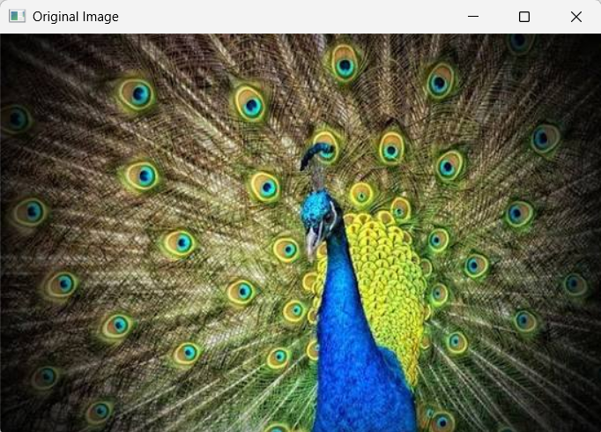

OUTPUT:
