Dilate an Image using Dilate function
import cv2
import numpy as np
image = cv2.imread(r"C:\Users\kalpa\Downloads\parrot.jpg")
kernel = np.ones((5,5), np.uint8)
dilated = cv2.dilate(image, kernel, iterations=1)
cv2.imshow("Original Image", image)
cv2.imshow("Dilated Image", dilated)
cv2.waitKey(0)
cv2.destroyAllWindows()

INPUT:
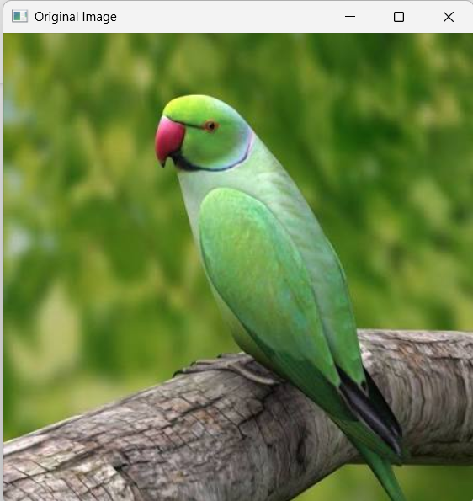

OUTPUT:
