Erode an Image using erode function
import cv2
import numpy as np
image = cv2.imread(r"C:\Users\kalpa\Downloads\butterflyy.jpg")
kernel = np.ones((5,5), np.uint8)
eroded = cv2.erode(image, kernel, iterations=1)
cv2.imshow("Original Image", image)
cv2.imshow("Eroded Image", eroded)
cv2.waitKey(0)
cv2.destroyAllWindows()

INPUT:
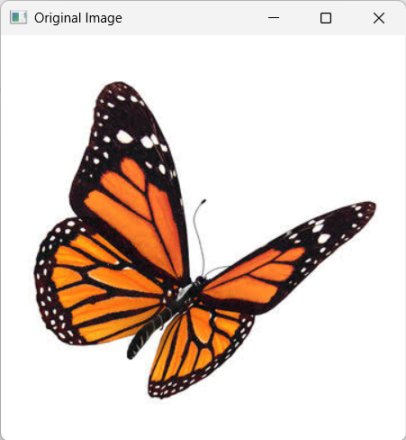

OUTPUT:
