Perform Edge detection using canny method
import cv2
import numpy as np
image = cv2.imread(r"C:\Users\kalpa\Downloads\parrot.jpg")
if image is None:
print("Error: Could not load image.")
else:
gray = cv2.cvtColor(image, cv2.COLOR_BGR2GRAY)
blurred = cv2.GaussianBlur(gray, (5, 5), 0)
edges = cv2.Canny(blurred, 100, 200)
cv2.imshow('Original Image', image)
cv2.imshow('Grayscale Image', gray)
cv2.imshow('Canny Edges', edges)
cv2.imwrite(r"C:\Users\susri\OneDrive\Desktop\COMPUTER VISION\edges_detected.jpg", edges)
cv2.waitKey(0)
cv2.destroyAllWindows()
INPUT:
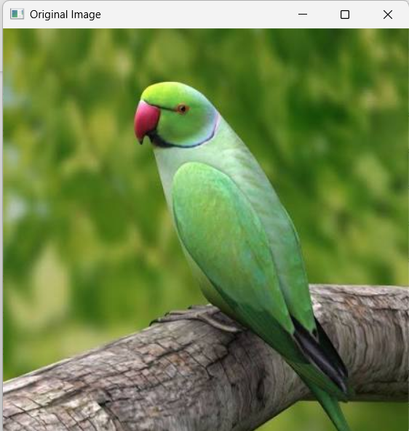
OUTPUT:
