Perform Edge detection using Sobel Matrix along Y axis
import cv2
import numpy as np
image = cv2.imread(
r"C:\Users\kalpa\Downloads\parrot.jpg",
cv2.IMREAD_GRAYSCALE
)
if image is None:
print("Error: Could not load image.")
else:
sobel_y = cv2.Sobel(image, cv2.CV_64F, 0, 1, ksize=3)
sobel_y = np.abs(sobel_y)
sobel_y = np.uint8(sobel_y)
cv2.imshow('Original Image', image)
cv2.imshow('Sobel Y Edge Detection', sobel_y)
cv2.waitKey(0)
cv2.destroyAllWindows()

INPUT:
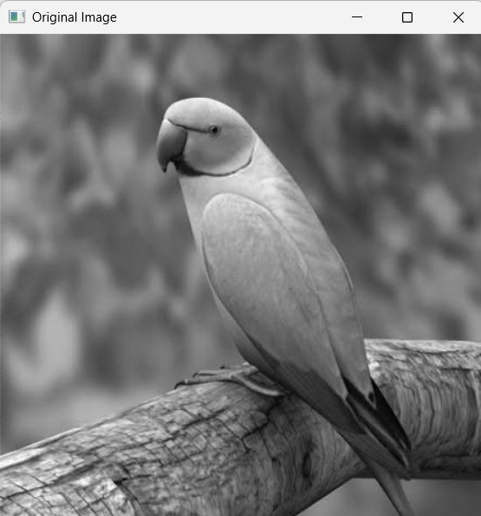
OUTPUT:
