Perform Edge detection using Sobel Matrix along XY axis
import cv2
import numpy as np
image = cv2.imread(
r"C:\Users\kalpa\Downloads\peocock.jpg",
cv2.IMREAD_GRAYSCALE
)
if image is None:
print("Error: Could not load image.")
else:
sobel_x = cv2.Sobel(image, cv2.CV_64F, 1, 0, ksize=3)
sobel_x = cv2.convertScaleAbs(sobel_x)
sobel_y = cv2.Sobel(image, cv2.CV_64F, 0, 1, ksize=3)
sobel_y = cv2.convertScaleAbs(sobel_y)
edge_image = cv2.bitwise_or(sobel_x, sobel_y)
cv2.imshow('Original Image', image)
cv2.imshow('Sobel X', sobel_x)
cv2.imshow('Sobel Y', sobel_y)
cv2.imshow('Combined Edge Image', edge_image)
cv2.imwrite(
r"C:\Users\susri\OneDrive\Desktop\COMPUTER VISION\edge_detected_image.jpg",
edge_image
)
cv2.waitKey(0)
cv2.destroyAllWindows()

INPUT:
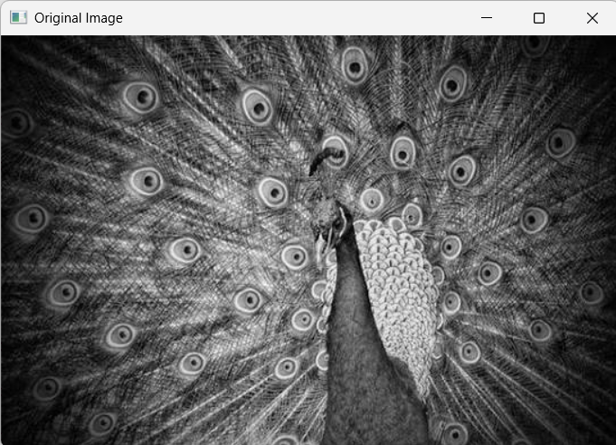
OUTPUT:
