Perform Sharpening of Image using Laplacian mask with negative center coefficient.
import cv2
import numpy as np
image = cv2.imread(
r"C:\Users\kalpa\Downloads\snake.jpg"
)
if image is None:
print("Error: Could not load image.")
else:
gray_image = cv2.cvtColor(image, cv2.COLOR_BGR2GRAY)
laplacian_kernel = np.array([[0, -1, 0],
[-1, 5, -1],
[0, -1, 0]], dtype=np.float32)
sharpened_image = cv2.filter2D(gray_image, -1, laplacian_kernel)
cv2.imshow('Original Image', gray_image)
cv2.imshow('Sharpened Image', sharpened_image)
cv2.imwrite(
r"C:\Users\susri\OneDrive\Desktop\COMPUTER VISION\sharpened_image.jpg",
sharpened_image
)
cv2.waitKey(0)
cv2.destroyAllWindows()

INPUT:
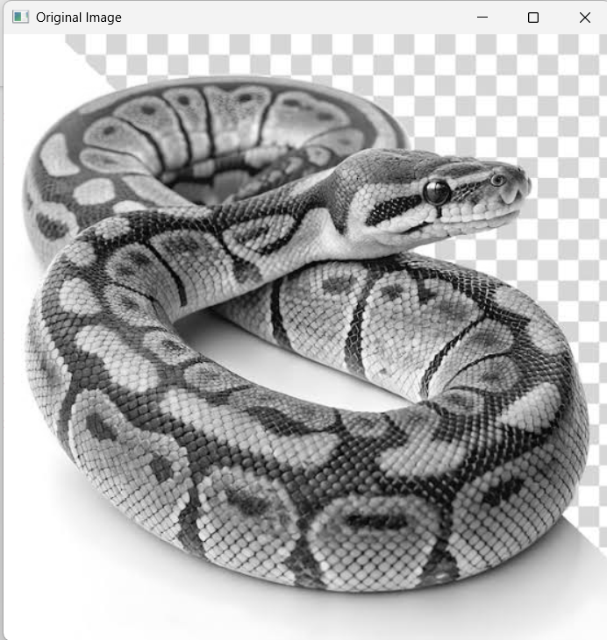
OUTPUT:
