Perform Sharpening of Image using Laplacian mask with an extension of diagonals
import cv2
import numpy as np
image = cv2.imread(r"C:\Users\kalpa\Downloads\butterflyy.jpg")
gray_image = cv2.cvtColor(image, cv2.COLOR_BGR2GRAY)
laplacian_kernel = np.array([[1, 1, 1],
[1, -8, 1],
[1, 1, 1]], dtype=np.float32)
laplacian = cv2.filter2D(gray_image, cv2.CV_32F, laplacian_kernel)
sharpened = gray_image - laplacian
sharpened = np.clip(sharpened, 0, 255).astype(np.uint8)
cv2.imshow("Original Image", image)
cv2.imshow("Gray Image", gray_image)
cv2.imshow("Sharpened Image", sharpened)
cv2.imwrite("sharpened_image.jpg", sharpened)
cv2.waitKey(0)
cv2.destroyAllWindows()
INPUT:
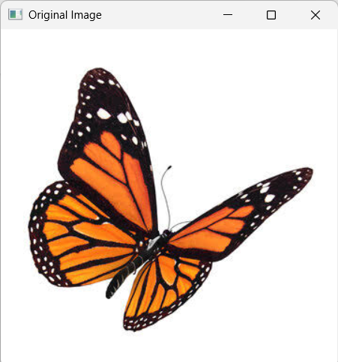

OUTPUT:
