 | FINAL THEORETICAL EXAM –SECOND Semester 2019-2020
Student Name: ……………………… |  | Date : MAY. -2020 | Computer Dep. | Program:
Major & Section : ………………….. |  | Time : deadline 20-5-2020 12 AM | CSE+ICT | Major :
Student No.:…………………………. |  | Lecturer: Ahmed Elagha | Internet Programming | Course :

1)10 marks(0.5 mark for each item)
Choose the correct answer and write it down in the table below:
1) <?php
echo $_ٌُREQUEST[]; ?>
a) shows variables that are in the $_GET
b) shows variables that are in the $_POST
c) shows variables that are in the $_POST, $GET and $_SESSION
d) None of the above

2) In PHP the error control operator is :
a) .
b) ^
c) @
d) &

3)Which of the following functions is used to terminate the script execution in PHP?
a) break()
b) quit()
c) die()

4) The include file must have the extension .inc:
a) True
b) False

5) The output value for the script below:
function tenTimes( &$n ) {
$n = $n * 10;}
$number = 50;
tenTimes( $number );
print $number;
a)500
b)50
c)Error

6)The output for the script:
<?php
$arr = array("A" => 1, "B" => 2);
$arr["B"] = 3;
unset($arr);
echo $arr["B"]; ?>
a) 1
b)Error
c) Null
d) 3

7)The output for the script:
<?php
$fruits = array("a", "b");
sort($fruits);
foreach ($fruits as $key => $val) {
echo "fruits[" . $key . "] = " . $val . ",";}?>
a) fruits[0]=a, fruits[1]=b
b) fruits[a]=a, fruits[b]=b
c) fruits[1]=a, fruits[2]=b

8)The output for the script :
<?php
$x=0;
settype($x,"string");
$x=$x+10;
echo $x; ?>
a) Error
b) 10
c) 0
d) Answer not available

9) The output for the script:
<?php
If (ereg( "PAL[A-Z]+","PALESTINE ") )
echo "TRUE"
else
echo "FALSE";?>
a) TRUE
b) FALSE
c) Error

10) <?php
function addNums( $firstnum, $secondnum ) {
$result = $firstnum + $secondnum;
return $result;}
print addNums(3,5);?>
a)8
b)Error in function script
c)Null
d)Answer not available

11)The output for the below script
<?php
print "\\a\"; ?>
a)\
b)\a
c)Error

12)Which of the following is used to upload a file?
a) move_uploaded_file()
b)upload_file()
c) move_file()
d) Answer not available

13)A constructor is a special kind of:
a) class
b) method
c) object
d) Answer not available

14) When we use POST method, requested data shown in :
a)URL
b)HTML
c)CSS
d)No data shown
أسفل النموذج

15) The object used in AJAX technology is :
a) XMLHttpRequest
b)XMLhttpREQUEST
c)Ajax.SEND
d)Ajax.POST

16)DreamWeaver is an example for :
a)Web server
b)Web editor
c)PHP interpreter
d)A+B

17) One of the below is not used to retrieve database records:
a) mysql_fetch_assoc()
b )mysql_fetch_array()
c) mysql_fetch_object()
d) mysql_fetch_records()

18) One of the below is used to retrieve number of rows affected by SQL statements:
a)mysql_affected_rows()
b)mysql_returned_rows()
c)mysql_updated_rows()

19)Session id can be retrieved by :
a)echo session();
b)echo session _id()
c)echo session_id[];

20)PHP supports:
a)polymorphism
b)inheritance
c)multiple inheritance
d)1+3

1 | 2 | 3 | 4 | 5 | 6 | 7 | 8 | 9 | 10
11 | 12 | 13 | 14 | 15 | 16 | 17 | 18 | 19 | 20

Q2)5 marks ( 1 mark for each)
Write down the Error below each of the PHP statement. There is only ONE error each.
PHP statement
$query = "select * from table_name where name = " . $_POST[‘name’] . ";"  $result = mysql_query($result) or die(mysql_error()); | 1
Error: | 1
$db_database = 'students';  $mysql = mysql_connect('localhost', 'root' ,'');  select_db($db_database); | 2
Error: | 2
if ($_POST['first_name'] = "ahmed"){  echo "Your are Welcome" ?> | 3
Error: | 3
$full_name = $_POST['first_name']+" "+ $_POST['last_name']; | 4
Error: | 4
<script language="javascript">  function text {  document.getElementById("first").innerHTML = "Hallo to Exam";}  </script>  <body>  onclick="text()"  <div id="first"></div></body> | 5
Error: | 5

Q3) 10 marks(2 marks for each)
Fill in the below table with the appropriate PHP statements and commands:
Request | COOKIES | SESSIONS
- Creation
- Calling and showing

- Destroying
- Storage
- Security

Q4)5 marks ( 1 mark for each)
Write the PHP statement for each:

Request | PHP statement
- Move the browser to the page
"new.php"
- Send data to the page "new.php" via HREF tag
- Generate the drop down list menu 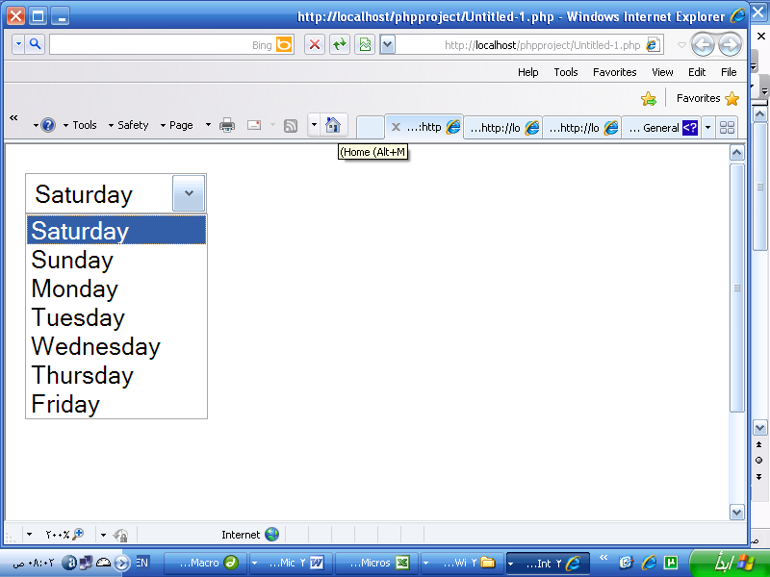
- Create the CLASS object:VECHILE with attributes :model and color

- Generate a unique id for 100 students access the database concurrently
(at same time)
Q5)10 marks ( 2 marks for each)
Given the below form :
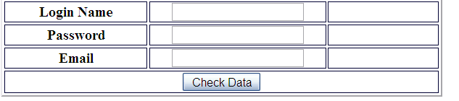
Suppose that names of fields in the form are the same within the script.
- Write a script that checks the correct password after pressing the button. Otherwise, it will abort the page to another one. The correct password =123.

- Write the regular expression to check the user email.

- How can you use the session variables to secure the website?. Write the script.

- How can you encrypt the Login name and password before the insertion in the database?.

5)How can you abort the page after 2 minutes without pressing the button?.

End of Exam

