Mini Exercise – User-Based Collaborative Filtering

- You are given “mini_user_colab.csv”, a file that contains users’ ratings (1 to 5) on books. The comma-delimited file looks like this:
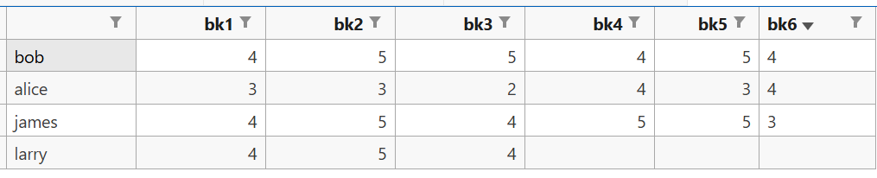
This bk1 should be feature and change to row in item based filter
- An entry without a rating means that the book has not been read by the user.

- The table shows that Larry has read three books.

- Write code to recommend books to him that similar users have rated at 4 or higher, using User-Based Collaborative Filtering.

- A user is considered similar to Larry if their cosine similarity value is 0.45 and above.

