Mini Exercise – Content-Based Filtering

- Consider the data in mini_item_based.csv:
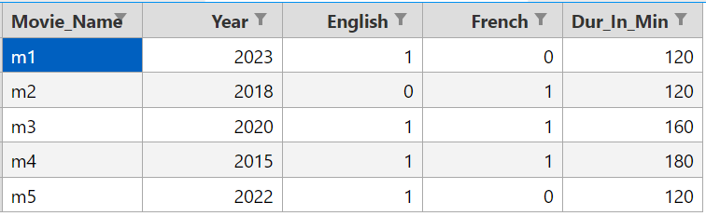

- The data shows certain characteristics of the movies in our database. For example, the Year column shows the release year and Dur_In_Min the movie duration. Note that the movie language is multi-hot encoded, where a 1 in both the English and French columns mean that a movie has a mix of English and French dialogues.

- Perform Standardization on the Year and Dur_In_Min columns, but leave the multi-hot encoded columns (English and French) as they were.

- James has watched the movie “m5” and liked it.

- Using Content-Based Filtering, recommend two other movies that James would enjoy watching.

