Mini Exercise – Item-Based Collaborative Filtering

- You are given “mini_item_colab.csv”, a file that contains users’ ratings (1 to 5) on books. The comma-delimited file looks like this:
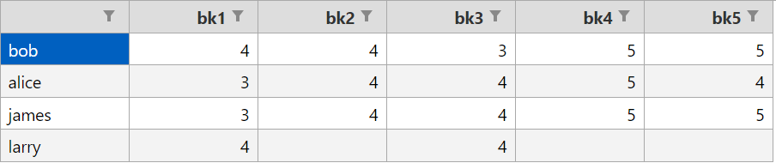

- An entry without a rating means that the book has not been read by the user.

- The table shows that Larry has only read two of the books titled “bk1” and “bk2”.

- Assuming Larry likes a book if he gives it a rating of 4 and above, write code to recommend a book to him using Item-Based Collaborative Filtering.

