Predicting CRM Sales Opportunities Using Machine Learning
Hong Thai Phan, Nguyen Khanh An Tran, and Hoang Thien Bao Bui
CS 582, Group 2

Abstract—We build a reproducible pipeline that estimates the probability that a CRM sales opportunity is Won or Lost and reports the input factors behind each score. We compare Logistic Regression (LR), Random Forest (RF), a multilayer perceptron (MLP) and TabNet against a prior-only control on the Maven CRM Sales Opportunities data, using a time-ordered split that excludes deals whose outcome was not yet known. LR is selected on validation ROC-AUC and reaches a test ROC-AUC of only 0.524, close to chance; no model beats the control in any practical sense. A deliberately invalid control that uses close value reaches AUC 1.0, showing how leakage produces misleading scores. Our contribution is an auditable, explainable evaluation workflow and an honest negative finding, not a new algorithm; each safeguard is measured. A naive random split raises test AUC by at most 0.036 without changing the conclusion, and resetting each deal’s top three explanation factors moves its score 3.1 times more than resetting three random ones. A controlled synthetic experiment with known win probabilities shows TabNet outperforming Random Forest only when outcomes depend smoothly on continuous deal signals.
Index Terms—sales opportunity prediction, CRM, TabNet, explainability, temporal evaluation, data leakage
I. INTRODUCTION
Sales teams must decide which open opportunities deserve attention and want to understand why a model favors a deal. We study this as binary classification of eventual outcome (Won = 1, Lost = 0) from attributes known when a deal enters the Engaging stage. The system outputs complementary probabilities P(Won) and P(Lost) and the factors associated with higher or lower scores. We model eventual recorded outcome among closed deals; the data do not support fixed-horizon claims such as “win within 30 days.”
Prior work frames win propensity as part of pipeline management [2] and describes end-to-end B2B prediction workflows [3]. TabNet [4] applies sequential attention to tabular data, and we test whether it helps here. We do not claim a new algorithm: our contribution is an audited, explainable workflow in which each safeguard is backed by evidence: an explicit leakage control, an availability-aware split compared against naive alternatives, calibrated probabilities with local explanations tested for faithfulness, missing-input warnings, and a known-truth synthetic benchmark that separates weak data from a broken pipeline. We also report the weak results candidly.
II. RELATED WORK
Yan et al. [2] treat win propensity as a component of sales pipeline management and evaluate a data-driven approach on enterprise B2B data; this motivates our probability output, though we cannot reproduce their proprietary data or claim a comparable business benefit. Rezazadeh [3] presents a B2B workflow linking training, prediction and decision boundaries, which motivates our separation of fitting, evaluation and scoring. We use a small CPU workflow rather than a cloud platform. Arik and Pfister [4] introduce TabNet; we compare an existing implementation with simpler learners, without its self-supervised pretraining. Explainable CRM scoring already exists, so our novelty is the applied design and audit of this workflow.
III. DATA AND PREPARATION
The Maven Analytics CRM data [1] describe a fictitious B2B computer-hardware vendor: 8,800 opportunities, 85 accounts, 7 products and 35 sales-team records. The pipeline table is left-joined to the other tables with many-to-one checks. Of the records, 6,711 are closed (4,238 Won, 2,473 Lost); 2,089 are open, of which 1,589 are Engaging and eligible for scoring while 500 Prospecting records are excluded. Open records are never labeled Lost.
Features are seven categorical fields (product, series, sector, account location, regional office, manager, sales agent) and eleven numeric fields (list price, account revenue, employees, revenue per employee, year established, account age, engagement calendar fields, subsidiary flag). The fields close_value, close_date, deal_stage and opportunity_id are excluded as predictors: dates only control label availability, stage defines the target, and IDs provide traceability. Preprocessing (constant imputation and one-hot encoding for categoricals; training medians and, for LR/MLP/TabNet, standardization for numerics) is fitted on training data only.
IV. EVALUATION DESIGN
Closed deals are ordered by engagement date; the 60th and 80th percentile dates form period boundaries, and rows sharing a date stay together. Training deals must engage and close before the validation start (2017-07-15); validation deals must close before the test start (2017-09-18); test deals engage on or after it, ending 2017-12-27. This yields 2,975 training, 583 validation and 1,361 test deals and purges 1,792 records whose outcomes arrived late. Win rates are 64.6%, 60.7% and 60.0%, respectively.
The model, early-stopping epoch, class threshold and calibration are chosen on validation only. The model is the one with the highest validation ROC-AUC; the threshold maximizes validation macro-F1 over 0.10–0.90. The test period is a single exploratory evaluation, not a pristine test, because the data were examined earlier in the project. We report Accuracy, Precision, Recall, F1 (Won as positive), ROC-AUC and confusion matrices, plus Brier score, as the proposal promised.
V. MODELS
The Dummy control outputs the training win rate. LR uses L2 regularization (C = 1). RF uses 300 trees with minimum leaf size 5. The MLP has two ReLU layers (64, 32) trained with Adam (learning rate 0.001) and early stopping on validation AUC (best epoch 38). TabNet uses n_d = n_a = 8, three decision steps, learning rate 0.02 and batch size 256 (best epoch 30), via the pytorch-tabnet package. All models use seed 42, run on CPU, and use modest fixed budgets rather than an exhaustive search.
VI. RESULTS
Table I lists test results at each model’s validation-selected threshold. Validation AUCs were LR 0.563, RF 0.540, MLP 0.529, TabNet 0.515, so LR was selected before test data were examined.
TABLE I. Test-set metrics (Won = positive; 1,361 deals).
Model | Acc. | Prec. | Rec. | F1 | AUC | Brier
Dummy prior | 0.600 | 0.600 | 1.000 | 0.750 | 0.500 | 0.242
Logistic Reg. | 0.437 | 0.615 | 0.166 | 0.262 | 0.524 | 0.279
Random Forest | 0.592 | 0.598 | 0.978 | 0.742 | 0.518 | 0.251
MLP | 0.485 | 0.593 | 0.453 | 0.514 | 0.495 | 0.331
TabNet | 0.536 | 0.600 | 0.678 | 0.637 | 0.507 | 0.249

All four classifiers have test ROC-AUC between 0.495 and 0.524, essentially chance. The prior control attains 60.0% accuracy and F1 0.750 simply by predicting Won for every deal, so accuracy and F1 alone are misleading: RF reaches similar numbers (recall 0.978, only 7 of 544 Lost deals identified) by behaving almost like the control. LR’s threshold, tuned for macro-F1 on validation, predicts Won rarely on test (recall 0.166), giving 43.7% accuracy. TabNet has the highest macro-F1 (0.497) and LR the highest balanced accuracy (0.505), but the differences are small and we ran no multi-seed or account-clustered uncertainty analysis, so we claim no significant ranking among models. The traditional-versus-TabNet comparison thus shows no advantage for the more complex architecture.
TABLE II. Test confusion counts, validation AUC and selected threshold.
Model | TN | FP | FN | TP | Val. AUC | Thr.
Dummy prior | 0 | 544 | 0 | 817 | 0.500 | 0.50
Logistic Reg. | 459 | 85 | 681 | 136 | 0.563 | 0.48
Random Forest | 7 | 537 | 18 | 799 | 0.540 | 0.52
MLP | 290 | 254 | 447 | 370 | 0.529 | 0.46
TabNet | 175 | 369 | 263 | 554 | 0.515 | 0.58

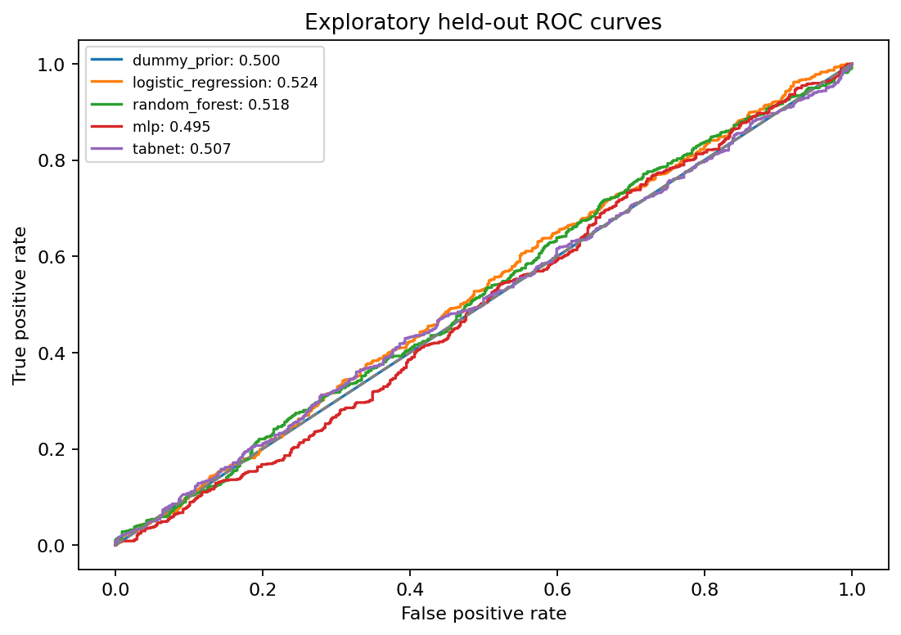
Fig. 1. Test ROC curves for all models.
A. Calibration
A sigmoid calibrator [5] fitted on validation scores of the frozen LR model lowers test Brier score from 0.279 to 0.244. This is still slightly worse than the prior control (0.242), and ROC-AUC is unchanged because calibration preserves ordering. The base model is not refit.
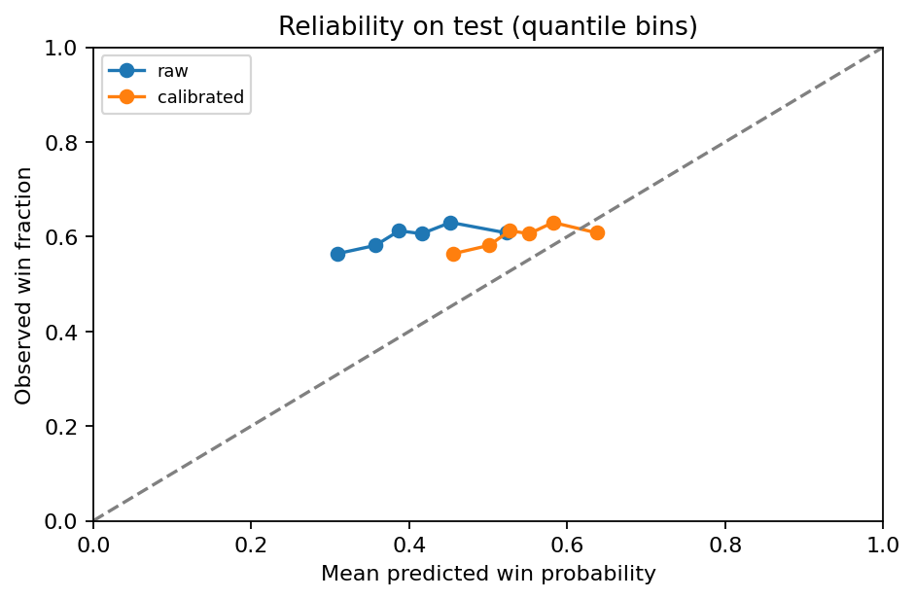
Fig. 2. Reliability of raw and calibrated LR probabilities on test data.
B. Leakage control
A depth-one tree on close_value, which is zero for every Lost deal, attains accuracy and AUC of 1.0 on the same test set. This invalid model is never used for selection or scoring; it illustrates why near-perfect scores from outcome-derived columns must be rejected.
C. Does the split protocol matter?
To measure what the availability-aware split contributes, we refit the four learned models under two alternatives (Table III). Chronological without purge keeps the same boundaries and the same 1,361 test deals but also trains on 1,048 deals whose outcome was not yet known at the cutoff. A random stratified 60/20/20 split ignores time and is repeated over five seeds. The random split reports slightly higher AUC (at most +0.036, MLP), and dropping the purge changes AUC by −0.029 to +0.006 on the shared test set; every paired bootstrap 95% interval for that change includes zero. All protocols remain near chance. On these data the split is therefore a safeguard with a small measured effect, not the reason the results are weak, and the outcome field in Section VI-B is a far larger risk. The as-of column reproduces Table I.
TABLE III. Real-data test ROC-AUC under three split protocols.
Model | As-of + purge | No purge | Random (5 seeds)
Logistic Reg. | 0.524 | 0.529 | 0.546 ± 0.009
Random Forest | 0.518 | 0.505 | 0.534 ± 0.010
MLP | 0.495 | 0.475 | 0.531 ± 0.009
TabNet | 0.507 | 0.478 | 0.506 ± 0.021
VII. EXPLANATIONS AND DECISION SUPPORT
We export LR coefficients, RF impurity importance, TabNet attention importance and held-out permutation importance. Permutation importance, measured as AUC drop, is largest for sales agent (0.023), followed by office location (0.008) and engagement month (0.006); the remaining features are below 0.004, consistent with a weak signal. For each open deal, the selected calibrated model reports reference sensitivities: the change in P(Won) when one input is replaced by its training median or mode. These are not additive SHAP values and not causal effects. Separately, TreeSHAP [6] on the raw RF for 64 test rows reconstructs its predictions with maximum error 1.8×10⁻¹², serving as an additive diagnostic of that RF only.
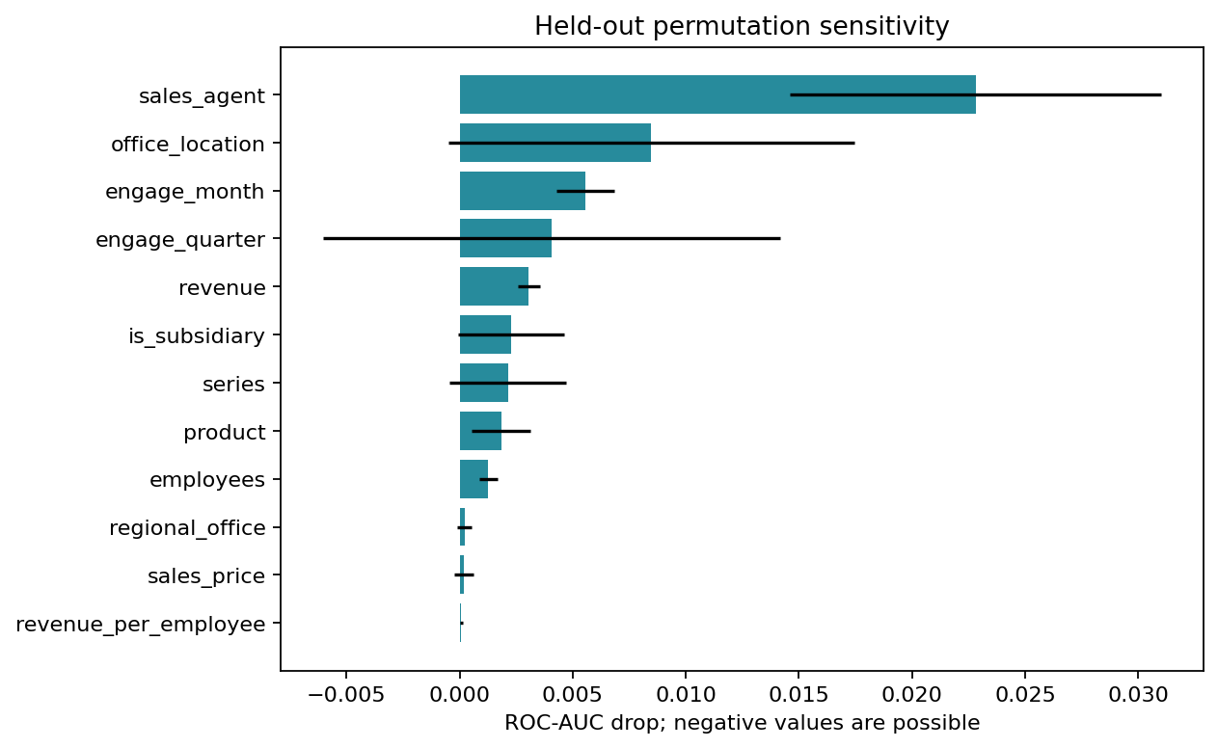
Fig. 3. Held-out permutation importance (mean AUC drop).
We also test whether these explanations describe the model; neither check tests causal effects. On the raw RF, reference sensitivity agrees with grouped TreeSHAP on the same 64 test rows: the median per-row Spearman correlation over the 18 inputs is 0.76, the top three inputs overlap 61% on average (17% expected by chance), and the leading SHAP input has the same sign in every row. In a deletion test on the selected calibrated LR, resetting each test deal’s top three inputs to their training references changes P(Won) by 0.131 on average, versus 0.042 for three random inputs (3.1 times), and by more in 95% of deals. The explanations therefore identify what drives the model’s score, even though that score ranks deals weakly.
Snapshot scores cover 1,589 Engaging open deals with P(Won), P(Lost), a predicted class, a heuristic priority band (Low < 0.40 ≤ Medium < 0.70 ≤ High) and warnings. 1,088 of them lack account data and lie outside training support, so they are flagged. The model was fitted using later events, so these are not historical as-of predictions. On test data the High and Low bands contain only 4 and 5 deals, so the priority bands are unvalidated and make no business claim.
VIII. CONTROLLED SYNTHETIC EXPERIMENT
Because the real data carry little signal, we also ask when the more complex models can help, using synthetic deals whose true win probability is known. A generator reuses the real accounts, agents, products and calendar, adds nine products, competitor attributes and five-year industry trends, and draws each outcome from a planted logistic model. The outcome mechanism is our own design, not an estimate of real sales behavior. Each setting has 100,000 deals and uses the same as-of split, preprocessing and model settings as Section VI, with the synthetic comparison and trend fields added as features, and is repeated over five data seeds.
We vary the planted structure: (a) mostly additive effects with weak interactions; (b) the same with step-like interactions tripled; (c) weak interactions plus four continuous per-deal signals (discount, quote gap, engagement, contact recency) that act through a smooth tanh of their linear combination. Setting (c) was chosen deliberately because it favors neural models.
TABLE IV. Synthetic test ROC-AUC, mean ± s.d. over five seeds.
Model | (a) Weak | (b) Step-like | (c) Smooth
Logistic Reg. | 0.761 ± 0.012 | 0.827 ± 0.008 | 0.833 ± 0.003
Random Forest | 0.758 ± 0.012 | 0.872 ± 0.007 | 0.846 ± 0.002
MLP | 0.766 ± 0.011 | 0.873 ± 0.008 | 0.866 ± 0.004
TabNet | 0.765 ± 0.013 | 0.875 ± 0.008 | 0.868 ± 0.001
Oracle (true p) | 0.779 | 0.886 | 0.881

With weak interactions all models lie within 0.01 AUC. Step-like interactions open a gap to LR (TabNet +0.048 in every seed) but leave RF, MLP and TabNet within 0.003. With smooth continuous signals TabNet beats RF by 0.021 AUC (range 0.019 to 0.024, all five seeds) and ties the MLP. TabNet’s advantage over trees thus appears only when outcomes depend smoothly on continuous features and data are plentiful, conditions absent from the real CRM data with its 2,975 training deals and mostly categorical inputs. In every setting the best model comes within 0.015 AUC of the oracle, so the same pipeline does learn when signal exists; this points to the inputs, not the pipeline, as the reason for the near-chance real-data result. These results illustrate model behavior; they are not evidence about real opportunities and do not change Section VI.
IX. FULL PIPELINE ON THE SIMULATED DATASET
Section VIII uses the generator only to compare models. We also run the complete pipeline (train, evaluate and predict) on one saved simulated dataset, data/crm_simulated/, to check that every stage works end to end on a larger dataset that has real signal. It is generated with seed 582 and the step-like interaction strength of setting (b). It contains 100,000 opportunities, the same 85 accounts and 35 sales-team records, and 16 products (the 7 real ones plus 9 simulated). Of these, 71,463 are closed (44,899 Won, 26,564 Lost, a 62.8% win rate) and 28,537 are open; 22,810 open deals are Engaging and can be scored, and 15,582 of them have no account, the same 68% share as in the real data. The tables keep the raw CRM format, so the code loads them by changing only the data folder.
Besides the 18 standard features, the models use 11 simulated deal-level ones: a sector-match flag, three five-year industry-trend values (average growth, slope and last growth), three product attributes (recycled share, expected longevity, made in USA), the price of a rival product, and the differences between our product and the rival on those three attributes. The as-of split places the boundaries at 2017-07-17 and 2017-09-18 and gives 32,470 training, 4,920 validation and 14,322 test deals, with 19,751 purged. Win rates are 62.3%, 60.5% and 61.3%.
TABLE V. Test-set metrics on the simulated dataset (Won = positive; 14,322 deals).
Model | Acc. | Prec. | Rec. | F1 | AUC | Brier
Dummy prior | 0.613 | 0.613 | 1.000 | 0.760 | 0.500 | 0.237
Logistic Reg. | 0.741 | 0.810 | 0.755 | 0.781 | 0.809 | 0.170
Random Forest | 0.799 | 0.835 | 0.836 | 0.836 | 0.864 | 0.141
MLP | 0.800 | 0.827 | 0.851 | 0.839 | 0.866 | 0.141
TabNet | 0.804 | 0.835 | 0.848 | 0.841 | 0.869 | 0.139
Oracle (true p) | 0.815 | 0.819 | 0.897 | 0.856 | 0.878 | 0.134

Here the models clearly learn. Validation AUCs were LR 0.827, RF 0.877, MLP 0.878 and TabNet 0.880, so TabNet is selected. On test it reaches AUC 0.869 and 80.4% accuracy, against 61.3% for the prior control, and it is only 0.009 AUC below an oracle that scores each deal by its true win probability (Table V). RF and MLP are within 0.005 AUC of TabNet, while LR trails by about 0.06 because it cannot represent the step-like interactions, which matches setting (b) in Table IV. Unlike on the real data, accuracy and F1 rise together with AUC, and RF no longer behaves like the control. The selected model is already well calibrated, so the sigmoid calibrator (slope 1.15) only lowers test Brier score from 0.1394 to 0.1386.
The extra deal-level features help but are not the main source of signal. In a separate run of the comparison script with only the 18 standard features, test AUC drops by about 0.025 for every model (LR 0.784, RF 0.840, MLP 0.838, TabNet 0.840), so most of the planted signal is carried by product, price, account and agent fields that the real data also contain. The priority bands also behave as intended on the simulated test set: the 4,340 Low deals win 17.6% of the time, the 2,445 Medium deals 61.3% and the 7,537 High deals 86.5%, close to their mean calibrated scores of 0.17, 0.58 and 0.87. On the real data the High and Low bands held only 4 and 5 test deals, so this is the only evidence that the bands separate deals when signal exists. As in Section VIII, these results describe our planted formula and are not evidence about real sales.
X. LIMITATIONS
(1) The dataset was examined earlier, so the test period is exploratory. (2) The availability purge reduces but cannot remove closed-only selection bias and censoring. (3) Account, product and team attributes are static snapshots. (4) Accounts and agents repeat across periods, so this is not a new-customer test. (5) Validation is reused for early stopping, selection, threshold and calibration, which may be optimistic. (6) The features lack richer engagement signals such as activity history, budget or competitors; this is a plausible, not demonstrated, cause of low AUC. (7) The 2,975-row training set is small after purging.
XI. CONCLUSION
We implemented the four required classifiers and a prior control on a leakage-aware temporal split, with calibrated probabilities and explanations. Under this protocol no model discriminates meaningfully (best test AUC 0.524), and complex models, including TabNet, do not help. We report this negative result openly rather than use post-outcome information. Measured safeguards support this reading: a naive random split does not change the conclusion, the explanations move the score 3.1 times more than random inputs, and the same pipeline nearly reaches the oracle on synthetic data with known signal. Synthetic experiments suggest TabNet beats trees only with smooth continuous signals and ample data. Future work includes multiple temporal windows, account-grouped evaluation, richer pre-close activity features, separate calibration data and prospective testing of any priority policy.
REPRODUCIBILITY
Running python -m src.run_project regenerates all numbers, figures and documents in reports/crm/final/. Source-file hashes, split assignments, model configurations (Python 3.12, scikit-learn 1.8.0, PyTorch 2.8.0 CPU, pytorch-tabnet 4.1.0) and raw test probabilities are saved with each run. The stages also run separately: python -m src.train fits and saves the models, python -m src.evaluate computes every metric, figure and check from the saved models, and python -m src.predict scores open deals or a CSV of new deals. The simulated run in Section IX uses the same stages with --data-dir data/crm_simulated for training and --output reports/crm/simulated/final for evaluation and prediction, and its results are never written to reports/crm/final/.
Contribution statements are left for each team member to complete.
REFERENCES
[1] Maven Analytics, “CRM Sales Opportunities,” https://mavenanalytics.io/data-playground/crm-sales-opportunities (accessed Oct. 6, 2026).
[2] J. Yan, M. Gong, C. Sun, J. Huang, and S. M. Chu, “Sales pipeline win propensity prediction: A regression approach,” in Proc. IFIP/IEEE IM, 2015.
[3] A. Rezazadeh, “A generalized flow for B2B sales predictive modeling: An Azure machine learning approach,” Forecasting, vol. 2, no. 3, 2020.
[4] S. Ö. Arik and T. Pfister, “TabNet: Attentive interpretable tabular learning,” in Proc. AAAI, vol. 35, no. 8, pp. 6679–6687, 2021.
[5] scikit-learn, “Probability calibration,” https://scikit-learn.org/stable/modules/calibration.html (accessed Oct. 6, 2026).
[6] SHAP documentation, “TreeExplainer,” https://shap.readthedocs.io/en/latest/generated/shap.TreeExplainer.html (accessed Oct. 6, 2026).

