How to setup project environment

+ ត្រូវ Install Source Control មួយឈ្មោះថា (GitHup)

* Install Source Control
  + Download GitHup(http://windows.github.com/)
* Install All software
* Create GitHup account https://github.com/
* Join Project Team
* Clone Project To local Machine (I clone to C:\Users\San\Documents\sarana)

+ PHP with SQLServer driver

* Download Wamp 32bit with PHP5(http://www.wampserver.com/en/#download-wrapper)
* Download driver from Microsft web site (http://www.microsoft.com/en-us/download/details.aspx?id=20098)
* Copy Driver (.dll) to PHP ext/ folder (mine is C:\wamp\bin\php\php5.3.13\ext)
* 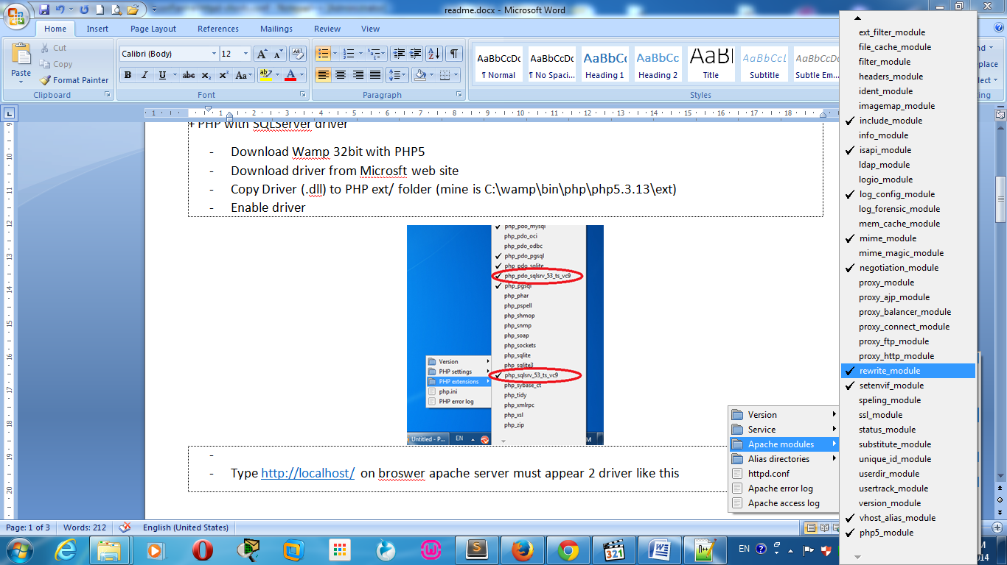Apache /Apache modules គូសលើ rewrite_module
* 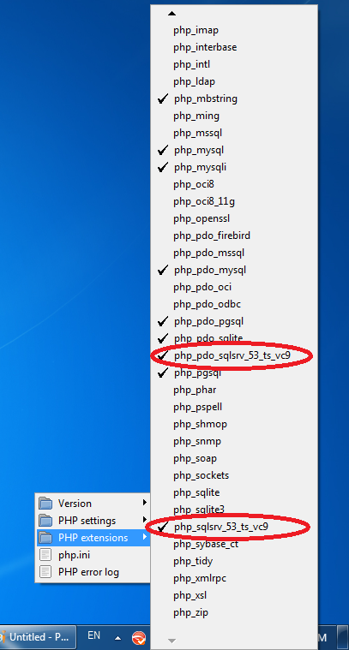Enable driver
* Type <http://localhost/> on broswer apache server must appear 2 driver like this

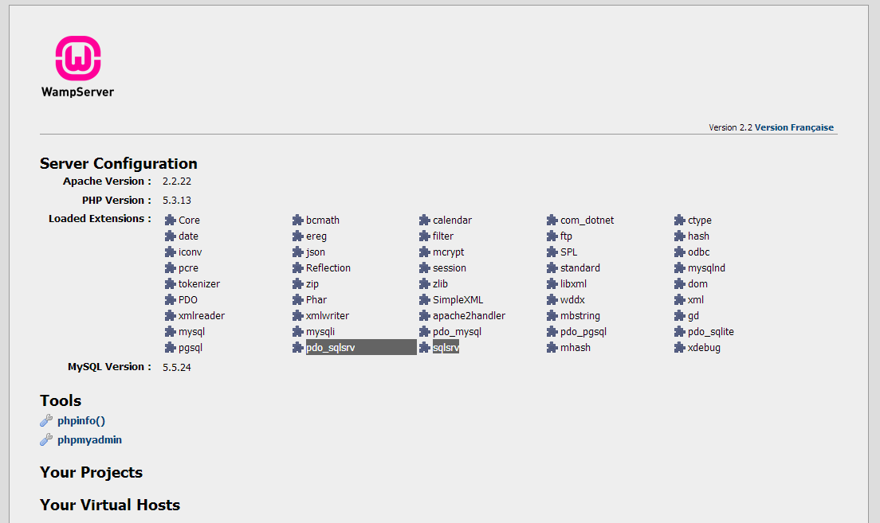

+ Create Own DNS

* Load vhost alias (C:\wamp\bin\apache\apache2.2.22\conf\httpd.conf )
  + Uncomment ( LoadModule vhost_alias_module modules/mod_vhost_alias.so ): maybe line 126
* Enable Virtual hosts (C:\wamp\bin\apache\apache2.2.22\conf\httpd.conf )
  + Uncomment ( Include conf/extra/httpd-vhosts.conf ):maybe line 466
* Config Vertual host (C:\wamp\bin\apache\apache2.2.22\conf\extra\httpd-vhost.conf)

NameVirtualHost *:80

<VirtualHost *:80>

ServerAdmin webmaster@localhost

DocumentRoot "C:\wamp\www"

ServerName localhost

<Directory "C:\wamp\www">

Options Indexes FollowSymLinks Includes ExecCGI

Order allow,deny

Allow from all

AllowOverride All

</Directory>

</VirtualHost>

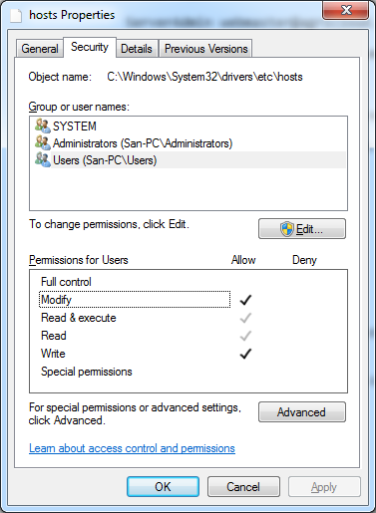<VirtualHost *:80>

ServerAdmin webmaster@agricloud.local

DocumentRoot "C:\Users\San\Documents\sarana"

ServerName sarana.local

<Directory "C:\Users\San\Documents\sarana">

Options Indexes FollowSymLinks Includes ExecCGI

Order allow,deny

Allow from all

AllowOverride All

</Directory>

</VirtualHost>

* Add to Window host file (C:\Windows\System32\drivers\etc\host)

127.0.0.1 sarana.local

(Host file must set Security for your current User to Modify)

* Finally type <http://sarana.local/> on web browser. Browser will appear you project