

## 1. Actors

|  |  |  |
| --- | --- | --- |
| **#** | **Actor** | **Description** |
| 1 | Guest | View public products, View Comment of Porduct |
| 2 | Customer | Manage shopping cart, orders, Product and payment, comment, chat, my transaction, my wallet, my profile, my favorite |
| 5 | Manager | Manager Transaction, add Account |
| 6 | Admin | Manager FinancialTransaction |

2. USECASE DIAGRAM

* 1. Sumary usecase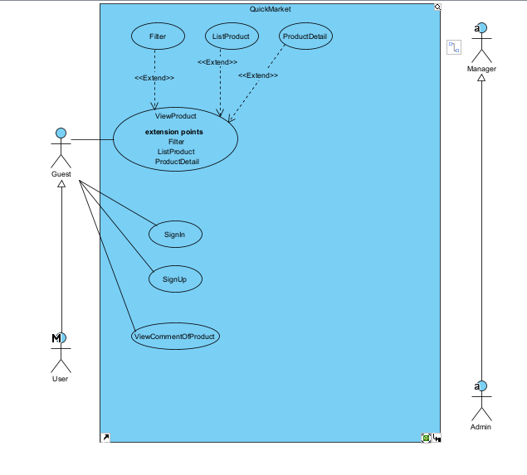

**b, User usecase**

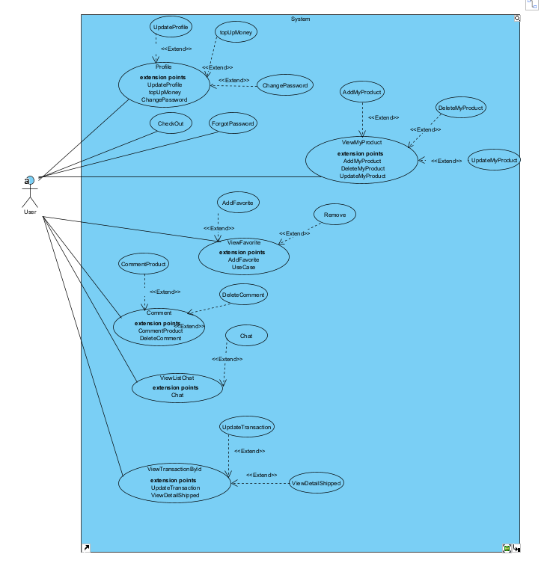

C, **UserCase admin and Manager**

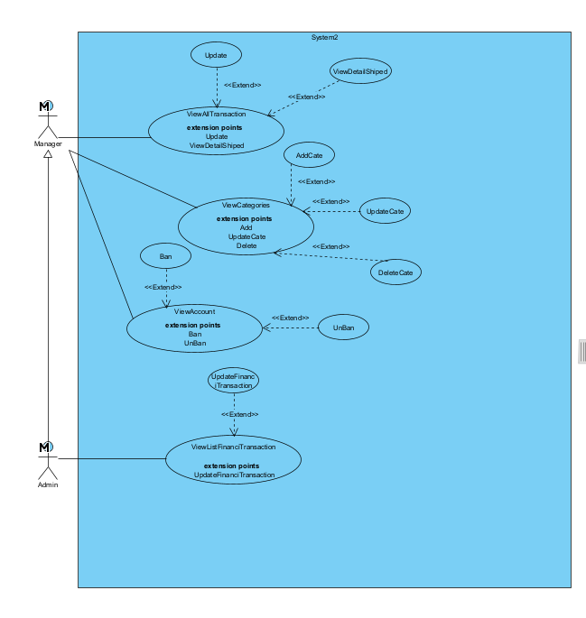

**3. Database Diagram**

