Step 1: Create package.json file

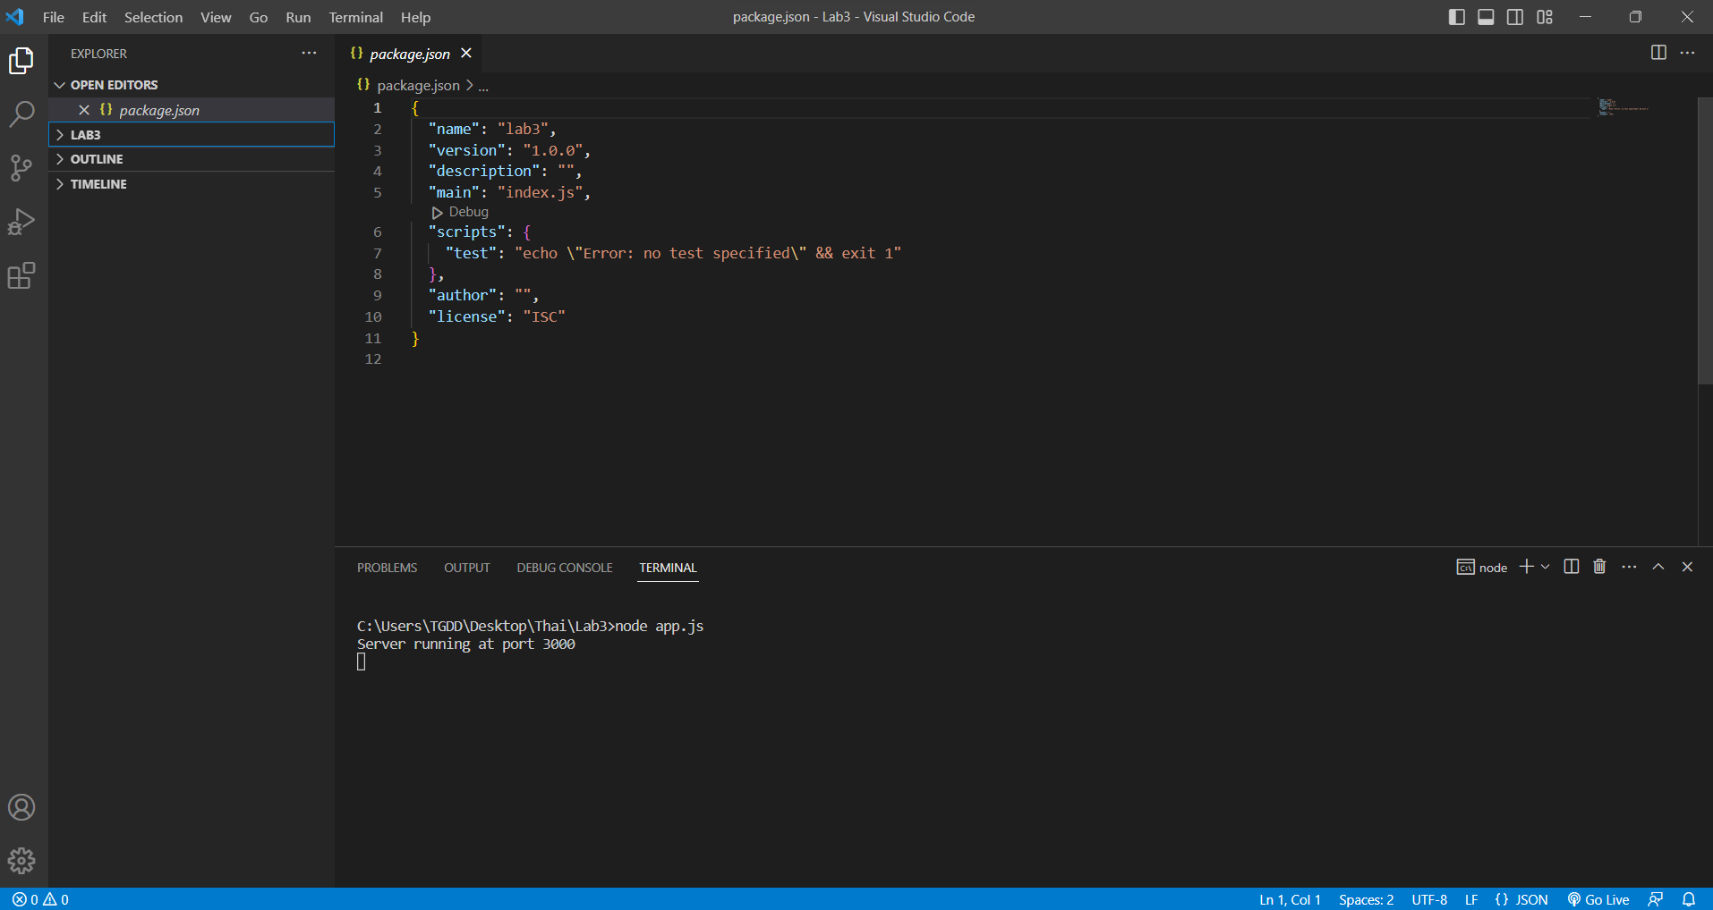

Step 2. Add a file, app.js, and paste the below code

