**Assignment 1 Template**

**Problem 1 (40 Marks): Fill in the information below based on your data set which was generated using your ID number as the seed for the random number generator.**

**The first five numbers in your Gaussian data set are:**

|  |  |  |  |  |
| --- | --- | --- | --- | --- |
| **-11.04** | **-8.57** | **-7.31** | **-7.28** | **-7.13** |

**Sample mean = 2.71045**

**Sample standard deviation = 4.412914**

**The five number summary is:**

|  |  |  |  |  |
| --- | --- | --- | --- | --- |
| **-11.04** | **-0.215** | **2.635** | **5.465** | **14.69** |

**Sample median = 2.635**

**Range = 14.69 – (-11.04) = 25.73**

**IQR = 5.465 – (-0.215) = 5.68**

**Sample skewness = -0.2029152**

**Sample kurtosis = 4.486426**

**Insert the plots of the relative frequency histogram with superimposed Gaussian probability density function and empirical cumulative distribution function with superimposed Gaussian cumulative distribution function on this page.**

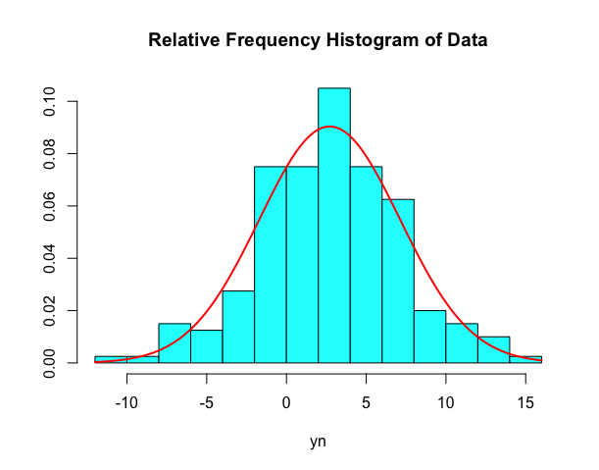

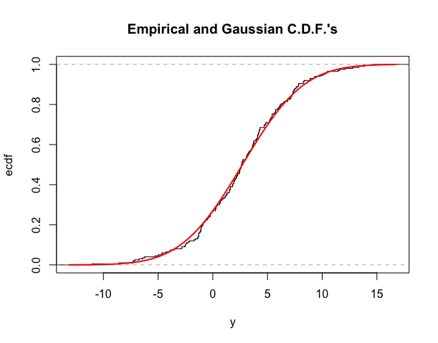

**Problem 2 (40 Marks): The first five numbers in your Exponential data set are:**

|  |  |  |  |  |
| --- | --- | --- | --- | --- |
| **0.01** | **0.13** | **0.18** | **0.24** | **0.26** |

**Sample mean = 7.9169**

**Sample standard deviation = 9.249768**

**The five number summary is:**

|  |  |  |  |  |
| --- | --- | --- | --- | --- |
| **0.010** | **2.070** | **5.095** | **11.120** | **90.520** |

**Sample median = 5.095**

**Range = 90.520 – 0.010 = 90.51**

**IQR = 11.120 – 2.070 = 9.05**

**Sample skewness = 4.198336**

**Sample kurtosis = 33.82573**

**Insert the plots of the relative frequency histogram with superimposed Exponential probability density function and empirical cumulative distribution function with superimposed Exponential cumulative distribution function on this page.**

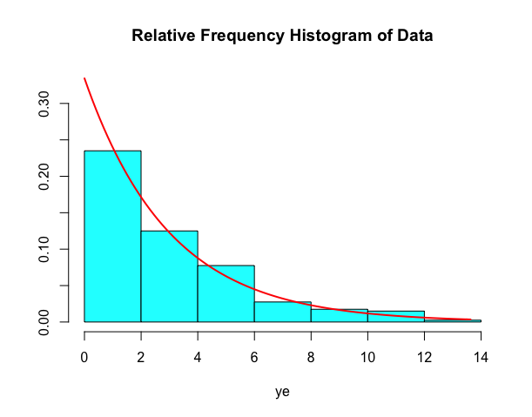

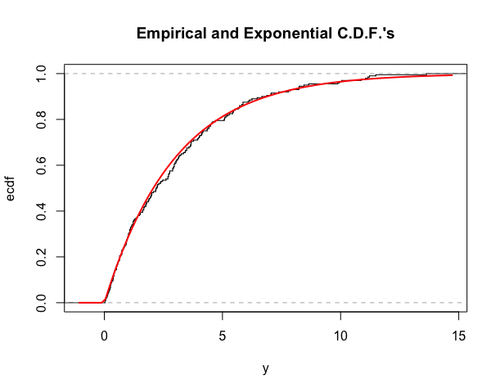

**Insert the boxplot comparing the Gaussian and Exponential data here.**

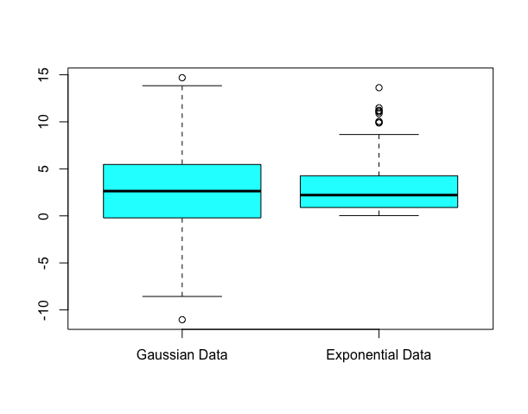

**Problem 3 (20 Marks):**

**Alpha = 8.11465 Beta = 7.9169**

**The first five pairs of numbers in your bivariate data set are:**

|  |  |
| --- | --- |
| **x** | **y** |
| **1.1** | **24.1** |
| **1.9** | **14.9** |
| **8.5** | **64.1** |
| **15.5** | **136.9** |
| **19.6** | **156.0** |

**Sample Correlation = 0.9365159**

**Insert the scatterplot of the data here.**

