|  |  |
| --- | --- |
| *https://lh4.googleusercontent.com/2kmr_ZrUDMsMbt5Ia0oTNuI2VERob3AO07nIX5MZtqQDdcqajLCEJY4dM1Bbc-G0g5VtGzPmL7aID7GMfl5CFAWmd3vV9ZQ4GL6qfNzOGgummKVflWPstbxb003exWASwPerv7fZ* | ***Study*** |

Read chapter 13 of the following book:

Learning Python:

<http://www.dsf.unica.it/~fiore/LearningPython.pdf>

Then answer the quiz in page 414

1. What are the main functional differences between a while and a for?

- The while loop is usually used when you need to repeat something until a given condition is true

- The for loop is usually used when you need to iterate a given number of times

2. What’s the difference between break and continue?

* Break: Jumps out of the closest enclosing loop (past the entire loop statement)
* Continue: Jumps to the top of the closest enclosing loop (to the loop’s header line)

3. When is a loop’s else clause executed?

* The else clause is only executed when the while condition becomes false

4. How can you code a counter-based loop in Python?

5. What can a range be used for in a for loop?

|  |  |
| --- | --- |
| *ttp://www.bestappsforkids.com/wp-content/uploads/2012/04/save-turtle.png* | ***Turtle exercises*** |

Using turtle to draw the following shapes:

1. 2.

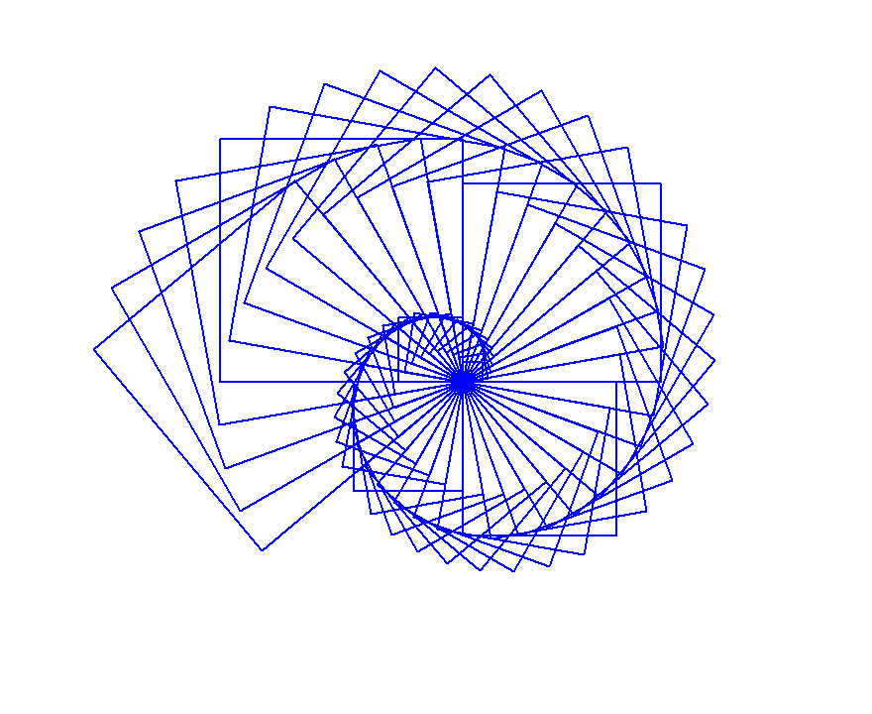

Answer 1:

from turtle import *

color("blue")

shape("classic")

speed(1000)

def square_divide():

for i in range(4):

forward(100)

left(90)

left(180)

for i in range(4):

forward(100)

left(90)

left(90)

for i in range(4):

forward(100)

left(90)

left(180)

for i in range(4):

forward(100)

left(90)

for i in range(6):

square_divide()

left(15)

exitonclick()

Answer 2:

from turtle import *

color("blue")

shape("classic")

speed(10000)

left(120)

# for i in range (4):

# forward(200)

# left(90)

for j in range (0,200,5):

left(-15)

for i in range (4):

forward(200-j)

left(90)

|  |  |
| --- | --- |
| *https://lh6.googleusercontent.com/bCyr2rSgu6vBSIJtKWOzUudXWGVZQXU2-ROjivd5VmkniARu2rziPKQQK3f-FTcvvNCCAuyH4mZaIhsf7WSxdTwNHbZ01UJsID6t2CO4vBX0M-Bz_OQ5Yx8-GMZcVv8y8qjL8C4z* | ***Serious exercises*** |

**Exercise 1**: Write a program to standardise user’s name:

https://lh6.googleusercontent.com/1Qkh_qtDuPiNTGJXxNZssHvowfNugeJkvA8Tyu57d313j61FJVX-tc53s_-EnVosLhPeZyQI6mtfm26_lwJTj-e45O9F0a-JtwKGIwmrJXgI2Jw1CYpKwxuzbBGkBZ_NIpm8_lkn

**Exercise 2**: Write a program to ask user to enter their balance then standardise it:

https://lh5.googleusercontent.com/mu9fXSJhL-qyYcpt2pIjDXGETTX3p9zSBAoSUM-O0h3j_DN8tSSwMW4jimYkBQrdkfshPmupmDp2ETpoOnRRz1eaRRFiNb1uHEpIMykFUTqrkWF2fI2RUlo_WJgLbcNzoA56SKCW