|  |
| --- |
| Logo_SB.jpg |

|  |  |  |
| --- | --- | --- |
| **PROG 24178** |  | |
| **Faculty of Applied Computing and Technology** | | **A3** |

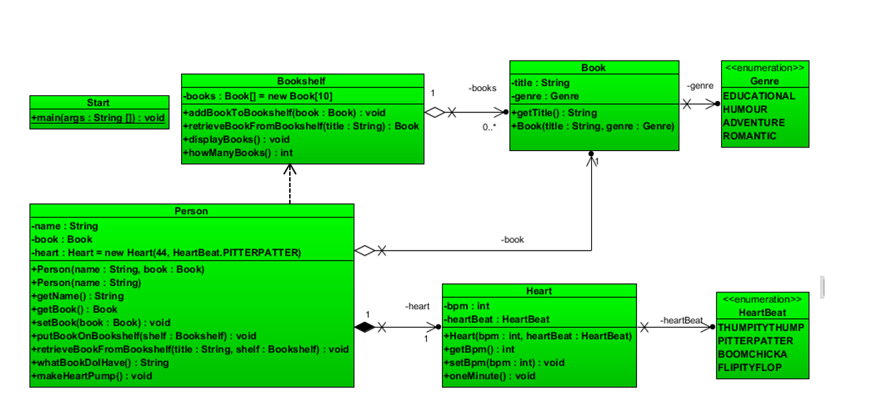

Build the program depicted in the UML diagram.

You have been given the Start class which should result in the following output:

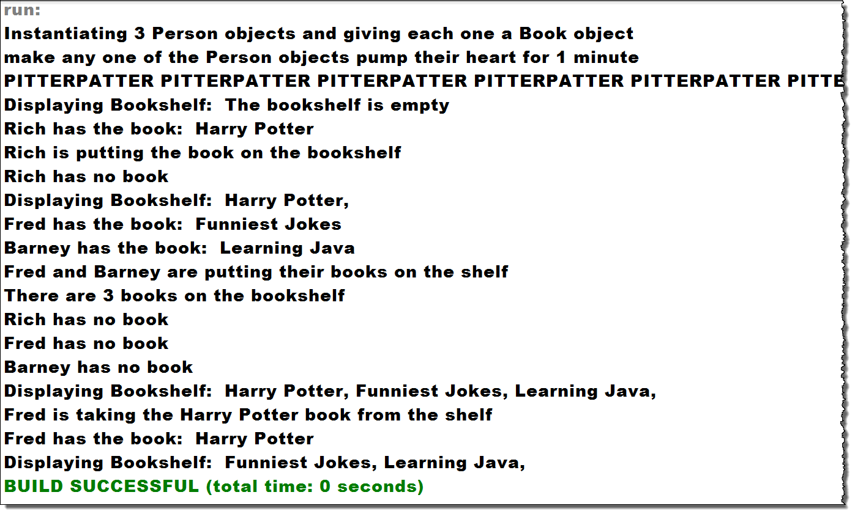

* Download the .zip file and open in VSCode.
* **There are 2 packages in this project:**
  + A3startclass includes the Start class which has the main method.
  + A3allotherclasses is where you will place all other classes.
* You will have to correctly import classes to make the Start class work.

**Person:**

* Add a comment to indicate the relationship between Person and Heart
* Add a comment to indicate the relationship between Person and Book
* Add a comment to indicate the relationship between Person and Bookshelf
* **whatBookDoIHave** will return a String that either contains ***<name> has no book*** if the instance variable ***Book*** is null or ***<name> has the book: <title>*** if the instance variable book holds a reference to a ***Book*** object.
* **retrieveBookFromBookshelf** accepts a String title and a BookShelf. It will call the retrieveBookFromBookshelf method in the Bookshelf class and place the returned value in the book instance variable.
* **putBookOnBookshelf** will accept a Bookshelf object and place the book that is in the book instance variable onto the Bookshelf object by calling the addBookToBookshelf method of the Bookshelf object
* **makeHeartPump** will call the oneMinute method of the Heart Object

**Bookshelf**

* Contains an instance variable called **books** that is an array of 10 Book objects
* **addBookToBookshelf** accepts a Book object and adds it to the first element of the books array that holds a null value.
* **retrieveBookFromBookshelf** accepts a String containing a title and looks for a Book object in the array that has a title instance variable that matches. If it finds one, it returns the Book object. (If you return a Book, you should remove it from the shelf by setting that element to null!) If it doesn’t find the Book object, it returns null
* **displayBooks** will PRINT out the titles of all Book objects that are stored in the books array.
* **howManyBooks** will return the number of array elements in the books array that are not null

**Heart**

* **oneMinute** method will print out the heartBeat instance variable as many times as the bpm instance variable is set to.

**Upload all of the zipped project to the dropbox and copy and paste all of the source code into the comment section**

***Remember that you can always get help from me or from the Learning Assistants!***