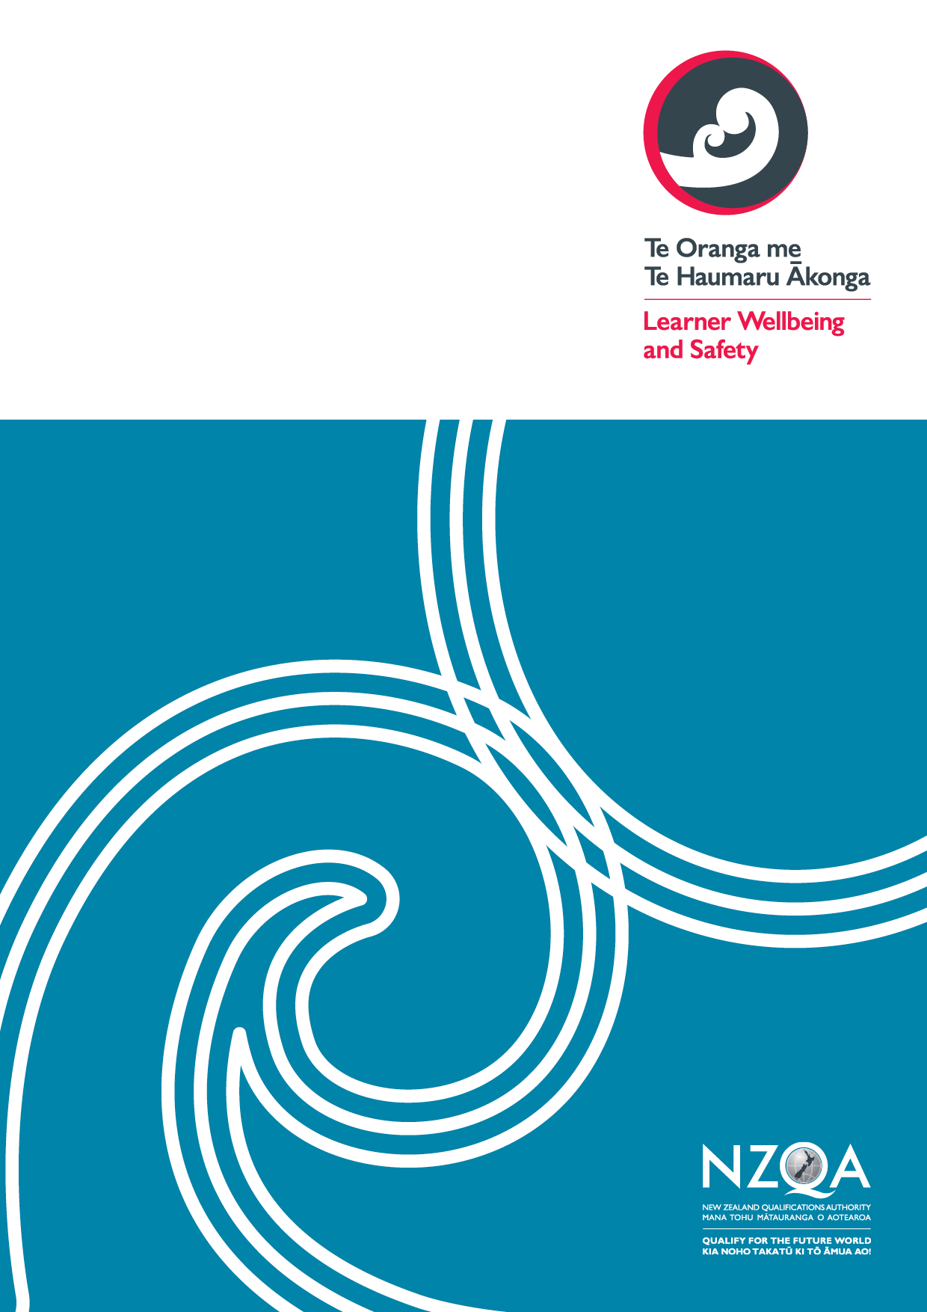

# **Tool E: self-review report template**

Use this optional template to shape your summary self-review report on your self-review of performance against the requirements of the Code.

## School information

|  |  |  |  |  |  |  |
| --- | --- | --- | --- | --- | --- | --- |
| **School Name** |  | | **MoE number** | |  | |
| **Code contact** | **Name** |  | **Job title** | |  | |
|  | **Email** |  | **Phone number** | |  | |
| **Current international learner enrolments** | **Total #** | # | | **18 y/o or older** | | # |
| **Under 18 y/o** | | # |
| **Report author(s)** |  | | | | | |

## Summary of performance under each outcome

|  |  |  |
| --- | --- | --- |
|  | | |
|  | **Summary of performance based on gathered information** (i.e. how effectively is our organisation doing what it needs to be doing?) | **How do we know?** (i.e. note supporting evidence with analysis to make sense of what it means) |
| **Outcome 13:**  Marketing and promotion |  |  |
| **Outcome 14:**  Managing and monitoring education agents |  |  |
| **Outcome 15:**  Offer, enrolment, contracts, and insurance |  |  |
| **Outcome 16:**  Immigration matters |  |  |
| **Outcome 17:**  Orientation |  |  |
| **Outcome 18:**  Safety and wellbeing |  |  |
| **Outcome 19:**  Learner support, advice and services |  |  |
| **Outcome 20:**  Managing withdrawal and closure |  |  |
| **Outcomes 21 and 22:**  Dealing with complaints and compliance with international learner contract Dispute Resolution Scheme (DRS) |  |  |

## Findings from gap analysis of compliance with key required processes

|  |  |
| --- | --- |
|  | **Identified gaps in compliance with key required processes** |
| **Outcome 13:**  Marketing and promotion |  |
| **Outcome 14:**  Managing and monitoring education agents |  |
| **Outcome 15:**  Offer, enrolment, contracts, and insurance |  |
| **Outcome 16:**  Immigration matters |  |
| **Outcome 17:**  Orientation |  |
| **Outcome 18:**  Safety and wellbeing |  |
| **Outcome 19:**  Learner support, advice and services |  |
| **Outcome 20:**  Managing withdrawal and closure |  |
| **Outcomes 21 and 22:**  Dealing with complaints and compliance with international learner contract Dispute Resolution Scheme (DRS) |  |

## Summary of action plan

Include information on how actions will be monitored for implementation and success.

|  |  |  |  |  |  |
| --- | --- | --- | --- | --- | --- |
|  | | | | | |
|  | **Action/s to be taken** | **Owner** | **Due date** | **Plan for monitoring implementation** | **Measures of success** |
| **Outcome 13:**  Marketing and promotion |  |  |  |  |  |
| **Outcome 14:**  Managing and monitoring education agents |  |  |  |  |  |
| **Outcome 15:**  Offer, enrolment, contracts, and insurance |  |  |  |  |  |
| **Outcome 16:**  Immigration matters |  |  |  |  |  |
| **Outcome 17:**  Orientation |  |  |  |  |  |
| **Outcome 18:**  Safety and wellbeing |  |  |  |  |  |
| **Outcome 19:**  Learner support, advice and services |  |  |  |  |  |
| **Outcome 20:**  Managing withdrawal and closure |  |  |  |  |  |
| **Outcomes 21 and 22:**  Dealing with complaints and compliance with international learner contract Dispute Resolution Scheme (DRS) |  |  |  |  |  |