

Course Project Report
Subject: SWD392

Academic Year: 2026

Table of Contents
Record of Changes 3
I. Overview 4
I.1 Project Information 4
I.2 Project Team 4
II. Requirement Specification 4
II.1 Problem description 4
II.2 Major Features 4
II.3 Context Diagram 4
II.4 Nonfunctional requirements 5
II.5 Functional requirements 5
II.5.1 Actors 5
II.5.2 Use Cases 5
II.5.2 .1 Diagram(s) 5
II.5.2.2 Use case descriptions 6
II.5.3 Activity diagram 7
III. Analysis models. 8
III.1 Interaction diagrams 8
III.2 State diagram 9
IV. Design specification 10
IV.1 Integrated Communication Diagrams 10
IV.2 System High-Level Design 10
IV.3 Component and Package Diagram 10
IV.3.1 Component Diagram 10
IV.3.1 . Package Diagram 11
IV.4 Class diagram 12
IV.5 Database Design 12
V. Implementation 12
V.1 Map architecture to the structure of the project 12
V.2 Map Class Diagram and Interaction Diagram to Code 12
VI. Applying Alternative Architecture Patterns 12
VI.1 Applying the ………….. (ex: Service-Oriented Architecture (SOA)) architecture 12
VI.2 Applying Service Discovery Pattern in the service-oriented architecture 12

Record of Changes
Date | A*  M, D | In charge | Change Description
2026-03-10 | A | Project Team | Filled Sections I and II with HMSS requirement-modeling content.
*A - Added M - Modified D - Deleted

I. Overview

I.1 Project Information
- Project name: Hostel Management and Search System
- Project code: HMSS
- Group name: SWD392-G1
- Software type: Web-based information system

I.2 Project Team
Full Name | Role | Email | Mobile

II. Requirement Specification

II.1 Problem description
The Hostel Management and Search System is a web-based platform that connects tenants who need suitable rental rooms with owners who manage one or more hostel properties. Within the scope of this project, a property is the overall hostel or rental house and a room is the smallest rentable unit. In release 1, one room corresponds to one listing.
Today, tenants usually search for rooms through fragmented channels such as social media posts, chat groups, personal contacts, or inconsistent listing websites. That makes room information difficult to compare, difficult to verify, and hard to track once availability changes. Owners face the opposite side of the same problem: they lack a centralized system for managing multiple properties and rooms, publishing trustworthy listings, and reviewing rental requests in a structured way.
HMSS addresses those problems with three business focuses: searching hostel room listings, managing properties and room listings, and handling rental requests. The system supports visitors, tenants, owners, and system administrators, while keeping the final rental arrangement outside the platform. Online payment, in-system chat, electronic contracts, and full tenancy lifecycle management are outside the current scope.

II.2 Major Features
The major HMSS features below summarize the business capabilities that drive the functional requirements.
- FE-01: Search publicly available hostel room listings using filters such as location, price range, amenities, move-in date, and requestability status.
- FE-02: View detailed room listing information, including property context, room conditions, amenities, pricing, and owner information.
- FE-03: Register and sign in as a tenant or owner account to access protected functions.
- FE-04: Allow owners to create and manage multiple properties and multiple rooms under each property.
- FE-05: Allow owners to create draft room listings and maintain listing information before publication.
- FE-06: Allow only verified owners to publish room listings so they become publicly searchable.
- FE-07: Allow tenants to submit rental requests for visible and requestable room listings.
- FE-08: Allow tenants to cancel submitted requests and track request status over time.
- FE-09: Allow owners to review rental requests and decide to accept, reject, or keep them pending.
- FE-10: Lock a room listing immediately after request acceptance and reopen it if the offline arrangement fails.
- FE-11: Allow system administrators to review owner verification submissions and manage user account status.
- FE-12: Allow system administrators to control the public visibility of suspicious or policy-violating listings.

II.3 Context Diagram
At the highest level, HMSS is treated as a single black-box system that exchanges information with human actors and external services.
External entities: Visitor, Tenant, Owner, System Admin, Google Maps, Cloud Storage, and Email Provider.
Inbound flows include search criteria, account data, property and listing data, owner verification submissions, rental requests, and administrative control actions.
[Image Placeholder: Context Diagram]
Outbound flows include search results, room detail information, request-status updates, verification results, listing-control results, notifications, and location display data.
No include or extend relationships were identified at the requirement-modeling stage.

II.4 Nonfunctional requirements
The following nonfunctional requirements summarize the performance, security, availability, reliability, and scalability constraints for HMSS.
# | Feature | System Function | Description
1 | Performance | Search response time | Search results for UC-01 should return within 3 seconds under normal load.
2 | Performance | Room detail load time | Room detail information for UC-02 should load within 3 seconds under normal conditions.
3 | Security | Credential and session protection | Credentials and authenticated sessions must be protected against unauthorized access and hijacking.
4 | Security | Verification document confidentiality | Owner verification documents must be stored securely and accessible only to System Admin during review.
5 | Security | Request access control | Rental request information must be accessible only to the relevant Owner and System Admin.
6 | Reliability | Business-rule enforcement | Unverified owners must never be allowed to bypass the publication gate for public listings.
7 | Availability | Public and protected access | Public search and protected user functions should remain available during normal operating periods with minimal interruption.
8 | Scalability | Growth support | The system must accommodate growth in listings, users, and concurrent rental requests without fundamental business-model changes.
9 | Integration | Notification support | Email-based status notifications should be supported even if temporary email delivery failures must be retried later.

II.5 Functional requirements

II.5.1 Actors
HMSS includes human actors, external-service actors, and one generalized actor used for shared authentication behavior.

# | Actor | Description
1 | Visitor | An unauthenticated user who can search public room listings and view room details.
2 | Registered User | A generalized actor representing Tenant, Owner, and System Admin for the shared Sign In use case.
3 | Tenant | A registered user who submits rental requests, cancels requests, and tracks request status.
4 | Owner | A registered user who manages properties, room listings, owner verification submission, and rental request review.
5 | System Admin | An administrator who reviews owner verification, manages account status, and controls suspicious listings.
6 | Google Maps | An external service that provides location data when the system displays property or listing map information.
7 | Cloud Storage | An external service that stores and serves room images and owner verification documents.
8 | Email Provider | An external service that delivers business notifications such as request-status and verification-status messages.

II.5.2 Use Cases
The HMSS use-case model contains 18 requirement-level use cases derived from the approved Phase 1 source material.

II.5.2 .1 Diagram(s)
The use case diagram should show Visitor, Registered User, Tenant, Owner, System Admin, Google Maps, Cloud Storage, and Email Provider connected to UC-01 through UC-18.
[Image Placeholder: Use Case Diagram]

II.5.2.2 Use case descriptions
The summary table and detailed specifications below are populated from the approved HMSS Phase 1 use-case set.
ID | Use Case | Actors | Use Case Description
UC-01 | Search Hostel Room | Visitor | Visitor enters search criteria to find available hostel room listings. System returns matching results filtered by location, price range, amenities, availability status, and move-in date.
UC-02 | View Room Details | Visitor | Visitor selects a room listing and receives complete room information including description, pricing, amenities, availability, property context, owner information, and map location.
UC-03 | Register Account | Visitor | Visitor creates a new Tenant or Owner account by providing required registration information. The system validates the input, creates the account with the selected role, and confirms the result.
UC-04 | Sign In | Registered User (Tenant, Owner, or System Admin) | A registered user authenticates with credentials to gain role-based access to protected system functions.
UC-05 | Submit Rental Request | Tenant | Tenant submits a rental request for a visible and requestable room listing by providing move-in details, occupant information, and contact preferences. System records the request and notifies the owner via email.
UC-06 | Cancel Rental Request | Tenant | Tenant cancels an eligible submitted rental request. System updates request status and notifies owner via email.
UC-07 | Track Rental Request Status | Tenant | Tenant views current statuses of all submitted rental requests to decide next actions.
UC-08 | Manage Property | Owner | Owner creates a new property or updates an existing property's information. System records the result.
UC-09 | Create Room Listing | Owner | Owner creates a new room listing under an existing property, entering room details and uploading images. System saves the listing as a draft.
UC-10 | Update Room Listing | Owner | Owner updates information on an existing room listing. System records the changes and updates listing data.
UC-11 | Publish Room Listing | Owner | A verified owner publishes a prepared room listing so it becomes publicly visible and searchable to visitors and tenants.
UC-12 | Change Listing Visibility | Owner | Owner hides or archives a published room listing, removing it from public search without deleting it.
UC-13 | Submit Owner Verification | Owner | Owner submits personal identification information and supporting documents for manual review by the System Admin. System records the submission and awaits administrative decision.
UC-14 | Review Rental Request | Owner | Owner reviews submitted rental requests for a room and decides to accept, reject, or keep each pending. Accepting locks the room from further requests and triggers an email notification to the tenant.
UC-15 | Reopen Room Listing | Owner | Owner revokes a previously accepted rental request after the offline arrangement fails and reopens the locked room to receive new requests.
UC-16 | Review Owner Verification | System Admin | System Admin reviews a pending owner verification submission and approves or rejects it. System updates the owner's verification status and notifies the owner via email.
UC-17 | Manage User Account Status | System Admin | System Admin controls the status of a user account (enable, suspend, or disable) when the account violates policy or requires administrative restriction.
UC-18 | Control Listing Visibility | System Admin | System Admin disables a suspicious or policy-violating listing from public search to protect platform integrity.

1. UC-01 Search Hostel Room

UC ID and Name: | UC-01 Search Hostel Room
Created By: | Project Team | Date Created: | 2026-03-10
Primary Actor: | Visitor | Secondary Actors: | Google Maps
Summary: | Visitor enters search criteria to find available hostel room listings. System returns matching results filtered by location, price range, amenities, availability status, and move-in date.
Preconditions: | At least one published room listing exists in the system.
Postconditions: | Visitor receives a list of room listings matching the entered criteria, or is informed that no match exists.
Dependency: | None
Description of main sequence: | 1. Visitor accesses the room search function.  2. System displays the search form with available filter options and current published listings.  3. Visitor enters or selects desired search criteria (location, price range, amenities, availability, move-in date).  4. System validates the criteria and queries matching published room listings.  5. Visitor confirms the search request.  6. System returns the list of matching room listings with essential information (title, price, location, availability).  7. Visitor reviews the results and may select a listing to view details.  8. System provides the selected listing entry point for further navigation.
Description of alternative sequences: | - Step 3: Visitor submits with no criteria  - 3.1: System returns all available published listings using default ordering.  - Returns to Step 7.  - Step 4: No listing matches the criteria  - 4.1: System informs the visitor that no matching room is currently available.  - 4.2: System invites the visitor to revise the search criteria.  - Returns to Step 3.
Exceptions: | None explicitly identified in Phase 1.
Nonfunctional requirements: | - Performance: Search results must return within 3 seconds under normal load.  - Usability: Filter options must be understandable to first-time users.
Outstanding questions: | - The exact default ordering of search results when no criteria are entered will be finalized later.
2. UC-02 View Room Details
UC ID and Name: | UC-02 View Room Details
Created By: | Project Team | Date Created: | 2026-03-10
Primary Actor: | Visitor | Secondary Actors: | Google Maps
Summary: | Visitor selects a room listing and receives complete room information including description, pricing, amenities, availability, property context, owner information, and map location.
Preconditions: | The selected room listing is publicly visible in the system.
Postconditions: | Visitor has reviewed the complete room listing information and may proceed to sign in and submit a rental request.
Dependency: | None
Description of main sequence: | 1. Visitor selects a room listing from search results or any listing entry point.  2. System retrieves the selected room listing information.  3. Visitor reviews the displayed page.  4. System displays full room details: title, description, price, amenities, capacity, availability status, move-in date, room images, property name and address, and basic owner information.  5. Visitor requests the map location of the property.  6. System requests location data from Google Maps and displays the property location on the map.  7. Visitor decides to submit a rental request or continue browsing.  8. System presents the rental request option (requires sign-in) or returns visitor to search results.
Description of alternative sequences: | - Step 2: The listing is no longer publicly visible  - 2.1: System informs the visitor that the room details are unavailable.  - 2.2: System returns the visitor to the listing search page.  - Use case ends.  - Step 5: Visitor does not request map location  - Skips Steps 5–6. Continues to Step 7.  - Step 6: Google Maps is unavailable  - 6.1: System informs the visitor that the map view is temporarily unavailable.  - Returns to Step 7.
Exceptions: | None explicitly identified in Phase 1.
Nonfunctional requirements: | - Performance: Room detail page must load within 3 seconds under normal conditions.  - Usability: Page must be readable and navigable on standard web devices.
Outstanding questions: | - The final set of room-detail fields shown in release 1 may be refined later.
3. UC-03 Register Account
UC ID and Name: | UC-03 Register Account
Created By: | Project Team | Date Created: | 2026-03-10
Primary Actor: | Visitor | Secondary Actors: | None
Summary: | Visitor creates a new Tenant or Owner account by providing required registration information. The system validates the input, creates the account with the selected role, and confirms the result.
Preconditions: | The visitor does not have an existing account and is not currently signed in.
Postconditions: | A new account exists in the system with the selected role. If the role is Owner, the account may prepare draft listings but cannot publish until verification is approved.
Dependency: | None
Description of main sequence: | 1. Visitor accesses the account registration function.  2. System displays the registration form with available account role options (Tenant or Owner).  3. Visitor selects the desired account role and enters required registration information (name, email, phone, password).  4. System validates that all required fields are complete, the email is not already registered, and the password meets requirements.  5. Visitor reviews the entered information and confirms the registration request.  6. System creates the new account with the selected role and assigns initial account status.  7. System informs the visitor that the account has been created successfully.
Description of alternative sequences: | - Step 4: Required information is incomplete or invalid  - 4.1: System informs the visitor which fields must be corrected.  - Returns to Step 3.  - Step 4: Email address is already associated with an existing account  - 4.1: System informs the visitor that an account with this email already exists.  - Returns to Step 3.
Exceptions: | None explicitly identified in Phase 1.
Nonfunctional requirements: | - Security: Registration credentials must be protected in transit and stored as a secure hash.  - Performance: Registration validation must complete within an acceptable response time.
Outstanding questions: | - Whether email verification is required immediately after registration will be finalized later.
4. UC-04 Sign In
UC ID and Name: | UC-04 Sign In
Created By: | Project Team | Date Created: | 2026-03-10
Primary Actor: | Registered User (Tenant, Owner, or System Admin) | Secondary Actors: | None
Summary: | A registered user authenticates with credentials to gain role-based access to protected system functions.
Preconditions: | The user has a registered account and is not currently signed in.
Postconditions: | The Registered User has an authenticated session with access rights corresponding to their account role (Tenant, Owner, or System Admin).
Dependency: | None
Description of main sequence: | 1. Registered User accesses the sign-in function.  2. System displays the sign-in form.  3. Registered User enters credentials (email and password).  4. System validates the credentials and checks the account status.  5. Registered User confirms the sign-in request.  6. System grants authenticated access and applies role-based access rights.  7. System informs the Registered User that sign-in has completed successfully.
Description of alternative sequences: | - Step 4: Credentials are invalid  - 4.1: System informs the user that the credentials are incorrect.  - Returns to Step 3.  - Step 4: Account is disabled or suspended  - 4.1: System informs the user that the account cannot access the system.  - Use case ends unsuccessfully.
Exceptions: | None explicitly identified in Phase 1.
Nonfunctional requirements: | - Security: Credentials must be protected in transit. Authenticated sessions must be secured against hijacking.  - Performance: Sign-in must complete within an acceptable response time.
Outstanding questions: | - Whether multi-factor authentication is required in release 1 will be finalized later.
5. UC-05 Submit Rental Request
UC ID and Name: | UC-05 Submit Rental Request
Created By: | Project Team | Date Created: | 2026-03-10
Primary Actor: | Tenant | Secondary Actors: | Email Provider
Summary: | Tenant submits a rental request for a visible and requestable room listing by providing move-in details, occupant information, and contact preferences. System records the request and notifies the owner via email.
Preconditions: | 1. Tenant has a registered account and is signed in.  2. The selected room listing is publicly visible and in Published Available status.
Postconditions: | A rental request with status Pending is recorded for the selected room, visible to the Owner for review.
Dependency: | None
Description of main sequence: | 1. Tenant accesses the rental request function from a selected room listing.  2. System displays the room summary and the rental request form.  3. Tenant enters the request information: move-in date, expected rental duration, number of occupants, occupation category, budget expectation, contact phone, preferred contact method, and any special notes.  4. System validates that all required fields are complete and that the room is still requestable.  5. Tenant reviews the entered request information and confirms the submission.  6. System records the rental request with status Pending.  7. System instructs Email Provider to notify the Owner that a new request has been received.  8. System informs the Tenant that the request has been submitted successfully.
Description of alternative sequences: | - Step 4: The room is no longer requestable (locked or hidden)  - 4.1: System informs the Tenant that the request cannot be submitted for this room.  - Use case ends unsuccessfully.  - Step 4: Required request fields are incomplete or invalid  - 4.1: System informs the Tenant which fields must be corrected.  - Returns to Step 3.  - Step 7: Email Provider is unavailable  - 7.1: System records the notification as failed but the request submission succeeds.  - Continues to Step 8.
Exceptions: | None explicitly identified in Phase 1.
Nonfunctional requirements: | - Security: Request information must be stored securely and accessible only to the relevant Owner and System Admin.  - Performance: Request submission must complete within an acceptable response time.
Outstanding questions: | - The exact set of optional request fields in release 1 may be adjusted later.
6. UC-06 Cancel Rental Request
UC ID and Name: | UC-06 Cancel Rental Request
Created By: | Project Team | Date Created: | 2026-03-10
Primary Actor: | Tenant | Secondary Actors: | Email Provider
Summary: | Tenant cancels an eligible submitted rental request. System updates request status and notifies owner via email.
Preconditions: | 1. Tenant is signed in.  2. Tenant has at least one submitted rental request in Pending status.
Postconditions: | Selected request status is Cancelled by Tenant.
Dependency: | None
Description of main sequence: | 1. Tenant accesses the request management function.  2. System displays the Tenant's submitted requests and their current statuses.  3. Tenant selects a request to cancel.  4. System checks that the selected request is still in Pending status and eligible for cancellation.  5. Tenant confirms the cancellation.  6. System updates the request status to Cancelled by Tenant.  7. System instructs Email Provider to notify the Owner of the cancellation.  8. System informs the Tenant that the cancellation has completed successfully.
Description of alternative sequences: | - Step 4: Request is no longer eligible for cancellation (already accepted or rejected)  - 4.1: System informs the Tenant the request cannot be cancelled.  - Use case ends unsuccessfully.  - Step 7: Email Provider unavailable  - 7.1: System records the notification as failed but the cancellation still succeeds.  - Continues to Step 8.
Exceptions: | None explicitly identified in Phase 1.
Nonfunctional requirements: | - Performance: Cancellation result must be reflected promptly in the request status.
Outstanding questions: | - The detailed cancellation rule for requests already in Accepted status will be finalized later.
7. UC-07 Track Rental Request Status
UC ID and Name: | UC-07 Track Rental Request Status
Created By: | Project Team | Date Created: | 2026-03-10
Primary Actor: | Tenant | Secondary Actors: | None
Summary: | Tenant views current statuses of all submitted rental requests to decide next actions.
Preconditions: | 1. Tenant is signed in.  2. Tenant has at least one submitted rental request.
Postconditions: | Tenant has reviewed current status information for submitted requests.
Dependency: | None
Description of main sequence: | 1. Tenant accesses the rental request status function.  2. System retrieves all submitted requests for the Tenant.  3. Tenant selects a specific request for more detail.  4. System displays the request list with current status of each request (Pending, Accepted, Rejected, Cancelled, Revoked).  5. Tenant reviews the detailed status information of the selected request.  6. System displays the selected request's full status details and available actions.
Description of alternative sequences: | - Step 2: Tenant has no submitted requests  - 2.1: System informs the Tenant that no request history is available.  - Use case ends successfully.
Exceptions: | None explicitly identified in Phase 1.
Nonfunctional requirements: | - Performance: Status information must be accurate and up to date at time of retrieval.
Outstanding questions: | - The exact level of request history detail visible to tenants will be finalized later.
8. UC-08 Manage Property
UC ID and Name: | UC-08 Manage Property
Created By: | Project Team | Date Created: | 2026-03-10
Primary Actor: | Owner | Secondary Actors: | None
Summary: | Owner creates a new property or updates an existing property's information. System records the result.
Preconditions: | Owner has a registered account and is signed in.
Postconditions: | Property information is created or updated in the system and available for room listing management.
Dependency: | None
Description of main sequence: | 1. Owner accesses the property management function.  2. System displays current properties and available actions (create new / update existing).  3. Owner selects the desired action and enters or updates property information: name, address, map location, description, and general policies.  4. System validates that required property fields are complete.  5. Owner reviews the information and confirms the action.  6. System records the property information.  7. System informs the Owner that the property has been managed successfully.
Description of alternative sequences: | - Step 4: Required property information is incomplete or invalid  - 4.1: System informs the Owner which fields must be corrected.  - Returns to Step 3.
Exceptions: | None explicitly identified in Phase 1.
Nonfunctional requirements: | - Performance: Property information must be persisted reliably and reflect promptly after confirmation.
Outstanding questions: | - The final list of optional property attributes may be adjusted later.
9. UC-09 Create Room Listing
UC ID and Name: | UC-09 Create Room Listing
Created By: | Project Team | Date Created: | 2026-03-10
Primary Actor: | Owner | Secondary Actors: | Cloud Storage
Summary: | Owner creates a new room listing under an existing property, entering room details and uploading images. System saves the listing as a draft.
Preconditions: | Owner is signed in and has at least one existing property.
Postconditions: | A new room listing with status Draft exists under the selected property.
Dependency: | None
Description of main sequence: | 1. Owner accesses the room listing creation function under a selected property.  2. System displays the room listing form with required and optional fields.  3. Owner enters room information: title, description, price, capacity, amenities, available-from date, furnished status, private WC status, and uploads room images.  4. System validates that required fields are present and sends uploaded images to Cloud Storage.  5. Owner reviews the entered listing information and confirms saving.  6. System records the new room listing with status Draft.  7. System informs the Owner that the room listing has been saved as draft successfully.
Description of alternative sequences: | - Step 4: Required fields are incomplete  - 4.1: System informs the Owner which fields must be corrected.  - Returns to Step 3.  - Step 4: Cloud Storage is unavailable  - 4.1: System informs the Owner that images could not be uploaded at this time.  - Returns to Step 3.
Exceptions: | None explicitly identified in Phase 1.
Nonfunctional requirements: | - Performance: Listing draft must be saved reliably. Image upload must complete within an acceptable time.
Outstanding questions: | - The final set of required versus optional room fields for draft saving will be finalized later.
10. UC-10 Update Room Listing
UC ID and Name: | UC-10 Update Room Listing
Created By: | Project Team | Date Created: | 2026-03-10
Primary Actor: | Owner | Secondary Actors: | Cloud Storage
Summary: | Owner updates information on an existing room listing. System records the changes and updates listing data.
Preconditions: | 1. Owner is signed in.  2. Owner has at least one existing room listing.
Postconditions: | Room listing information is updated in the system.
Dependency: | None
Description of main sequence: | 1. Owner accesses the room listing management function and selects an existing listing to update.  2. System displays the current listing information in editable form.  3. Owner modifies the desired fields (title, description, price, capacity, amenities, available-from date) and optionally uploads new images.  4. System validates the updated fields and sends any new images to Cloud Storage.  5. Owner reviews the changes and confirms the update.  6. System records the updated listing information.  7. System informs the Owner that the listing has been updated successfully.
Description of alternative sequences: | - Step 4: Required fields are cleared or invalid  - 4.1: System informs the Owner which fields must be corrected.  - Returns to Step 3.  - Step 4: Cloud Storage unavailable  - 4.1: System informs the Owner that image upload failed at this time.  - Returns to Step 3.
Exceptions: | None explicitly identified in Phase 1.
Nonfunctional requirements: | - Performance: Updated listing information must be persisted reliably and reflect promptly.
Outstanding questions: | - Whether updating a published listing triggers a re-verification step will be finalized later.
11. UC-11 Publish Room Listing
UC ID and Name: | UC-11 Publish Room Listing
Created By: | Project Team | Date Created: | 2026-03-10
Primary Actor: | Owner | Secondary Actors: | Cloud Storage
Summary: | A verified owner publishes a prepared room listing so it becomes publicly visible and searchable to visitors and tenants.
Preconditions: | 1. Owner is signed in and has been verified by System Admin.  2. Selected room listing exists in Draft or unpublished state.  3. Listing has at least one uploaded image in Cloud Storage.
Postconditions: | Room listing status is Published Available and the listing appears in public search results.
Dependency: | None
Description of main sequence: | 1. Owner accesses the publication function for a prepared listing.  2. System displays the listing information and publication requirements checklist.  3. Owner reviews the listing and requests publication.  4. System verifies the Owner is verified, listing fields are complete, and at least one image exists in Cloud Storage.  5. Owner confirms the publication request.  6. System updates the listing status to Published Available.  7. System informs the Owner that the listing is now publicly searchable.
Description of alternative sequences: | - Step 4: Owner not yet verified  - 4.1: System informs the Owner that unverified owners cannot publish listings.  - Use case ends unsuccessfully.  - Step 4: Required listing fields are incomplete  - 4.1: System informs the Owner which fields are missing.  - Returns to Step 3.  - Step 4: No images exist for the listing  - 4.1: System informs the Owner that at least one image is required before publication.  - Returns to Step 3.
Exceptions: | None explicitly identified in Phase 1.
Nonfunctional requirements: | - Performance: Publication status must be reflected promptly in public search.  - Security: Publication rules must be enforced consistently — unverified owners must never bypass this check.
Outstanding questions: | - The exact minimum completeness rule for release 1 publication will be finalized later.
12. UC-12 Change Listing Visibility
UC ID and Name: | UC-12 Change Listing Visibility
Created By: | Project Team | Date Created: | 2026-03-10
Primary Actor: | Owner | Secondary Actors: | None
Summary: | Owner hides or archives a published room listing, removing it from public search without deleting it.
Preconditions: | 1. Owner is signed in.  2. Owner has at least one published room listing.
Postconditions: | The listing is no longer visible in public search. Status is Hidden or Archived.
Dependency: | None
Description of main sequence: | 1. Owner accesses the listing management function and selects a published listing.  2. System displays the current listing status and available visibility actions (Hide / Archive).  3. Owner selects the desired visibility action.  4. System checks that the selected action is valid for the listing's current status.  5. Owner confirms the visibility change.  6. System updates the listing status to Hidden or Archived.  7. System informs the Owner that the listing visibility has been changed successfully.
Description of alternative sequences: | - Step 4: Selected action is not valid for the listing's current status  - 4.1: System informs the Owner that the action cannot be applied.  - Use case ends unsuccessfully.
Exceptions: | None explicitly identified in Phase 1.
Nonfunctional requirements: | - Performance: Visibility change must be reflected immediately so the listing no longer appears in public search.
Outstanding questions: | - The archive retention policy and whether archived listings can be restored will be finalized later.
13. UC-13 Submit Owner Verification
UC ID and Name: | UC-13 Submit Owner Verification
Created By: | Project Team | Date Created: | 2026-03-10
Primary Actor: | Owner | Secondary Actors: | Cloud Storage
Summary: | Owner submits personal identification information and supporting documents for manual review by the System Admin. System records the submission and awaits administrative decision.
Preconditions: | 1. Owner is signed in.  2. Owner has not yet been verified, or has a previously rejected verification submission.
Postconditions: | Owner verification submission is recorded with status Pending Review. Owner cannot publish listings until System Admin approves the submission.
Dependency: | None
Description of main sequence: | 1. Owner accesses the owner verification submission function.  2. System displays the required verification information fields and document requirements.  3. Owner enters personal information and uploads supporting identification documents.  4. System validates that all required fields are present and sends uploaded documents to Cloud Storage.  5. Owner reviews the submission and confirms it.  6. System records the verification submission with status Pending Review.  7. System informs the Owner that the submission has been received and is pending admin review.
Description of alternative sequences: | - Step 4: Required information or documents are missing  - 4.1: System informs the Owner which items must be corrected or completed.  - Returns to Step 3.  - Step 4: Cloud Storage is unavailable  - 4.1: System informs the Owner that document upload failed at this time.  - Returns to Step 3.
Exceptions: | None explicitly identified in Phase 1.
Nonfunctional requirements: | - Security: Verification documents must be stored securely and accessible only to System Admin.  - Performance: Submission must be recorded reliably without data loss.
Outstanding questions: | - The final list of required verification document types will be finalized later.
14. UC-14 Review Rental Request
UC ID and Name: | UC-14 Review Rental Request
Created By: | Project Team | Date Created: | 2026-03-10
Primary Actor: | Owner | Secondary Actors: | Email Provider
Summary: | Owner reviews submitted rental requests for a room and decides to accept, reject, or keep each pending. Accepting locks the room from further requests and triggers an email notification to the tenant.
Preconditions: | 1. Owner is signed in.  2. At least one rental request exists for a room managed by the Owner.
Postconditions: | Selected request is updated to Accepted, Rejected, or Pending. If Accepted, the room status is Locked / Not Requestable.
Dependency: | None
Description of main sequence: | 1. Owner accesses the rental request review function for a selected room.  2. System displays all submitted requests for that room with their visible request information.  3. Owner selects a request to handle.  4. System displays the request details and available decision options (Accept / Reject / Keep Pending).  5. Owner selects the desired decision.  6. System records the decision for the selected request.  7. System updates the request status and, if accepted, updates the room status to Locked / Not Requestable.  8. System instructs Email Provider to notify the Tenant of the decision.  9. System informs the Owner that the decision has been recorded successfully.
Description of alternative sequences: | - Step 5: Owner keeps request pending  - 5.1: System preserves Pending status.  - Returns to Step 2.  - Step 5: Owner rejects the request  - 5.1: System updates status to Rejected.  - 5.2: Room remains requestable if no other request was accepted.  - Continues to Step 8.  - Step 8: Email Provider unavailable  - 8.1: System records the notification as failed but the decision still succeeds.  - Continues to Step 9.
Exceptions: | None explicitly identified in Phase 1.
Nonfunctional requirements: | - Performance: Decision must be reflected promptly in both request and room status.  - Security: Request information must be accessible only to the relevant Owner and System Admin.
Outstanding questions: | - The exact comparison view for reviewing multiple requests side by side may be refined later.
15. UC-15 Reopen Room Listing
UC ID and Name: | UC-15 Reopen Room Listing
Created By: | Project Team | Date Created: | 2026-03-10
Primary Actor: | Owner | Secondary Actors: | Email Provider
Summary: | Owner revokes a previously accepted rental request after the offline arrangement fails and reopens the locked room to receive new requests.
Preconditions: | 1. Owner is signed in.  2. At least one of the Owner's rooms has a rental request in Accepted status and is currently Locked / Not Requestable.
Postconditions: | Selected request status is Revoked by Owner. Room status is Published Available and accepts new rental requests.
Dependency: | None
Description of main sequence: | 1. Owner accesses the accepted arrangement management function.  2. System displays the accepted request and the corresponding locked room information.  3. Owner selects the accepted arrangement to handle.  4. System displays the reopen action and the business consequence (request will be Revoked, room will become requestable again).  5. Owner confirms that the offline arrangement has failed and requests reopening.  6. System updates the accepted request status to Revoked by Owner.  7. System updates the room status to Published Available.  8. System instructs Email Provider to notify the Tenant that the accepted request has been revoked.  9. System informs the Owner that the room listing has been reopened successfully.
Description of alternative sequences: | - Step 3: Selected request is no longer in Accepted status  - 3.1: System informs the Owner that the room cannot be reopened from this request.  - Use case ends unsuccessfully.  - Step 8: Email Provider unavailable  - 8.1: System records the notification as failed but the reopen action still succeeds.  - Continues to Step 9.
Exceptions: | None explicitly identified in Phase 1.
Nonfunctional requirements: | - Performance: Room status must be updated promptly so new requests can be submitted without delay.
Outstanding questions: | - The business note shown to the tenant after revocation will be finalized later.
16. UC-16 Review Owner Verification
UC ID and Name: | UC-16 Review Owner Verification
Created By: | Project Team | Date Created: | 2026-03-10
Primary Actor: | System Admin | Secondary Actors: | Email Provider
Summary: | System Admin reviews a pending owner verification submission and approves or rejects it. System updates the owner's verification status and notifies the owner via email.
Preconditions: | 1. System Admin is signed in.  2. At least one owner verification submission has status Pending Review.
Postconditions: | Owner verification status is Verified or Rejected. A Verified Owner may now publish room listings.
Dependency: | None
Description of main sequence: | 1. System Admin accesses the owner verification review function.  2. System displays pending verification submissions.  3. System Admin selects a submission to review.  4. System displays the submitted owner information and supporting documents.  5. System Admin reviews the submission and selects Approve or Reject.  6. System records the administrative decision.  7. System updates the owner's verification status to Verified or Rejected.  8. System instructs Email Provider to notify the Owner of the verification result.  9. System informs the System Admin that the review has been completed successfully.
Description of alternative sequences: | - Step 5: System Admin rejects the submission  - 5.1: System records the rejection result.  - 5.2: Owner retains inability to publish listings.  - Continues to Step 8.  - Step 8: Email Provider unavailable  - 8.1: System records the notification as failed but the decision still succeeds.  - Continues to Step 9.
Exceptions: | None explicitly identified in Phase 1.
Nonfunctional requirements: | - Security: Verification documents must remain confidential and accessible only to System Admin during review.
Outstanding questions: | - The final rejection-reason categories presented to the admin will be finalized later.
17. UC-17 Manage User Account Status
UC ID and Name: | UC-17 Manage User Account Status
Created By: | Project Team | Date Created: | 2026-03-10
Primary Actor: | System Admin | Secondary Actors: | Email Provider
Summary: | System Admin controls the status of a user account (enable, suspend, or disable) when the account violates policy or requires administrative restriction.
Preconditions: | 1. System Admin is signed in.  2. The target user account exists in the system.
Postconditions: | User account status is updated. A disabled or suspended account cannot access protected system functions.
Dependency: | None
Description of main sequence: | 1. System Admin accesses the user account administration function.  2. System displays user accounts and available account-management actions.  3. System Admin selects a user account to manage.  4. System displays the current account information and status.  5. System Admin selects the desired status-management action (Enable / Suspend / Disable).  6. System validates that the selected action is permitted under current business rules.  7. System Admin confirms the action.  8. System updates the user account status.  9. System instructs Email Provider to notify the user of the status change.  10. System informs the System Admin that the account-management action has been applied successfully.
Description of alternative sequences: | - Step 6: Selected action is not permitted under current business rules  - 6.1: System informs the System Admin that the action cannot be completed.  - Use case ends unsuccessfully.  - Step 9: Email Provider unavailable  - 9.1: System records the notification as failed but the account status update still succeeds.  - Continues to Step 10.
Exceptions: | None explicitly identified in Phase 1.
Nonfunctional requirements: | - Security: Account-management actions must be traceable and applied consistently. Disabled accounts must not retain unauthorized access.
Outstanding questions: | - The final list of account status values (enabled, suspended, disabled) will be confirmed later.
18. UC-18 Control Listing Visibility
UC ID and Name: | UC-18 Control Listing Visibility
Created By: | Project Team | Date Created: | 2026-03-10
Primary Actor: | System Admin | Secondary Actors: | Email Provider
Summary: | System Admin disables a suspicious or policy-violating listing from public search to protect platform integrity.
Preconditions: | 1. System Admin is signed in.  2. The target listing is currently publicly visible.
Postconditions: | The listing is removed from public search and no longer visible to visitors or tenants.
Dependency: | None
Description of main sequence: | 1. System Admin accesses the listing administration function.  2. System displays publicly visible listings with their associated information.  3. System Admin selects a listing to review.  4. System displays the listing details and available control actions.  5. System Admin selects the Disable action for the listing.  6. System Admin confirms the disable action.  7. System removes the listing from public search results.  8. System instructs Email Provider to notify the Owner that the listing has been disabled.  9. System informs the System Admin that the listing has been disabled successfully.
Description of alternative sequences: | - Step 8: Email Provider unavailable  - 8.1: System records the notification as failed but the listing is still disabled.  - Continues to Step 9.
Exceptions: | None explicitly identified in Phase 1.
Nonfunctional requirements: | - Security: Admin listing control must be traceable and applied immediately to protect platform users.
Outstanding questions: | - Whether a disabled listing can be re-enabled by admin or owner, and under what conditions, will be finalized later.

II.5.3 Activity diagram
The requirement model identifies the following activity-diagram candidates for later visual elaboration.
Recommended activity-diagram coverage:
Search Hostel Room and View Room Details
Submit Rental Request and Track Rental Request Status
Review Rental Request and Reopen Room Listing
Publish Room Listing and Review Owner Verification
[Image Placeholder: Activity Diagram(s)]

II.6 Entity Relationship Diagram
The core entity model follows the clarified business structure Owner -> Property -> Room Listing, extended with rental-request and verification support entities.

II.6.1 Entity Descriptions
The principal entities for the requirement-modeling stage are listed below.
# | Entity | Description
1 | User | Stores account information, role, account status, and authentication-related data.
2 | Property | Stores the overall hostel or rental-house information managed by an owner.
3 | RoomListing | Stores the public-facing room listing information, visibility state, and requestability state.
4 | RentalRequest | Stores a tenant's rental request, move-in expectations, and review status.
5 | OwnerVerification | Stores verification submissions, review outcomes, and supporting document references for owner accounts.
6 | ListingImage | Stores image metadata associated with a room listing.
7 | Amenity | Stores reusable amenity definitions that can be attached to room listings.
8 | RoomAmenity | Resolves the many-to-many relationship between room listings and amenities.
9 | Notification | Stores optional system-generated notification records for business events.
Recommended core relationships:
One Owner manages many Properties.
One Property contains one or more Room Listings in release 1.
One Tenant can submit many Rental Requests.
One Room Listing can receive many Rental Requests over time.
One Owner has at most one active Owner Verification record at a given review stage.
[Image Placeholder: Entity Relationship Diagram]

III. Analysis models.

III.1 Interaction diagrams
[Interaction diagrams are a type of UML diagram that illustrate how objects interact in a particular scenario of a use case. They focus on the flow of messages between objects or components over time.
There are two main types:
- Sequence Diagram – Emphasizes the time-ordering of messages
- Communication Diagram – Emphasizes the structure and relationships between objects]

III.1.1.Sequence Diagram

[Provide the sequence diagram(s) for the feature, see the sample below]
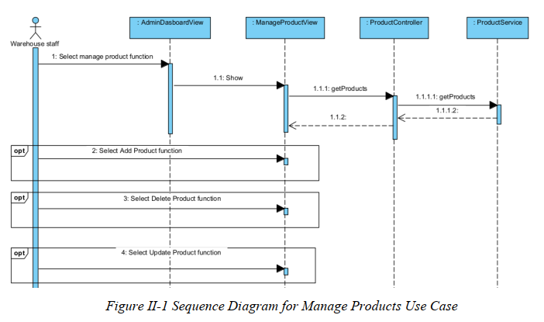

III.1.2. Communication Diagram
[Provide the Communication diagram(s) for the feature, see the sample below]

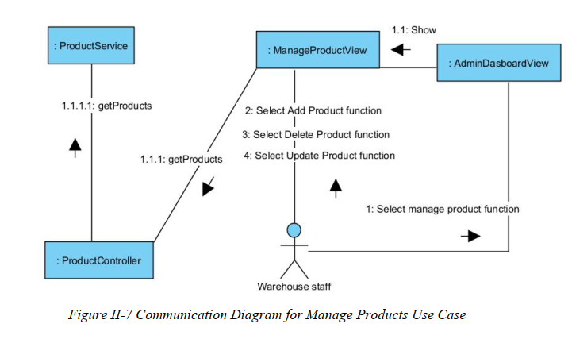

III.2 State diagram
[Provide the State diagram(s) for the feature, see the sample below]
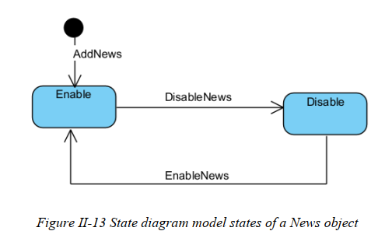

IV. Design specification

IV.1 Integrated Communication Diagrams
Sample
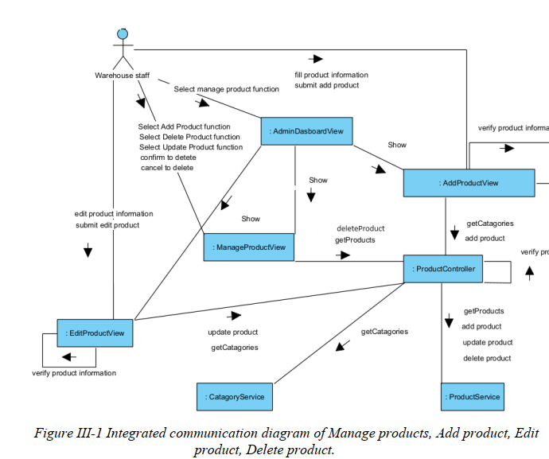

IV.2 System High-Level Design
Sample
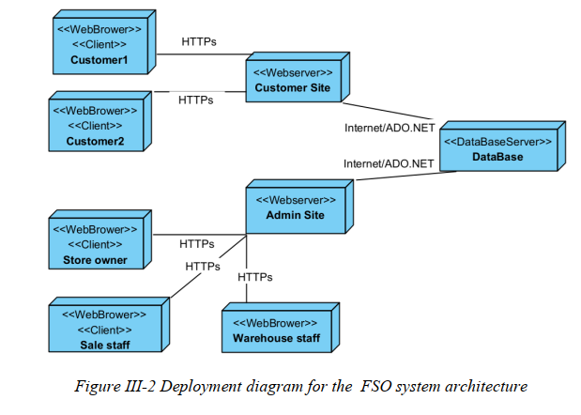

IV.3 Component and Package Diagram

IV.3.1 Component Diagram
Sample
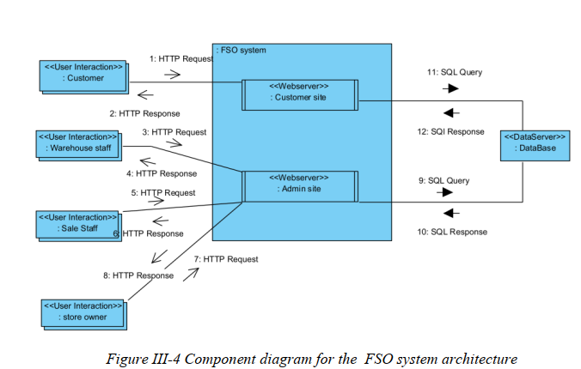

IV.3.1 . Package Diagram
[Provide the package diagram for each sub-system. The content of this section including the overall package diagram, the explanation, package and class naming conventions in each package. Please see the sample & description table format below (please note: package names don’t follow Java package naming convention yet)]
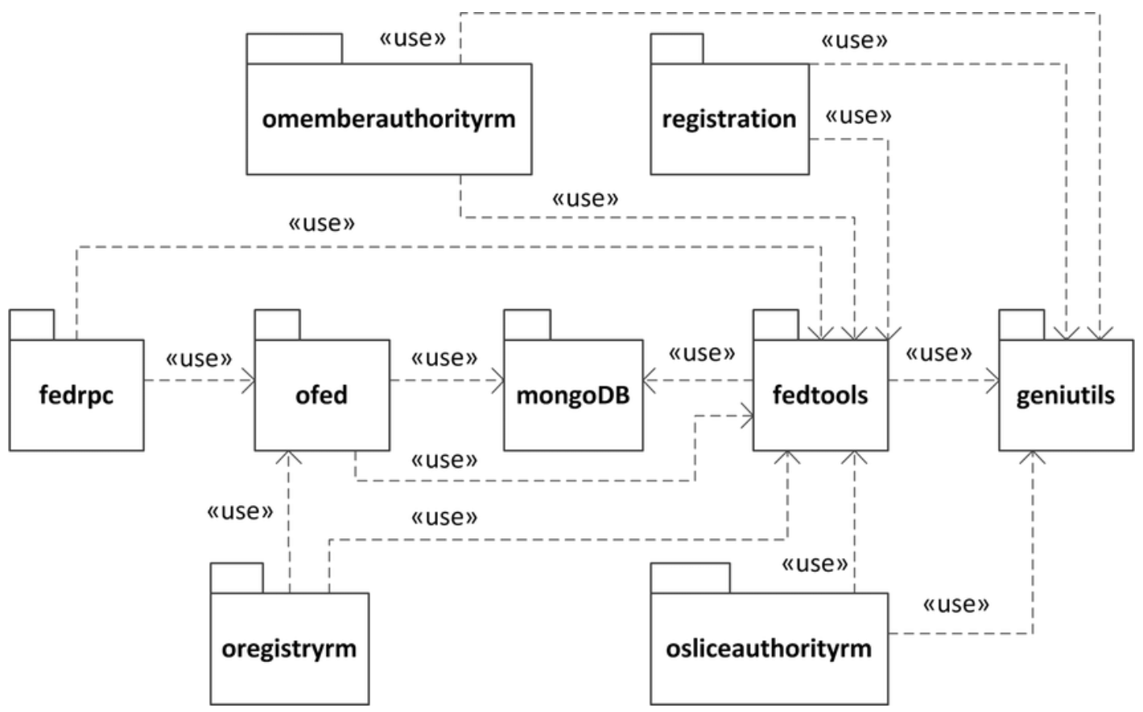
Package descriptions
No | Package | Description
01 | omemberauthorityrm | <Description of the package>
02 | registration | <Description of the package>
03 | fedrpc | <Description of the package>
04 | ofed | <Description of the package>
05 | mongoDB | <Description of the package>
06 | fedtools | <Description of the package>
07 | …

IV.4 Class diagram
[This part presents the class diagram for the relevant feature]

IV.5 Database Design
[Provide the tables relationship like example below – following MySQL database naming convention]

V. Implementation

V.1 Map architecture to the structure of the project
[Provide:
- Overview of the Chosen Architecture
Briefly describe the architectural style (e.g., Layered, MVC, Service-Oriented Architecture)
Explain why it was selected for this project (e.g., to meet non-functional requirements like maintainability, scalability, reusability)
- Mapping to Project Structure
Present the actual project folder/package structure
Map each layer/component in the architecture to concrete project modules]

V.2 Map Class Diagram and Interaction Diagram to Code
[Demo the implementation of several features using design patterns]

VI. Applying Alternative Architecture Patterns

VI.1 Applying the ………….. (ex: Service-Oriented Architecture (SOA)) architecture
[Redesign part of the system architecture using Service-Oriented Architecture (SOA) to improve reusability, scalability, and modularity.
Students must provide:
- Problem Identification
Briefly describe which non-functional requirement(s) are not fully supported by the current architecture (e.g., NF-05: Reusability)
- SOA-Based Solution
Reorganize system components into independent services
E.g., refactor FSOData into separate service modules
- Supporting Diagrams
Deployment Diagram
Updated Class Diagram
Component Diagram showing separate services]

VI.2 Applying Service Discovery Pattern in the service-oriented architecture
[Support dynamic service registration and discovery in SOA or microservice-based architecture for horizontal scalability and ease of expansion.
Students must provide:
- Problem & Requirement
Explain the relevant non-functional requirement (e.g., NF-06: Scalability)
Describe the need for service discovery in a growing system (e.g., multiple branches, independent modules)
- Service Discovery-Based Solution
Integrate a Service Discovery Pattern
Mention possible technologies: Consul, Eureka, Kubernetes DNS
- Supporting Diagrams
Deployment Diagram (with multiple instances and registry)
Updated Class/Component Diagram including a Discovery Service]

