FPT ACADEMY INTERNATIONAL FPT – APTECH COMPUTER EDUCATION

Centre Name: ACE-HCMC-2-FPT.

Address: 21Bis Hau Giang, Tan Son Nhat, Ho Chi Minh City, Viet Nam.

Sky Gazing

Supervisor: | Ms. Le Mong Thuy
Semester: | 1
Batch No: | T3.2502.E0
Group No: | 5
Order: | Name | Student ID
1. | Doan Duy Thai | Student1637699
2. | Mai Mai Truong Quoc Hung | Student1634676
3. | Hong Tai Loi | Student1634674

Date: August - 2025

This is to certify that

Mr. Doan Duy Thai

Mr. Hong Tai Loi

Mr. Mai Truong Quoc Hung

have successfully designed & developed:

eProject: Sky Gazing

Submitted by:

Ms. Le Mong Thuy

Date of issue: 8/23/2025

Authorized Signature:
Table of Contents
ACKNOWLEGMENT 3
SYNOPSIS 3
ANALYSIS 3
- Purpose of the Website 3
- Design and Interface 3
- Technical Requirements 4
CUSTOMER'S REQUIREMENTS SPECIFICATIONS 4
- Business/Project Objective 4
- Hardware/ Software Requirements 5
  - Hardware 5
  - Software 5
SCOPE OF THE WORK (IN BRIEF) 6
- Home 6
- Astronomy topics 6
- Constellations 6
- Comets 6
- Sky gazing 6
- Observatories 6
- NEWS 6
- ABOUT US 6
ARCHITECTURE AND DESIGN OF THE SYSTEM 7
DIAGRAM OF THE WEBSITE 8
TASK SHEET REVIEW 1 9
SITE MAP 10
MOCK OF THE WEBSITE 11
- Home 11
- Astronomy topics 12
- Constellations 12
- Comets 12
- Sky gazing 13
- Observatories 14
- NEWS 15
- ABOUT US 16
TASK SHEET REVIEW 2 17
WEBSITE DESCRIPTION
- Home 11
- Astronomy topics 12
- Constellations 12
- Comets 12
- Sky gazing 13
- Observatories 19
- NEWS 19
ABOUT US 19
TASK SHEET REVIEW 3 31

ACKNOWLEGMENT

On behalf of team members. I would like to thank everyone who supported my team to successfully complete this eProject report. Especially, our teacher, she has supported us a lot since we started studying at FPT Aptech. With this eProject, she guided us very meticulously, enthusiastically and strictly. With her guidance, we were able to successfully complete this project. Besides, I also want to thank all the team members, each of whom worked hard to complete the eProject in earnest during the month of working together. Finally, our group would like to say thank you to my classmates and family for sharing and creating for the group the best environment to focus on the project, motivating the members to achieve their goals.

SYNOPSIS

Astronomy is a scientific field that studies celestial objects and phenomena in the universe. It is one of the oldest sciences and includes many subfields, ranging from observing planets and stars to studying the structure and evolution of the universe. Here is a summary of some key aspects of astronomy:

Celestial Objects: Stars, Planets, Galaxies, Nebulae.

Astronomical Phenomena: Supernova, Black Holes, Gravitational Lensing.

Research and Tools: Telescopes, Space Observatories.

Universe and Origins: Big Bang, Expanding Universe.

Modern Exploration and Research: Search for Exoplanets, Dark Matter and Dark Energy Research.

ANALYSIS

Purpose of the Website.

The website aims to provide an informative and engaging platform for users to explore various aspects of astronomy. This website will serve as a comprehensive resource, offering detailed information on planets, constellations, comets, astronomical theories, and the latest developments in the field.

Design and Interface.

  - The website features a user-friendly environment and navigation. Key menus are positioned at the top for easy access to information.
  - The interface and color scheme are harmoniously combined to create a visually appealing and engaging experience for users.

Technical Requirements

  - The website must perform well across all major browsers including Chrome, IE, Firefox, etc., ensuring accessibility from various devices and platforms.
  - It utilizes a Single-Page-Application (SPA) approach to deliver a seamless and fast web browsing experience.
  - Features are designed to meet technical requirements, facilitating quick and accurate loading and display of information.

The space exploration website aims to become a valuable and engaging source of information for space enthusiasts, providing everything from basic knowledge to practical insights from researchers and major space research agencies around the world.

CUSTOMER'S REQUIREMENTS SPECIFICATIONS

Client: APT India Co.

Business/Project Objective

The portal will be designed as a Single-Page-Application and responsive Website with a set of pages and menus that represent choice of activities to be performed. The pages, menus, and other visual elements must be designed in a visually appealing manner with attractive fonts, colors, and animations.

All of these should also be laid out in a responsive manner

The Web site is to be created based on the following requirements.

- The web page should have the description/images about various planets. If user clicks on the same, navigational link must be available.
- There should be categories providing details about Solar Eclipse, big bang theory, evolution of earth etc
- Various sections such as –
  - When best to Star Gaze
  - Where is best to Star Gaze
  - What to expect to see in a Star Gaze

- The site should also list and explain various planets available as well as details about them as
  - When discovered
  - Size
  - Atmosphere there
  - Distance from sun and earth
  - Other available important details about them.
- There should be information on constellations as what is it/how it is formed and various constellations.
- There should also be a section on comet giving information related.
- Also include a section which will provide details on various latest developments in the field of astronomy related to planets and stars.
- List of Few top Observatories with details and location displayed using GeoLocation API (eg. GoogleMaps).
- Site map, Gallery, About us, Contact us link must be added.
- About Us and Contact Us: This menu option should display Email id, address, and contact number of Sky Gazing Company.

Over and above this, the portal should implement the following functionalities:

- Display a continuous scrolling ticker at the bottom of the page with current date, time, and location (hint: Use geolocation features of HTML5).
- Display a visitor count at the top right corner of the page beside a logo image.
- The menu options should change color on hover and also after clicking.
- Fade in and fade out options can be used for the menus.

Hardware/ Software Requirements
Hardware
- Intel Core i3/i5 Processor or higher
- 8 GB RAM or above
- Color SVGA
- 500 GB Hard Disk space
- Mouse
- Keyboard

Software
Technologies to be used:
- Frontend: HTML5, CSS, Bootstrap, JavaScript, jQuery, React/AngularJS, Figma, XML
- Data Store: JSON files or TXT files

Other Requirements:
- Operating Portal: Windows
- Browsers: Edge, Chrome, Mozilla Firefox, Safari

SCOPE OF THE WORK (IN BRIEF)

Home: Displays an overview of mountaineering and the website's logo.

Astronomy Topics:
- Solar Eclipses: Explanation of solar eclipses, viewing tips, and upcoming eclipse dates
- Witnessing Planet Birth: Insights into planet formation with examples from modern astronomical observations.
- Big Bang Theory: Information on the origin of the universe.
- Evolution of Earth: Detailed explanation of Earth's formation and development.
- Planets: Discovery date, Size, Atmosphere, Distance from the Sun and Earth, Other significant details.
- Constellations: Explanation of constellations, their formation, and information on various known constellations.
- Comets: Information on comets, including notable examples and their characteristics

- Star gazing: Information on the best seasons, dates, and times for stargazing activities.
- Observatories:
- Content: List of top observatories, including their details and locations.

Feature: Display observatories on a map using the Geolocation API (e.g., Google Maps).

Gallery: Videos, Images: A collection of informative and illustrative videos on galaxy, planets, stars, etc., optimized for quick loading and viewing.

- News: Updates on recent discoveries and advancements in the field of astronomy related to planets and stars.

About Us: Contact information for users to reach out or send feedback.

ARCHITECTURE AND DESIGN OF THE SYSTEM

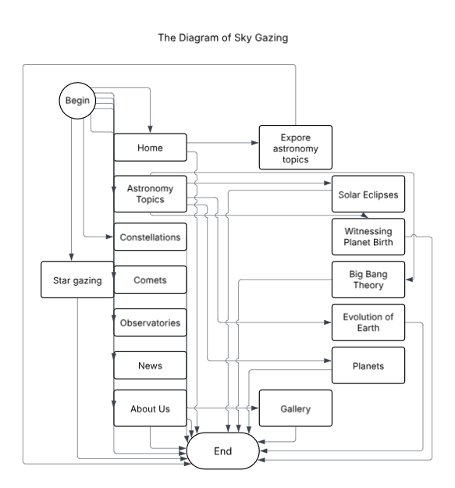

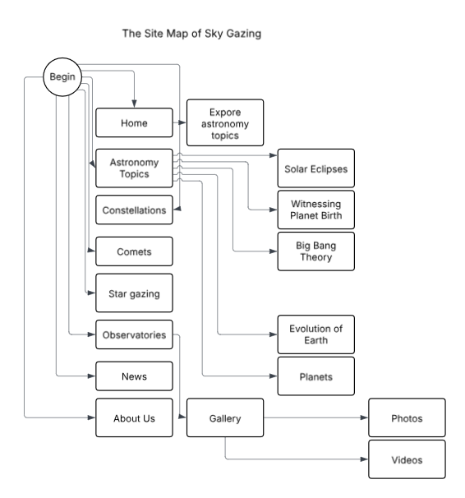

Project Ref. No.: eProject |  | Project Title: | Activity Plan Prepared By: | Date of Preparation of Activity Plan:
Sr.No | Task | Project Title: | Activity Plan Prepared By: | Actual Start Date | Actual Days | Team Mate Names | Status
1 | Synopsis | Sky Gazing | Thai | 7/24/25 | 1 | Thai | Completed
2 | Analysis | Sky Gazing | Thai | 7/24/25 | 1 | Thai | Completed
3 | The scope of the work (in brief) | Sky Gazing | Thai | 7/25/25 | 1 | Loi | Completed
4 | Architecture and design of the system | Sky Gazing | Thai | 7/25/25 | 1 | Loi | Completed
5 | Diagram of the website | Sky Gazing | Thai | 7/25/25 | 2 | Hung | Completed
6 | Task Sheet Review | Sky Gazing | Thai | 7/27/25 | 1 | Loi | Completed

Date: 02/8/2025
Signature of Instructor:  Le Mong Thuy | Signature of Team Leader:  Doan Duy Thai

MOCK OF THE WEBSITE

1/ HOME
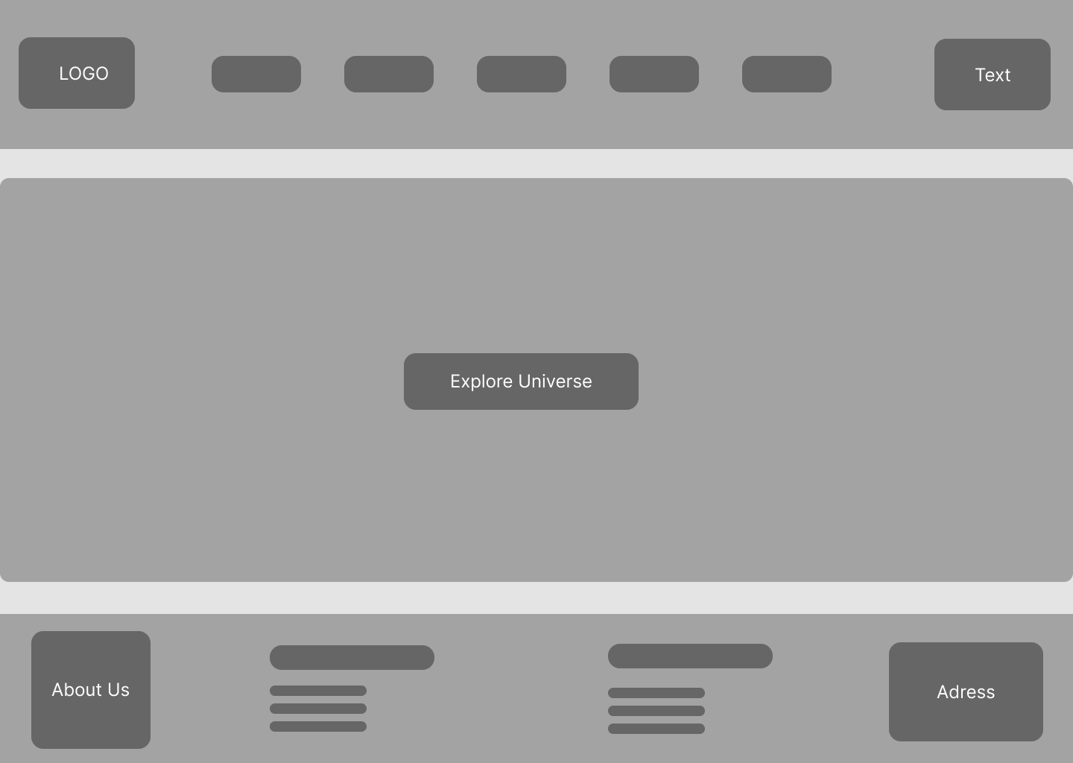

2/ Planets
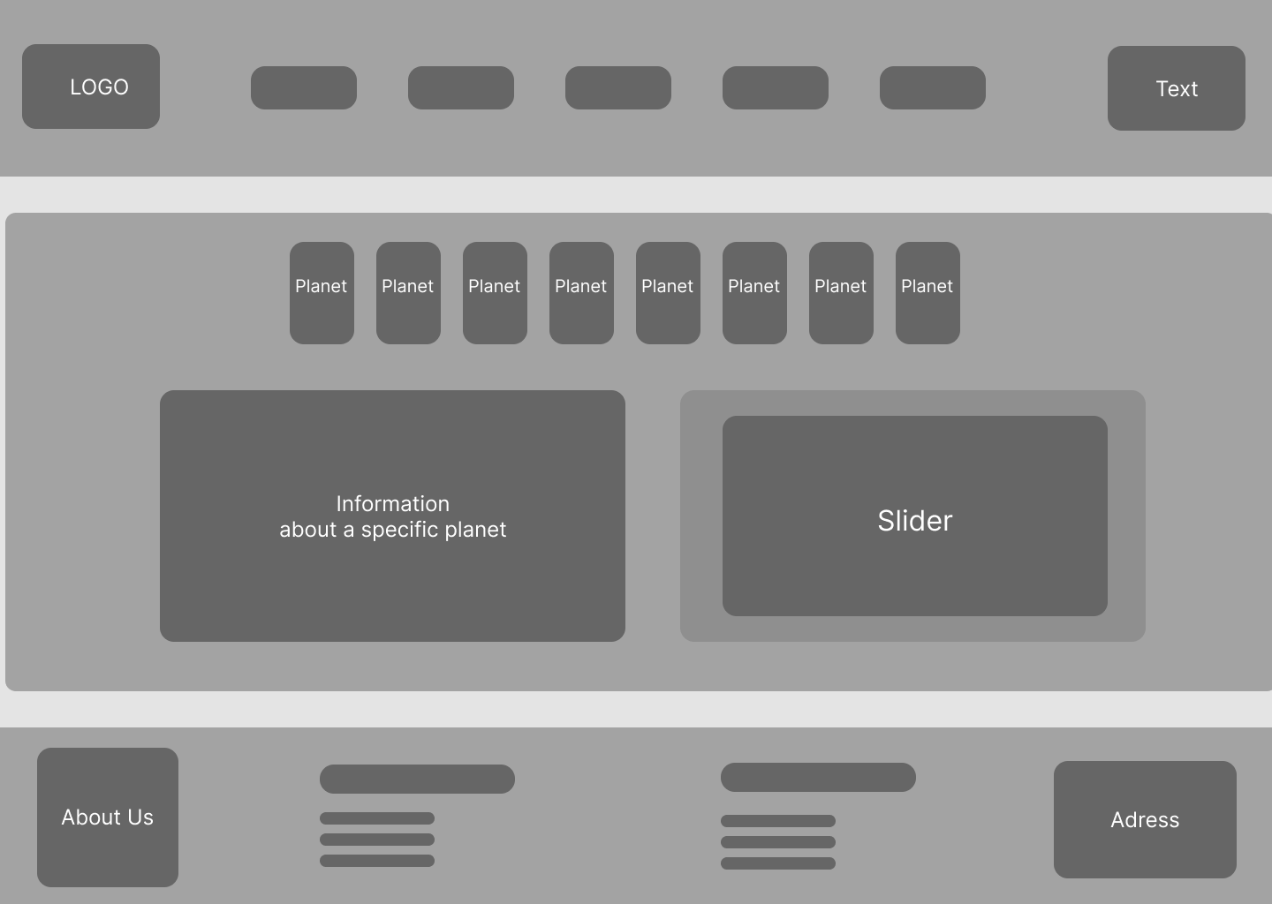

3/ Astronomy topics

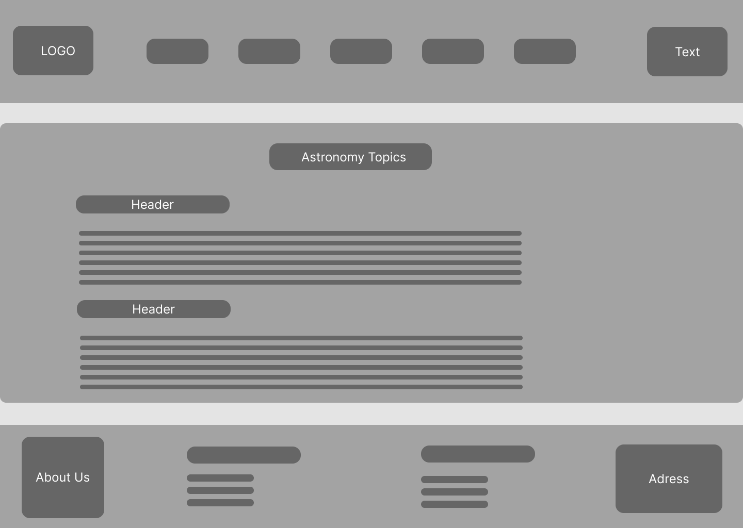

4/ Constellations

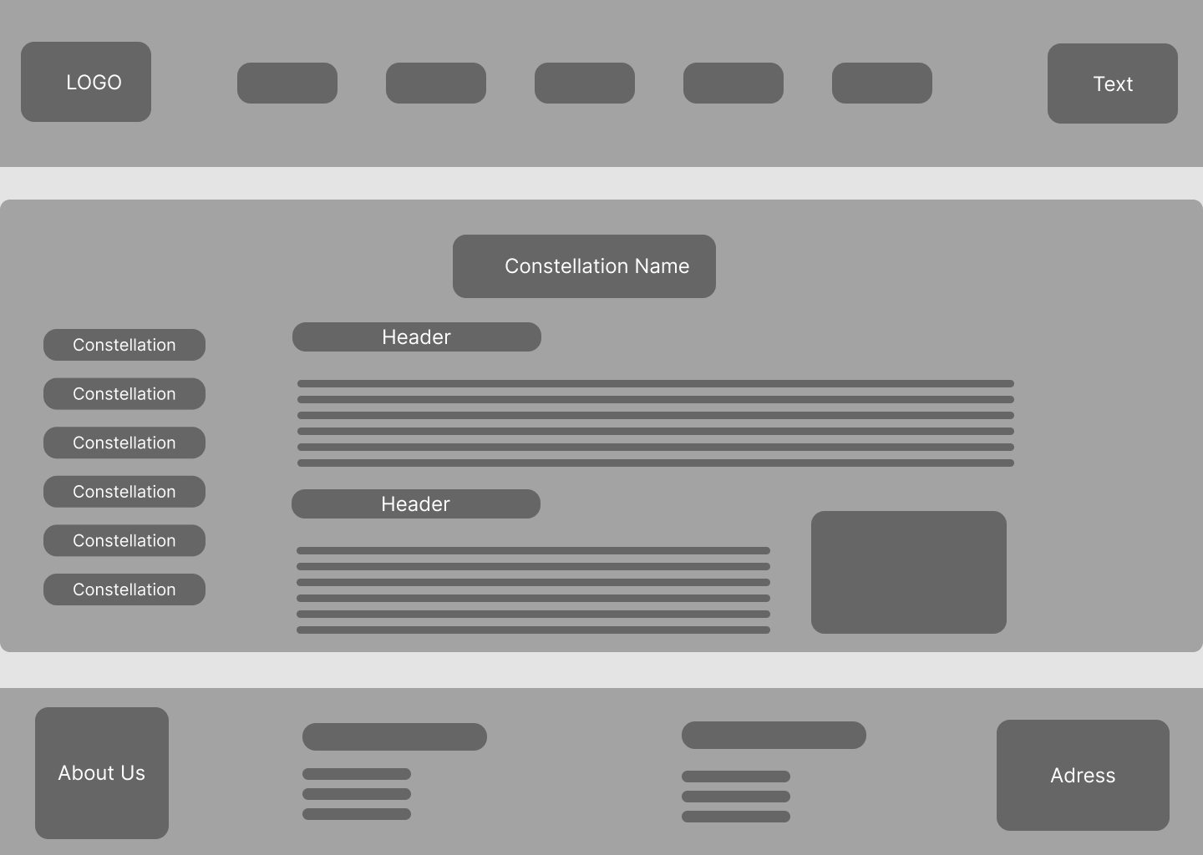

5/ Comets

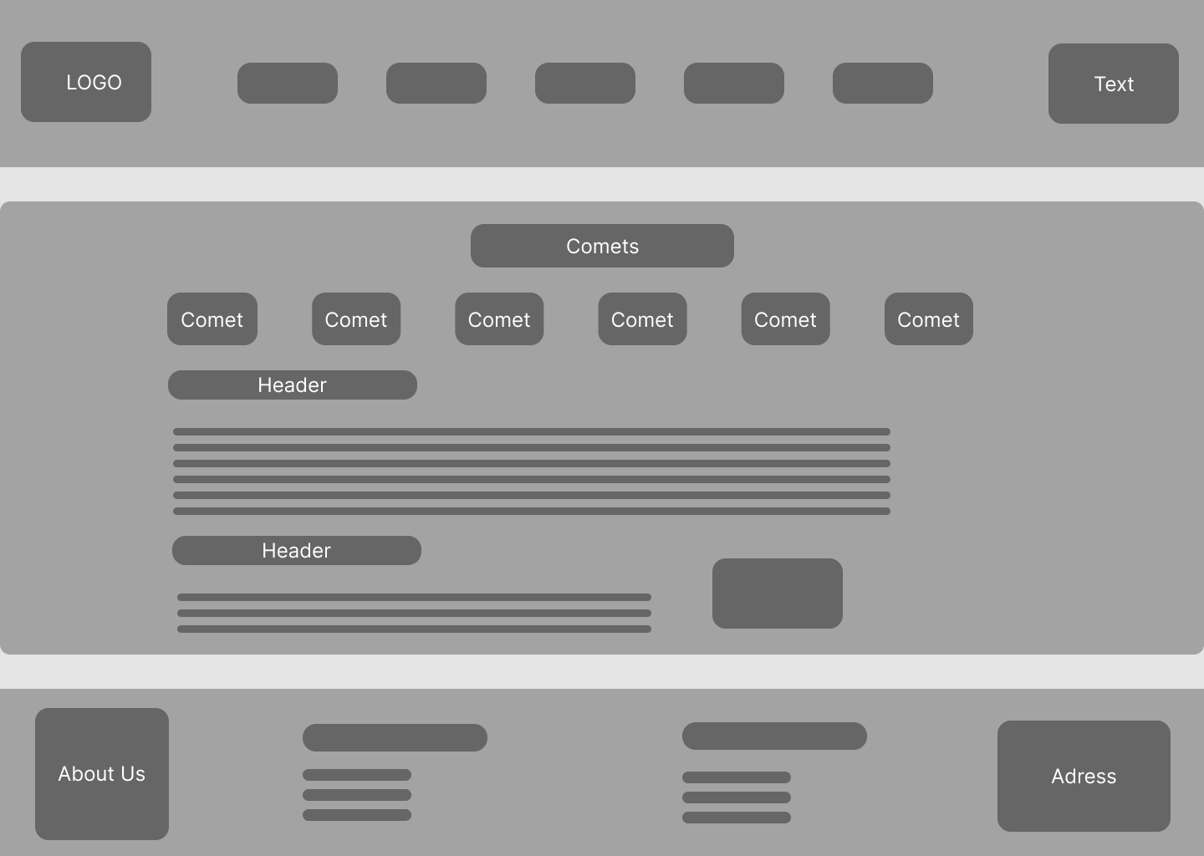

6/ Star Gazing

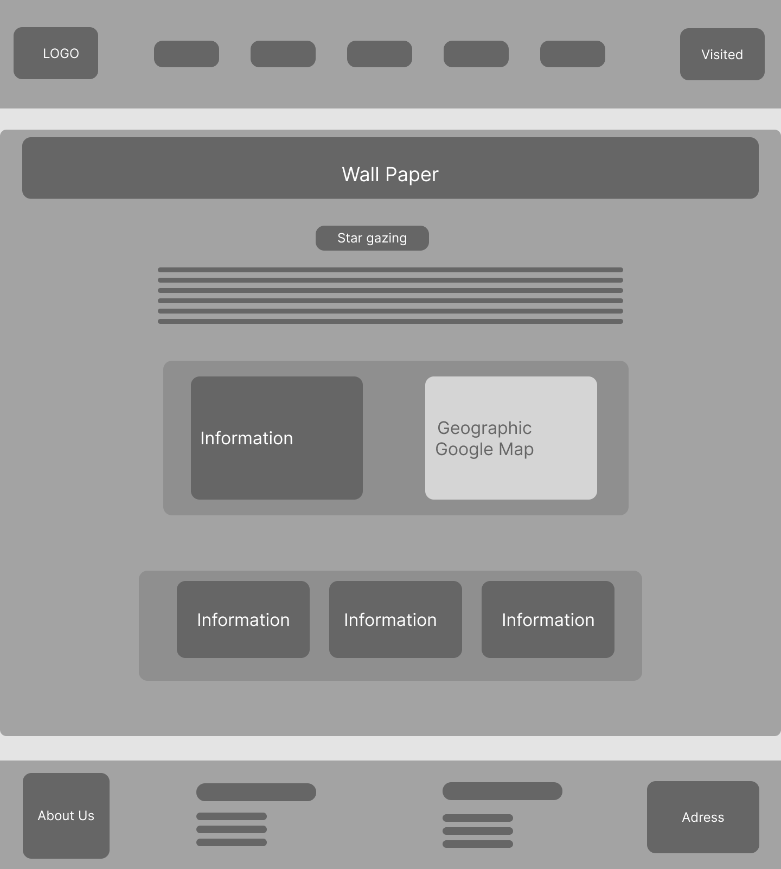

7/ Observatories

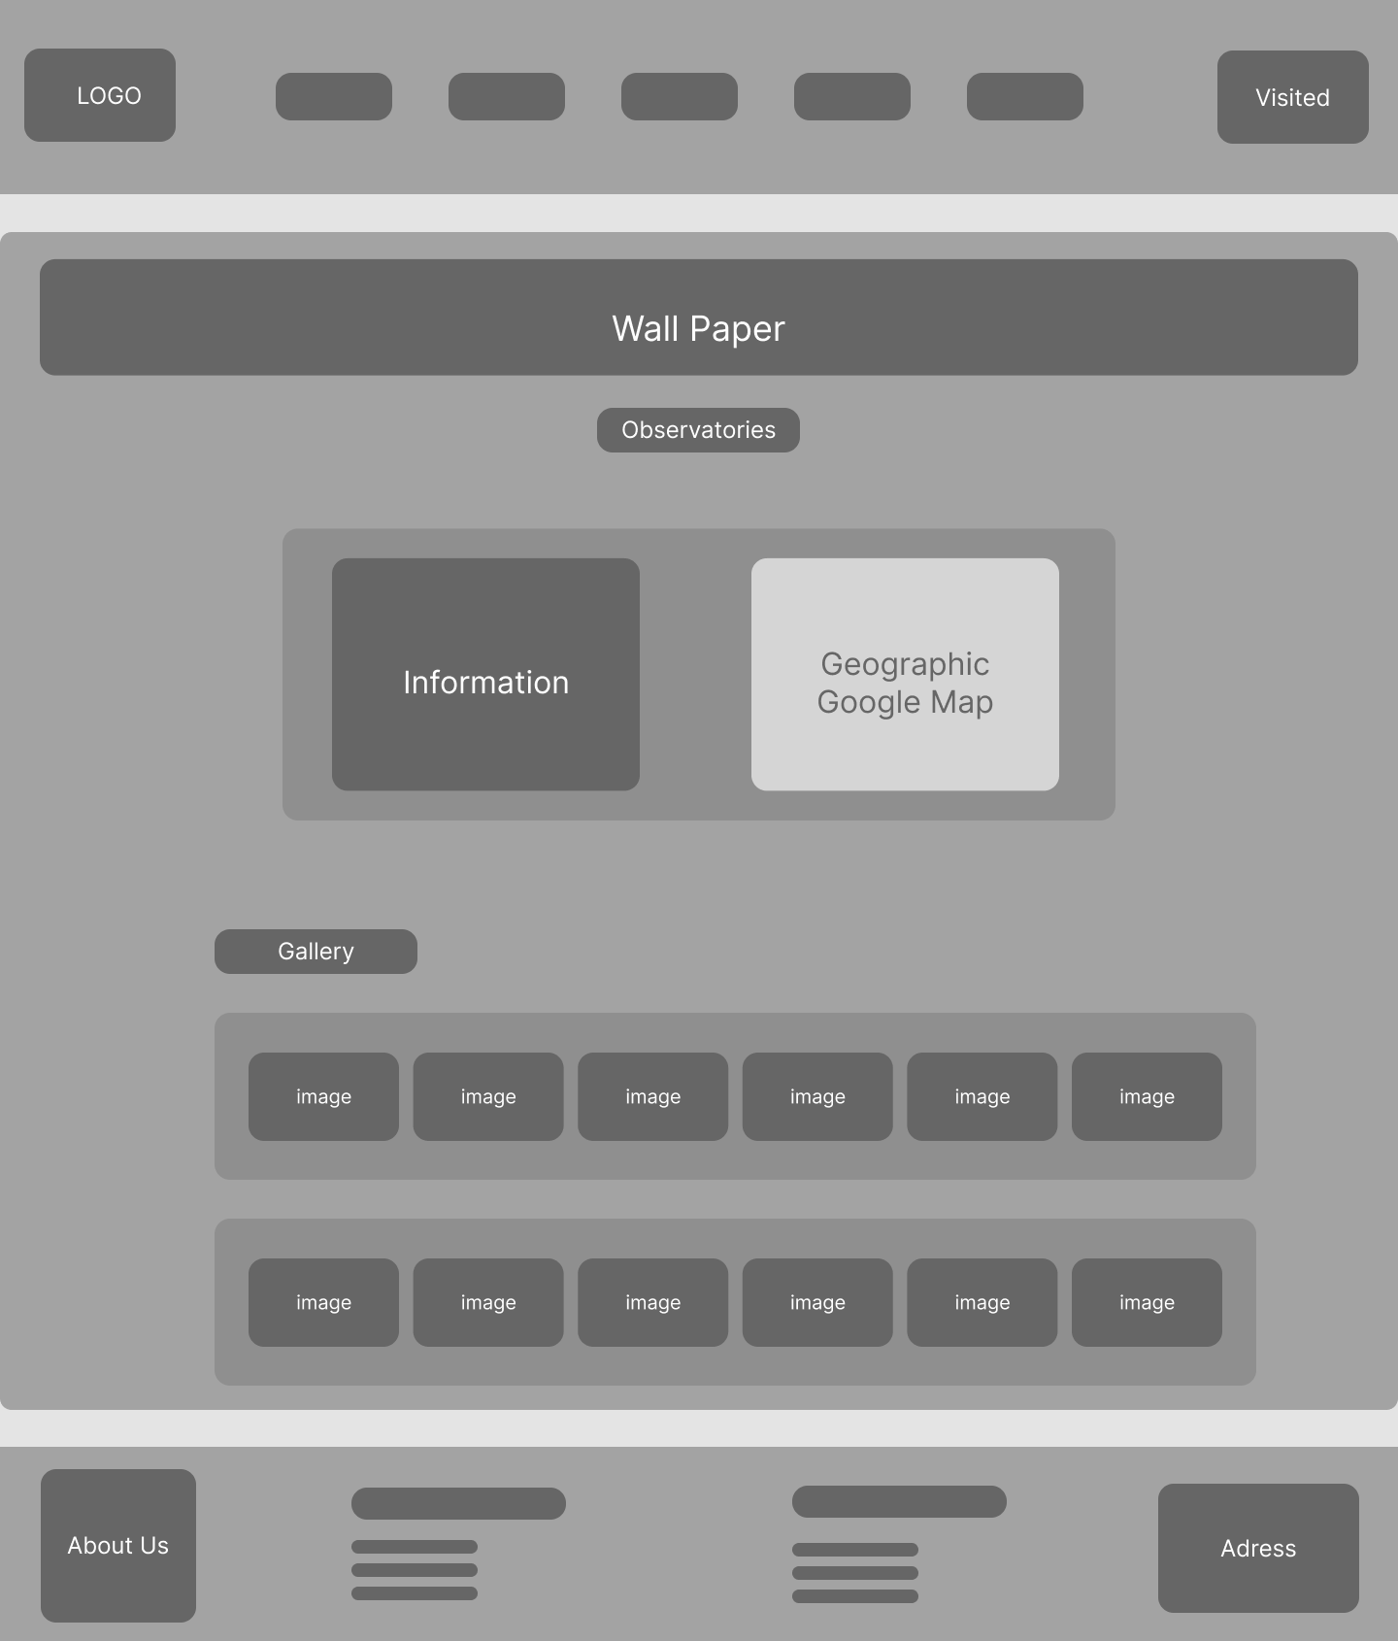

8/ News
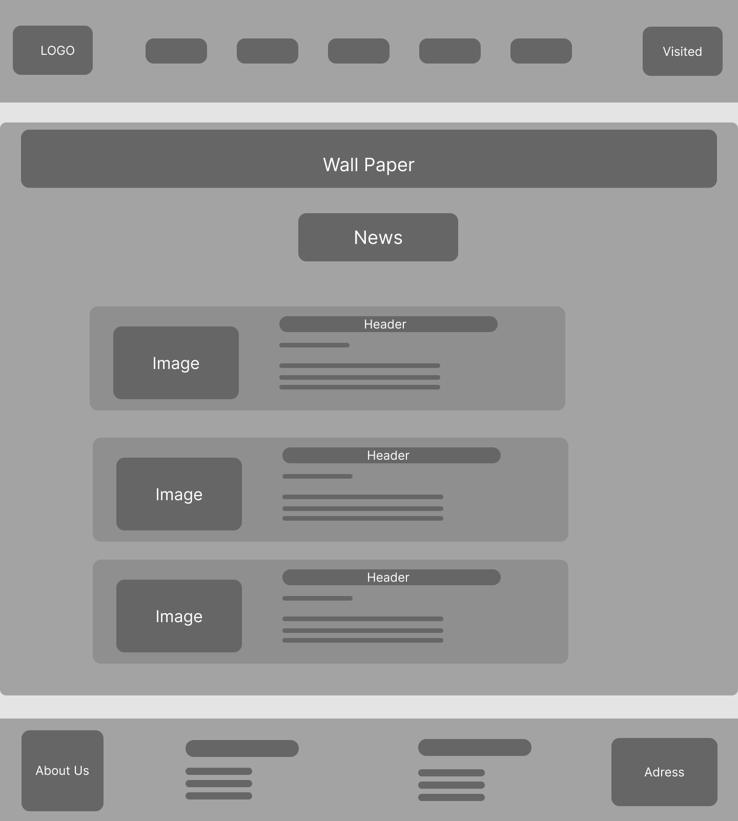

9/ About Us
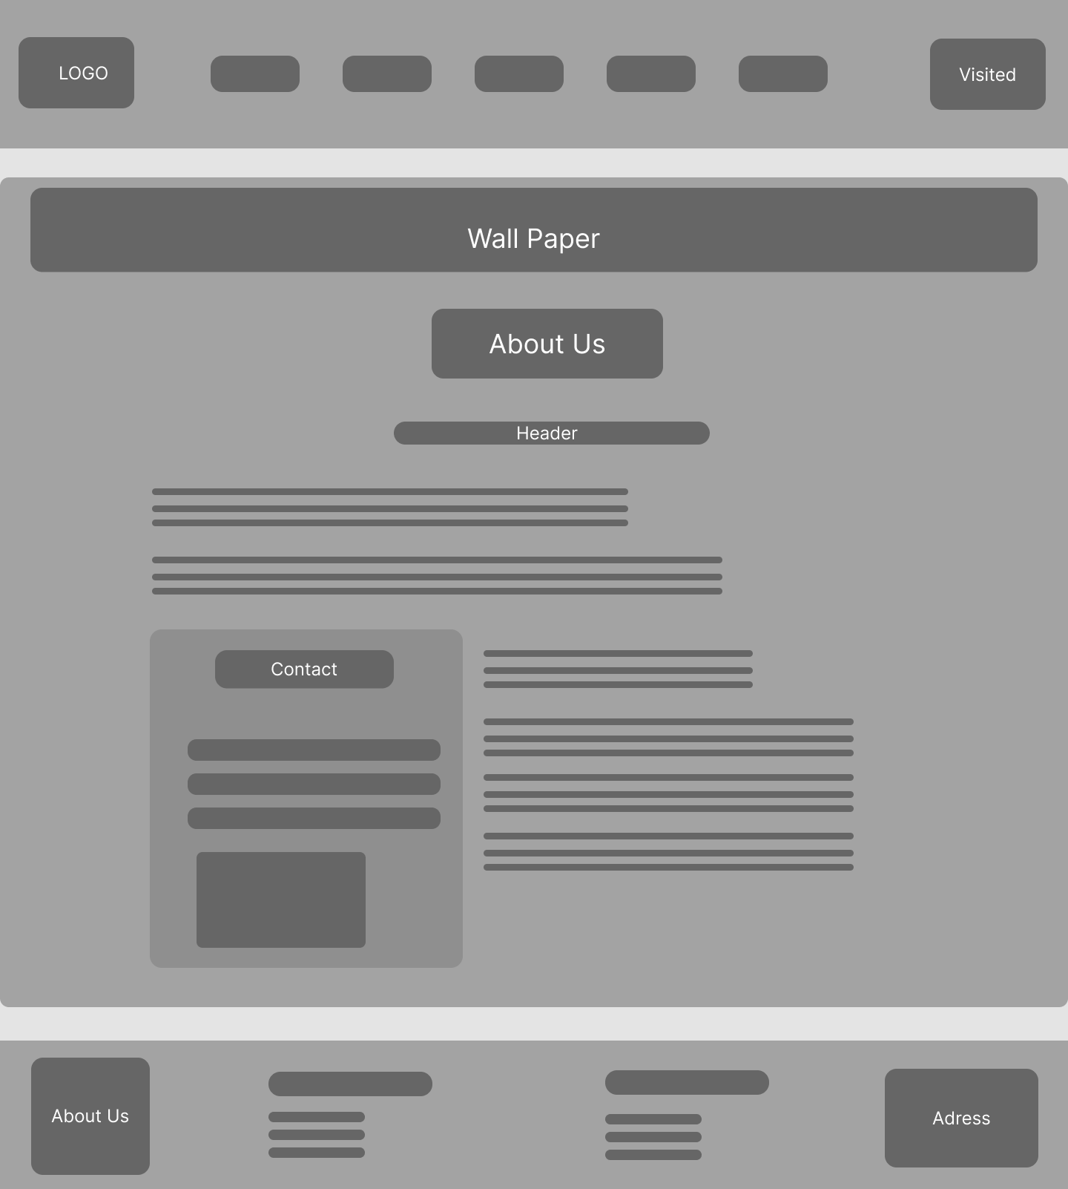

Project Ref. No.: eProject |  | Project Title: | Activity Plan Prepared By: | Date of Preparation of Activity Plan:
Sr.No. | Task | Project Title: | Activity Plan Prepared By: | Actual Start Date | Actual Days | Team Mate Names | Status
1 | Site map | Sky Gazing | Thai | 7/31/2025 | 1 | Thai | Completed
2 | Mock of website | Sky Gazing | Thai | 1/8/2025 | 1 | Thai | Completed
3 | Task sheet Review | Sky Gazing | Thai | 2/8/2025 | 1 | Loi | Completed

Date: 8/02/2025
Signature of Instructor:  Ms. Le Mong Thuy | Signature of Team Leader:  Doan Duy Thai

Problem definitions
- The web page should have the description/images about various planets. If user clicks on the same, navigational link must be available.
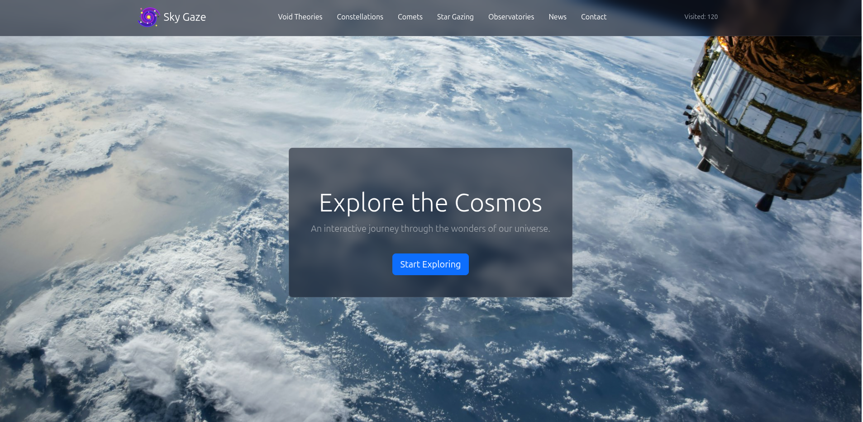
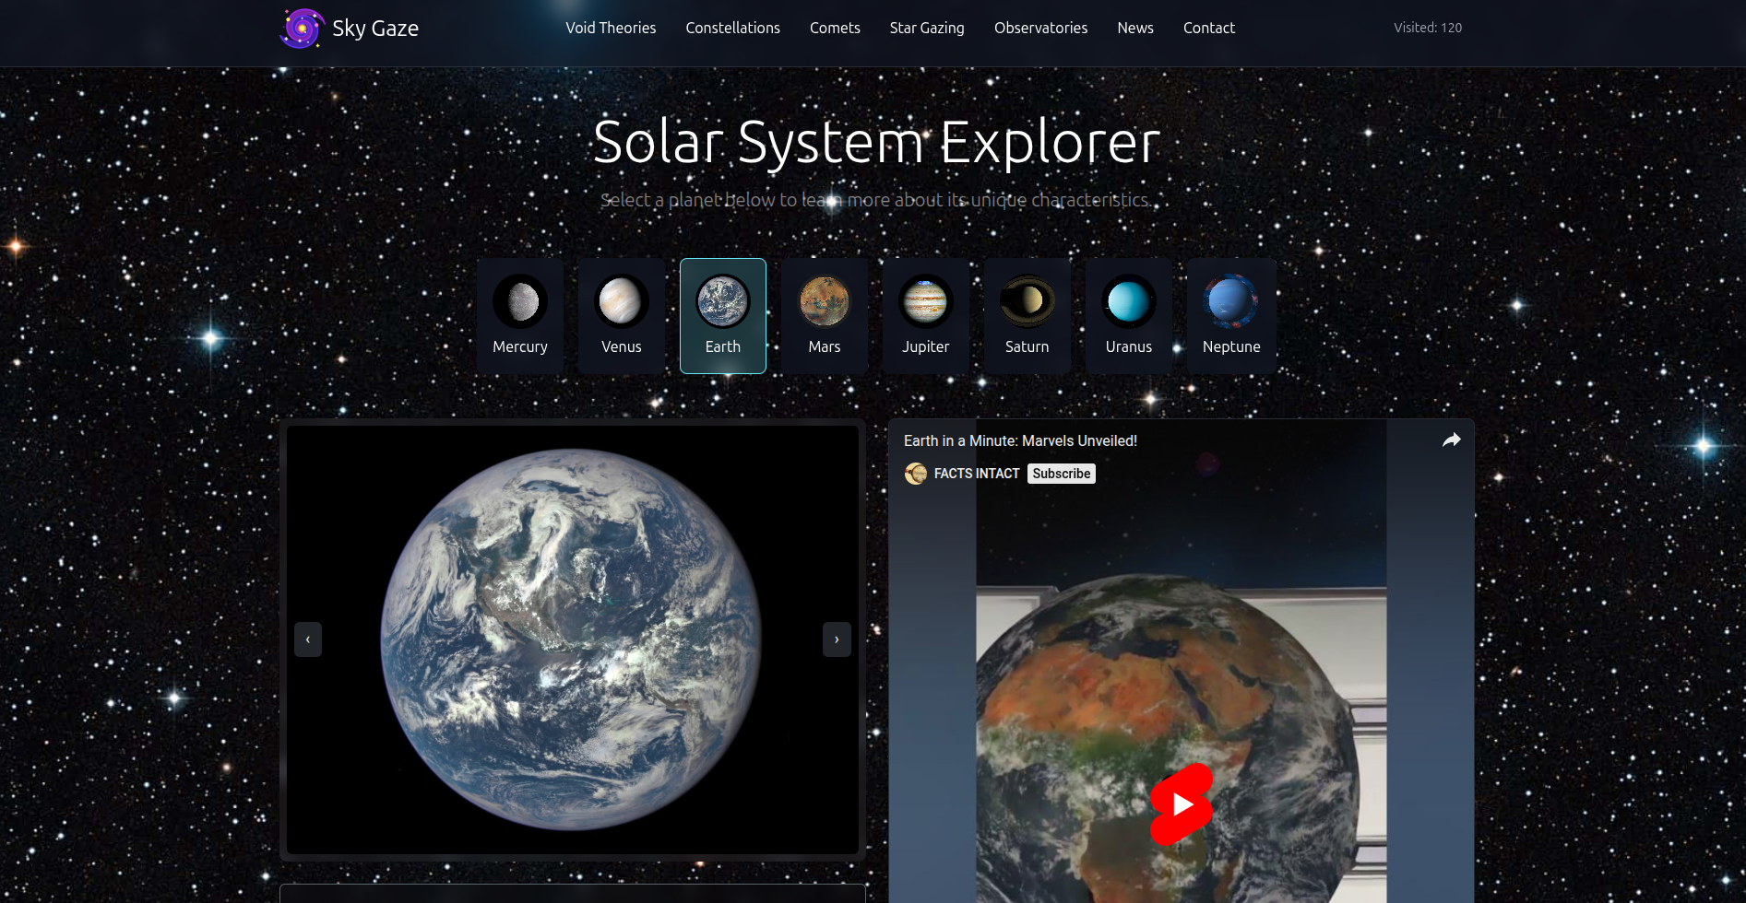
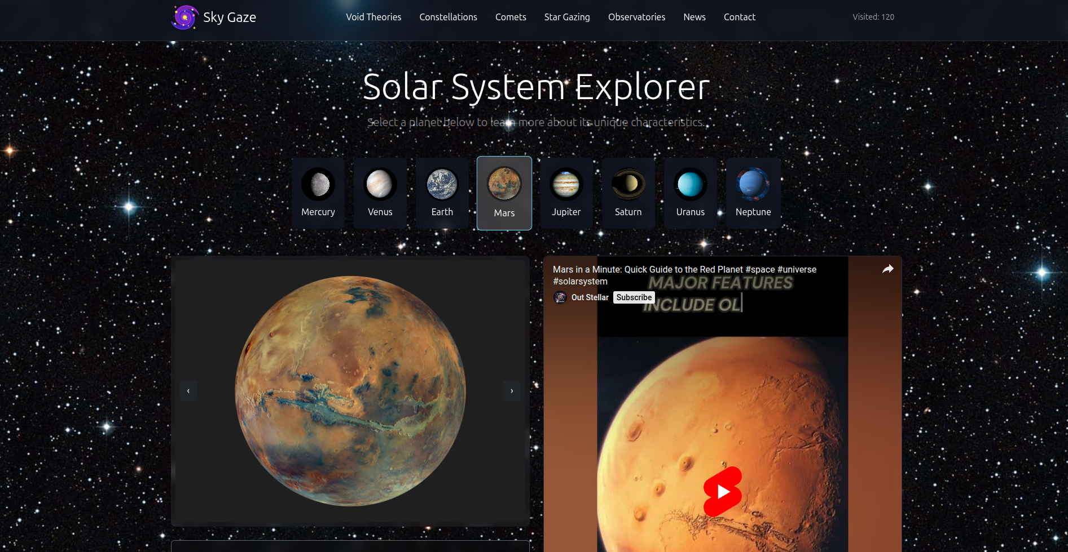
- There should be categories providing details about Solar Eclipse, big bang theory, evolution of earth etc
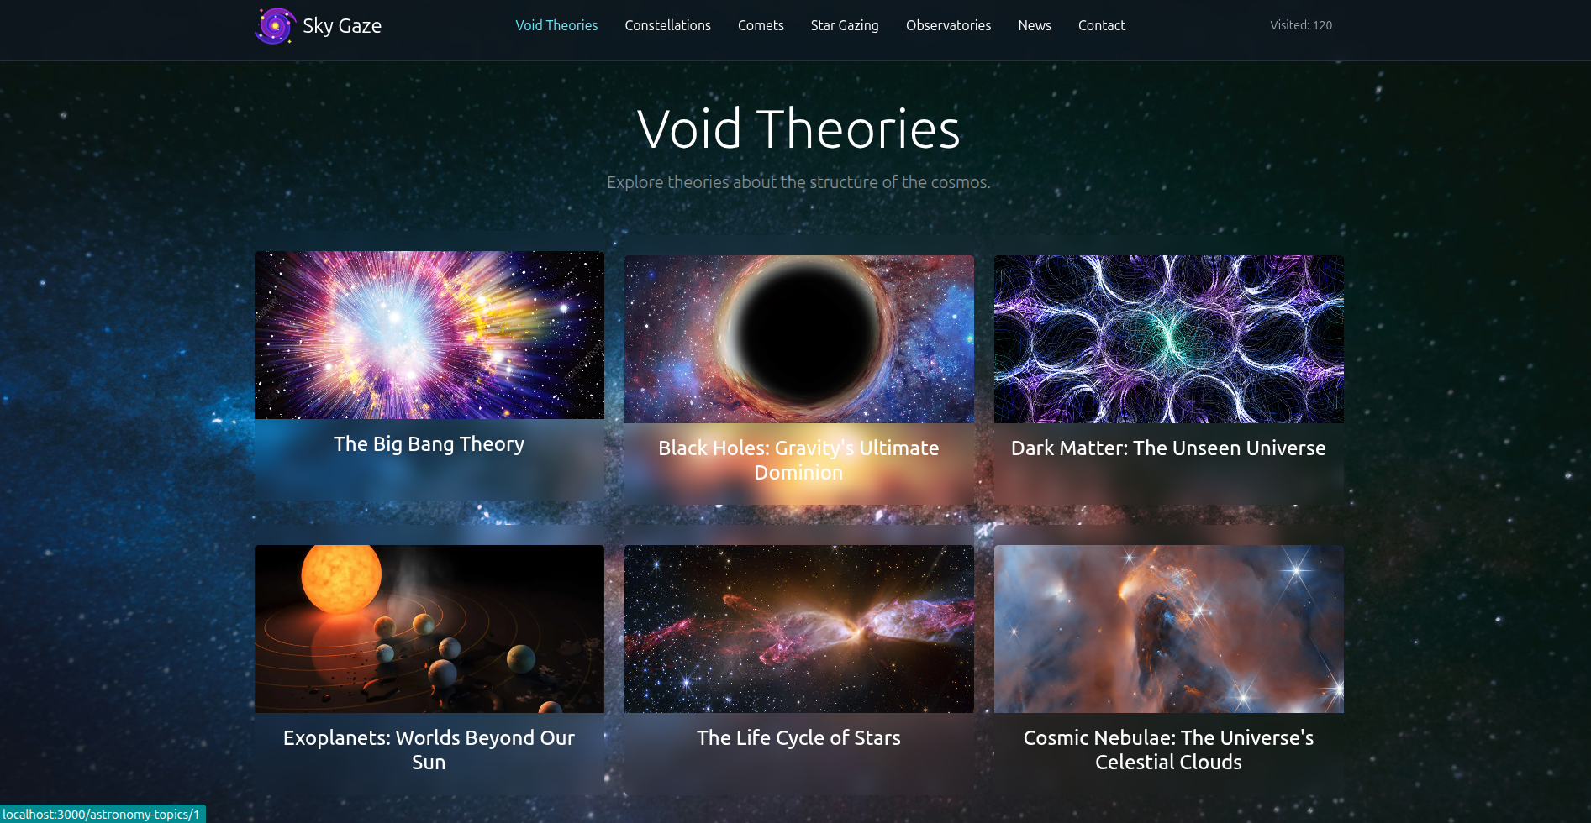
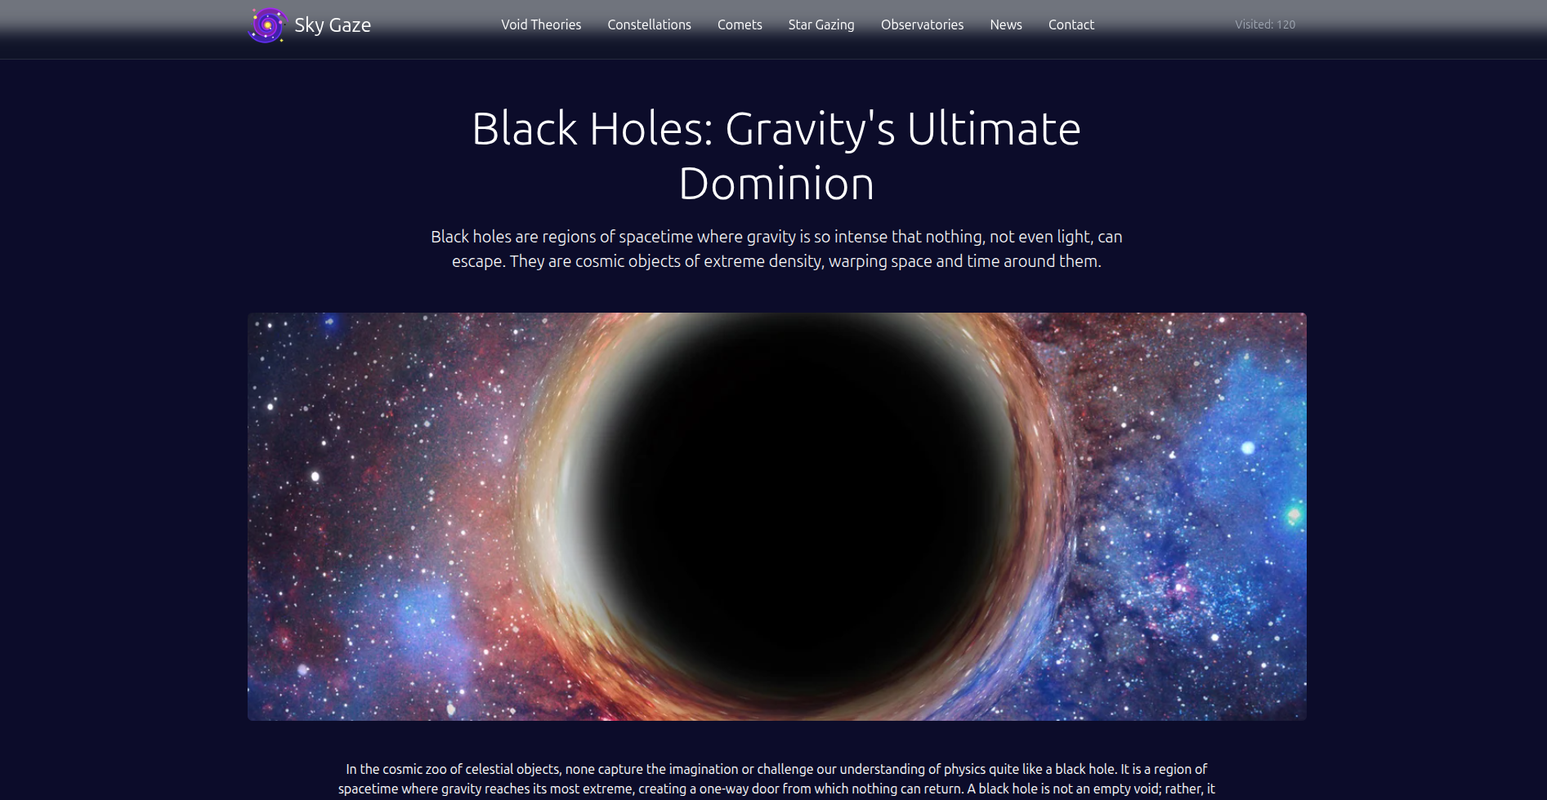
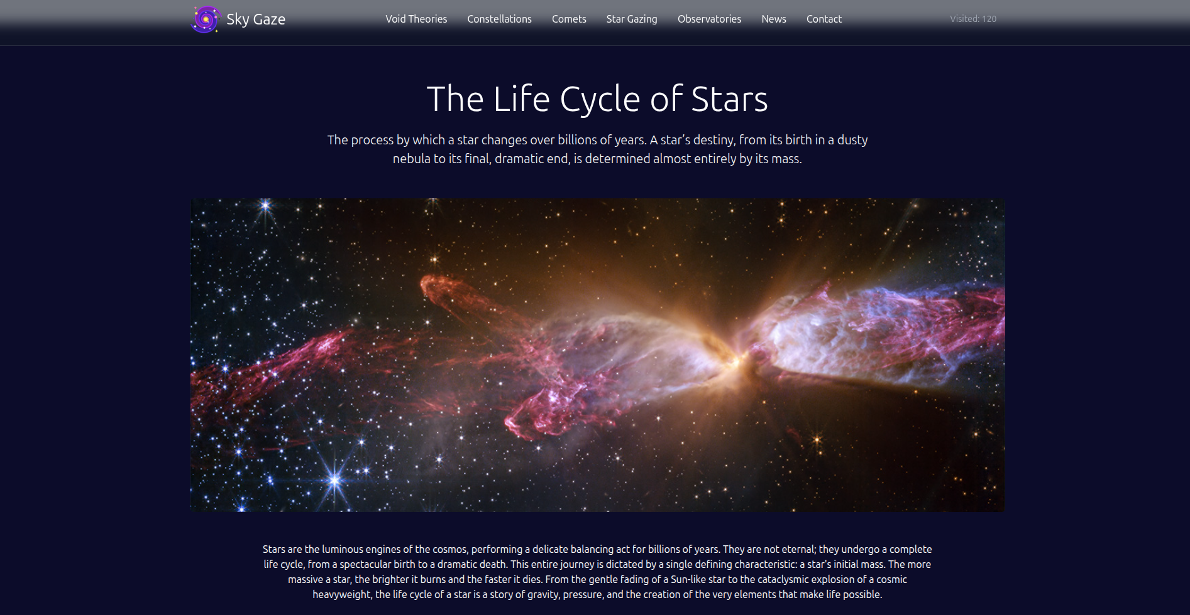

- Various sections such as –
  - When best to Star Gaze
  - Where is best to Star Gaze
  - What to expect to see in a Star Gaze
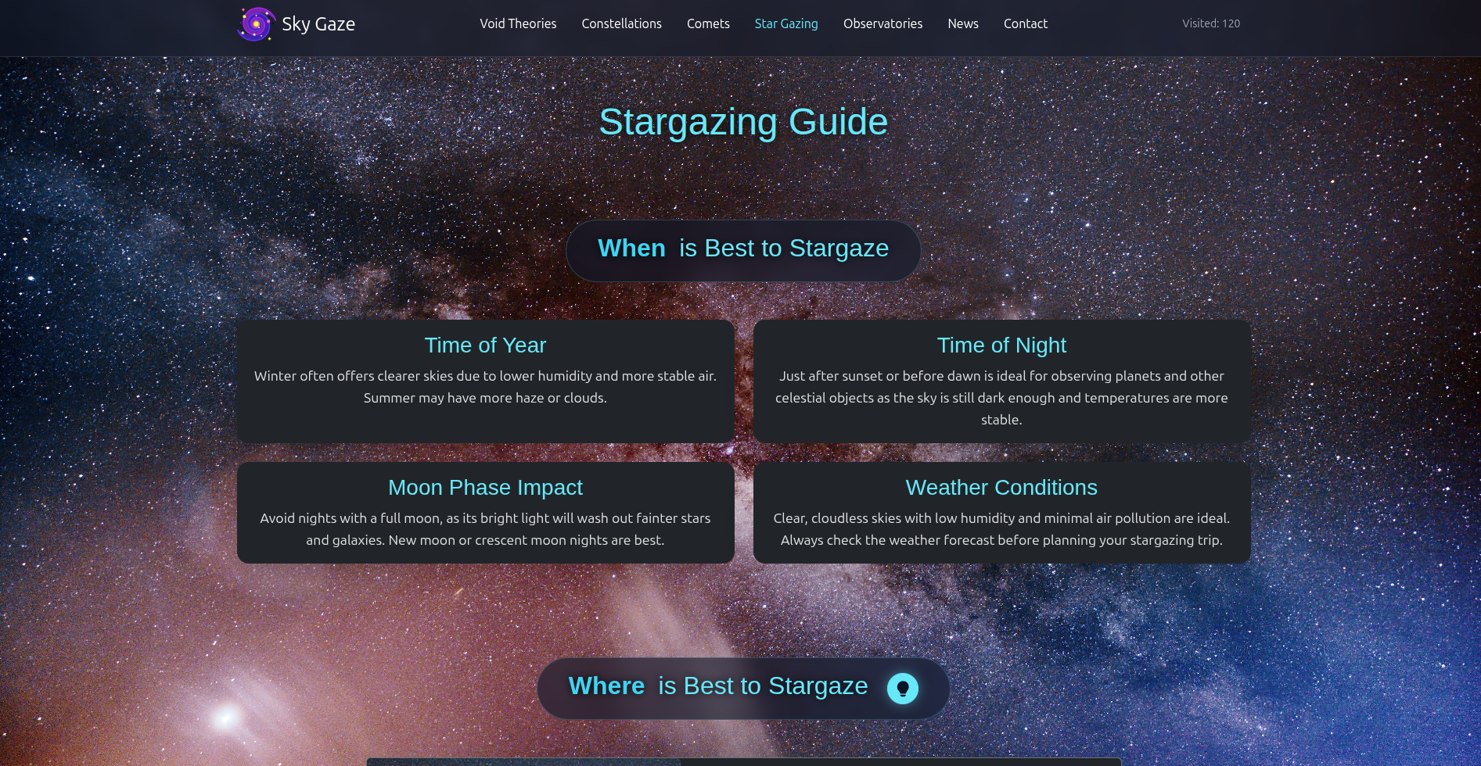
- 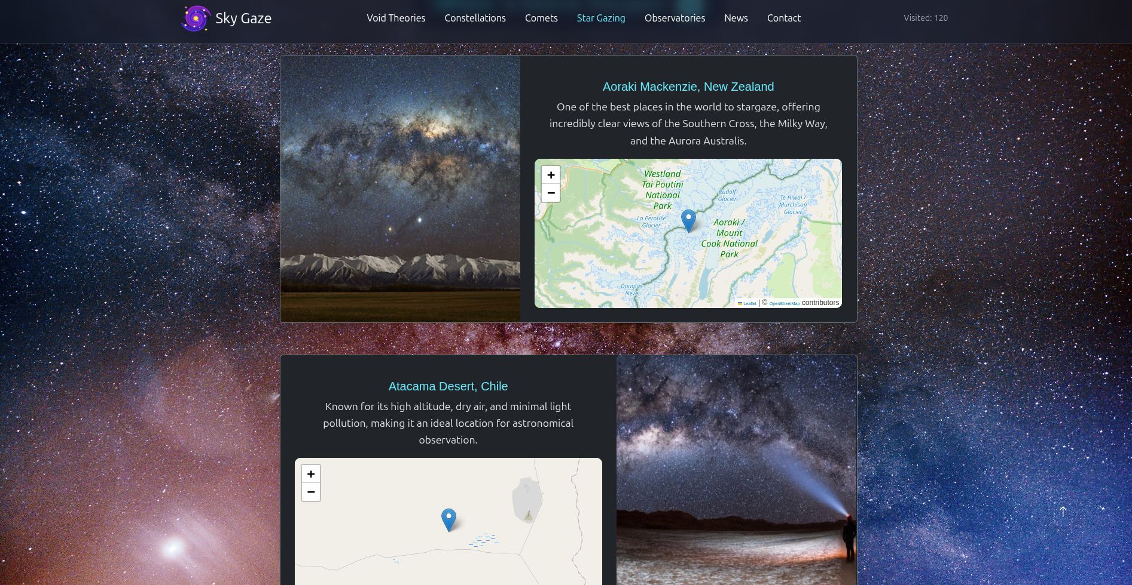
- The site should also list and explain various planets available as well as details about them as
  - When discovered
  - Size
  - Atmosphere there
  - Distance from sun and earth
  - Other available important details about them.
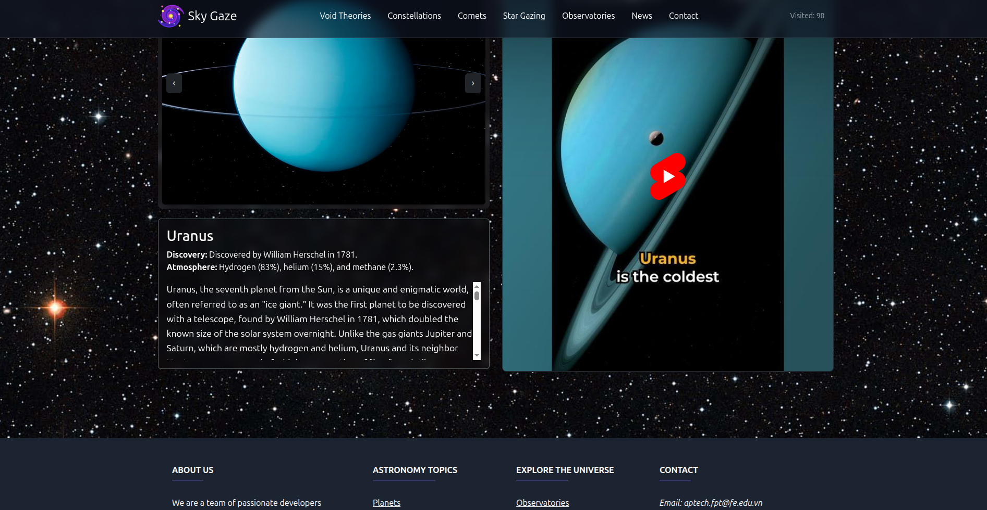
- There should be information on constellations as what is it/how it is formed and various constellations.
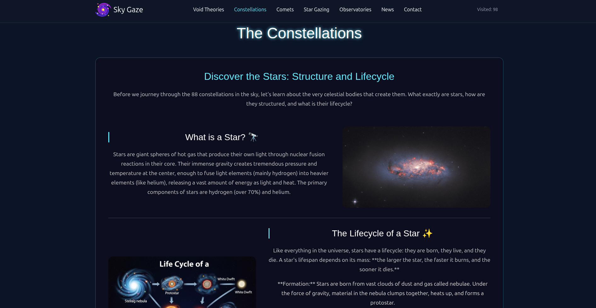
- There should also be a section on comet giving information related.
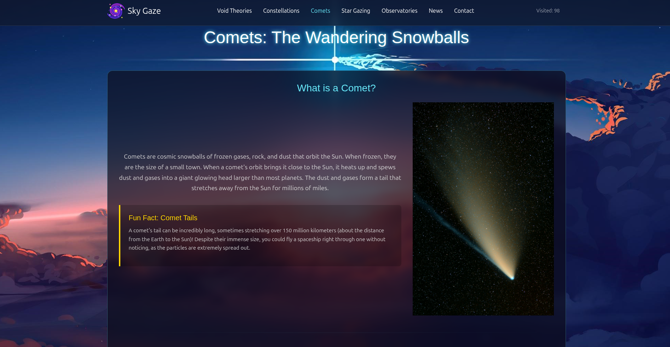
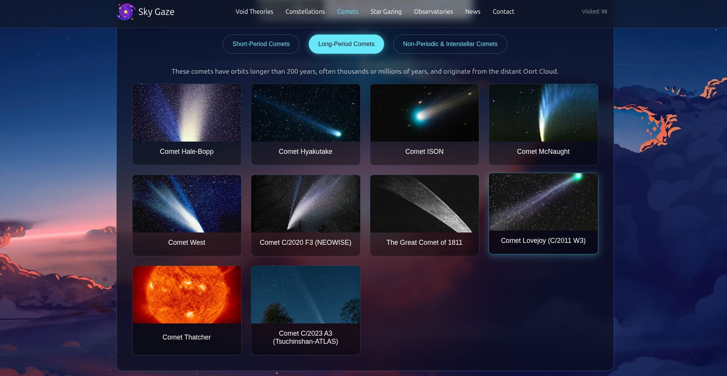
- Also include a section which will provide details on various latest developments in the field of astronomy related to planets and stars.
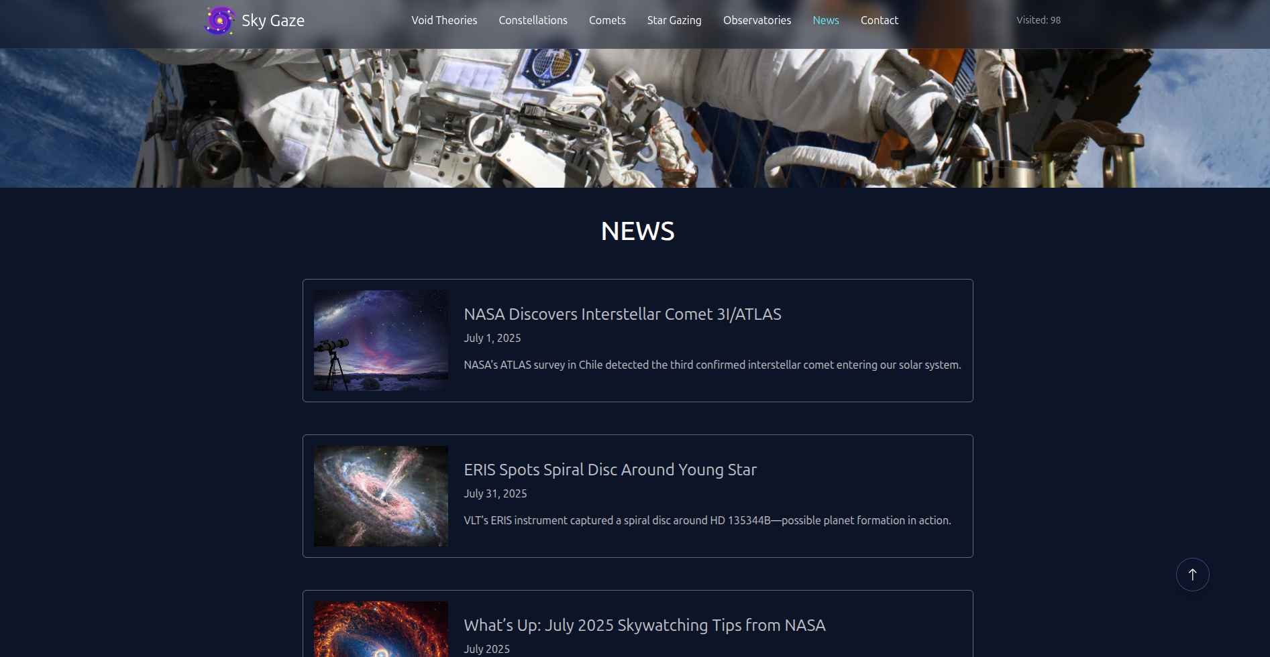
- List of Few top Observatories with details and location displayed using GeoLocation API (eg. GoogleMaps).
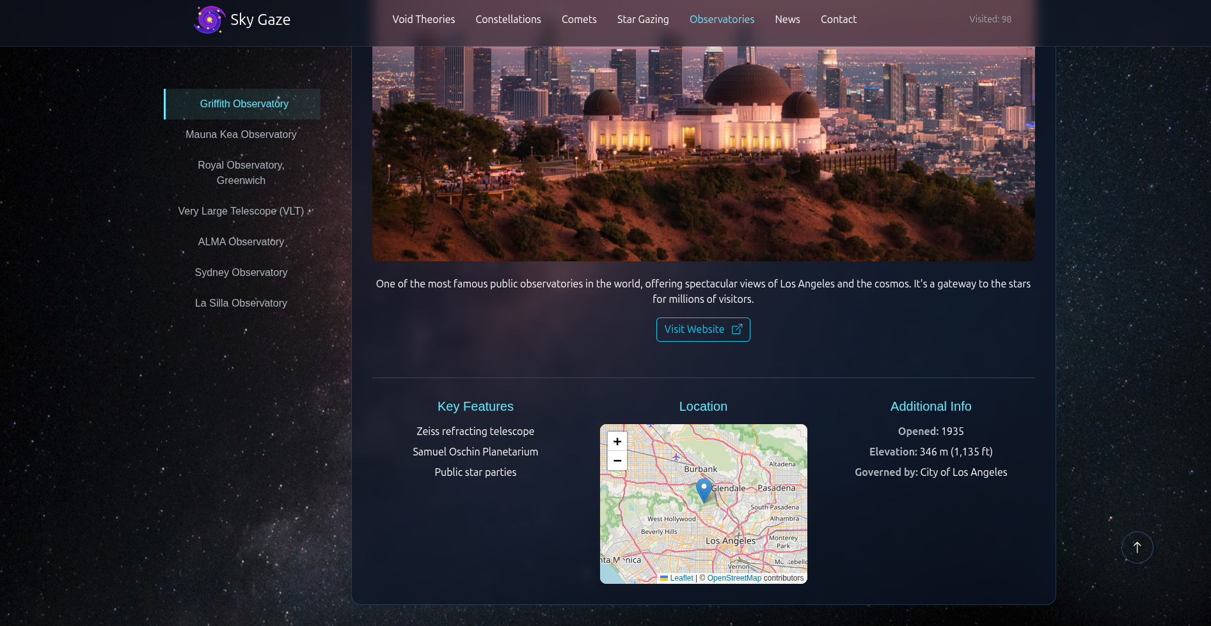
- Site map, Gallery, About us, Contact us link must be added. About Us and Contact Us: This menu option should display Email id, address, and contact number of Sky Gazing Company.
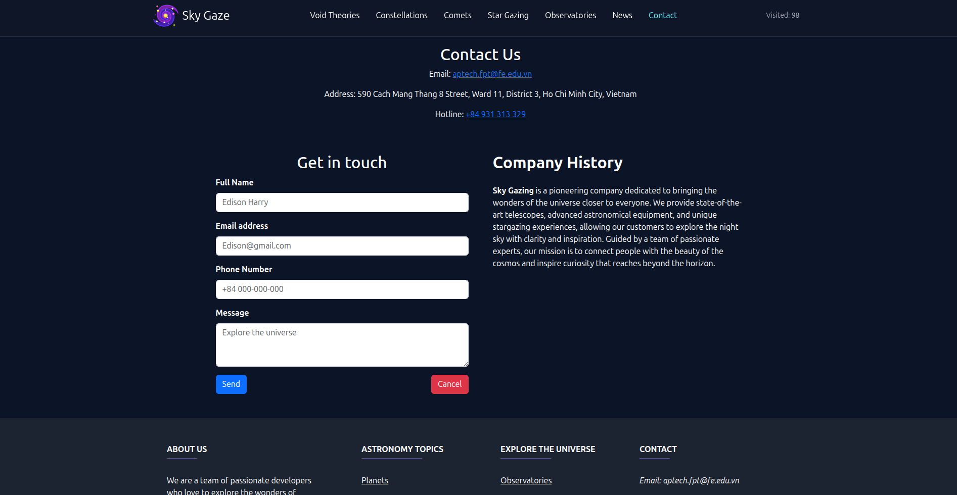
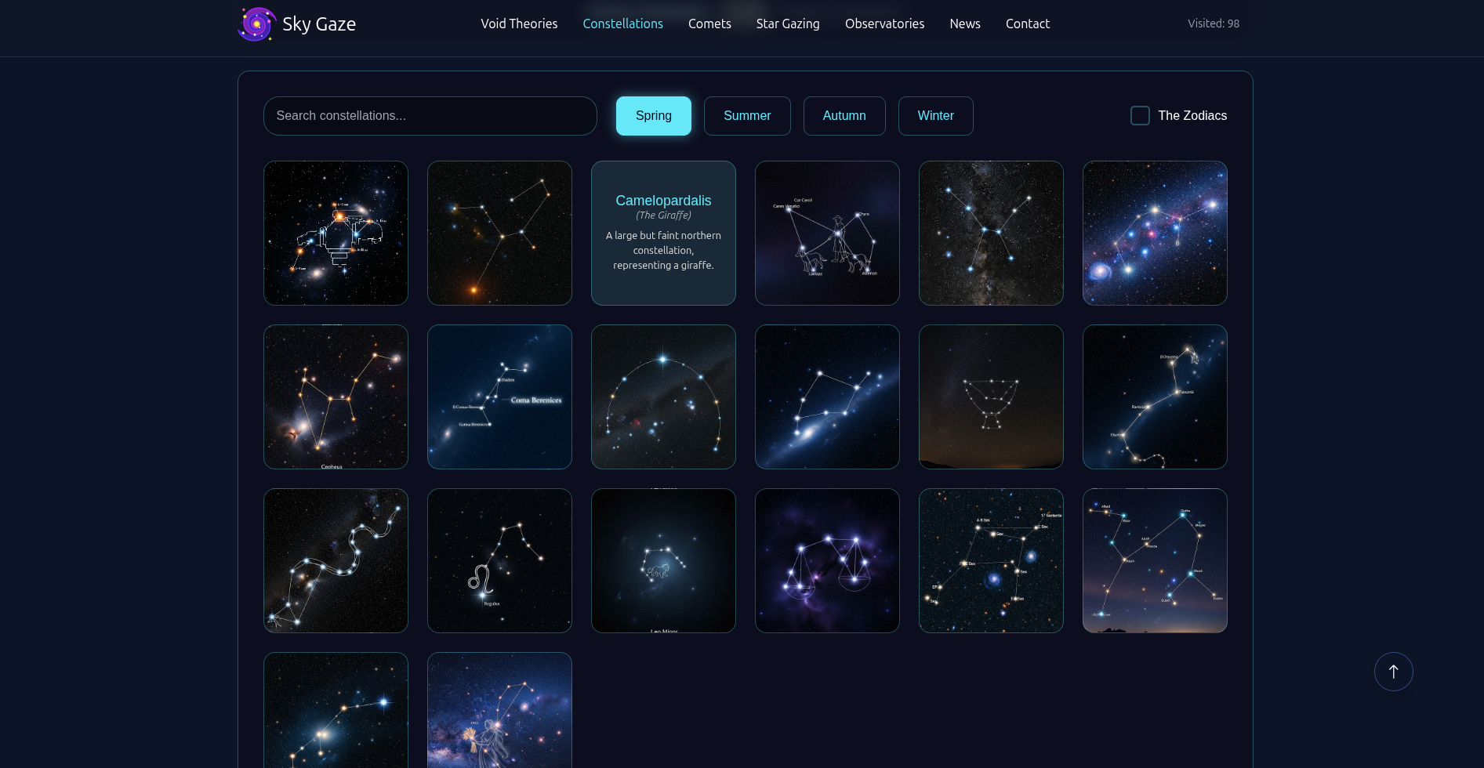
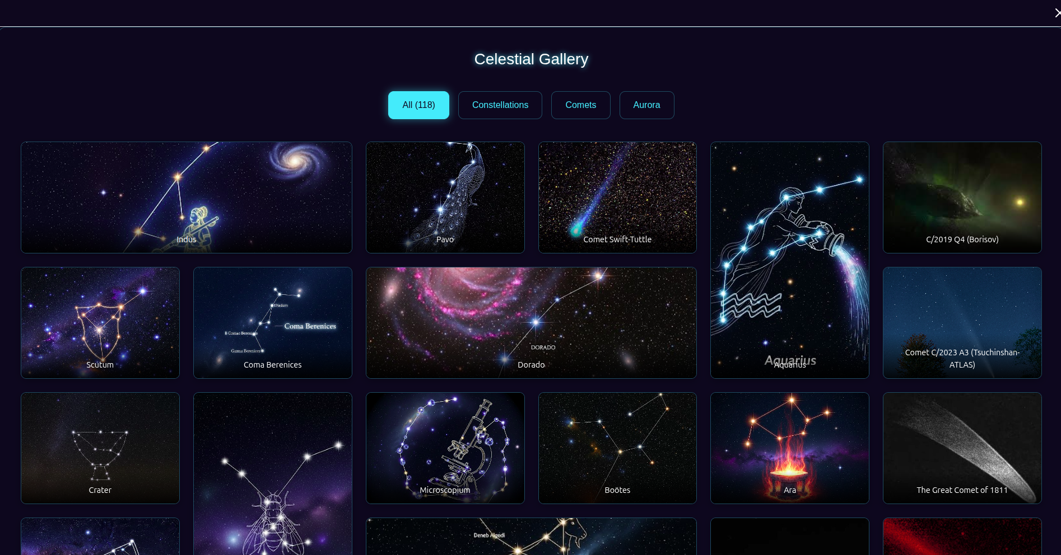

Task Sheet Review 3

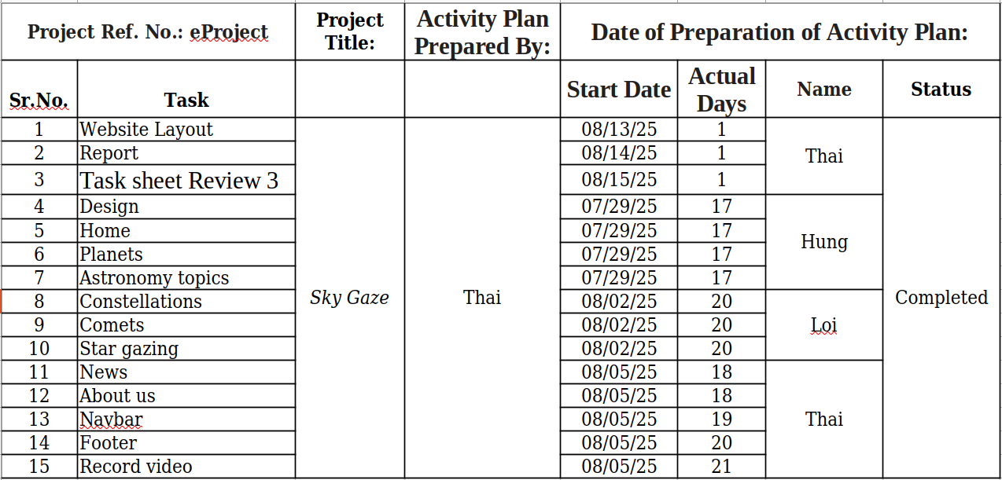

Date: 8/15/2025
Signature of Instructor:  Ms. Le Mong Thuy | Signature of Team Leader:  Doan Duy Thai

