

JAVA BASICS
Lab Guides

Program Code
Version | 0.1
Effective date | 11/05/2011

Hanoi, 05/2011

RECORD OF CHANGES
*A - Added M - Modified D - Deleted

Date | Changes | A*  M, D | Contents | Version
11/05/2011 | Create new | A | All | 0.1

Contents
Day 1: Lab Guides 4
Lab Guide 1: Fundamental Programming Structures in Java 4
Lab Guide 2: Loops (while) 4
Lab Guide 3: Loops (For) 5
Lab Guide 4: Array 6
Lab Guide 5: Class 7

Day 1: Lab Guides

Lab Guide 1: Fundamental Programming Structures in Java
The program asks for the user's name and age and then prints a message like:
Hello, Cay. Next year, you'll be 46

Solutions:

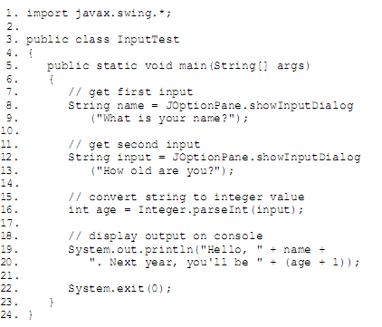

Lab Guide 2: Loops (while)
The program determines how long it will take to save a specific amount of money for your well-earned retirement, assuming that you deposit the same amount of money per year and that the money earns a specified interest rate.
Solutions:
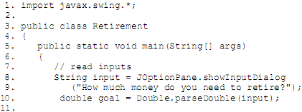
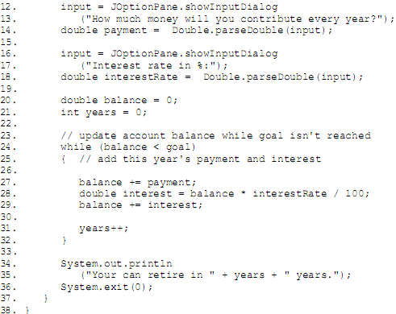

Lab Guide 3: Loops (For)
This program shows a typical example of a for loop.
The program computes the odds on winning a lottery. For example, if you must pick 6 numbers from the numbers 1 to 50 to win, then there are (50 x 49 x 48 x 47 x 46 x 45)/(1 x 2 x 3 x 4 x 5 x 6) possible outcomes, so your chance is 1 in 15,890,700.
Solutions:
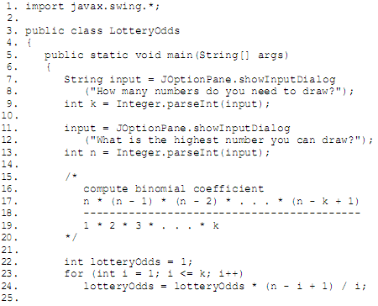
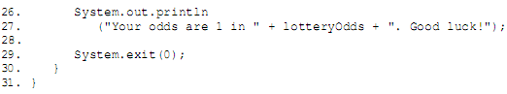

Lab Guide 4: Array
The program puts arrays to work. This program draws a random combination of numbers for a lottery game. For example, if you play a "choose 6 numbers from 49" lottery, then the program might print:
Solutions:
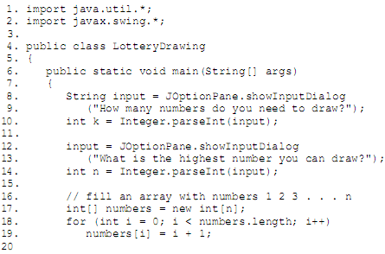
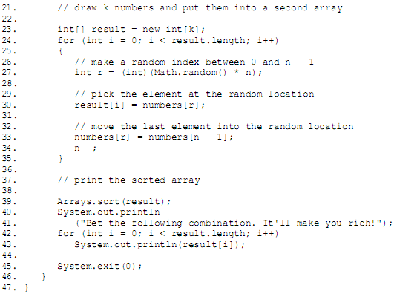

Lab Guide 5: Class
We break down the implementation of this class in some detail in the sections that follow. First, though, this solution shows a program code that shows the Employee class in action.
In the program, we construct an Employee array and fill it with three employee objects:
Employee[] staff = new Employee[3];
staff[0] = new Employee("Carl Cracker", . . .);
staff[1] = new Employee("Harry Hacker", . . .);
staff[2] = new Employee("Tony Tester", . . .);

Next, we use the raiseSalary method of the Employee class to raise each employee's salary by 5%:
for (Employee e : staff)
e.raiseSalary(5);

Finally, we print out information about each employee, by calling the getName, getSalary, and getHireDay methods:
for (Employee e : staff)
System.out.println("name=" + e.getName()
+ ",salary=" + e.getSalary()
+ ",hireDay=" + e.getHireDay());
Solutions:
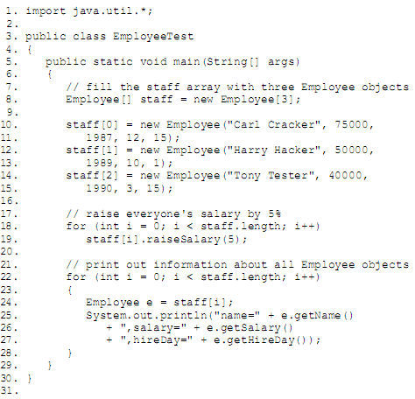
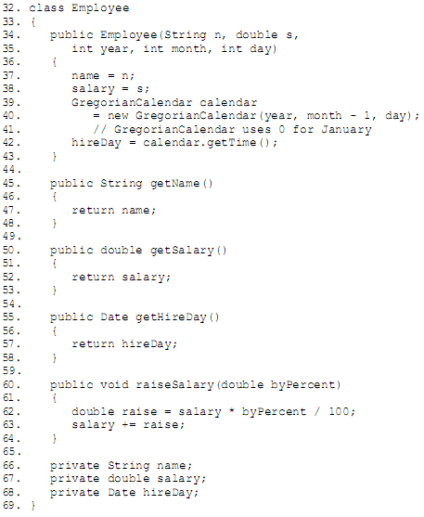

Lab Guide 6: Java Package
The program is distributed over two packages: the PackageTest class belongs to the default package and the Employee class belongs to the com.horstmann.corejava package. Therefore, the Employee.class file must be contained in a subdirectory com/horstmann/corejava. In other words, the directory structure is as follows:
. (base directory)
PackageTest.java
PackageTest.class
com/
horstmann/
corejava/
Employee.java
Employee.class
To compile this program, simply change to the base directory and run the command
javac PackageTest.java

Solutions:
