

OOP IN JAVA
Lab Guides

Program Code
Version | 0.1
Effective date | 11/05/2011

Hanoi, 05/2011

RECORD OF CHANGES
*A - Added M - Modified D - Deleted

Date | Changes | A*  M, D | Contents | Version
11/05/2011 | Create new | A | All | 0.1

Contents
Day 1: Lab Guides 4
Lab Guide 6: Constructor 4
Lab Guide 7: Classes, Superclasses, and Subclasses 6
Lab Guide 8: Abstract Classes 8

Day 1: Lab Guides

Lab Guide 1: Constructor
The program shows many of the features that we discussed in this section:
- Overloaded constructors
- A call to another constructor with this(...)
- A default constructor
- An object initialization block
- A static initialization block
- An instance field initialization
Solutions:

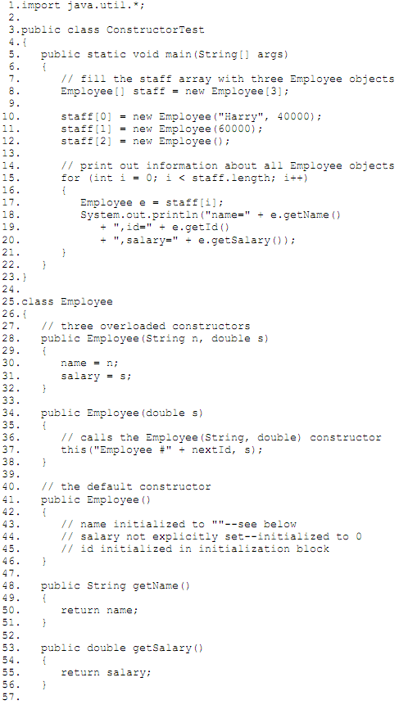

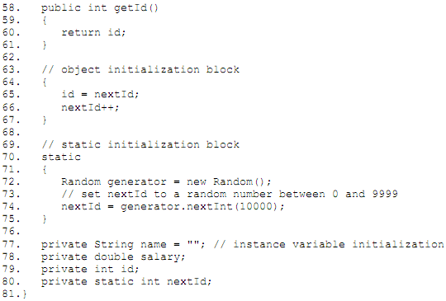

Lab Guide 2: Classes, Superclasses, and Subclasses
The Employee class is a superclass, but not because it is superior to its subclass or contains more functionality. The Manager class encapsulates more data and has more functionality than its superclass Employee.
You need to supply a new method to override the superclass method:
class Manager extends Employee
{
. . .
public double getSalary()
{
. . .
}
. . .
}
This program that shows how the salary computation differs for Employee and Manager objects.
Solutions:
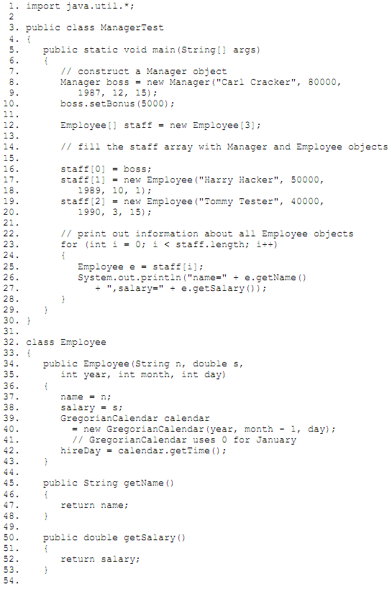
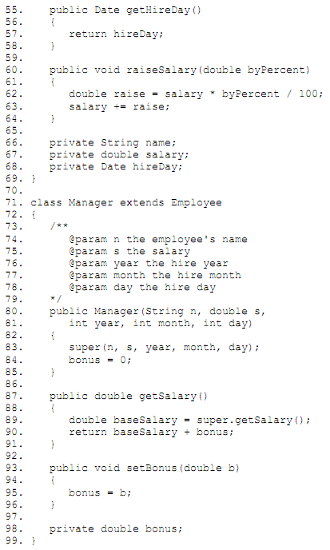

Lab Guide 3: Abstract Classes
The program defines the abstract superclass Person and two concrete subclasses, Employee and Student. We fill an array of Person references with employee and student objects.
Person[] people = new Person[2];
people[0] = new Employee(. . .);
people[1] = new Student(. . .);

We then print the names and descriptions of these objects:
for (Person p : people)
System.out.println(p.getName() + ", " + p.getDescription());

Some people are baffled by the call
p.getDescription()

Solutions:
