## Assignment 7.1 (2 marks): Create a sample form

The page is shown below:

## 

## Assignment 7.2 (4 marks): Create a login and registration web pages

Users first go to index.htm page for login, the page is shown below:

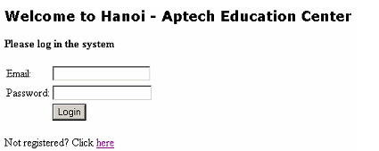

If the users already registered, they can enter their email and password. Implement

the following form validation when form is submitted:

- Email and password must be entered

- Email must be in correct format

- When the email equals to hnaptech@aptech.com and password equals to 123

show a welcome message to the use, else show a message denoting

unauthorized user and ask them to register

If the user has not been registered, they can click the hyperlink to show the

register.htm page

User register via register.htm page as shown below:

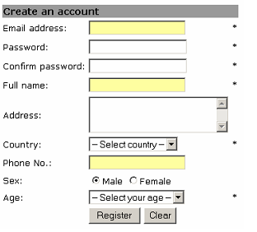

When each field receives focus, change its background color to pink, when user

leaves change the backgound color back to normal

Implement the following form validation before submit:

- All fields with (*) sign are mandatory

- Email must be in correct format

- Country drop down list has the following options:

o – Select country --

o Vietnam

o United States

o United Kingdom

o Australia

o Singapore

User must select 1 country

- Phone no must be in correct format

- Age drop down list has the following options:

o – Select age –

o < 6

o 6 – 18

o 18 – 22

o 23 – 30

o 30 – 40

o > 40

User must select 1 age range

- When Register button is clicked, validate the form, if form data is valid, submit

to success.htm page, if form data is not valid at any field do the followings:

o Alert user with the error

o Set the cursor to the invalid field to allow user correct it

o Cancel form submission

- When clear is clicked, clear all data on form

3. Create page success.htm as follows:

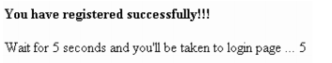

This page is displayed when user successfully registered, it informs users of their

registration and after 5 seconds, bring them back to index.htm page for logging in.

The page also displays a reverse counter of seconds from 5 to 0, when the second

reaches 0, show index.htm page to the users

## 

## Assignment 7.3 (4 marks): Write a JavaScript program

Write a Javascript program to print time

**Objective**:

**Problem Description**:

Write a Javascript program to print time in HH:MM:SS A/P format as shown below:  
The current time is 11:57:28 A  
You have to use the following digits set (The image for this digits set are attached with this assignment)