|  |  |
| --- | --- |
|  | **2021** |
|  | JUNGDO UIT  Thai Hoang Vinh |

|  |
| --- |
| **[PreVIEW oF SOLUTION ARCHITECTURE]** |
| A preview of analysis the architecture requirements of Smart city Tamky Project based on research of existing IoT frameworks and previous projects on smart city field |

1. **Project vision**

* Create a smart city operation and management platform
* Maintains a fundamental database for a smart city.
* Provide implementations to get involved of citizens (citizen engagement) on making decisions and policies related to smart city operations

1. **Summary on the framework of architecture view points**

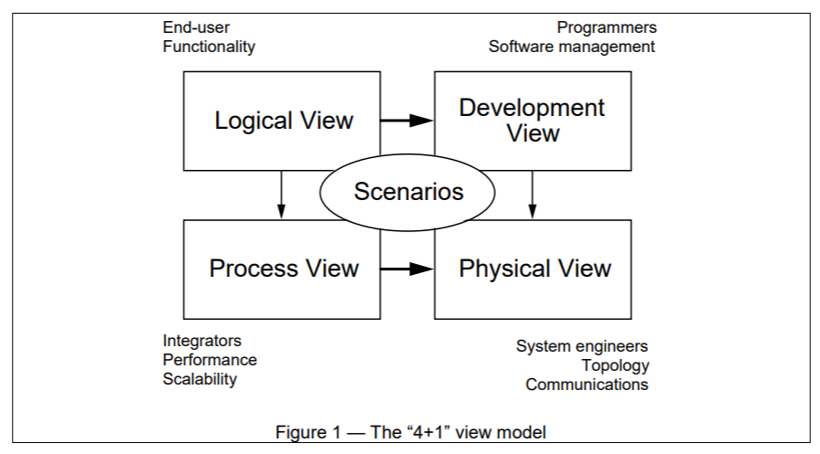

**Scenarios:** The description of architecture is illustrated using a small set of use case, or scenarios. This view is also known as the use case view. In order to represent the view, we Use [case diagram](https://en.wikipedia.org/wiki/Class_diagram).

**Logical View:** The logical view is concerned with the functionality that the system provides to end-users.  In order to represent the view, we use [Class diagrams](https://en.wikipedia.org/wiki/Class_diagram), or State diagram.

**Process View:** The process view deals with the dynamic aspects of the system, explains the system processes and how they communicate, and focuses on the run time behavior of the system. In order to represent the view, we use [Sequence diagram](https://en.wikipedia.org/wiki/Sequence_diagram), [Communication diagram](https://en.wikipedia.org/wiki/Communication_diagram), [Activity diagram](https://en.wikipedia.org/wiki/Activity_diagram)

**Development View:** The development view illustrates a system from a programmer's perspective and is concerned with software management. In order to represent the view, we use [Component diagram](https://en.wikipedia.org/wiki/Component_diagram)s and [Package diagram](https://en.wikipedia.org/wiki/Package_diagram).

**Physical View:** The physical view depicts the system from a system engineer's point of view. In order to represent the view, we use [Deployment diagram](https://en.wikipedia.org/wiki/Deployment_diagram)

1. **Functional Requirements and Non-Functional Requirements**

| **Req_ID** | **Category** | **Description** |
| --- | --- | --- |
| FR_EA_01 | Energy efficiency | Monitoring of most relevant KPIs (Key Performance Indicators) at different levels household, building and city. There are two types of KPIs as Indoor KPIs (e.g. temperature, humidity, energy) and Outdoors KPIs (e.g. street lights, temperature, speed of wind, humidity, waste collection) |
| FR_EA_02 | Energy efficiency | The system should provide means of identifying energy consumption patterns |
| FR_EA_03 | Energy efficiency | The system should provide means of detecting buildings in city with poor energy performance |
| FR_EA_04 | Energy efficiency | The system should support decision making capabilities to guide stakeholders on the implementation of energy efficiency measures (e.g. Identification of priorities for intervention) |
| FR_EA_05 | Energy efficiency | The system should support an integrated electrical and thermal network energy management |
| FR_EA_06 | Energy efficiency | The system should have access to specific information from dwellings and buildings through sensors or meters to be installed (e.g. temperature, humidity, electricity consumption, gas, water), through a weather forecast station (exterior temperature, wind speed, sunshine) |
| FR_EA_07 | Energy efficiency | The system should provide an energy use forecast at dwelling and city level by means of incorporating weather forecasts. A set of recommendations could be emitted to the end-users and ESCOs with the aim at managing the energy use in an efficient way |
| FR_MB_01 | Mobility | The system should provide services that allow the optimization of public transportation routes and the last mile logistic |
| FR_ MB _02 | Mobility | The system should provide services that inform the users about the availability of shared green vehicles |
| FR_ MB _03 | Mobility | The system should provide services that allow the management of EVs recharging network and the availability of EVs recharging points |
| FR_ MB _04 | Mobility | The system should provide analysis results of CO2 emissions based on the efficient use of mobility resources |
| FR_ MB _05 | Mobility | The system should have access to specific information from vehicles through meters to be installed (e.g. distances travelled, geo-location) or provided by vehicle users (e.g. costs, investment, operation costs) |
| FR_ MB _06 | Mobility | The system should provide citizens with resources to calculate the total cost of ownership of EV |
|  | Healthy |  |
|  | Environment |  |
| FR_CE_01 | Citizen Engagement | The system should provide citizens with information about smart city policies and implementation programs |
| FR_CE_02 | Citizen Engagement | The system should provide information about schedules and routes of public transportation |
| FR_CE_03 | Citizen Engagement | The system should enable the citizens to provide feedback about failures in the services (e.g. EVs charging points, public transportation, bike sharing) |
| FR_CE_04 | Citizen Engagement | The system should allow launching surveys in the district about the smart city policies and implementation programs |
| FR_CE_05 | Citizen Engagement | The system should enable the answering of questions from comments regarding the smart city implementation programs (technical, regulatory, process, funding, etc.) |
| FR_CE_06 | Citizen Engagement | The system should have suitable data to offer citizens and a direct connection among platform and building owners for energy domains or platform user for other domains |
| FR_CE_07 | Citizen Engagement | The system should allow to broadcast any type of information to the residents in the form of a digital TV channel |
| FR_DM_01 | Device management | The system should provide a way to manage connected devices. Management activities include adding and removing devices, managing ownership and hierarchy, relations to other assets |
| FR_DM_02 | Device management | The system should provide means of defining and reusing the data model profiles for various devices |
| FR_DM_03 | Device management | Devices should be able to advertise which services they provide (service discovery) |
| FR_UM_01 | User management | The system should enable several users to access the system using their own username and password. |
| FR_UM_02 | User management | Based on authorization level, existing users can add new user |
| FR_UM_03 | User management | Users only have access to data of their own assets and to assets they have been given permissions to |
| FR_DE_01 | Decision Engine | The system should provide a way to apply automatic business rules (for example turn on a light when motion in the room is detected). This may be either internal to the platform or using external callbacks |
| FR_RA_01 | Remote Actions | The system should allow for certain actions to be triggered remotely, sending commands to the devices |
| FR_DA_01 | Data Analysis | The system should provide a way to gather historical device measurements data |
| FR_DA_02 | Data Analysis | The platform should support storing all communication with any device or component in an external data analytics platform |
| FR_DA_03 | Data Analysis | The system should provide varying charts for visualize statistics data collected from vertical domain data |
| FR_DA_03 | Data Analysis | It should be possible to export the data to be analyzed |
| FR_GEO_01 | Geo-location | The system should enable storing the physical coordinates of devices |
| FR_GEO_02 | Geo-location | The system should provide means of querying for devices by their coordinates |
| FR_GEO_03 | Geo-location | The system should provide GIS capabilities for visualization of added value services |

|  |  |  |
| --- | --- | --- |
| **Req_ID** | **Category** | **Description** |
| NFR_SEC_01 | Security | User data should be protected from unauthorized access from many services deployed and accessed remotely |
| NFR_ SEC_02 | Security | The security and privacy mechanism should sufficient to be trustworthy for the clients |
| NFR_ SEC_03 | Security | The system should make it difficult to spy on messages communicated in the system (for example, use HTTPS) |
| NFR_ SEC_04 | Security | The system should provide a secure environment protected from common attack vectors |
| NFR_ SEC_05 | Security | The system components should be updateable to protect against known vulnerabilities |
| NFR_ PRI_01 | Privacy | The system should respect user’s privacy, preventing unauthorized access |
| NFR_ PRI _02 | Privacy | Users without applicable permissions should not be able to track what other users are doing in the system |
| NFR_ PRI_03 | Privacy | It is ok to publicly share aggregated user data (data combined for a number of users for some prolonged period of time) |
| NFR_ PRI _04 | Privacy | The physical location of users should not be made accessible to other parties without the required permissions |
| NFR_ PRI_05 | Privacy | The system should prevent tracking of devices by unauthorized entities |
| NFR_ PRI _06 | Privacy | The system should not be configured to collect more data than it needs |
| NFR_ PRI_07 | Privacy | When relocating existing devices, the new owner should not be able to view the history of previous device owner |
| NFR_ PRI _08 | Privacy | In case of aggregated data, it should not be determinable exactly from whom was this data gathered from |
| NFR_ NET _01 | Networking | The platform should be able to operate over different networks (wired and wireless internet, GSM) |
| NFR_ NET _02 | Networking | It’s a benefit if the system uses standard HTTP communication, not requiring special firewall configurations |
| NFR_ NET _03 | Networking | The system should be able to handle heterogeneous networks such as wireless internet and data over mobile networks |
| NFR_ NET _04 | Networking | The system should be able to run on distributed networks and operate over VPN if required |
| NFR_ NET _05 | Networking | When using networks such as mobile network, the system should be able to gracefully handle roaming services |
| NFR_ NET _06 | Networking | Support for IPv6 is a benefit |
| NFR_AUD_01 | Auditing | All changes made to the system should leave an automatic and permanent audit trail showing who and when made which changes |
| NFR_BAC_01 | Backup | The system should provide means or ways to back up the data periodically |
| NFR_BAC_02 | Backup | The system should provide means to restore to a backed up version |
| NFR_HOS_01 | Hosting | The data stored and generated in the system should belong to the clients and operators and be subject to laws of the deployed country |
| NFR_HOS_02 | Hosting | It’s a benefit if it’s possible to host the platform on the operator’s infrastructure |
| NFR_EXT_01 | Extensibility | The system should be extensible with new functionality either through modifying its source code or by utilizing the API interfaces to build external 3rd party modules |
| NFR_AVA_01 | Availability | The system should take measures to provide high availability |
| NFR_AVA_02 | Availability | The system should provide high Quality of Service |
| NFR_SCA_01 | Scalability | The system requirements meet a large number of users access concurrently and the number of users will increase unexpectedly in the future |
| NFR_INT_01 | Interoperability | The system should provide ways for different external 3rd party systems to communicate with the platform |
| NFR_INT_02 | Interoperability | If the system has its own administration interface, the provided API should allow performing all the same functions by 3rd party application given sufficient privileges |
| NFR_FAU_01 | Fault tolerance | The system should be able to handle faulty or compromised devices sending invalid data or at high rates |
| NFR_FAU_02 | Fault tolerance | The system should be able to detect and notify about devices not reporting expected data |
| NFR_MAI_01 | Maintainability | The system should be designed to be operated and maintained for a prolonged period of time |
| NFR_MAI_02 | Maintainability | The components and dependencies should be updateable |
| NFR_MAI_03 | Maintainability | The system should not lock the client into a certain vendor |
| NFR_DOC_01 | Documentation | The platform and its functions should be sufficiently documented so new people could be included to work on it without dependence on original developers |
| NFR_DOC_02 | Documentation | The public API interface should be extensively documented |

1. **Systems**

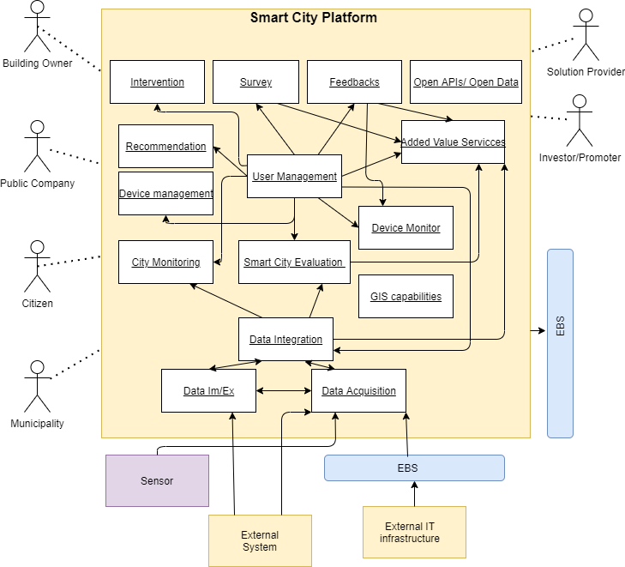

1. **Scenarios**

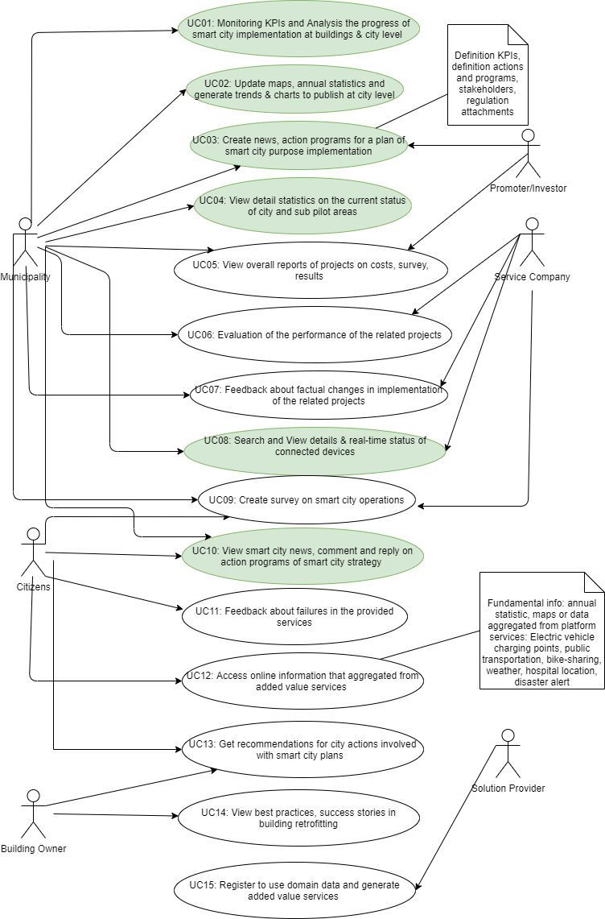

1. **Logical View**
2. **Process View**
3. **Development View**
4. **Physical View**
5. **Technical stack on summary**
6. **References**