Security Fundamentals Assessment
Authorized Security Assessment of Metasploitable 2

Assessment machine | Kali Linux in VMware
Assessment IP | 192.168.174.129
Target machine | Metasploitable 2
Target IP | 192.168.174.128
Environment | VMware isolated/training lab
Authorization | Intentionally vulnerable training environment

1. Executive Summary
A security assessment was conducted against the Metasploitable 2 virtual machine from Kali Linux. The assessment identified four security issues: an exposed Telnet service, a vulnerable vsftpd 2.3.4 service, an outdated Apache/PHP web stack, and anonymous SMB access to a network share. The most significant issue identified was the vsftpd 2.3.4 service because the exact version is associated with a known backdoor command-execution vulnerability. The assessment was limited to enumeration and validation in the training lab; no exploit was executed.

2. Objective and Scope
This assessment was performed in an authorized, intentionally vulnerable training environment. The objective was to identify security risks, document affected components and evidence, assess potential impact, and recommend appropriate mitigations. No exploitation was performed as part of this assessment.
The assessment scope was limited to the following lab target:
- Assessment IP: 192.168.174.129
- Target machine: Metasploitable 2
- Target IP: 192.168.174.128

3. Methodology
- Confirmed the Kali Linux and Metasploitable 2 machines were on the same VMware lab network.
- Performed host and service discovery with Nmap.
- Enumerated selected services and versions on the target.
- Used SearchSploit to identify publicly documented security references for the detected vsftpd version.
- Used HTTP response headers to verify Apache and PHP versions.
- Enumerated SMB shares without credentials to test whether anonymous access was permitted.
- Documented evidence with screenshots and prepared remediation recommendations.

4. Tools Used
- Nmap
- SearchSploit
- Netcat (nc)
- curl
- smbclient
- Kali Linux
- VMware Workstation

5. Findings

F-01 — Telnet Service Exposed
Severity | Medium
Affected component | TCP port 23 — Linux Telnet service
Evidence | Nmap identified 23/tcp as open and reported the service as Linux telnetd.
Risk | Telnet does not provide the same encrypted protection as SSH. If used for authentication or sensitive administration, credentials and session information may be exposed to network interception.
Recommended mitigation | Disable Telnet where it is not required. Use SSH for remote administration, enforce strong authentication, and restrict administrative access to trusted networks.

F-02 — Vulnerable vsftpd 2.3.4 Service
Severity | Critical
Affected component | TCP port 21 — FTP / vsftpd 2.3.4
Evidence | Nmap identified 21/tcp as open and reported vsftpd 2.3.4. SearchSploit also returned references for 'vsftpd 2.3.4 - Backdoor Command Execution'. No exploit was executed.
Risk | The identified version is associated with a known backdoor command-execution issue. If the vulnerable service is reachable by an attacker, it can create a path to unauthorized command execution and host compromise.
Recommended mitigation | Remove or upgrade the vulnerable vsftpd version to a supported, patched release. Restrict FTP exposure, use secure file-transfer alternatives such as SFTP where appropriate, and monitor authentication and service activity.

F-03 — Outdated Apache and PHP Web Stack
Severity | High
Affected component | TCP port 80 — Apache HTTP Server 2.2.8 / PHP 5.2.4
Evidence | Nmap reported Apache httpd 2.2.8. An HTTP HEAD request returned 'Server: Apache/2.2.8 (Ubuntu) DAV/2' and 'X-Powered-By: PHP/5.2.4-2ubuntu5.10'.
Risk | The web stack is obsolete and may contain known security weaknesses. Exposing exact software versions also provides useful information for attackers when identifying potential attack paths.
Recommended mitigation | Upgrade Apache and PHP to supported versions, apply current security updates, remove unnecessary modules, and minimize unnecessary version disclosure in HTTP response headers.

F-04 — Anonymous SMB Access to the tmp Share
Severity | High
Affected component | TCP ports 139/445 — Samba SMB service
Evidence | Nmap identified Samba on ports 139 and 445. 'smbclient -L //192.168.174.128 -N' returned 'Anonymous login successful' and listed several shares. An unauthenticated connection to the tmp share also succeeded and allowed directory listing.
Risk | Allowing unauthenticated access to network shares can expose files and directory information to unauthorized users. The actual impact depends on the permissions and sensitivity of the exposed resources.
Recommended mitigation | Disable guest/anonymous SMB access unless explicitly required. Require authentication, apply least-privilege permissions, restrict share access by network and user, and disable unnecessary shares.

6. Risk Summary
Finding | Severity | Primary concern
F-01 Telnet exposed | Medium | Unencrypted remote administration
F-02 vsftpd 2.3.4 | Critical | Known backdoor command-execution issue
F-03 Outdated Apache/PHP | High | Obsolete software and version disclosure
F-04 Anonymous SMB | High | Unauthenticated share and file enumeration

7. Recommended Remediation Priority
- Immediately remove or upgrade vsftpd 2.3.4 and restrict unnecessary FTP exposure.
- Disable anonymous/guest SMB access and review permissions on all exposed shares.
- Upgrade Apache and PHP to supported versions and apply security updates.
- Disable Telnet and use SSH for secure remote administration.
- After remediation, repeat the service and access checks to verify that the identified weaknesses are no longer present.

8. Evidence Appendix
The following screenshots document the assessment activities. They were captured from the Kali Linux VM running in VMware.
Evidence 1 — Telnet service exposed
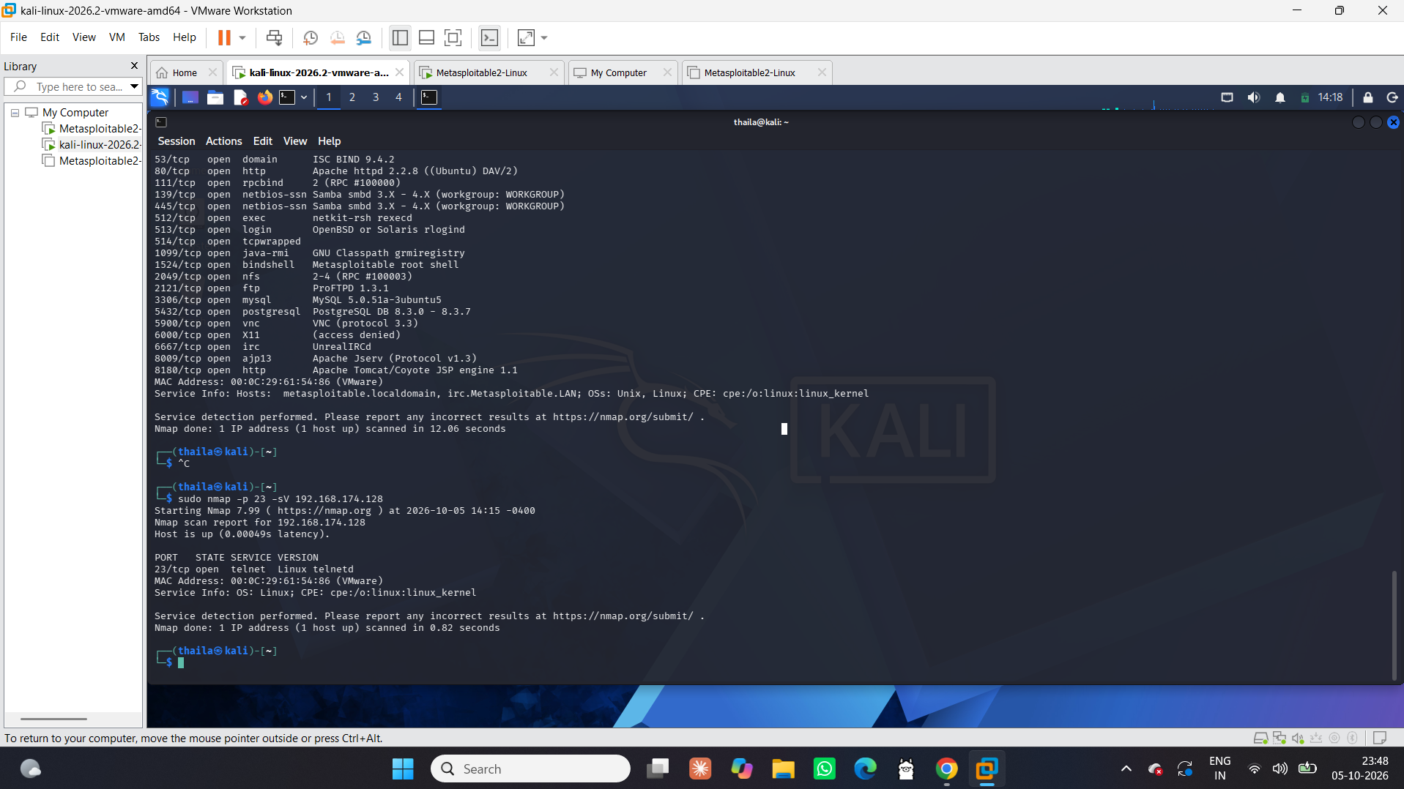

Evidence 2 — vsftpd 2.3.4 detected
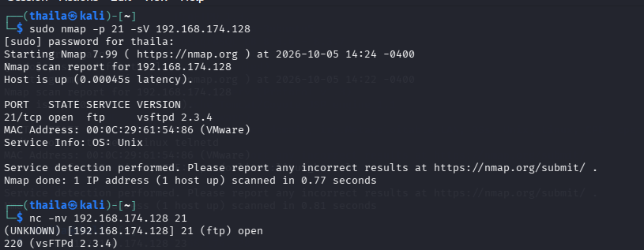

Evidence 3 — SearchSploit reference for vsftpd 2.3.4

Evidence 4 — Apache/PHP versions
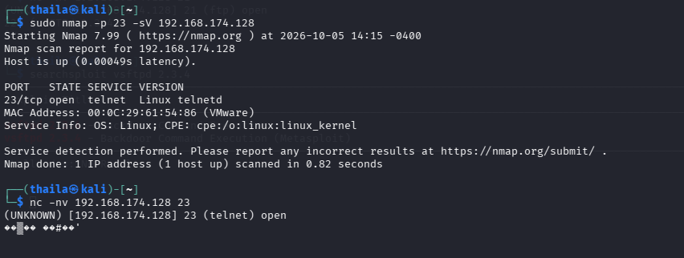

Evidence 5 — SMB services and anonymous share enumeration
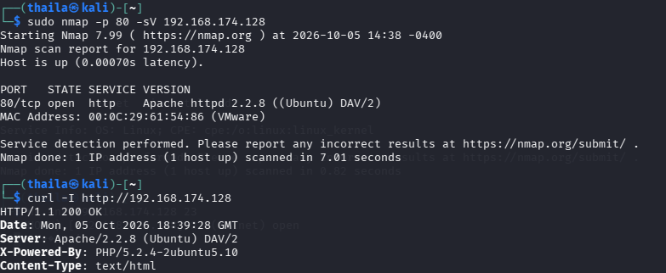

Evidence 6 — Anonymous SMB access to tmp share
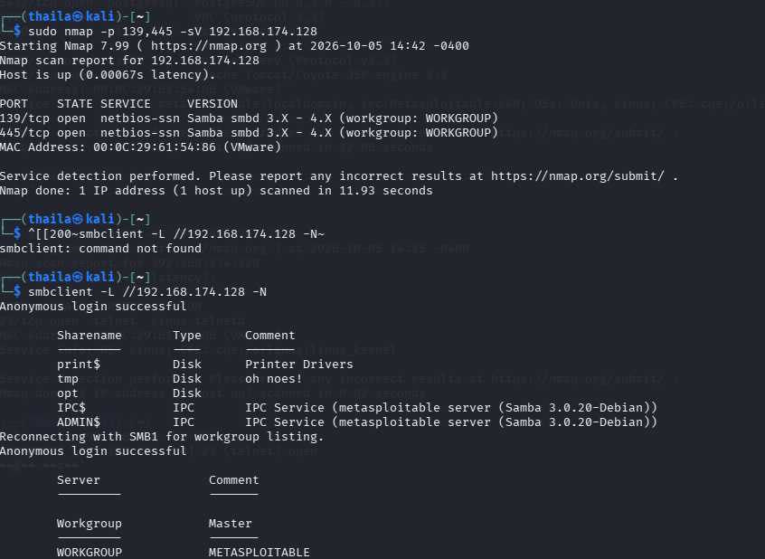

Evidence 7 — SMB tmp share contents
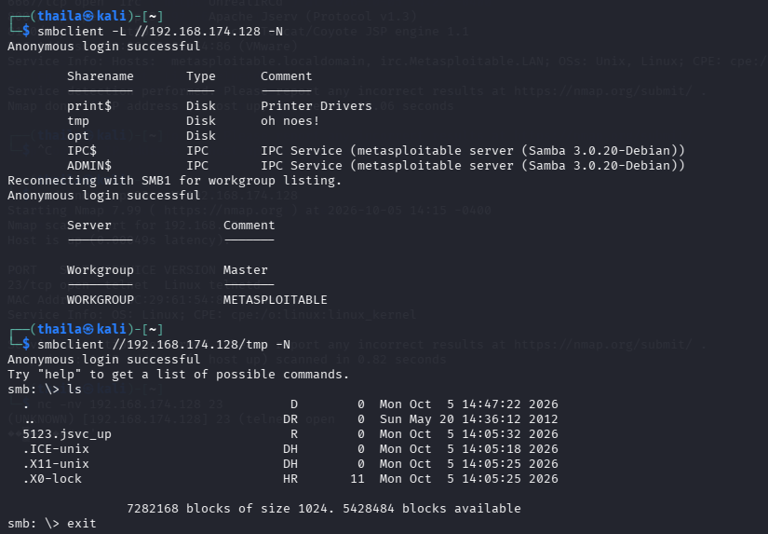

9. Conclusion
The assessment demonstrated several security weaknesses in the intentionally vulnerable Metasploitable 2 environment. The findings show why unnecessary services, obsolete software, insecure remote-access protocols, and anonymous file-sharing access should be removed or securely configured. The assessment was performed within an authorized training environment and focused on identification, evidence collection, risk assessment, and remediation rather than exploitation.

End of Report

