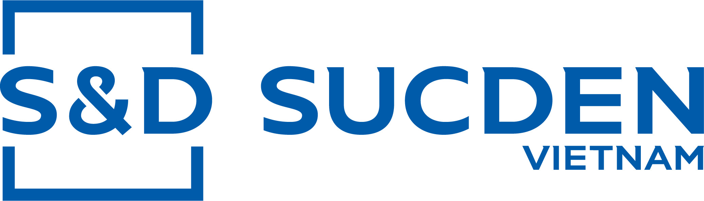

De Ruijterkade 113-2, 1011 AB,
Amsterdam, The Netherlands
Tel: +31 (0) 20 23 52 523
EORI number: NL813786368.B01
Email: Nedtrade@sucden.com
Sucden coffee Vietnam
Công ty Sucden coffee Vietnam
Cum Cong nghiep Tan An 2
BUON MA THUOT, DAKLAK
Vietnam

Contract No: <o.p_name> | Your ref: <o.name or ''> | Amsterdam ,<get_dates_mos(o.date)>

Dear Sirs,

We have pleasure in confirming today's business at the following conditions:

- SELLER | Yourselves
- BUYER | Ourselves
- INTERMEDIARY
- QUANTITY | <formatLang(o.total_qty/1000,digits=2)> MT
- COFFEE BEANS | From Vietnam
- QUALITY | <o.contract_line[0].name or ''>
- PRICE | <formatLang(o.contract_line[0].price_unit, digits=2)> <o.currency_id.name or ''>/MT
- TERM | <o.shipping_id.incoterms_id.name>
- SHIPMENT
- ARRIVAL AND/OR DELIVERY | <get_date_mos(o.deadline)>
- WEIGHT | Net Shipped Weights
- PAYMENT | Net Cash Against Documents
- ARBITRATION | If any, in London
- GENERAL CONDITIONS | According to the conditions of European Contract for Coffee
- SPECIAL CONDITIONS | The "Uniform Law on the International Sale of Goods" shall not  apply to this contract
- SI | <o.si or ''>
- SD | <o.sd or ''>
- Certificate | <o.get_certificate()>
- License | <o.get_license()>

We send you this contract in duplicate and kindly request you to return the copy duly signed
and stamped for your agreement

Your faithfully,
SUCDEN COFFEE NETHERLANDS BV

