Q What is unsupervised learning? When is it used?

Unsupervised learning is type of machine learning algorithm in which your examples are not labeled so in such cases algorithm itself cannot create or invent so it try doing clustering the data into different groups. For example algorithm itself won’t be able to recognize face of horse but it will be able to differentiate between horses face from dog so it can do grouping.

Unsupervised learning could be used for grouping/segmentation for example places with population or in marketing or to categories customers.

Q Describe three business applications in your industry where cluster analysis will be useful?

Well in my world of mobile applications I believe,

1. Game applications can use cluster analysis to differentiate or group items from each other
2. Marketing applications, where we can categorize customers of different sort
3. Computer vision or Image recognizing industry.

Q Data about height and weight for a few volunteers is available. Create a set of clusters for the following data, to decide how many sizes of T-shirts should be ordered?

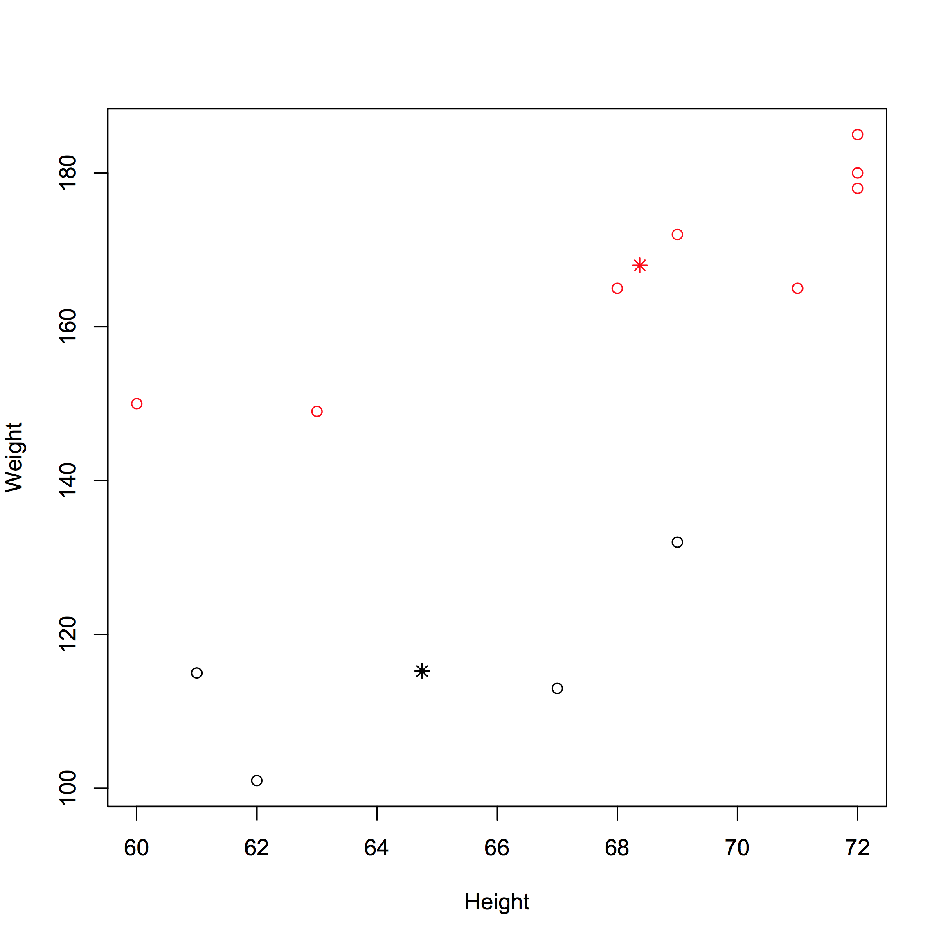

Caselet: Cluster Analysis

Q2. Could this segmentation apply to other service businesses? Which ones?

Yes, segmentation can be applied to other service businesses as well for example grocery stores we can create groups on the basis of our products and sales.