**ANLY500 Homework 6**

8.2. A consumer products company has collected some data relating monthly demand to the price of one of its products:

| **Price** | **Demand** |
| --- | --- |
| $11 | 2,100 |
| $13 | 2,020 |
| $17 | 1,980 |
| $19 | 1,875 |

What type of model would best represent these data? Use the Trendline tool to find the best among the options provided.

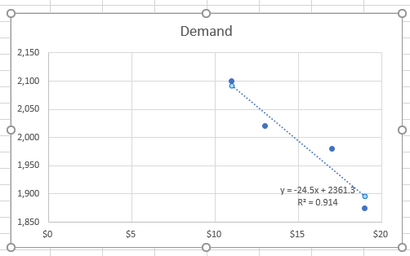

8.8. The managing director of a consulting group has the following monthly data on total overhead costs and professional labor hours to bill to clients:

| **Overhead Costs** | **Billable Hours** |
| --- | --- |
| $365,000 | 3,000 |
| $400,000 | 4,000 |
| $430,000 | 5,000 |
| $477,000 | 6,000 |
| $560,000 | 7,000 |
| $587,000 | 8,000 |

1. Develop a trendline to identify the relationship between billable hours and overhead costs.

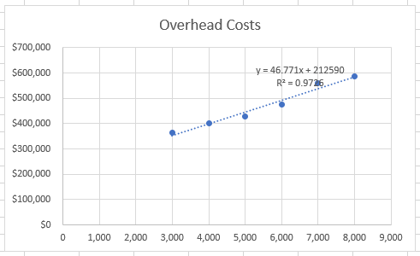

1. Interpret the coefficients of your regression model. Specifically, what does the fixed component of the model mean to the consulting firm?

|  |
| --- |
| When 1 billable hour is increased, cost will go up 46.771$. The fix value 212590$ represents the fix cost independent to billable hours. |

1. If a special job requiring 1,000 billable hours that would contribute a margin of $38,000 before overhead was available, would the job be attractive?

Y = 1000 * 46.771 +212590 = 259361

So it’s not attractive because the job only contribute 38000$.

8.21. The Excel file *Major League Baseball* provides data on the 2010 season.

1. Construct and examine the correlation matrix. Is multicollinearity a potential problem?

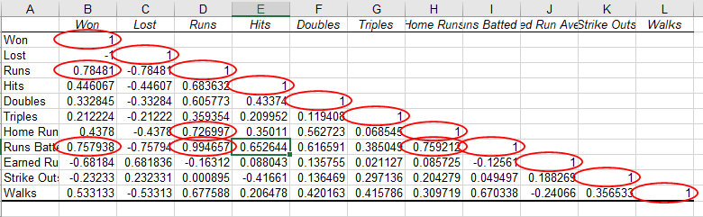

1. Suggest an appropriate set of independent variables that predict the number of wins by examining the correlation matrix.

|  |
| --- |
| Review the correlation table, we should model the function of Hits, Doubles, Triples, Home run, Strike out |

1. Find the best multiple regression model for predicting the number of wins. How good is your model? Does it use the same variables you thought were appropriate in part (b)?

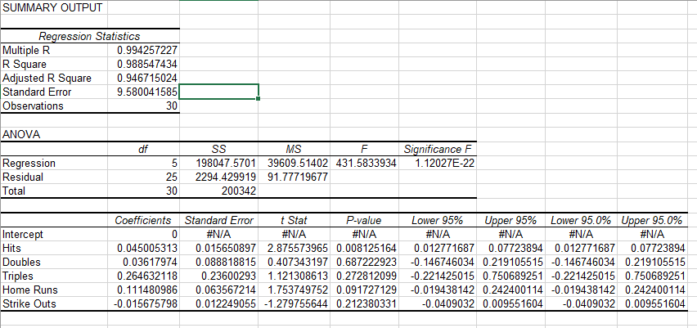

8.29. The Helicopter Division of Aerospatiale is studying assembly costs at its Marseilles plant. Past data indicates the following labor hours per helicopter:

| **Helicopter Number** | **Labor Hours** |
| --- | --- |
| 1 | 2,000 |
| 2 | 1,400 |
| 3 | 1,238 |
| 4 | 1,142 |
| 5 | 1,075 |
| 6 | 1,029 |
| 7 | 985 |
| 8 | 957 |

Using these data, apply simple linear regression, and examine the residual plot. What do you conclude? Construct a scatter chart and use the *Trendline* feature to identify the best type of curvilinear trendline that maximizes *R*2.

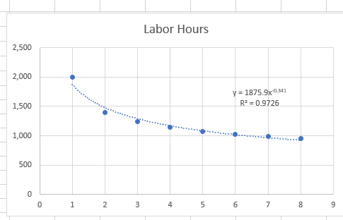

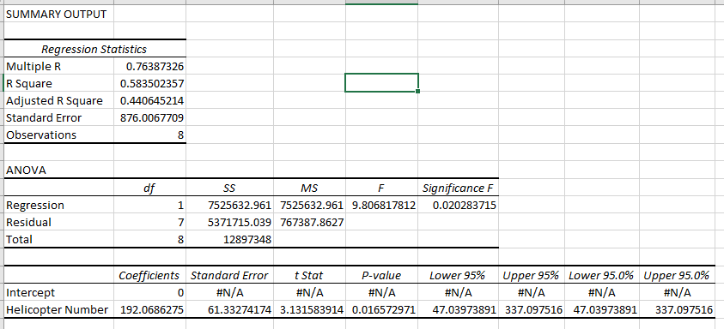

Conclusion: Labor hours is decreased when increasing number of helicopter