|  |
| --- |
| 7.1, page 228 |
| 7.2, page 228 |
| 7.3, page 228 |
| 7.4, page 228 |

1. Create an Excel workbook with worksheet templates (similar to the Excel workbook Confidence Intervals) for one-sample hypothesis tests for means and proportions. Apply your templates to the example problems in this chapter. (For subsequent problems, you should use the formulas in this chapter to perform the calculations, and use this template only to verify your results!)
   1. 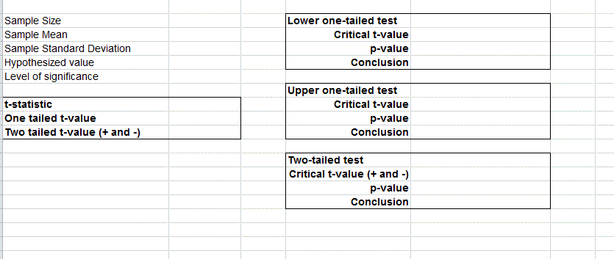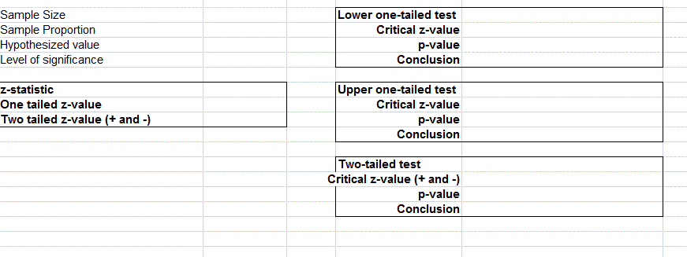
2. A business school has a goal that the average number of years of work experience of MBA applicants is at least 3 years. Based on last year’s applicants, it was found that among a sample of 47, the average number of years of work experience is 2.57 with a standard deviation of 3.67. What conclusion can the school reach?
   1. 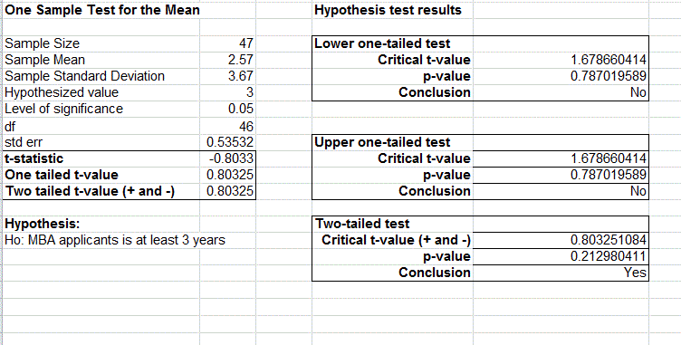
3. A bank has historically found that the average monthly charges in recent years on its credit card were $1,350. With an improving economy, they suspect that this has increased. A sample of 42 customers resulted in an average monthly charge of $1,376.54 with a standard deviation of $183.89. Does this data provide statistical evidence that the average monthly charges have increased?
   1. 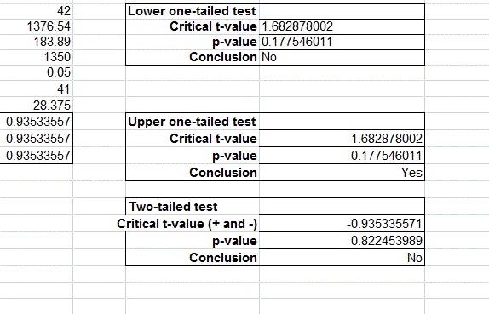
4. A retailer believes that its new advertising strategy will increase sales. Previously, the mean spending in 15 categories of consumer items in both the 18–34 and 35+ age groups was $70.00.
   1. Formulate a hypothesis test to determine if the mean spending in these categories has statistically increased.
   2. After the new advertising campaign was launched, a marketing study found that the mean spending for 300 respondents in the 18–34 age group was $75.86, with a standard deviation of $50.90. Is there sufficient evidence to conclude that the advertising strategy significantly increased sales in this age group?
   3. For 700 respondents in the 35+ age group, the mean and standard deviation were $68.53 and $45.29, respectively. Is there sufficient evidence to conclude that the advertising strategy significantly increased sales in this age group?

