EASTERN INTERNATIONAL UNIVERSITY | Practice Assignment – Quarter 1, 2026- 2027
SCHOOL OF COMPUTING  AND INFORMATION TECHNOLOGY | Course Name: Coding Practice  Course Code: CSE 422
Student’s Full Name: Thai Phan Thanh Sang
Student ID: 2231200114

LAB 05
GitHub Link: https://github.com/thaiphanthanhsang/CSE422_CodingPractice.git
- Introduction
This project is a simple library management system implemented as a C# console application. It uses Microsoft SQL Server to store documents, users, and borrowing transactions. The main purpose of the laboratory is to demonstrate four object-oriented design patterns through a practical application.
- Project Objectives
- Add and display library documents (books, magazines, and newspapers).
- Add and display users.
- Borrow available documents, calculate the loan fee, and reduce stock.
- Return borrowed documents, update the loan status, and restore stock.
- View loan records and display notifications to subscribed observers.
- Keep classes in separate C# files to make the application easier to understand.
- Database Design
Table | Main columns | Purpose
Documents | Id, Title, DocumentType, Quantity | Stores document types and available stock.
Users | Id, Name | Stores registered library users.
Loans | Id, DocumentId, UserId, BorrowDate, ReturnDate, Days, Fee, IsReturned | Stores borrowing and returning transactions.

- Singleton Parttern
Purpose
Singleton ensures that the application uses one instance of a database-management class. It centralizes the SQL Server connection string and provides a method to open SQL connections.
Implementation
File: Database/DatabaseConnection.cs
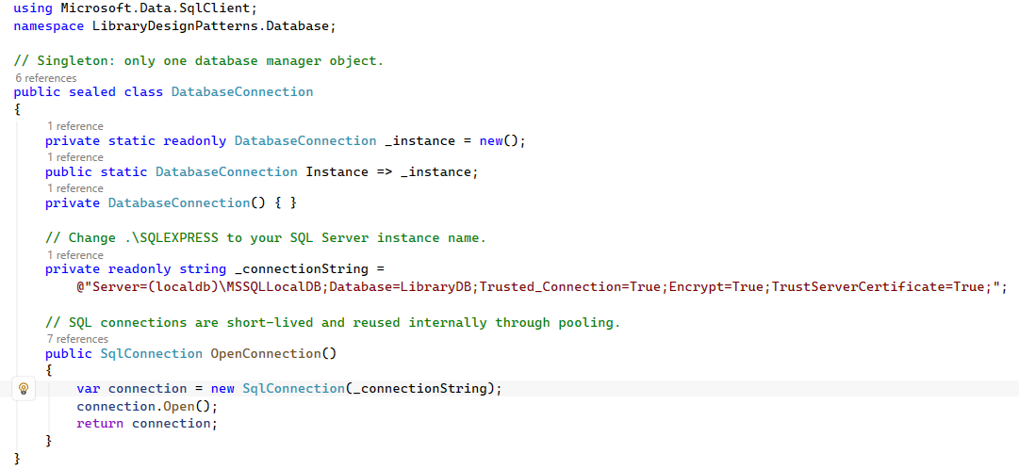
The constructor is private, so other classes cannot instantiate DatabaseConnection directly. LibraryService accesses the shared instance through DatabaseConnection.Instance. Each operation opens a separate short-lived SqlConnection; the singleton is the manager, not one permanently open physical database connection.
- Factory Method Pattern
Purpose
Factory Method delegates document creation to specialized creator classes, so the calling code does not need to construct Book, Magazine, or Newspaper directly.
Implementation
Files: FactoryMethod/IDocument.cs, DocumentCreator.cs, BookCreator.cs, MagazineCreator.cs, NewspaperCreator.cs, Book.cs, Magazine.cs, Newspaper.cs
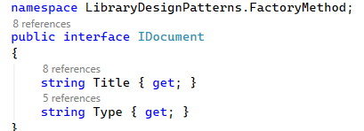
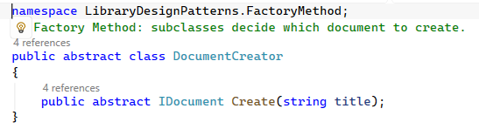
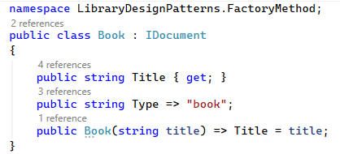
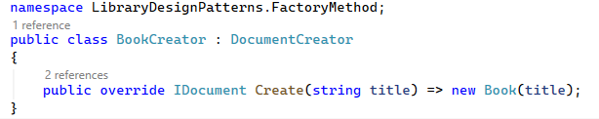
The DocumentCreator abstraction defines the factory method. Each concrete creator implements it to return the matching document type. The service selects a creator based on input and calls Create(title).
- Observer Pattern
Purpose
Observer lets subscribers receive a message when library activity occurs, without hard-coding a notification for each user inside the borrowing logic.
Implementation
Files: Observer/ISubscriber.cs, UserSubscriber.cs, LibraryNotifier.cs
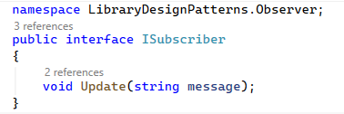
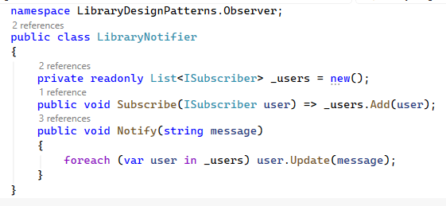
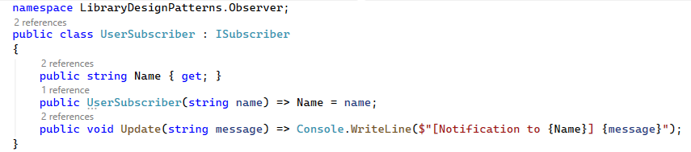
The notifier keeps an in-memory collection of subscribers. Each UserSubscriber implements the update operation and prints the message in the console. In this simple version, subscriptions last only for the current program session and notifications are sent to all registered subscribers; document-specific subscription filtering is not implemented.
- Strategy Pattern
Purpose
Strategy separates the borrowing-fee formula from the borrowing workflow. Different document types can use different rates without changing the Loan calculator
Implementation
Files: Strategy/IFeeStrategy.cs, BookFeeStrategy.cs, MagazineFeeStrategy.cs, NewspaperFeeStrategy.cs, Loan.cs
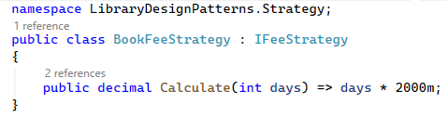
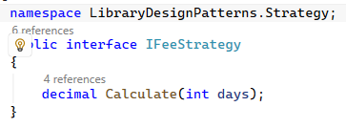
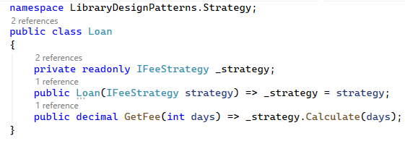
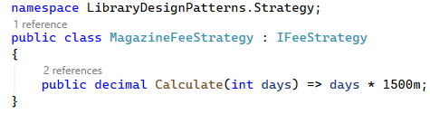
For example, borrowing a book for five days costs 5 × 2,000 = 10,000 VND. The strategy object is chosen from DocumentType and then passed to Loan.
- Demo Project


