EASTERN INTERNATIONAL UNIVERSITY | Practice Assignment – Quarter 1, 2026- 2027
SCHOOL OF COMPUTING  AND INFORMATION TECHNOLOGY | Course Name: Coding Practice  Course Code: CSE 422
Student’s Full Name: Thai Phan Thanh Sang
Student ID: 2231200114

LAB 04
GitHub Link: https://github.com/thaiphanthanhsang/CSE422_CodingPractice.git
- Problem Statement and Requirements
  - Functional requirements
Area | Required behavior
Books | Add a title, author, category and quantity; allocate a unique book ID.
Search | Find books by title or category using case-insensitive keyword matching.
Readers | Maintain readers with unique IDs; list and add reader records.
Borrow | Permit a loan only when a copy/license is available and the reader has fewer than three active  loans.
Return | Close a valid active loan and increment available quantity.
Reports | Show each reader, borrowed title and status (Borrowing or Returned).

  - Technical requirements
- Apply all five SOLID principles using cohesive classes and focused interfaces.
- Separate book management, reader management, borrowing services and reporting.
- Support different book types with inheritance and an extensible factory abstraction.
- Provide sample data and automated/manual testing scenarios.
- Domain Model and UML
The core domain is built around three entities: Book, Reader and Loan. Book is abstract; PrintedBook, EBook and Magazine are substitutable subtypes. Each borrowing operation creates a Loan that links one Reader and one Book.
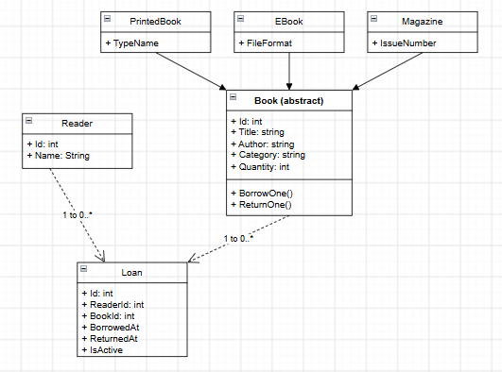
Figure 1. Domain UML: inheritance, book subtypes and loan relationships
Domain invariants
• IDs must be positive and unique in their respective repositories.
• Book title, author and category cannot be blank; quantity cannot be negative.
• Loan keeps BorrowedAt, optional ReturnedAt and derived IsActive status.
- Architecture and Interface Design
The program follows a layered organization. The console menu calls interfaces, the service layer enforces use cases, repositories encapsulate storage, and domain models protect internal state. Program.cs is the composition root that creates concrete objects and injects them into services.
Main interfaces and implementations
Interface | Concrete class / role
IBookService | BookService: add, list, retrieve and search titles/categories
IReaderService | ReaderService: add, list and retrieve readers
ILendingService | LendingService: borrow/return operations
IReportService | ReportService: reader borrowing history
IBookRepository | InMemoryBookRepository: book data access
IReaderRepository | InMemoryReaderRepository: reader data access
ILoanRepository | InMemoryLoanRepository: loan data access
IBorrowingPolicy | MaxThreeBooksPolicy: loan-count and duplicate-loan rules
IBookFactory | PrintedBookFactory / EBookFactory / MagazineFactory
IIdGenerator | SequentialIdGenerator: unique ID allocation
- Application of SOLID Principles
S - Single Responsibility Principle
BookService handles the book catalogue; ReaderService manages readers; LendingService manages borrowing and returns; ReportService produces report text; MaxThreeBooksPolicy enforces borrowing restrictions. Each has one main reason to change.
O - Open/Closed Principle
A new media type such as AudioBook can subclass Book and receive its own IBookFactory implementation. The book catalogue, lending and reporting services operate on Book and do not need changes. A new policy can be introduced by implementing IBorrowingPolicy.
L - Liskov Substitution Principle
PrintedBook, EBook and Magazine share the invariant-preserving BorrowOne/ReturnOne behavior inherited from Book. All three can be used through the Book abstraction wherever a lendable item is expected.
I - Interface Segregation Principle
Separate service interfaces (IBookService, IReaderService, ILendingService, IReportService) and repository interfaces keep contracts task-specific. Classes are not forced to implement unrelated operations.
D - Dependency Inversion Principle
LendingService receives IBookRepository, IReaderRepository, ILoanRepository, IBorrowingPolicy and IIdGenerator through constructor injection. InMemory repositories are created only in Program.cs, so storage may later be replaced.
- Implementation and Sample Data
LibraryManagementSOLID/
Models/ Book, PrintedBook, EBook, Magazine, Reader, Loan
Interfaces/ Service, repository, factory, policy contracts
Repositories/ In-memory data access
Services/ BookService, ReaderService, LendingService, ReportService
Policies/ MaxThreeBooksPolicy
Factories/ Three book factories
Infrastructure/ SequentialIdGenerator
Data/ SampleDataSeeder
Tests/ SmokeTests
Docs/ UML diagrams and design notes
Program.cs Application entry point and dependency wiring
- Demo


