EASTERN INTERNATIONAL UNIVERSITY | Practice Assignment – Quarter 1, 2026- 2027
SCHOOL OF COMPUTING  AND INFORMATION TECHNOLOGY | Course Name: Coding Practice  Course Code: CSW 434
Student’s Full Name: Thai Phan Thanh Sang
Student ID: 2231200114

LAB 02
GitHub Link: https://github.com/thaiphanthanhsang/CSW434.git
- Battery Screen
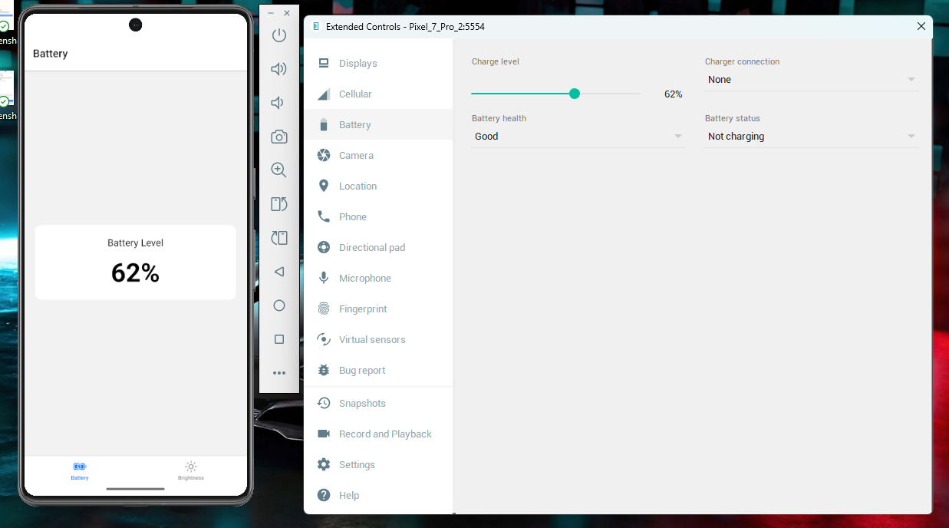
- Brightness Screen


