

<<PROJECT NAME>>
Software Requirement Specification

– Hanoi, August 2022 –

Record of changeS
Date | A*  M, D | In charge | Change Description
13/Apr | A | KienNT | Thêm mô tả chức năng Setting Details (II.1.a)
*A - Added M - Modified D - Deleted

Table of Contents
I. Overview 4
1. Introduction 4
2. System Functions 5
3. Entity Relationship Diagram 6
II. Functional Requirements 7
1. <<Feature Name 1>> 7
a. <<Function Name 1>> 7
b. <<Function Name 2>> 7
2. <<Feature Name 2>> 7

I. Overview

1. Introduction
[Content part 1: presents a high-level overview of the product and the environment in which it will be used, the users, and known constraints, assumptions, and dependencies]
[Content part 2: describes the product's context in the form of a context diagram in which you present the boundary and connections between the system you’re developing and everything else in the universe. This identifies external entities (or terminators – software, hardware, human components, and other systems) outside the system that interface to it in some way, as well as data, control, and material flows between the terminators and the system]
<<Sample: The Cafeteria Ordering System is a new software system that replaces the current manual and telephone processes for ordering and picking up meals in the Process Impact cafeteria. The system is expected to evolve over several releases, ultimately connecting to the Internet ordering services for several local restaurants and to credit and debit card authorization services.
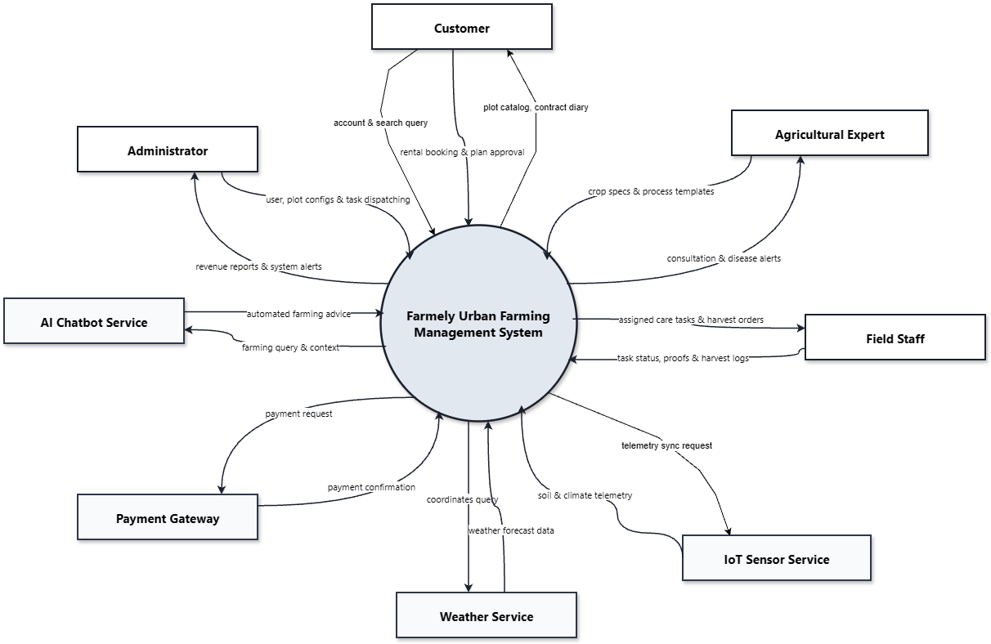>>

2. System Functions

3.1.1 Screens Flow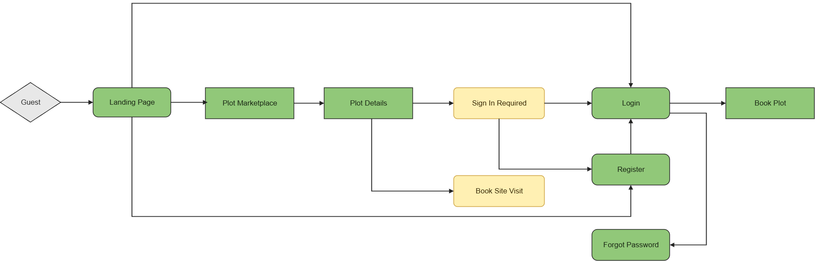
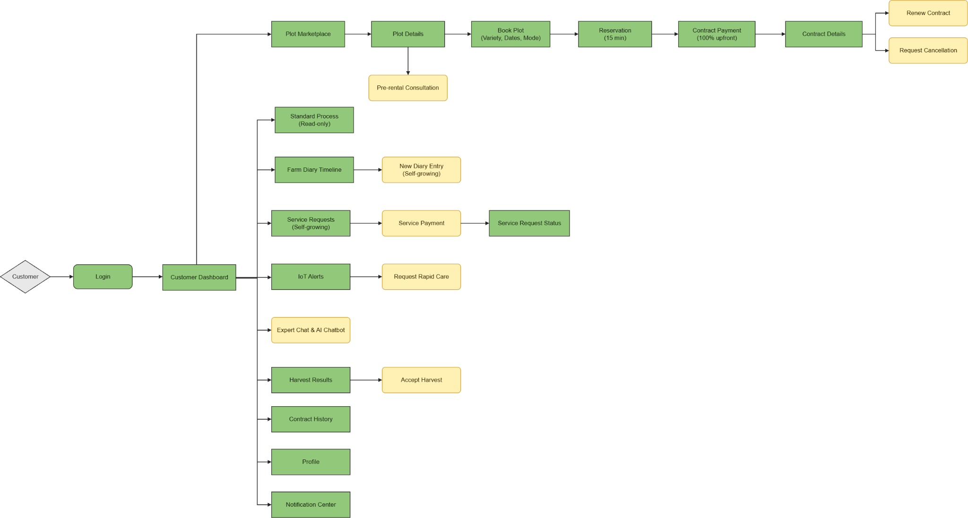
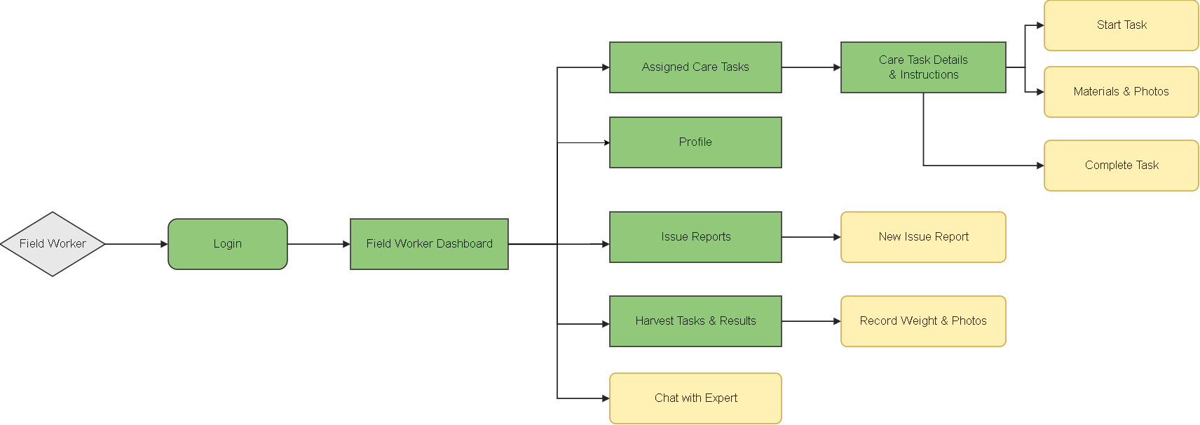
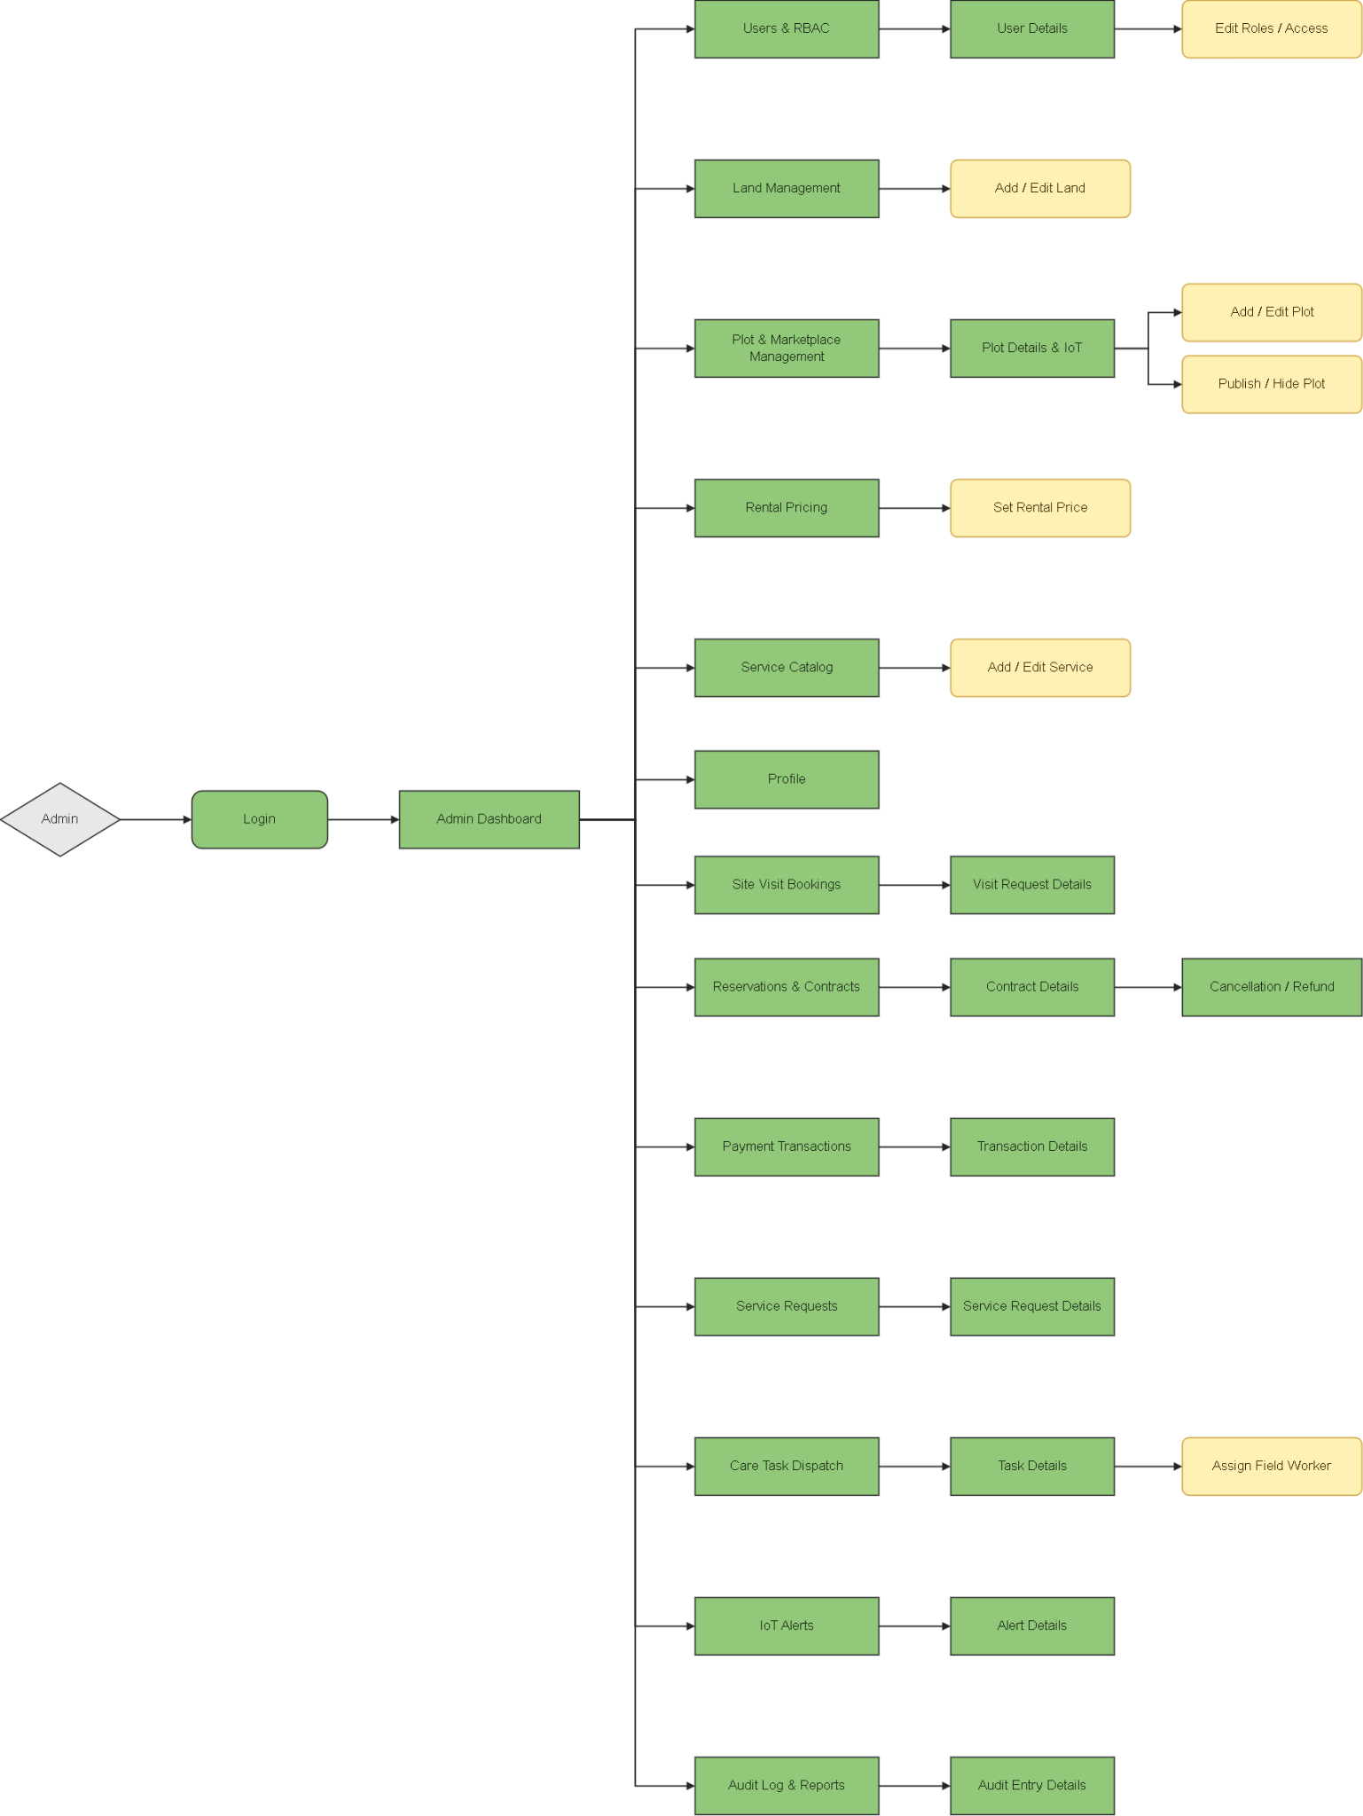

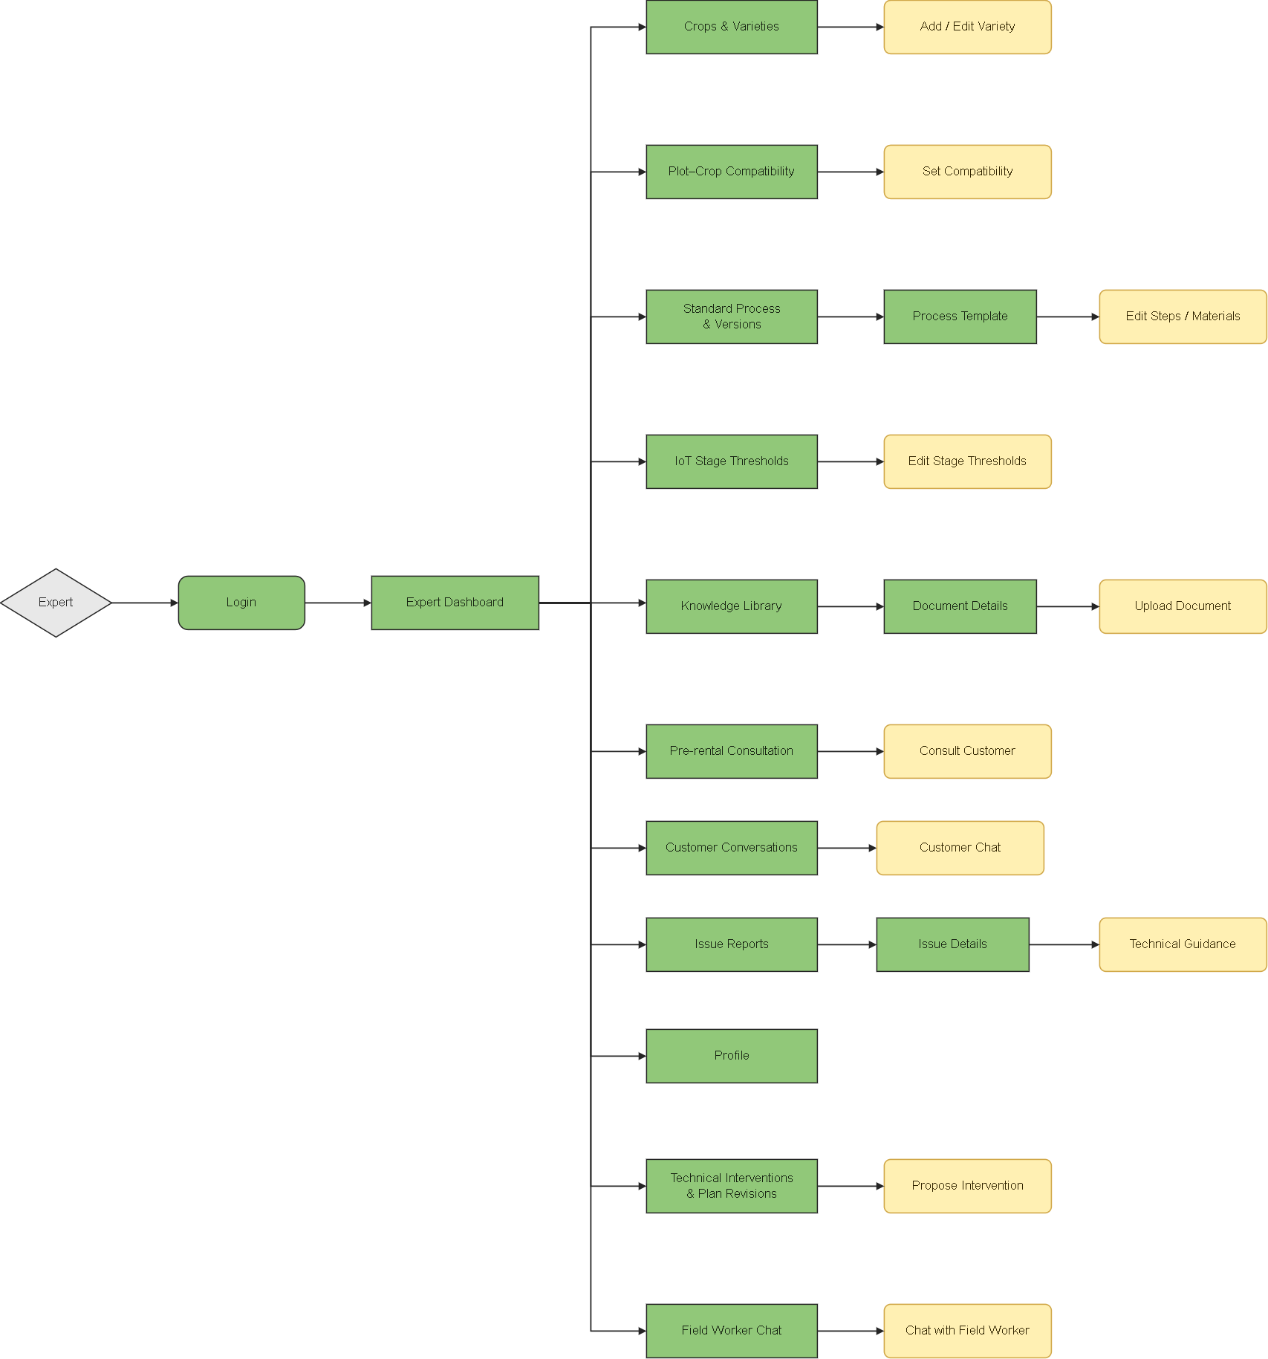

3.1.2 Screen Descriptions

# | Feature | Screen | Description
1 | Public Access | Landing Page | Introduces the platform and provides access to the Marketplace, registration, and login.
2 | Public Access | Plot Marketplace | Lists published plots and allows visitors to search and filter available rental options.
3 | Public Access | Plot Details | Displays plot information, compatible varieties, rental prices, availability, IoT readings, and weather.
4 | Public Access | Book Site Visit | Provides a popup for visitors to enter contact information and select a visit date and session.
5 | Authentication | Sign In Required | Prompts guests to register or log in before renting a plot.
6 | Authentication | Register | Provides a form for visitors to create a customer account.
7 | Authentication | Login | Authenticates users and redirects them to their role-specific dashboard or pending booking.
8 | Authentication | Forgot Password | Allows users to request an email verification link and reset their password.
9 | Account Management | Profile | Displays personal information and allows users to update their profile and password.
10 | Account Management | Notification Center | Displays personal notifications and provides access to related records.
11 | Customer Dashboard | Customer Dashboard | Displays contract summaries, cultivation progress, plot conditions, diary updates, and harvest information.
12 | Plot Rental | Book Plot | Allows customers to select a compatible variety, rental dates, and cultivation mode.
13 | Plot Rental | Reservation | Displays booking information, the price summary, and the remaining reservation time.
14 | Plot Rental | Contract Payment | Allows customers to pay the full rental amount through mock payment.
15 | Contract Management | Contract Details | Displays contract information and provides renewal and cancellation popups when eligible.
16 | Contract Management | Contract History | Lists previous contracts and provides read-only access to completed rental records.
17 | Expert Consultation | Pre-rental Consultation | Provides a chat popup for customers to consult an expert before renting a plot.
18 | Cultivation Monitoring | Standard Process | Displays read-only cultivation stages, technical instructions, and material guidelines.
19 | Cultivation Monitoring | Farm Diary Timeline | Displays cultivation records and provides a new-entry popup for Self-growing customers.
20 | Additional Services | Service Requests | Allows Self-growing customers to select additional services or a Temporary Full-care Month Pass.
21 | Additional Services | Service Payment | Provides a popup for customers to review and pay the selected service charge.
22 | Additional Services | Service Request Status | Displays a service request’s payment status, processing progress, and completion information.
23 | Cultivation Monitoring | IoT Alerts | Displays plot alerts and provides a rapid-care request popup for Self-growing customers.
24 | Communication | Expert Chat | Provides a popup for customers to exchange messages and photos with an agricultural expert.
25 | Communication | AI Chatbot | Provides a popup for AI-assisted questions about cultivation knowledge and plant problems.
26 | Harvest Management | Harvest Results | Displays harvest weight and evidence photos and provides a customer acceptance popup.
27 | Administration | Admin Dashboard | Displays revenue, plot occupancy, pending assignments, overdue tasks, and operational alerts.
28 | User Management | Users & RBAC | Lists user accounts and provides user details, role editing, and account access controls.
29 | Land Management | Land Management | Lists land records and provides popups for adding or editing land information.
30 | Plot Management | Plot & Marketplace Management | Lists plots and provides plot details, editing, IoT information, and publication controls.
31 | Pricing Management | Rental Pricing | Displays rental rates and provides a popup for configuring rental and care charges.
32 | Service Management | Service Catalog | Lists additional services and provides popups for adding or editing service information and prices.
33 | Site Visit Management | Site Visit Bookings | Lists visit requests and provides their contact details, schedules, and handling status.
34 | Contract Administration | Reservations & Contracts | Lists reservations and contracts and provides access to details and cancellation/refund handling.
35 | Payment Monitoring | Payment Transactions | Lists payment transactions and provides their amounts, statuses, and related records.
36 | Service Administration | Service Requests | Lists paid customer service requests and provides details for operational coordination.
37 | Task Dispatch | Care Task Dispatch | Lists care tasks and provides task details and worker assignment or reassignment popups.
38 | Alert Monitoring | IoT Alerts | Displays farm-wide alerts, invalid sensor warnings, and related operational details.
39 | System Monitoring | Audit Log & Reports | Displays system activities, audit entry details, revenue reports, and plot occupancy statistics.
40 | Expert Dashboard | Expert Dashboard | Displays consultation requests, technical issues, conversations, and activities concerning assigned plots.
41 | Crop Management | Crops & Varieties | Allows experts to manage crop information and add or edit varieties.
42 | Compatibility Management | Plot–Crop Compatibility | Displays plot suitability and provides a popup for configuring crop or variety compatibility.
43 | Process Management | Standard Process & Versions | Displays process templates and versions, with access to template details and step/material editing.
44 | Threshold Management | IoT Stage Thresholds | Displays cultivation-stage thresholds and provides a popup for editing their values.
45 | Knowledge Management | Knowledge Library | Lists technical documents and provides document details and an upload popup.
46 | Expert Consultation | Pre-rental Consultation | Lists customer consultation requests and provides a popup for responding to customers.
47 | Communication | Customer Conversations | Lists customer conversations and provides a customer chat popup.
48 | Technical Support | Issue Reports | Displays reported issues and their details and provides a technical guidance popup.
49 | Technical Support | Technical Interventions & Plan Revisions | Displays technical changes and provides a popup for proposing interventions for affected plots.
50 | Communication | Field Worker Chat | Lists worker conversations and provides a popup for technical communication.
51 | Worker Dashboard | Field Worker Dashboard | Displays today’s assigned tasks, overdue work, completed activities, and assignment notifications.
52 | Task Execution | Assigned Care Tasks | Lists assigned tasks and provides instructions and popups for starting, recording materials/photos, and completing work.
53 | Field Reporting | Issue Reports | Lists the worker’s relevant issue reports and provides a popup for submitting a new report.
54 | Harvest Recording | Harvest Tasks & Results | Displays assigned harvest activities and provides a popup for recording weight and evidence photos.
55 | Communication | Chat with Expert | Provides a popup for workers to request technical advice and exchange messages or photos with experts.

3.1.3 Screen Authorization

Screen | Guest | KH | AD | CGNN | CVLĐ
Landing Page | X | X | X | X | X
Plot Marketplace | X | X | X | X | X
Plot Details | X | X | X | X | X
Book Site Visit | X | X | — | — | —
Sign In Required | X | — | — | — | —
Register | X | — | — | — | —
Login | X | X | X | X | X
Forgot Password | X | X | X | X | X
Profile | — | X | X | X | X
Notification Center | — | X | X | X | X
Customer Dashboard | — | X | — | — | —
Book Plot | — | X | — | — | —
Reservation | — | X | — | — | —
Contract Payment | — | X | — | — | —
Contract Details — Customer | — | X | — | — | —
Contract History | — | X | — | — | —
Pre-rental Consultation — Customer | — | X | — | — | —
Standard Process — Customer | — | X | — | — | —
Farm Diary Timeline — Customer | — | X | — | — | —
Service Requests — Customer | — | X | — | — | —
Service Payment | — | X | — | — | —
Service Request Status | — | X | — | — | —
IoT Alerts — Customer | — | X | — | — | —
Expert Chat | — | X | — | — | —
AI Chatbot | — | X | — | — | —
Harvest Results — Customer | — | X | — | — | —
Admin Dashboard | — | — | X | — | —
Users & RBAC | — | — | X | — | —
Land Management | — | — | X | — | —
Plot & Marketplace Management | — | — | X | — | —
Rental Pricing | — | — | X | — | —
Service Catalog | — | — | X | — | —
Site Visit Bookings | — | — | X | — | —
Reservations & Contracts | — | — | X | — | —
Payment Transactions | — | — | X | — | —
Service Requests — Admin | — | — | X | — | —
Care Task Dispatch | — | — | X | — | —
IoT Alerts — Admin | — | — | X | — | —
Audit Log & Reports | — | — | X | — | —
Expert Dashboard | — | — | — | X | —
Crops & Varieties | — | — | — | X | —
Plot–Crop Compatibility | — | — | — | X | —
Standard Process & Versions | — | — | — | X | —
IoT Stage Thresholds | — | — | — | X | —
Knowledge Library | — | — | — | X | —
Pre-rental Consultation — Expert | — | — | — | X | —
Customer Conversations | — | — | — | X | —
Issue Reports — Expert | — | — | — | X | —
Technical Interventions & Plan Revisions | — | — | — | X | —
Field Worker Chat | — | — | — | X | —
Field Worker Dashboard | — | — | — | — | X
Assigned Care Tasks | — | — | — | — | X
Issue Reports — Worker | — | — | — | — | X
Harvest Tasks & Results | — | — | — | — | X
Chat with Expert | — | — | — | — | X

Chú thích vai trò:
• KH (Khách hàng): Người thuê plot, trải nghiệm canh tác, theo dõi từ xa.
• CGNN (Chuyên gia Nông nghiệp): Chuyên gia kỹ thuật, thiết kế quy trình, tư vấn.
• CVLĐ (Công nhân Vận hành): Đội đồng, thực hiện chăm sóc thực tế.
• AD (Admin): Quản trị viên hệ thống, toàn quyền quản lý.

3.1.4 Non-Screen Functions
[
# | Feature | System Function | Description
1 | Authentication | Authentication and Access Control | Verifies credentials, account status, role permissions, and access to requested records.
2 | Authentication | Password Reset Email | Generates a time-limited reset link and sends it to the registered email address.
3 | Plot Rental | Booking Validation | Checks variety compatibility, minimum cultivation duration, plot availability, and conflicting rental schedules.
4 | Plot Rental | Price Calculation | Calculates rental and care charges, including the first-month Starter Kit and additional service prices.
5 | Plot Rental | Reservation Expiration | Releases unpaid reservations after 15 minutes, with a three-minute grace period for PAYMENT_PENDING.
6 | Payment | Mock Payment Processing | Records mock payment results and updates the related contract or service request without duplicate processing.
7 | Contract Management | Contract Lifecycle Processing | Confirms paid contracts, activates them on the start date, and completes unrenewed contracts on the end date.
8 | Contract Management | Renewal Processing | Validates the seven-day renewal deadline and availability, then creates a linked continuation contract.
9 | Contract Management | Refund Calculation | Calculates an 80% or 50% refund before the start date according to the cancellation policy.
10 | Plot Management | Maintenance Scheduling | Blocks the plot for four days after an unrenewed contract ends before reopening its availability.
11 | Care Management | Automatic Task Generation | Generates care tasks from standard processes for Assisted-growing contracts and successfully paid care services.
12 | IoT Monitoring | Sensor Simulation and Validation | Generates readings every three hours, filters invalid temperature values, and records administrator warnings.
13 | Weather Integration | Weather Data Retrieval | Retrieves local forecasts and returns an unavailable status when the weather service cannot respond.
14 | Alert Management | Alert Evaluation and Routing | Detects prolonged threshold breaches and routes alerts or emergency tasks according to cultivation mode and operating hours.
15 | Care Management | Watering Task Postponement | Postpones watering when heavy rain is forecast or soil humidity reaches at least 80%.
16 | Task Management | Overdue Task Detection | Marks unfinished tasks as overdue after 23:59 and notifies the administrator the following morning.
17 | Task Management | Completion Validation and Diary Synchronization | Requires task evidence before completion and automatically adds completed care activities to the Farm Diary.
18 | Technical Support | Intervention Application | Associates expert-issued technical interventions with affected plots and their operational activities.
19 | Communication | Message Polling | Retrieves authorized customer–expert and worker–expert messages through five-second HTTP polling.
20 | AI Assistance | Knowledge Indexing and Response Generation | Indexes expert documents, retrieves relevant knowledge, and generates chatbot answers without memory between sessions.
21 | Notification | Notification Generation | Creates in-app notifications for payments, contracts, assignments, alerts, services, and harvest events.
22 | File Management | Upload Validation | Validates uploaded attachments and enforces image limits of 5 MB per file and ten photos per task.
23 | System Monitoring | Audit Logging | Records relevant user and system actions with their actor, timestamp, and affected record.
24 | Reporting | Summary Aggregation | Calculates dashboard summaries and reports from data accessible to the requesting user.

3. Entity Relationship Diagram
[Provide the entity relationship diagram and the entity descriptions in the table format as below]
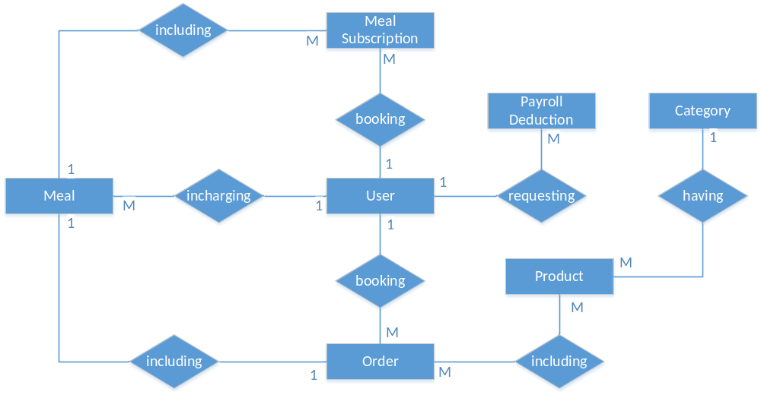
Entities Description
# | Entity | Description
1 | User
2 | Meal
3 | Meal Subscription
4 | …

II. Functional Requirements

1. Account Management and Authentication

a. User Registration (SCR-PUB-02)
Function trigger:
An unauthenticated guest clicks the "Register" button on the global top navigation bar of the landing page (SCR-PUB-01) or selects the "Don't have an account? Sign up" hyperlink on the login page (SCR-PUB-03). The browser navigates to /register.
Function description:
Allows new customers to create a personal account. The system validates input criteria, checks for identity uniqueness, creates a new record in users with role_id mapped to ROLE_CUSTOMER, and activates the account. Internal roles (Agricultural Specialist, Field Staff, Administrator) cannot self-register; those accounts are provisioned exclusively by the Administrator.
Screen layout:
+-------------------------------------------------------------------------------+
| FARMELY LOGO Home Marketplace About [Login] [Register]|
+-------------------------------------------------------------------------------+
| |
| Create Customer Account |
| |
| Full Name: [ Enter your full name ] |
| Email Address: [ user@example.com ] |
| Phone Number: [ 0901234567 ] |
| Password: [ ******** ] |
| Confirm Pass: [ ******** ] |
| |
| [ Create Account ] |
| |
| Already registered? Log in here |
| |
+-------------------------------------------------------------------------------+
| Footer: (c) 2026 Farmely Agricultural Platform. All rights reserved. |
+-------------------------------------------------------------------------------+
Function Details:
Field Description:
# | Field | Type | Required | Constraint | Default | Note / DB Column
1 | Full Name | Text | Yes | 2 to 100 characters | None | users.full_name
2 | Email | Email | Yes | Valid RFC 5322 format, unique | None | users.email (Primary login identity)
3 | Phone Number | Tel | Yes | 10 digits starting with 0, unique | None | users.phone_number
4 | Password | Password | Yes | Minimum 8 characters, >= 1 uppercase, >= 1 lowercase, >= 1 digit | None | Hashed with bcrypt (cost 12) -> users.password_hash
5 | Confirm Password | Password | Yes | Exact match with Password field | None | Client/Server validation only (not persisted)

Validations:
ID | Field | Validation Rule
V1.1 | Full Name | Must not be blank. Length between 2 and 100 characters. No leading or trailing spaces.
V1.2 | Email | Must match standard email format. Must not exist in users.email. Checked via GET /api/v1/auth/check-email.
V1.3 | Phone Number | Regex ^0[0-9]{9}$. Must not exist in users.phone_number. Checked via GET /api/v1/auth/check-phone.
V1.4 | Password | Minimum 8 characters. Must contain at least one uppercase letter, one lowercase letter, and one numerical digit.
V1.5 | Confirm Password | Value must be identical to Password. Evaluated before network dispatch.

Messages:
ID | Condition | Message | Type
M1.1 | Duplicate email address | "This email address is already registered." | Inline Error
M1.2 | Duplicate phone number | "This phone number is already linked to an account." | Inline Error
M1.3 | Weak password pattern | "Password must be at least 8 characters long and contain uppercase, lowercase, and numbers." | Inline Error
M1.4 | Password mismatch | "Passwords do not match." | Inline Error
M1.5 | Registration success | "Account created successfully. Please log in." | Toast (Success)
M1.6 | Database connection failure | "Unable to complete registration. Please try again later." | Toast (Error)

Business Logic:
1. Passwords are salted and hashed on the server using bcrypt with a work factor of 12 before persistence.
2. The newly registered record automatically receives role_id = 1 (ROLE_CUSTOMER) and status = 'ACTIVE'.
3. Upon successful registration (HTTP 201), the application clears sensitive form fields and redirects the user to the Login page (/login) with a confirmation toast.
---

b. User Login (SCR-PUB-03)
Function trigger:
An unauthenticated user clicks the "Login" button on the top navigation bar or is redirected from protected route guards. The browser navigates to /login.
Function description:
Authenticates credentials for all user roles (Customer, Agricultural Specialist, Field Staff, Administrator). The backend verifies the password hash, produces a signed JSON Web Token (JWT), and returns user profile metadata to determine client-side role authorization and view routing.
Screen layout:
+-------------------------------------------------------------------------------+
| FARMELY LOGO Home Marketplace About [Login] [Register]|
+-------------------------------------------------------------------------------+
| |
| Sign In to Farmely |
| |
| Email Address: [ user@example.com ] |
| Password: [ ******** ] |
| |
| [ Remember Me ] Forgot password? |
| |
| [ Log In ] |
| |
| Don't have an account? Register here |
| |
+-------------------------------------------------------------------------------+
Function Details:
Field Description:
# | Field | Type | Required | Constraint | Default | Note
1 | Email Address | Email | Yes | Valid email format | None | Authenticates identity
2 | Password | Password | Yes | Non-empty string | None | Verified against stored bcrypt hash
3 | Remember Me | Checkbox | No | Boolean | False | Extends JWT refresh window from 2h to 14d

Validations:
ID | Field | Validation Rule
V2.1 | Email Address | Required. Must conform to valid email syntax.
V2.2 | Password | Required. Minimum length 1 character.

Messages:
ID | Condition | Message | Type
M2.1 | Invalid credentials | "Incorrect email or password." | Inline Error
M2.2 | Inactive or suspended status | "Your account is currently disabled. Please contact the administrator." | Modal (Alert)
M2.3 | Login success | "Welcome back, {full_name}." | Toast (Success)

Business Logic:
1. The server checks the credential pair against the database. If verification fails, it returns a generic error message (M2.1) without revealing whether the email or the password was incorrect.
2. If account status is SUSPENDED or INACTIVE, authentication is rejected (HTTP 403 Forbidden).
3. On successful authentication, the server generates a JWT containing user_id, role, and token expiration timestamp. The token is stored securely in an HTTP-only cookie.
4. Role-based client redirection:
- ROLE_CUSTOMER -> /customer/dashboard (SCR-KH-01)
- ROLE_EXPERT -> /expert/dashboard (SCR-CGNN-01)
- ROLE_STAFF -> /staff/dashboard (SCR-CVLD-01)
- ROLE_ADMIN -> /admin/dashboard (SCR-AD-01)
---

c. On-Site Inspection Booking for Guests (SCR-PUB-05)
Function trigger:
A prospective client visits the marketplace or plot detail page and clicks "Book Farm Tour" without being required to log in. Routes to /site-visit/book.
Function description:
Captures pre-lease marketing leads by allowing guests and prospective customers to schedule physical plot visits. Collects contact info, preferred plot, date, and time slot (Morning or Afternoon). If the visitor is logged in, their user ID is tied directly to the record; otherwise, the guest's contact info is saved for administrative dispatch.
Screen layout:
+-------------------------------------------------------------------------------+
| FARMELY LOGO Home Marketplace About [Login] [Register]|
+-------------------------------------------------------------------------------+
| |
| Schedule an On-Farm Inspection |
| |
| Full Name: [ John Doe ] |
| Phone Number: [ 0987654321 ] |
| Email (Optional): [ john@example.com ] |
| Selected Plot: [ Plot B04 - 30m2 (Vegetable Garden) V ] |
| Visit Date: [ 2026-10-15 D ] |
| Time Slot: (o) Morning (08:30 - 10:30) |
| ( ) Afternoon (14:30 - 16:30) |
| Party Size: [ 2 Persons V ] |
| Notes: [ Looking to grow organic kale ] |
| |
| [ Confirm Booking ] |
| |
+-------------------------------------------------------------------------------+
Function Details:
Field Description:
# | Field | Type | Required | Constraint | Default | Note / DB Column
1 | Full Name | Text | Yes | 2 to 100 characters | None (or user's name if logged in) | site_visits.guest_name
2 | Phone Number | Tel | Yes | 10 digits starting with 0 | None (or user's phone if logged in) | site_visits.guest_phone
3 | Email | Email | No | Valid email syntax if provided | None | site_visits.guest_email
4 | Selected Plot | Dropdown | Yes | Active plot ID | None | site_visits.plot_id
5 | Visit Date | Date | Yes | >= Current Date + 1 day, <= Current Date + 30 days | Tomorrow | site_visits.visit_date
6 | Time Slot | Radio | Yes | MORNING or AFTERNOON | MORNING | site_visits.time_slot
7 | Party Size | Number | Yes | Integer between 1 and 5 | 1 | site_visits.number_of_visitors
8 | Notes | Textarea | No | Max 500 characters | Empty | site_visits.note

Validations:
ID | Field | Validation Rule
V3.1 | Phone Number | Must match Vietnamese phone format: ^0[0-9]{9}$.
V3.2 | Visit Date | Booking must be scheduled at least 24 hours in advance to allow staff coordination.
V3.3 | Capacity Cap | Maximum 5 visitors per booking session to maintain farm safety.

Messages:
ID | Condition | Message | Type
M3.1 | Past date selected | "Inspection dates must be scheduled at least one day in advance." | Inline Error
M3.2 | Booking confirmed | "Inspection booked. Farm reception will confirm your tour within 2 hours." | Modal (Success)

Business Logic:
1. If authenticated, customer_id is linked to site_visits.customer_id; otherwise, the field remains NULL.
2. Initial record status is set to PENDING_CONFIRMATION.
3. System sends a notification to the Administrator dashboard queue (SCR-AD-01) for tour assignment.
---

2. Marketplace and Plot Lease Contracts

a. Marketplace Plot Directory (SCR-KH-02)
Function trigger:
The user clicks "Marketplace" on the main navigation bar. Accessible by both public visitors and authenticated customers. Routes to /marketplace.
Function description:
Presents all plots marked as AVAILABLE across the farm. Users can filter by land sector, square footage, monthly rental pricing, and supported crop varieties. Clicking any card opens the detailed plot specifications.
Screen layout:
+-------------------------------------------------------------------------------+
| FARMELY LOGO Home [Marketplace] My Garden (User Profile)|
+-------------------------------------------------------------------------------+
| Filter Plots: |
| Sector: [ All Sectors V ] Area: [ 20m2 - 50m2 V ] Crop: [ All Crops V ] |
| Price: [ Under 2M VND V ] Status: [ Available Only ] [ Reset Filters ]|
+-------------------------------------------------------------------------------+
| Available Plots (Showing 12 results) |
| |
| +-------------------------+ +-------------------------+ +----------------+ |
| | [ Image: Plot A01 ] | | [ Image: Plot A02 ] | | [ Image: B01 ] | |
| | Plot Code: A01 (30 m2) | | Plot Code: A02 (45 m2) | | Code: B01 | |
| | Sector: Organic Garden | | Sector: Organic Garden | | Sector: Herb | |
| | Rate: 1,500,000 VND/mo | | Rate: 2,100,000 VND/mo | | 1,200,000 VND | |
| | Suitable: Kale, Cabbage | | Suitable: Tomato, Pepper| | Mint, Basil | |
| | [ View Plot Details ] | | [ View Plot Details ] | | [ View Details]| |
| +-------------------------+ +-------------------------+ +----------------+ |
| |
| Pagination: [ < Prev ] [ 1 ] [ 2 ] [ 3 ] [ Next > ] |
+-------------------------------------------------------------------------------+
Function Details:*
Field Description:
# | Filter Control | Type | Values / Constraints | Default
1 | Sector | Dropdown | Populated from active lands records | All Sectors
2 | Area Range | Dropdown | < 25m2, 25 - 50m2, > 50m2 | All Ranges
3 | Crop Compatibility | Dropdown | Populated from active crops records | All Crops
4 | Price Ceiling | Dropdown | < 1.5M, 1.5M - 3.0M, > 3.0M VND | All Prices

Business Logic:
1. Only records where plots.status = 'AVAILABLE' and plots.is_published = TRUE are queried.
2. Plots undergoing the 4-day soil fallow cycle (plots.status = 'MAINTENANCE') or currently occupied (RENTED, RESERVED) are hidden from standard listings.
3. Pagination standard: 9 cards per page, sorted by plots.plot_code ascending.
---

b. Master Lease Agreement and Plot Configuration (SCR-KH-04)
Function trigger:
An authenticated customer selects one or multiple available plots from the marketplace and clicks "Proceed to Agreement". Routes to /contracts/create.
Function description:
Formalizes the Master Lease Agreement. Enables the tenant to lease multiple adjacent or distinct plots under a single legal contract. For each leased plot, the customer selects the intended crop variety (constrained to certified compatible varieties) and the cultivation mode (Self-growing or Assisted-growing). The system computes the total contract amount, validates duration constraints, and places a 15-minute temporary reservation lock on the plots.
Screen layout:
+-------------------------------------------------------------------------------+
| FARMELY LOGO Home Marketplace [My Garden] (User Profile)|
+-------------------------------------------------------------------------------+
| MASTER AGRICULTURAL LEASE AGREEMENT |
| |
| Tenant: Nguyen Van A | Phone: 0901234567 | Term: 2026-11-01 to 2027-01-31 |
+-------------------------------------------------------------------------------+
| Configured Plot Allocations: |
| |
| [1] Plot A01 (30 m2) - Base: 1,500,000 VND/mo |
| * Crop Variety: [ Curly Kale (Brassica oleracea) V ] |
| * Cultivation Mode: (o) Self-growing (Free weekend garden visits) |
| ( ) Assisted-growing (Full-care by Farm Staff) |
| * Plot Subtotal: 4,500,000 VND (3 Months) |
| |
| [2] Plot A02 (45 m2) - Base: 2,100,000 VND/mo |
| * Crop Variety: [ Roma Tomato (Solanum lycopersicum) V ] |
| * Cultivation Mode: ( ) Self-growing |
| (o) Assisted-growing (+800,000 VND/mo full care) |
| * Plot Subtotal: 8,700,000 VND (3 Months + Dedicated Care) |
+-------------------------------------------------------------------------------+
| Financial Summary: |
| Total Leased Area: 75 m2 | Total Plots: 2 |
| First Month Starter Kit (Seeds + Trays): INCLUDED (0 VND Promotional Benefit) |
| Total Contract Value: 13,200,000 VND (100% Upfront Lease Payment) |
| |
| [x] I agree to the Farm Standard Terms of Service and Operational Rules. |
| |
| [ Cancel ] [ Sign Contract & Pay ] |
+-------------------------------------------------------------------------------+
Function Details:*
Field Description:
# | Field | Type | Required | Constraint | Default | Note / DB Column
1 | Leased Plots | Multi-select | Yes | Minimum 1 plot, status must be AVAILABLE | Pre-selected | Maps to contract_plots
2 | Start Date | Date | Yes | >= Current Date + 3 days (prep buffer) | Current Date + 3d | contracts.start_date
3 | End Date | Date | Yes | end_date >= start_date + max(expected_duration + buffer_time) | Computed | contracts.end_date
4 | Variety Selection | Dropdown | Yes | Must be in plot_crop_compatibility for that specific plot | None | contract_plots.variety_id
5 | Cultivation Mode | Radio | Yes | SELF_GROWING or ASSISTED_GROWING | SELF_GROWING | contract_plots.cultivation_mode
6 | Service Package | Dropdown | Conditional | Required if mode is ASSISTED_GROWING | Standard Care | contract_plots.service_id
7 | Terms Acceptance | Checkbox | Yes | Must be checked | False | System prerequisite

Validations:
ID | Field | Validation Rule
V4.1 | Compatibility | Checked against plot_crop_compatibility. Selecting an uncertified variety is rejected.
V4.2 | Lease Duration | Lease tenure must equal or exceed the biological maturity duration plus safety buffer: (end_date - start_date) >= (varieties.expected_duration + varieties.buffer_time).
V4.3 | Schedule Overlap | Target plot must not have an active or reserved tenancy during [start_date, end_date + 4 days].

Messages:
ID | Condition | Message | Type
M4.1 | Duration too short | "Lease period must be at least {min_days} days to accommodate the growth cycle of {variety_name}." | Inline Error
M4.2 | Race condition collision | "Plot {plot_code} was just reserved by another tenant. Please select an alternate plot." | Modal (Warning)
M4.3 | Reservation lock created | "Plot reserved for 15 minutes. Redirecting to payment checkout." | Toast (Info)

Business Logic:
1. Database transaction creates one master record in contracts (status = 'PENDING_PAYMENT').
2. Inserts individual allocated lines into contract_plots linking contract_id, plot_id, variety_id, and cultivation_mode.
3. Sets plots.status = 'RESERVED' with an expiration timestamp: reservation_expires_at = NOW() + INTERVAL '15 minutes'.
4. Material inventory is not tracked. Baseline seeds and potting trays are provided via the standard Starter Kit included in month 1.
---

c. Contract Payment and Grace Period Processing (SCR-KH-05)
Function trigger:
Triggered immediately upon contract submission from SCR-KH-04, routing to /checkout/{contractId}.
Function description:
Processes full 100% upfront lease payments via integrated Payment Gateway (mock or QR bank transfer). Applies a 10-minute Grace Period extension once the user reaches the checkout screen to prevent accidental reservation timeouts while entering banking credentials or OTPs.
Screen layout:
+-------------------------------------------------------------------------------+
| FARMELY LOGO Home Marketplace [My Garden] (User Profile)|
+-------------------------------------------------------------------------------+
| PAYMENT CHECKOUT |
| |
| Master Contract Code: CTR-2026-089 |
| Time Remaining to Complete Payment: [ 09:42 ] (10-Minute Grace Period Active) |
+-------------------------------------------------------------------------------+
| Invoice Breakdown: |
| * Plot A01 (30m2 - Kale, Self-growing): 4,500,000 VND |
| * Plot A02 (45m2 - Tomato, Assisted-growing): 8,700,000 VND |
| * Organic Starter Kit (Month 1 Promotion): 0 VND |
| ----------------------------------------------------------------------------- |
| Total Payable Amount: 13,200,000 VND |
+-------------------------------------------------------------------------------+
| Select Payment Method: |
| (o) VietQR / Bank Transfer (Instant Confirmation) |
| ( ) Domestic ATM Card / Napas |
| |
| [ QR Code Displayed Here: Scan via Banking App ] |
| |
| [ I Have Completed Payment ] [ Cancel Order ] |
+-------------------------------------------------------------------------------+
Function Details:*
Field Description:
# | Field | Type | Note
1 | Contract ID | Integer | Foreign key referencing contracts.contract_id
2 | Total Amount | Decimal | Exact payable sum from contracts.total_price
3 | Payment Method | Radio | VIETQR, VNPAY, or MOCK_BANKING

Business Logic:
1. Grace Period Execution: When the checkout page loads, the system updates contracts.status = 'PAYMENT_PENDING' and grants an extra 10 minutes to the reservation expiry clock.
2. Upon receiving payment callback or webhook confirming transaction success:
- Inserts record into payment_transactions (transaction_type = 'PAYMENT', status = 'SUCCESS').
- Updates contracts.status = 'CONFIRMED'.
- Updates all plots in contract_plots to plots.status = 'RENTED'.
3. When contracts.start_date arrives, a backend cron job switches contracts.status from CONFIRMED to ACTIVE.
4. If the payment timer hits zero without transaction completion:
- System reverts plots.status = 'AVAILABLE'.
- Sets contracts.status = 'CANCELLED'.
---

d. Contract Renewal (SCR-KH-15)
Function trigger:
An authenticated customer views an active contract on their dashboard and selects "Renew Contract" at least 3 days before the agreement expires. Routes to /contracts/{contractId}/renew.
Function description:
Permits existing tenants to extend their lease tenure without vacating the plot or losing continuous soil history and diary timelines. If the plots remain unbooked by other users, the system creates a successor contract linked back to the prior agreement via parent_contract_id.
Screen layout:
+-------------------------------------------------------------------------------+
| FARMELY LOGO Home Marketplace [My Garden] (User Profile)|
+-------------------------------------------------------------------------------+
| RENEW LEASE AGREEMENT |
| |
| Current Contract: CTR-2026-089 | Current Expiry Date: 2027-01-31 |
| Leased Plots: Plot A01 (Kale), Plot A02 (Tomato) |
+-------------------------------------------------------------------------------+
| Extension Options: |
| |
| Additional Lease Duration: [ 3 Months (Standard Season Extension) V ]|
| New Agreement End Date: 2027-04-30 |
| |
| Plot Maintenance Selection: |
| * Plot A01: [ Continue Cultivation with Same Variety V ]|
| * Plot A02: [ Rotate to Certified Compatible Crop: Bell Pepper V ]|
| |
| Renewal Subtotal: 13,200,000 VND (Includes continuing maintenance packages) |
| |
| [ Back to Dashboard ] [ Confirm & Proceed to Pay ] |
+-------------------------------------------------------------------------------+
Function Details:*
Business Logic:
1. Eligibility Threshold: Renewal must be requested at least 3 days prior to contracts.end_date (BR11b).
2. The system verifies that no future reservations exist for the leased plots beyond end_date.
3. Creates a new contract with parent_contract_id = old_contract.contract_id.
4. The existing contract remains ACTIVE until its original expiration date, at which point its status shifts to RENEWED while the successor contract becomes ACTIVE.
---

e. Lease Cancellation and Refund Audit (SCR-KH-16)
Function trigger:
The customer clicks "Request Cancellation" on an upcoming or active contract details page. Routes to /contracts/{contractId}/cancel.
Function description:
Processes contract termination requests. The system calculates statutory penalty deductions based on cancellation lead time, logs the formal request into cancellation_requests, and schedules the refund for administrative clearance.
Screen layout:
+-------------------------------------------------------------------------------+
| FARMELY LOGO Home Marketplace [My Garden] (User Profile)|
+-------------------------------------------------------------------------------+
| CANCEL LEASE CONTRACT REQUEST |
| |
| Contract: CTR-2026-089 | Total Paid: 13,200,000 VND | Start Date: 2026-11-01 |
+-------------------------------------------------------------------------------+
| Cancellation Policy Evaluation: |
| Current Date: 2026-10-25 (7 Days prior to Start Date) |
| Applicable Deduction Tier: >= 3 Days Prior to Start (20% Processing Penalty) |
| |
| Financial Assessment: |
| * Gross Paid Amount: 13,200,000 VND |
| * Cancellation Penalty Deduction (20%): -2,640,000 VND |
| ----------------------------------------------------------------------------- |
| Estimated Refund Amount: 10,560,000 VND |
+-------------------------------------------------------------------------------+
| Reason for Cancellation: |
| [ Relocating to another city for work and unable to attend the plot ] |
| |
| Banking Details for Refund Disbursement: |
| Bank Name: [ Vietcombank V ] Account Number: [ 01234567890 ] Account Name: [ NGUYEN VAN A ] |
| |
| [ Keep My Lease ] [ Submit Cancellation Request ] |
+-------------------------------------------------------------------------------+
Function Details:*
Business Logic:
1. Deduction Schedule (BR10):
- Cancelled >= 3 days before start_date: 20% penalty deduction, 80% refund.
- Cancelled < 3 days before start_date: 50% penalty deduction, 50% refund.
- Cancelled on or after start_date: 100% penalty, 0% refund.
2. Submission creates a record in cancellation_requests with status = 'PENDING_APPROVAL'.
3. Once approved by the Administrator, the backend generates a payment_transactions record with transaction_type = 'REFUND', and the leased plots transition to AVAILABLE (after mandatory maintenance).
---

3. Standard Agronomy Processes and Cultivation

a. Crop Variety Process Formulation (SCR-CGNN-04)
Function trigger:
An Agricultural Specialist logs in, navigates to the Agronomy Management section on the sidebar, and selects "Process Templates". Routes to /expert/process-templates/new.
Function description:
Allows agricultural specialists to author and publish standardized technical agronomy templates (process_templates and template_steps) tied to specific crop varieties. Defines day-by-day care steps, job types (irrigation, fertilization, pest inspection), and environmental thresholds (safe temperature and humidity ranges). These templates serve as the sole execution baseline for Assisted-growing contracts and provide guidance for Self-growing tenants.
Screen layout:
+-------------------------------------------------------------------------------+
| FARMELY SPECIALIST Knowledge Base Process Templates (Dr. Green)|
+-------------------------------------------------------------------------------+
| DEFINE STANDARD AGRONOMY TEMPLATE |
| |
| Crop Variety: [ Curly Kale - Variety #04 V ] Template Version: [ v2.1 ] |
| Climate Bounds: Temp: [ 18.0 ]C to [ 30.0 ]C | Soil Moisture: [ 60% ] to [ 80% ] |
+-------------------------------------------------------------------------------+
| Sequential Operational Steps: |
| |
| Day 01: [ Seedbed Preparation and Soil Aeration ] Type: [ Soil Prep V]|
| Instructions: Lightly till top 5cm soil and place starter seedlings. |
| Day 05: [ Initial Root Irrigation ] Type: [ Watering V]|
| Instructions: Apply 2 liters per m2 before 09:00 AM. |
| Day 15: [ Organic Compost Top-Dressing ] Type: [ Fertilizing V]|
| Instructions: Distribute worm castings evenly around base of stems. |
| Day 40: [ Final Harvest Assessment ] Type: [ Harvesting V]|
| Instructions: Check leaf surface span >= 15cm; prepare harvesting box.|
| |
| [ + Add Next Operational Step ] |
| |
| [ Discard Draft ] [ Publish Official Template ] |
+-------------------------------------------------------------------------------+
Function Details:*
Field Description:
# | Field | Type | Required | Constraint | DB Mapping
1 | Variety | Dropdown | Yes | Active record in varieties | process_templates.variety_id
2 | Version | Text | Yes | Semantic versioning format (e.g., v1.0, v2.0) | process_templates.version
3 | Safe Climate Limits | Numbers | Yes | min_temp < max_temp, min_humidity < max_humidity | process_templates.min_temp, etc.
4 | Step Offset | Integer | Yes | Days elapsed from start date (>= 0) | template_steps.day_offset
5 | Task Type | Dropdown | Yes | WATERING, FERTILIZING, PEST_CONTROL, HARVESTING | template_steps.task_type

Business Logic:
1. Templates are standardized per biological variety. No customized variations are permitted for individual customers (anti-customization rule).
2. Material inventory quantities are omitted; steps specify operational guidelines and best practices.
3. Once published, any Assisted-growing plot allocated with this variety automatically generates care_tasks on the matching calendar day.
---

b. Cultivation Progress Monitoring (SCR-KH-07)
Function trigger:
An authenticated customer selects a leased plot from their "My Garden" dashboard view. Routes to /customer/plots/{contractPlotId}/progress.
Function description:
Provides a transparent view of the plot's cultivation lifecycle. Assisted-growing tenants see upcoming, completed, and in-progress operational tasks handled by farm staff. Self-growing tenants view the recommended agronomic schedule as a reference roadmap while retaining full autonomy over their own gardening activities.
Screen layout:
+-------------------------------------------------------------------------------+
| FARMELY LOGO Home Marketplace [My Garden] (User Profile)|
+-------------------------------------------------------------------------------+
| Plot A02: Roma Tomato | Mode: Assisted-growing | Specialist: Dr. Le Van B |
| Cycle: Day 24 of 75 | Overall Progress: [=========> ] 32% |
+-------------------------------------------------------------------------------+
| Agronomic Progress Roadmap: |
| |
| [x] Day 01: Initial Seedbed Planting Completed: 2026-11-01 |
| * Executed by: Worker Tran Van C (Staff ID #12) |
| * Evidence: [ Photo: Seedling Tray ] [ Photo: Planting Bed ] |
| |
| [x] Day 10: Organic Root Feeding Completed: 2026-11-10 |
| * Executed by: Worker Tran Van C | Notes: Soil aeration optimal |
| * Evidence: [ Photo: Fertilizer Distribution ] |
| |
| [>] Day 24: Foliage Pruning and Trellis Securing IN PROGRESS (Today) |
| * Assigned Staff: Worker Tran Van C | Target Completion: 17:00 |
| |
| [ ] Day 35: Flowering Nutrient Inspection Scheduled: 2026-12-05 |
| [ ] Day 65: Color Break Harvest Readiness Scheduled: 2027-01-04 |
+-------------------------------------------------------------------------------+
Function Details:*
Business Logic:
1. For Assisted-growing plots, clicking any completed task opens the high-resolution photo proof submitted from the field worker's mobile interface.
2. For Self-growing plots, the UI displays: "Recommended Reference Roadmap by Farm Specialist. You may follow these milestones or apply your own cultivation schedule." No specialist approval is required for departures from the template.
---

4. Field Operations and Care Tasks

a. Field Staff Mobile Work Queue (SCR-CVLD-01)
Function trigger:
A field staff member logs in using a mobile device or navigates to /staff/tasks.
Function description:
Displays the daily task queue for assigned plots. Organizes activities by priority (Urgent IoT alerts first, scheduled routine tasks second) and geographic sector. Workers can view plot locations, inspect technical instructions, update task states, and attach on-site photos as proof of completion.
Screen layout:
+-------------------------------------------------------------------------------+
| [=] FARMELY FIELD STAFF Logged: Staff #12 (Tran Van C)|
+-------------------------------------------------------------------------------+
| TODAY'S SCHEDULE - 2026-11-24 |
| Assigned Plots: 8 | Tasks Remaining: 3 | Overdue: 0 |
+-------------------------------------------------------------------------------+
| ( ! ) URGENT ACTION: |
| Plot B03 - Strawberry | Mode: Assisted | Emergency Rescue Task |
| * Reason: Soil moisture dropped below critical 40% (Sensor: 34%) |
| * Action: Inspect drip irrigation nozzle and apply manual 5L drenching. |
| [ Start Emergency Task ] |
+-------------------------------------------------------------------------------+
| ROUTINE CARE TASKS: |
| |
| [>] Task #1042: Plot A02 (Tomato) - Trellis Securing |
| * Scheduled Window: 13:30 - 17:00 | Status: IN PROGRESS |
| * Instructions: Tie vertical growing shoots to guide trellis wires. |
| [ Open Camera & Submit Completion Proof ] |
| |
| [ ] Task #1043: Plot A05 (Kale) - Organic Pest Inspection |
| * Scheduled Window: 14:00 - 17:00 | Status: PENDING |
| [ Start Task ] |
+-------------------------------------------------------------------------------+
Function Details:*
Business Logic:
1. Emergency tasks generated by IoT threshold alerts take top visual priority and display a warning banner.
2. Staff must transition a task to IN_PROGRESS before completing it.
3. Transitioning to COMPLETED requires uploading at least one real-time photograph taken at the plot (enforced via camera capture).
4. Material usage inputs are not required. The worker confirms completion and includes qualitative notes if needed.
5. Tasks remaining incomplete at 23:59 are flagged as OVERDUE by the night-audit cron job, notifying the Administrator.
---

5. Microclimate Telemetry and Alerts

a. Plot Telemetry Dashboard (SCR-KH-10)
Function trigger:
The customer selects "Environmental Sensors" from the plot management menu. Routes to /customer/plots/{plotId}/telemetry.
Function description:
Presents near-real-time sensor readings collected from the physical plot (ambient temperature, air humidity, soil moisture). Graphs illustrate 24-hour trends alongside safe agronomic operating bands established by the agricultural specialist.
Screen layout:
+-------------------------------------------------------------------------------+
| FARMELY LOGO Home Marketplace [My Garden] (User Profile)|
+-------------------------------------------------------------------------------+
| Environmental Monitoring: Plot A01 (Curly Kale) |
| Sensor Station: IOT-A01-STATION | Last Ingestion: 2026-11-24 14:00:12 |
+-------------------------------------------------------------------------------+
| Current Readings: |
| [ Temp: 24.5 C - Normal ] [ Air Hum: 68% - Normal ] [ Soil Moisture: 72% - OK ]|
+-------------------------------------------------------------------------------+
| 24-Hour Microclimate Historical Trend: |
| |
| Moisture % |
| 100 | |
| 80 |================== Safe Maximum Bound (80%) ========================== |
| 60 | .-. .-. .-. (Recorded Moisture Level: 68% - 74%) |
| 40 |-----/---\---/---\---/---\- Safe Minimum Bound (40%) ----------------- |
| 0 +------------------------------------------------------------ |
| 00:00 04:00 08:00 12:00 16:00 20:00 |
+-------------------------------------------------------------------------------+
| Integrated Weather Forecast (Next 3 Days - Hoc Mon Station): |
| * Tomorrow: 26 C - Scattered Showers (Automatic rain suspension active) |
| * Day After: 28 C - Partly Cloudy |
+-------------------------------------------------------------------------------+
Function Details:*
Business Logic:
1. Telemetry data is tied directly to the physical asset (plots.plot_id), independent of tenant tenancy records.
2. If soil moisture exceeds 80% or heavy rain is forecast via weather API, the system auto-pauses scheduled irrigation tasks to prevent root rot.
3. If soil moisture falls below 40% for more than 30 consecutive minutes:
- For Assisted-growing plots: Automatically generates an Emergency Care Task for the on-duty field staff.
- For Self-growing plots: Dispatches an SMS/push alert to the tenant with a "Request Emergency Care" shortcut button.
---

6. Farm Diary and Produce Harvest

a. Automated Farm Diary Feed (SCR-KH-08)
Function trigger:
The customer navigates to the "Farm Diary" tab on their active garden view. Routes to /customer/plots/{plotId}/diary.
Function description:
Provides a social-feed-style timeline documenting the plot's growth journey. For Assisted-growing contracts, the diary updates automatically whenever field staff mark a care task complete, displaying on-site photo proof and field observations (BR17). Self-growing tenants can upload their own journal entries, field notes, and family photos.
Screen layout:
+-------------------------------------------------------------------------------+
| FARMELY LOGO Home Marketplace [My Garden] (User Profile)|
+-------------------------------------------------------------------------------+
| Farm Diary Timeline - Plot A01 (Curly Kale) |
| Mode: Assisted-growing | System Auto-Sync Enabled |
+-------------------------------------------------------------------------------+
| [ Auto-Generated Entry ] - 2026-11-20 09:30 AM |
| Title: Organic Root Irrigation and Aeration Completed |
| Attending Staff: Tran Van C (Field Staff #12) |
| Field Notes: Seedlings rooting firmly; no signs of flea beetles or leaf spot. |
| |
| [ Photo Proof: Healthy Green Leaves ] [ Photo Proof: Moist Root Zone ] |
+-------------------------------------------------------------------------------+
| [ Auto-Generated Entry ] - 2026-11-05 08:15 AM |
| Title: Seedling Germination Milestone |
| Attending Staff: Tran Van C |
| Field Notes: 95% germination rate across all 4 planting beds. |
| [ Photo Proof: Emerging Shoots ] |
+-------------------------------------------------------------------------------+
Function Details:*
Business Logic:
1. Automated Synchronization (BR17): Completing a care task (care_tasks.status = 'COMPLETED') triggers an event that inserts a corresponding record into farm_diaries. Staff do not need to create separate diary posts manually.
2. Self-growing tenants create manual posts via the "New Diary Entry" form (SCR-KH-09).
---

b. Harvest Yield Logging and Customer Acceptance (SCR-CVLD-07 & SCR-KH-14)
Function trigger:
- Field Staff: Clicks "Record Harvest" on a mature plot at /staff/harvest/{plotId}.
- Customer: Clicks "Review Harvest Yield" upon receiving an alert at /customer/harvest/{harvestId}.
Function description:
Records the final yield from the plot. The field staff member cuts the produce, weighs it on a digital scale, photographs the scale readout, and logs the weight under their staff ID. The customer receives a notification to review the photos, accept the yield, and select their delivery preference (free on-farm pickup or home delivery with shipping fee).
Screen layout (Field Staff Recording View):
+-------------------------------------------------------------------------------+
| [=] FARMELY FIELD STAFF Logged: Staff #12 (Tran Van C)|
+-------------------------------------------------------------------------------+
| RECORD HARVEST WEIGHT - Plot A01 (Curly Kale) |
| Tenant: Nguyen Van A | Master Contract: CTR-2026-089 |
+-------------------------------------------------------------------------------+
| Harvest Details: |
| |
| Actual Measured Weight: [ 18.5 ] Kilograms (kg) |
| Digital Scale Photo: [ Camera / Choose File ] -> scale_reading_2026.jpg |
| Basket Produce Photo: [ Camera / Choose File ] -> harvest_produce_2026.jpg |
| Quality Grading: (o) Grade A (Premium Market Quality) |
| ( ) Grade B (Standard Table Quality) |
| Worker Field Notes: [ Clean harvest; crisp leaves, no insect blemish. ] |
| |
| [ Cancel ] [ Submit Official Yield ] |
+-------------------------------------------------------------------------------+
Screen layout (Customer Acceptance View):
+-------------------------------------------------------------------------------+
| FARMELY LOGO Home Marketplace [My Garden] (User Profile)|
+-------------------------------------------------------------------------------+
| HARVEST YIELD INSPECTION & ACCEPTANCE |
| Plot A01: Curly Kale | Harvest Date: 2027-01-20 |
+-------------------------------------------------------------------------------+
| Certified Field Measurements: |
| Total Weight Logged: 18.5 Kilograms |
| Weighed by Staff Member: Tran Van C (Staff ID #12) |
| |
| Verification Proof: |
| [ Photo: 18.5 kg Scale Reading ] [ Photo: Freshly Packed Crates ] |
+-------------------------------------------------------------------------------+
| Produce Delivery Method: |
| (o) Weekend Farm Pickup (Free) |
| * Location: Farm Depot Gate 2, Hoc Mon Farm (Saturday/Sunday 08:00 - 17:00)|
| ( ) Home Delivery (+120,000 VND Flat Courier Fee) |
| * Address: 123 Nguyen Hue Street, District 1, Ho Chi Minh City |
| |
| [ Dispute Yield ] [ Accept Produce Yield ] |
+-------------------------------------------------------------------------------+
Function Details:*
Field Description:
# | Field | Type | Required | Constraint | DB Mapping
1 | Actual Weight | Decimal | Yes | Greater than 0.00 kg | harvest_results.actual_yield
2 | Staff ID | Integer | Yes | Session ID of logged staff | harvest_results.staff_id
3 | Photo Evidence | File/URL | Yes | Image file showing scale reading | harvest_results.photo_url
4 | Delivery Option | Radio | Yes | FARM_PICKUP or HOME_DELIVERY | harvest_results.delivery_option
5 | Tenant Approval | Boolean | Yes | Set to true upon acceptance | harvest_results.customer_confirmed

Business Logic:
1. Field staff accountability: Every harvest record is permanently tied to the staff member who conducted the weighing (staff_id).
2. After customer acceptance, if the contract term is complete, the plot transitions to MAINTENANCE status for a mandatory 4-day soil recovery and aeration cycle before reopening as AVAILABLE (BR23).
---

7. Direct Consultation and System Communication

a. Agricultural Advisory Messaging (SCR-KH-12 / SCR-CGNN-09)
Function trigger:
The customer clicks "Ask Specialist" from their garden view or plot monitoring screen. Routes to /customer/messages/expert/{contractId}.
Function description:
Provides a direct communication channel between the tenant and their assigned agricultural specialist. Tenants can share plant photos and ask about pest treatment or growth concerns. Specialists review the plot's telemetry history and diary logs to provide diagnostic advice.
Screen layout:
+-------------------------------------------------------------------------------+
| FARMELY LOGO Home Marketplace [My Garden] (User Profile)|
+-------------------------------------------------------------------------------+
| Consultation Channel: Plot A02 (Tomato) |
| Participant: Dr. Le Van B (Agronomy Specialist) |
+-------------------------------------------------------------------------------+
| Conversation History: |
| |
| [2026-11-22 10:14] Nguyen Van A: |
| Hello Doctor, I noticed small yellow spots on the lower leaves of my tomato |
| plants this morning. Attaching a close-up photo here. |
| [ Attached Image: leaf_spot_detail.jpg ] |
| |
| [2026-11-22 10:35] Dr. Le Van B: |
| Good morning. That appears to be early blight caused by recent humid weather. |
| I have instructed the field crew to apply an organic copper-fungicide spray |
| this afternoon. Please keep foliage dry during any self-visits. |
+-------------------------------------------------------------------------------+
| Type Message: [ ] [ Attach Image ] |
| [ Send Message ] |
+-------------------------------------------------------------------------------+
Function Details:*
Business Logic:
1. Two discrete communication channels are maintained:
- Customer <-> Specialist: Cultivation advice and diagnostic support.
- Staff <-> Specialist: Internal technical reporting and field escalation.
2. Direct customer-to-field-worker messaging is prohibited to prevent conflicting instructions on the farm (BR25).
---

b. AI Farming Assistant Chatbot (SCR-PUB-06 / SCR-KH-13)
Function trigger:
The user clicks the floating "AI Assistant" icon in the lower-right corner of the interface.
Function description:
Provides a 24/7 informational Q&A assistant powered by Retrieval-Augmented Generation (RAG) over the platform's agricultural knowledge base (knowledge_documents). Answers general questions about organic vegetable care, plant varieties, and farm operations.
Screen layout:
+-------------------------------------------------------------------------------+
| [X Close AI Chatbot Assistant]
| Farmely AI Knowledge Assistant (Automated Advisor) |
+-------------------------------------------------------------------------------+
| AI: Hello! I can assist with general vegetable cultivation guidelines, ideal |
| planting windows, and farm platform procedures. How can I help you today? |
| |
| User: How often should I water curly kale during sunny weeks? |
| |
| AI: Based on Farmely's organic kale guidelines, kale requires roughly 25 to |
| 30 mm of water weekly. During hot spells, a deep watering every 2-3 days in |
| the early morning (before 09:00 AM) is recommended to prevent water loss and |
| maintain root zone moisture. |
| |
| *Notice: AI guidance is for general reference only. For active pest or crop |
| disease issues, please open a direct advisory ticket with your farm specialist.|
+-------------------------------------------------------------------------------+
| Ask a question... [ ] [ Send ] |
+-------------------------------------------------------------------------------+
Function Details:*
Business Logic:
1. Scope Boundary: The AI serves purely as an informational chatbot. It does not automatically generate binding farm treatment plans, adjust contracts, or diagnose critical crop failure.
2. Every AI response includes a disclaimer directing users to contact farm specialists for actual field issues.
---

8. System Administration and Master Data Management

a. Master Services Catalog Management (SCR-AD-06)
Function trigger:
The Administrator logs in, expands "Service Management" in the admin sidebar, and selects "Services Master Catalog". Routes to /admin/services.
Function description:
Maintains the centralized catalog of billable agricultural services (services). Covers itemized à-la-carte care services (single weeding, pest spraying) and full-care packages. Self-growing tenants can purchase temporary 30-day full-care coverage when away, with rates calculated at 1.2x the standard monthly care fee (BR27).
Screen layout:
+-------------------------------------------------------------------------------+
| [=] FARMELY ADMIN CONSOLE Users Plots [Services] (Administrator)|
+-------------------------------------------------------------------------------+
| MASTER AGRICULTURAL SERVICES CATALOG |
| [ + Add New Service Item ]|
+-------------------------------------------------------------------------------+
| Search Catalog: [ Search by name or code... ] Filter: [ All Service Types V ]|
| |
| ID | Service Code | Service Name | Type | Base Price | Status | Actions|
|:---|:-------------|:-----------------------|:-------------|:------------|:-------|:-------|
| 01 | SRV-IRR-01 | Manual Deep Irrigation | A-la-carte | 50,000 VND | Active | Edit |
| 02 | SRV-PEST-01 | Bio Neem Oil Spraying | A-la-carte | 80,000 VND | Active | Edit |
| 03 | SRV-WEED-01 | Plot Bed Weeding | A-la-carte | 70,000 VND | Active | Edit |
| 04 | SRV-CARE-30D | 30-Day Full Care Pass | Package | 960,000 VND | Active | Edit |
| | | (Assisted Care x 1.2) | (Temporary) | | | |
+-------------------------------------------------------------------------------+
| Showing 4 active service definitions |
+-------------------------------------------------------------------------------+
Function Details:*
Business Logic (BR27):
1. À-la-carte Services: Purchasing an individual service automatically inserts one care_tasks record for the plot, scheduled for the requested date.
2. 30-Day Full Care Package: Allows Self-growing tenants to delegate care during vacations or busy periods.
- Pricing formula: Package Fee = Monthly Assisted Care Rate * 1.2 (the 20% surcharge covers short-term staff allocation).
- System scans active template_steps for the plot's variety where day_offset falls within the 30-day window, then batch-inserts corresponding care_tasks for field staff.
- When the 30-day window expires, the plot returns to self-growing mode automatically.
---

b. Land Allocation and Plot Lifecycle Governance (SCR-AD-03 & SCR-AD-04)
Function trigger:
Administrator selects "Land & Plots" from the sidebar navigation. Routes to /admin/plots.
Function description:
Manages farm sectors (lands) and individual plot subdivisions (plots). Allows the Administrator to configure plot boundaries, square footage, monthly base rates, connected IoT device IDs, and certified crop compatibilities (plot_crop_compatibility). Also monitors plot availability across the tenancy and maintenance lifecycles.
Screen layout:
+-------------------------------------------------------------------------------+
| [=] FARMELY ADMIN CONSOLE Users [Plots] Services (Administrator)|
+-------------------------------------------------------------------------------+
| PLOT INVENTORY MANAGEMENT |
| Sector: [ Sector A - High-Tech Greenhouse V ] [ + Create Plot ]|
+-------------------------------------------------------------------------------+
| Summary: Total Plots: 20 | Rented: 14 | Available: 4 | In Maintenance: 2 |
| |
| Plot | Area | Monthly Rate | Current Status | Compatible Crops | IoT Device | Actions|
|:-----|:-----|:-------------|:---------------|:-----------------|:------------|:-------|
| A01 | 30m2 | 1,500,000 | RENTED | Kale, Cabbage | IOT-A01-01 | View |
| A02 | 45m2 | 2,100,000 | RENTED | Tomato, Pepper | IOT-A02-01 | View |
| A03 | 30m2 | 1,500,000 | MAINTENANCE | Kale, Salad | IOT-A03-01 | Logs |
| | | | (Day 2 of 4) | | | |
| A04 | 30m2 | 1,500,000 | AVAILABLE | Kale, Cabbage | IOT-A04-01 | Edit |
+-------------------------------------------------------------------------------+
Function Details:*
Business Logic:
1. Soil Maintenance Cycle (BR23): When a contract ends or produce is harvested, the plot automatically enters MAINTENANCE status for 4 days. During this period, staff turn and solarize the soil. Once 4 full days elapse, a nightly cron job automatically updates the status back to AVAILABLE.
2. Asset-Centric Telemetry: IoT telemetry hardware is bound directly to the physical plot record (plots.iot_device_code) during setup, completely separate from tenant contract records.
---

9. Non-Screen Background Functions
# | Feature | Background Function | Trigger & Interval | Operational Description
1 | Reservation | ExpireStaleReservationsJob | Every 60 seconds | Scans contracts where status = 'PENDING_PAYMENT' and reservation_expires_at < NOW(). Reverts associated plots to AVAILABLE and marks the contract EXPIRED.
2 | Contract | ActivateCommencingContractsJob | Daily at 00:01 AM | Scans contracts where status = 'CONFIRMED' and start_date <= TODAY. Updates contract status to ACTIVE.
3 | Plot Fallow | CompletePlotMaintenanceJob | Daily at 01:00 AM | Scans plots where status = 'MAINTENANCE' and maintenance elapsed time >= 4 days. Updates plot status to AVAILABLE.
4 | Operations | GenerateDailyCareTasksJob | Daily at 05:00 AM | Evaluates active Assisted-growing plots and temporary 30-day packages. Maps current growth day against template_steps.day_offset and batch-inserts daily records into care_tasks.
5 | Operations | FlagOverdueTasksJob | Daily at 23:59 PM | Identifies care_tasks where status IN ('PENDING', 'IN_PROGRESS') and due_date = TODAY. Updates status to OVERDUE and alerts the Administrator.
6 | Telemetry | IngestIoTSensorTelemetry | Every 10 minutes | Ingests data packets from plot sensor hardware, logs readings to sensor_readings, and checks values against crop threshold bounds.
7 | Alerting | EvaluateMicroclimateThresholds | Triggered by telemetry | If soil moisture remains out of bounds for >30 minutes: auto-generates an urgent care_tasks record for Assisted plots; dispatches a push alert with an emergency care booking link for Self-growing plots.
8 | Weather | SyncWeatherForecastJob | Every 3 hours | Queries the OpenWeatherMap API for regional weather data. If rainfall probability exceeds 80%, sets an automated pause on scheduled irrigation tasks.

