

<<PROJECT NAME>>
Software Requirement Specification

– Hanoi, August 2022 –

Record of changeS
Date | A*  M, D | In charge | Change Description
13/Apr | A | KienNT | Thêm mô tả chức năng Setting Details (II.1.a)
*A - Added M - Modified D - Deleted

Table of Contents
I. Overview 4
1. Introduction 4
2. System Functions 5
3. Entity Relationship Diagram 6
II. Functional Requirements 7
1. <<Feature Name 1>> 7
a. <<Function Name 1>> 7
b. <<Function Name 2>> 7
2. <<Feature Name 2>> 7

I. Overview

1. Introduction
[Content part 1: presents a high-level overview of the product and the environment in which it will be used, the users, and known constraints, assumptions, and dependencies]
[Content part 2: describes the product's context in the form of a context diagram in which you present the boundary and connections between the system you’re developing and everything else in the universe. This identifies external entities (or terminators – software, hardware, human components, and other systems) outside the system that interface to it in some way, as well as data, control, and material flows between the terminators and the system]
<<Sample: The Cafeteria Ordering System is a new software system that replaces the current manual and telephone processes for ordering and picking up meals in the Process Impact cafeteria. The system is expected to evolve over several releases, ultimately connecting to the Internet ordering services for several local restaurants and to credit and debit card authorization services.
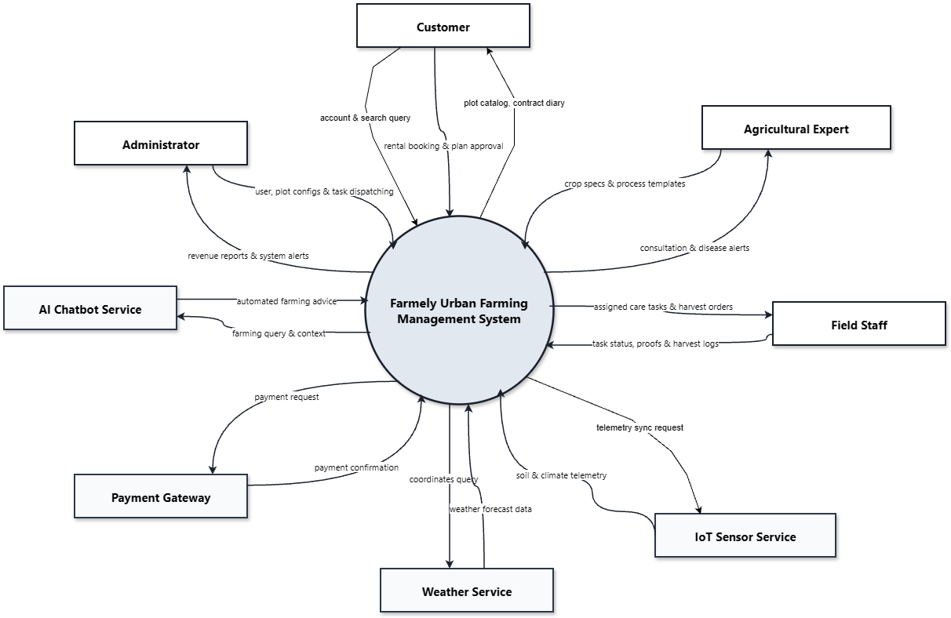>>

2. System Functions

3.1.1 Screens Flow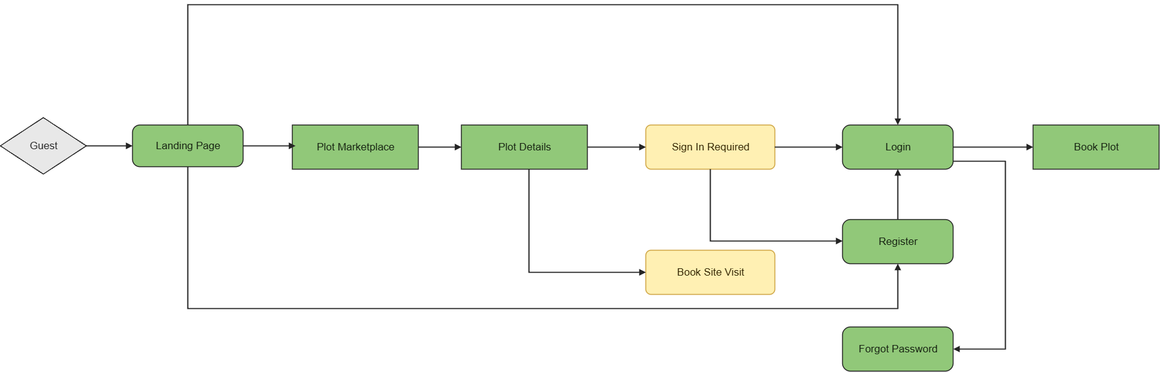
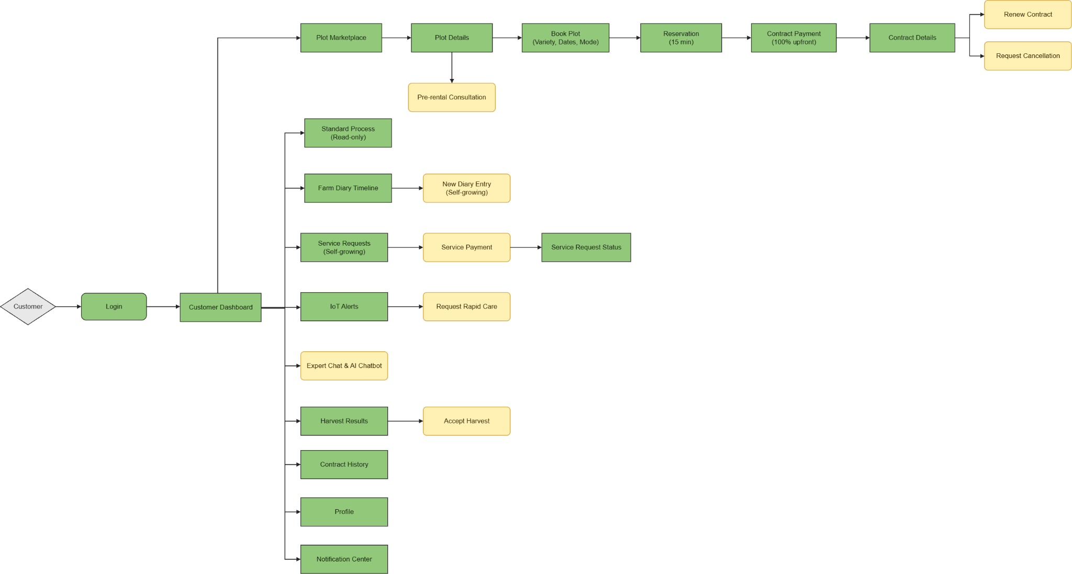
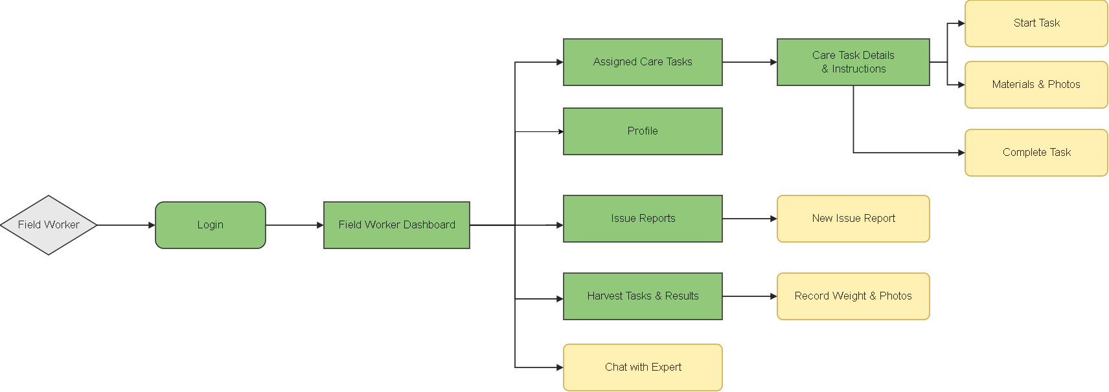
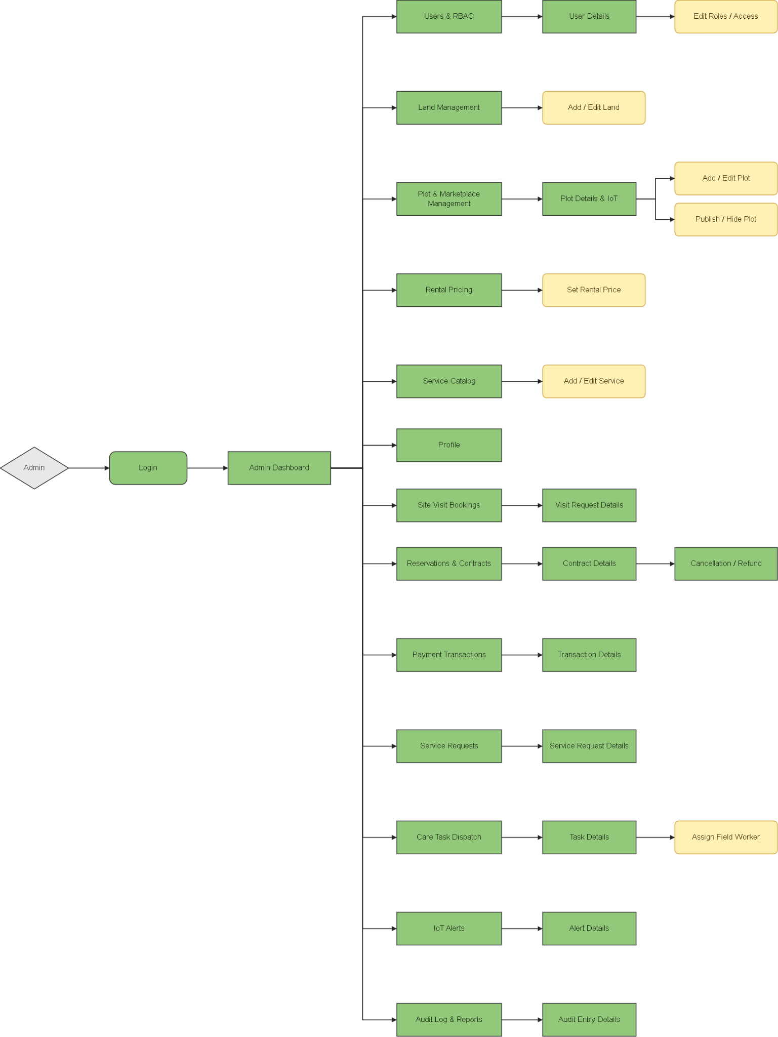

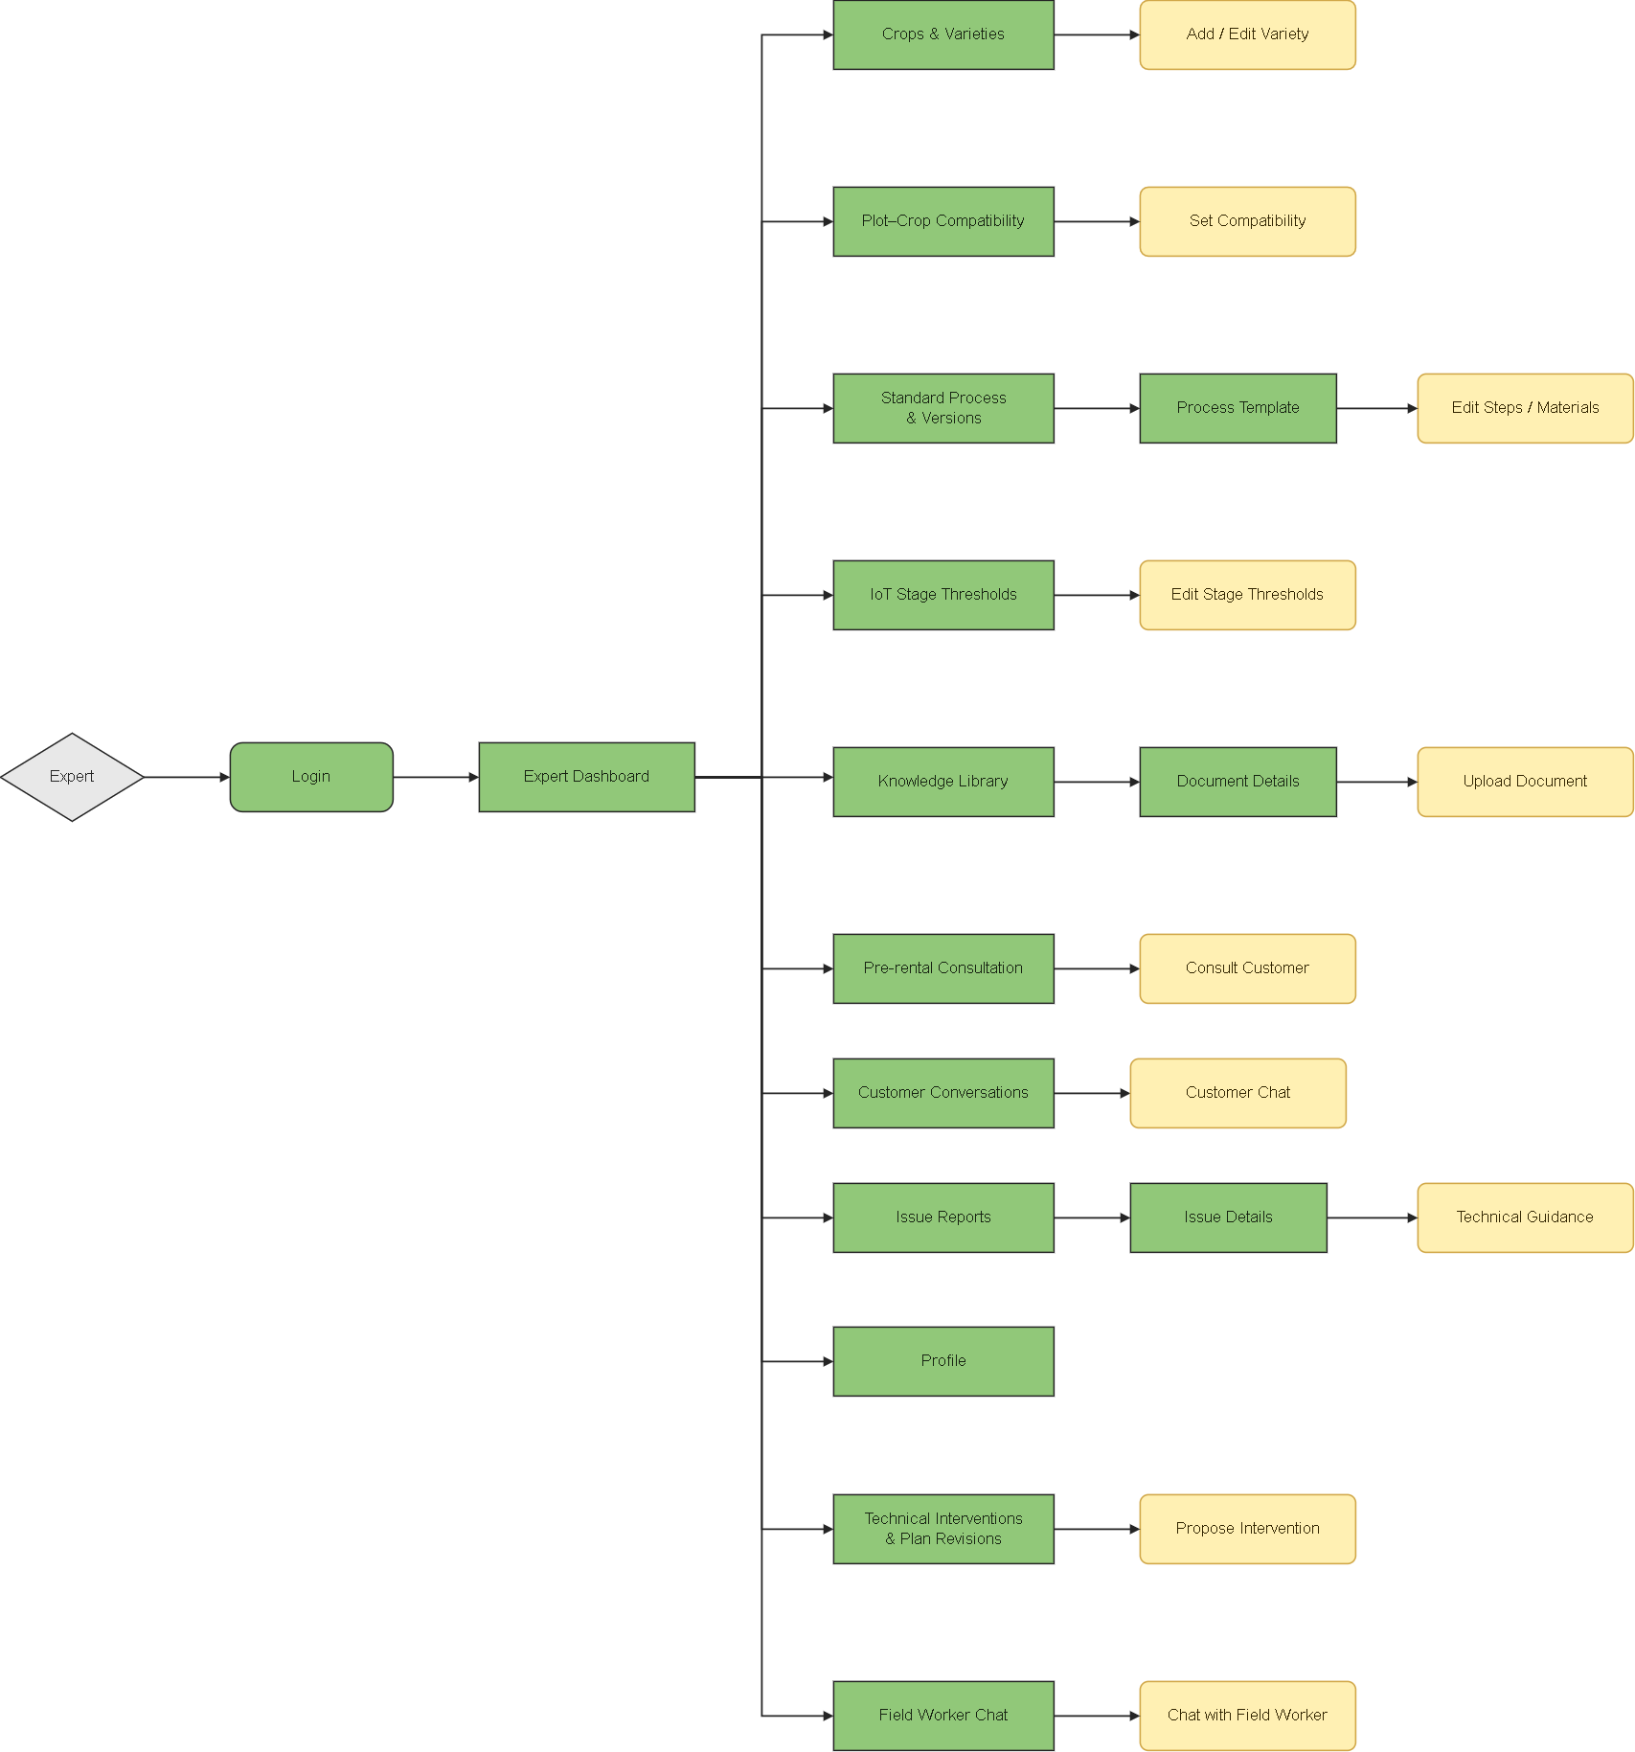

3.1.2 Screen Descriptions

# | Feature | Screen | Description
1 | Public Access | Landing Page | Introduces the platform and provides access to the Marketplace, registration, and login.
2 | Public Access | Plot Marketplace | Lists published plots and allows visitors to search and filter available rental options.
3 | Public Access | Plot Details | Displays plot information, compatible varieties, rental prices, availability, IoT readings, and weather.
4 | Public Access | Book Site Visit | Provides a popup for visitors to enter contact information and select a visit date and session.
5 | Authentication | Sign In Required | Prompts guests to register or log in before renting a plot.
6 | Authentication | Register | Provides a form for visitors to create a customer account.
7 | Authentication | Login | Authenticates users and redirects them to their role-specific dashboard or pending booking.
8 | Authentication | Forgot Password | Allows users to request an email verification link and reset their password.
9 | Account Management | Profile | Displays personal information and allows users to update their profile and password.
10 | Account Management | Notification Center | Displays personal notifications and provides access to related records.
11 | Customer Dashboard | Customer Dashboard | Displays contract summaries, cultivation progress, plot conditions, diary updates, and harvest information.
12 | Plot Rental | Book Plot | Allows customers to select a compatible variety, rental dates, and cultivation mode.
13 | Plot Rental | Reservation | Displays booking information, the price summary, and the remaining reservation time.
14 | Plot Rental | Contract Payment | Allows customers to pay the full rental amount through mock payment.
15 | Contract Management | Contract Details | Displays contract information and provides renewal and cancellation popups when eligible.
16 | Contract Management | Contract History | Lists previous contracts and provides read-only access to completed rental records.
17 | Expert Consultation | Pre-rental Consultation | Provides a chat popup for customers to consult an expert before renting a plot.
18 | Cultivation Monitoring | Standard Process | Displays read-only cultivation stages, technical instructions, and material guidelines.
19 | Cultivation Monitoring | Farm Diary Timeline | Displays cultivation records and provides a new-entry popup for Self-growing customers.
20 | Additional Services | Service Requests | Allows Self-growing customers to select additional services or a Temporary Full-care Month Pass.
21 | Additional Services | Service Payment | Provides a popup for customers to review and pay the selected service charge.
22 | Additional Services | Service Request Status | Displays a service request’s payment status, processing progress, and completion information.
23 | Cultivation Monitoring | IoT Alerts | Displays plot alerts and provides a rapid-care request popup for Self-growing customers.
24 | Communication | Expert Chat | Provides a popup for customers to exchange messages and photos with an agricultural expert.
25 | Communication | AI Chatbot | Provides a popup for AI-assisted questions about cultivation knowledge and plant problems.
26 | Harvest Management | Harvest Results | Displays harvest weight and evidence photos and provides a customer acceptance popup.
27 | Administration | Admin Dashboard | Displays revenue, plot occupancy, pending assignments, overdue tasks, and operational alerts.
28 | User Management | Users & RBAC | Lists user accounts and provides user details, role editing, and account access controls.
29 | Land Management | Land Management | Lists land records and provides popups for adding or editing land information.
30 | Plot Management | Plot & Marketplace Management | Lists plots and provides plot details, editing, IoT information, and publication controls.
31 | Pricing Management | Rental Pricing | Displays rental rates and provides a popup for configuring rental and care charges.
32 | Service Management | Service Catalog | Lists additional services and provides popups for adding or editing service information and prices.
33 | Site Visit Management | Site Visit Bookings | Lists visit requests and provides their contact details, schedules, and handling status.
34 | Contract Administration | Reservations & Contracts | Lists reservations and contracts and provides access to details and cancellation/refund handling.
35 | Payment Monitoring | Payment Transactions | Lists payment transactions and provides their amounts, statuses, and related records.
36 | Service Administration | Service Requests | Lists paid customer service requests and provides details for operational coordination.
37 | Task Dispatch | Care Task Dispatch | Lists care tasks and provides task details and worker assignment or reassignment popups.
38 | Alert Monitoring | IoT Alerts | Displays farm-wide alerts, invalid sensor warnings, and related operational details.
39 | System Monitoring | Audit Log & Reports | Displays system activities, audit entry details, revenue reports, and plot occupancy statistics.
40 | Expert Dashboard | Expert Dashboard | Displays consultation requests, technical issues, conversations, and activities concerning assigned plots.
41 | Crop Management | Crops & Varieties | Allows experts to manage crop information and add or edit varieties.
42 | Compatibility Management | Plot–Crop Compatibility | Displays plot suitability and provides a popup for configuring crop or variety compatibility.
43 | Process Management | Standard Process & Versions | Displays process templates and versions, with access to template details and step/material editing.
44 | Threshold Management | IoT Stage Thresholds | Displays cultivation-stage thresholds and provides a popup for editing their values.
45 | Knowledge Management | Knowledge Library | Lists technical documents and provides document details and an upload popup.
46 | Expert Consultation | Pre-rental Consultation | Lists customer consultation requests and provides a popup for responding to customers.
47 | Communication | Customer Conversations | Lists customer conversations and provides a customer chat popup.
48 | Technical Support | Issue Reports | Displays reported issues and their details and provides a technical guidance popup.
49 | Technical Support | Technical Interventions & Plan Revisions | Displays technical changes and provides a popup for proposing interventions for affected plots.
50 | Communication | Field Worker Chat | Lists worker conversations and provides a popup for technical communication.
51 | Worker Dashboard | Field Worker Dashboard | Displays today’s assigned tasks, overdue work, completed activities, and assignment notifications.
52 | Task Execution | Assigned Care Tasks | Lists assigned tasks and provides instructions and popups for starting, recording materials/photos, and completing work.
53 | Field Reporting | Issue Reports | Lists the worker’s relevant issue reports and provides a popup for submitting a new report.
54 | Harvest Recording | Harvest Tasks & Results | Displays assigned harvest activities and provides a popup for recording weight and evidence photos.
55 | Communication | Chat with Expert | Provides a popup for workers to request technical advice and exchange messages or photos with experts.

3.1.3 Screen Authorization

Screen | Guest | KH | AD | CGNN | CVLĐ
Landing Page | X | X | X | X | X
Plot Marketplace | X | X | X | X | X
Plot Details | X | X | X | X | X
Book Site Visit | X | X | — | — | —
Sign In Required | X | — | — | — | —
Register | X | — | — | — | —
Login | X | X | X | X | X
Forgot Password | X | X | X | X | X
Profile | — | X | X | X | X
Notification Center | — | X | X | X | X
Customer Dashboard | — | X | — | — | —
Book Plot | — | X | — | — | —
Reservation | — | X | — | — | —
Contract Payment | — | X | — | — | —
Contract Details — Customer | — | X | — | — | —
Contract History | — | X | — | — | —
Pre-rental Consultation — Customer | — | X | — | — | —
Standard Process — Customer | — | X | — | — | —
Farm Diary Timeline — Customer | — | X | — | — | —
Service Requests — Customer | — | X | — | — | —
Service Payment | — | X | — | — | —
Service Request Status | — | X | — | — | —
IoT Alerts — Customer | — | X | — | — | —
Expert Chat | — | X | — | — | —
AI Chatbot | — | X | — | — | —
Harvest Results — Customer | — | X | — | — | —
Admin Dashboard | — | — | X | — | —
Users & RBAC | — | — | X | — | —
Land Management | — | — | X | — | —
Plot & Marketplace Management | — | — | X | — | —
Rental Pricing | — | — | X | — | —
Service Catalog | — | — | X | — | —
Site Visit Bookings | — | — | X | — | —
Reservations & Contracts | — | — | X | — | —
Payment Transactions | — | — | X | — | —
Service Requests — Admin | — | — | X | — | —
Care Task Dispatch | — | — | X | — | —
IoT Alerts — Admin | — | — | X | — | —
Audit Log & Reports | — | — | X | — | —
Expert Dashboard | — | — | — | X | —
Crops & Varieties | — | — | — | X | —
Plot–Crop Compatibility | — | — | — | X | —
Standard Process & Versions | — | — | — | X | —
IoT Stage Thresholds | — | — | — | X | —
Knowledge Library | — | — | — | X | —
Pre-rental Consultation — Expert | — | — | — | X | —
Customer Conversations | — | — | — | X | —
Issue Reports — Expert | — | — | — | X | —
Technical Interventions & Plan Revisions | — | — | — | X | —
Field Worker Chat | — | — | — | X | —
Field Worker Dashboard | — | — | — | — | X
Assigned Care Tasks | — | — | — | — | X
Issue Reports — Worker | — | — | — | — | X
Harvest Tasks & Results | — | — | — | — | X
Chat with Expert | — | — | — | — | X

Chú thích vai trò:
• KH (Khách hàng): Người thuê plot, trải nghiệm canh tác, theo dõi từ xa.
• CGNN (Chuyên gia Nông nghiệp): Chuyên gia kỹ thuật, thiết kế quy trình, tư vấn.
• CVLĐ (Công nhân Vận hành): Đội đồng, thực hiện chăm sóc thực tế.
• AD (Admin): Quản trị viên hệ thống, toàn quyền quản lý.

3.1.4 Non-Screen Functions
[
# | Feature | System Function | Description
1 | Authentication | Authentication and Access Control | Verifies credentials, account status, role permissions, and access to requested records.
2 | Authentication | Password Reset Email | Generates a time-limited reset link and sends it to the registered email address.
3 | Plot Rental | Booking Validation | Checks variety compatibility, minimum cultivation duration, plot availability, and conflicting rental schedules.
4 | Plot Rental | Price Calculation | Calculates rental and care charges, including the first-month Starter Kit and additional service prices.
5 | Plot Rental | Reservation Expiration | Releases unpaid reservations after 15 minutes, with a three-minute grace period for PAYMENT_PENDING.
6 | Payment | Mock Payment Processing | Records mock payment results and updates the related contract or service request without duplicate processing.
7 | Contract Management | Contract Lifecycle Processing | Confirms paid contracts, activates them on the start date, and completes unrenewed contracts on the end date.
8 | Contract Management | Renewal Processing | Validates the seven-day renewal deadline and availability, then creates a linked continuation contract.
9 | Contract Management | Refund Calculation | Calculates an 80% or 50% refund before the start date according to the cancellation policy.
10 | Plot Management | Maintenance Scheduling | Blocks the plot for four days after an unrenewed contract ends before reopening its availability.
11 | Care Management | Automatic Task Generation | Generates care tasks from standard processes for Assisted-growing contracts and successfully paid care services.
12 | IoT Monitoring | Sensor Simulation and Validation | Generates readings every three hours, filters invalid temperature values, and records administrator warnings.
13 | Weather Integration | Weather Data Retrieval | Retrieves local forecasts and returns an unavailable status when the weather service cannot respond.
14 | Alert Management | Alert Evaluation and Routing | Detects prolonged threshold breaches and routes alerts or emergency tasks according to cultivation mode and operating hours.
15 | Care Management | Watering Task Postponement | Postpones watering when heavy rain is forecast or soil humidity reaches at least 80%.
16 | Task Management | Overdue Task Detection | Marks unfinished tasks as overdue after 23:59 and notifies the administrator the following morning.
17 | Task Management | Completion Validation and Diary Synchronization | Requires task evidence before completion and automatically adds completed care activities to the Farm Diary.
18 | Technical Support | Intervention Application | Associates expert-issued technical interventions with affected plots and their operational activities.
19 | Communication | Message Polling | Retrieves authorized customer–expert and worker–expert messages through five-second HTTP polling.
20 | AI Assistance | Knowledge Indexing and Response Generation | Indexes expert documents, retrieves relevant knowledge, and generates chatbot answers without memory between sessions.
21 | Notification | Notification Generation | Creates in-app notifications for payments, contracts, assignments, alerts, services, and harvest events.
22 | File Management | Upload Validation | Validates uploaded attachments and enforces image limits of 5 MB per file and ten photos per task.
23 | System Monitoring | Audit Logging | Records relevant user and system actions with their actor, timestamp, and affected record.
24 | Reporting | Summary Aggregation | Calculates dashboard summaries and reports from data accessible to the requesting user.

3. Entity Relationship Diagram
[Provide the entity relationship diagram and the entity descriptions in the table format as below]
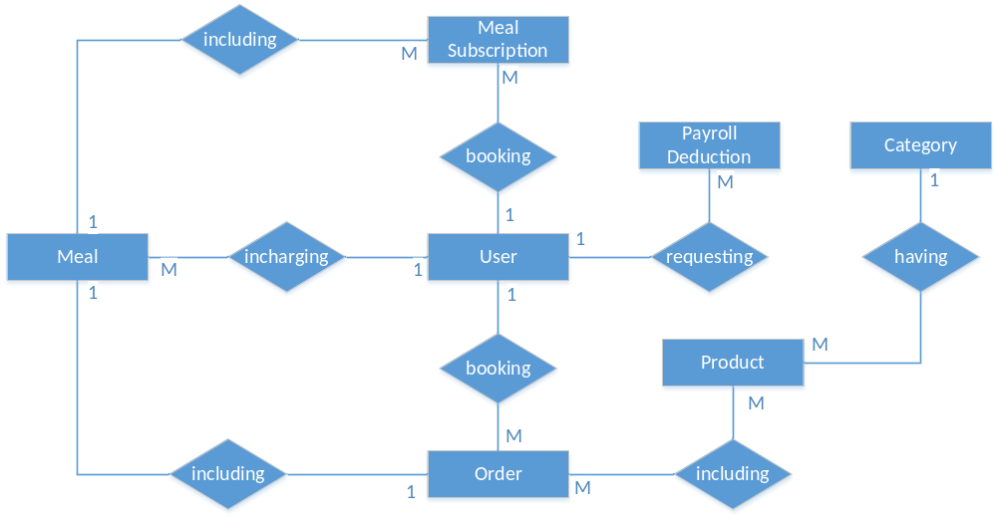
Entities Description
# | Entity | Description
1 | User
2 | Meal
3 | Meal Subscription
4 | …

II. Functional Requirements

1. <<Feature Name 1>>

a. <<Function Name 1>>
[A function can be a screen or a non-screen function (listed in the part I.2.d above). In this part, you need to provide the details on the related function, focus on mentioning below information
- Function trigger: how this function is triggered (navigation path, a timing frequency, etc.)
- Function description: actors/roles, purpose, interface, data processing, etc.
- Screen layout: mockup prototype of the screen, sample below is for Manage Products screen
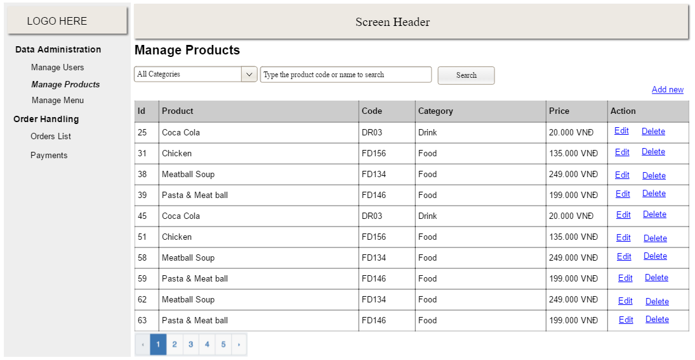
- Function Details: provide explanation for the data, validation, business logics, functionalities (for both normal cases and abnormal cases), etc. of the function so that the reader can image how it work.
]

b. <<Function Name 2>>
…

2. <<Feature Name 2>>
…

