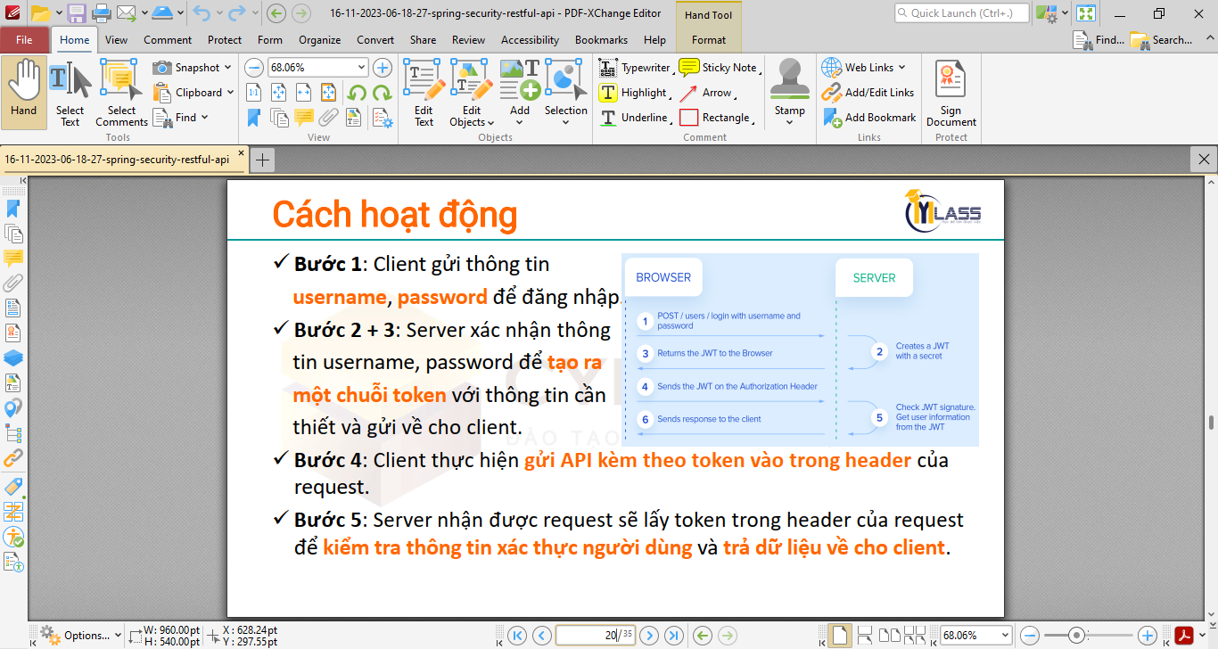

Library: JJWT

<https://github.com/jwtk/jjwt>

**Java JWT: JSON Web Token for Java and Android**

JJWT aims to be the easiest to use and understand library for creating and verifying JSON Web Tokens (JWTs) and JSON Web Keys (JWKs) on the JVM and Android.

JJWT is a pure Java implementation based exclusively on the [JOSE Working Group](https://datatracker.ietf.org/wg/jose/documents/) RFC specifications:

* [RFC 7519: JSON Web Token (JWT)](https://tools.ietf.org/html/rfc7519)
* [RFC 7515: JSON Web Signature (JWS)](https://tools.ietf.org/html/rfc7515)
* [RFC 7516: JSON Web Encryption (JWE)](https://tools.ietf.org/html/rfc7516)
* [RFC 7517: JSON Web Key (JWK)](https://tools.ietf.org/html/rfc7517)
* [RFC 7518: JSON Web Algorithms (JWA)](https://tools.ietf.org/html/rfc7518)
* [RFC 7638: JSON Web Key Thumbprint](https://www.rfc-editor.org/rfc/rfc7638.html)
* [RFC 9278: JSON Web Key Thumbprint URI](https://www.rfc-editor.org/rfc/rfc9278.html)
* [RFC 7797: JWS Unencoded Payload Option](https://www.rfc-editor.org/rfc/rfc7797.html)
* [RFC 8037: Edwards Curve algorithms and JWKs](https://www.rfc-editor.org/rfc/rfc8037)

It was created by [Les Hazlewood](https://github.com/lhazlewood) and is supported and maintained by a [community](https://github.com/jwtk/jjwt/graphs/contributors) of contributors.

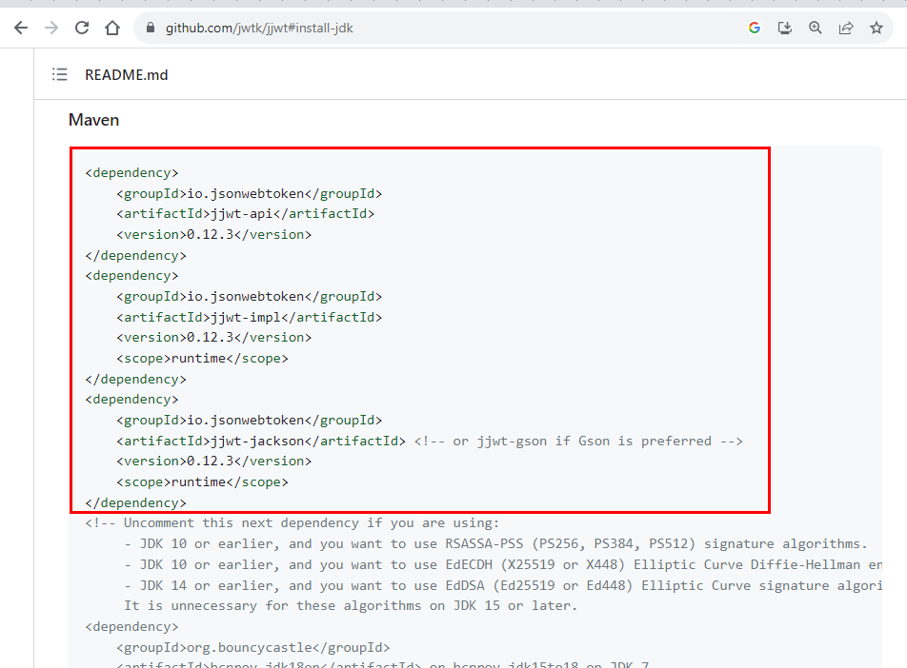

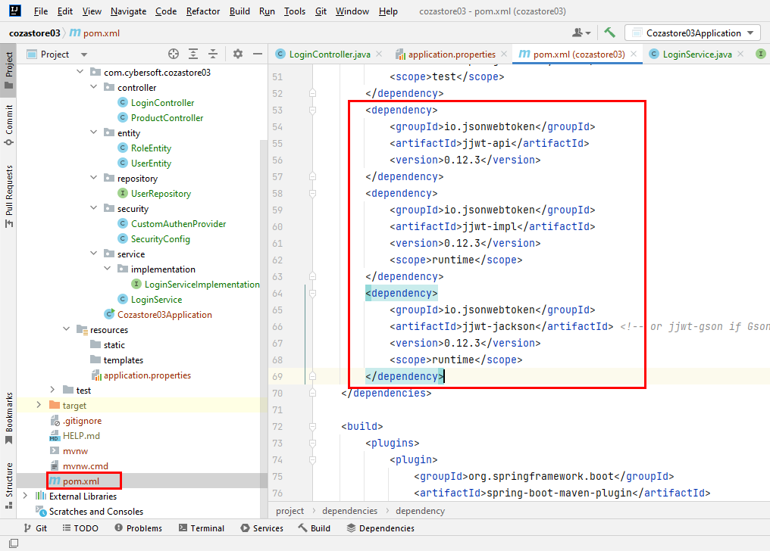

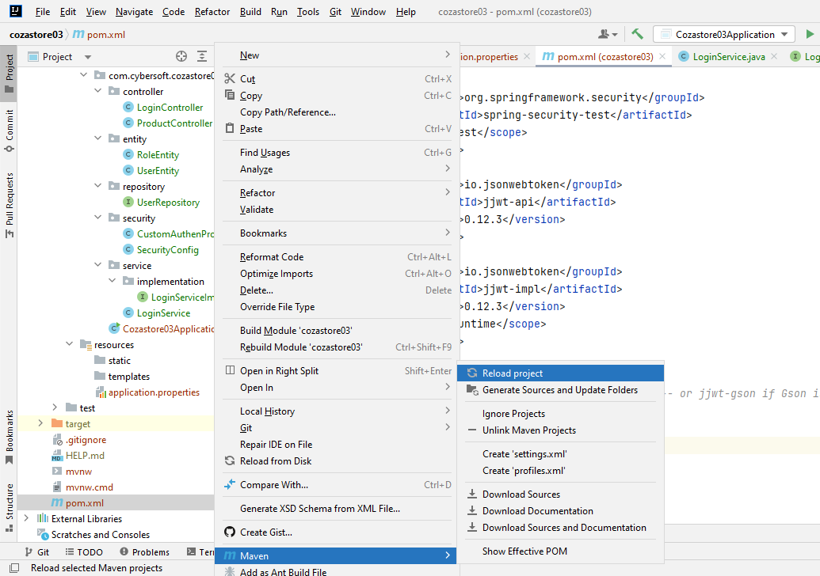

<https://github.com/jwtk/jjwt#jws-key-create-secret>

