Which is the best Visual Studio Code extension to get color code from opening image file in VS code ?

There are a few Visual Studio Code extensions that can help you get the color code from an opening image file in VS Code. Here are a few of the best:

* VS Color Picker: This extension allows you to pick a color from anywhere in your code editor, including images.

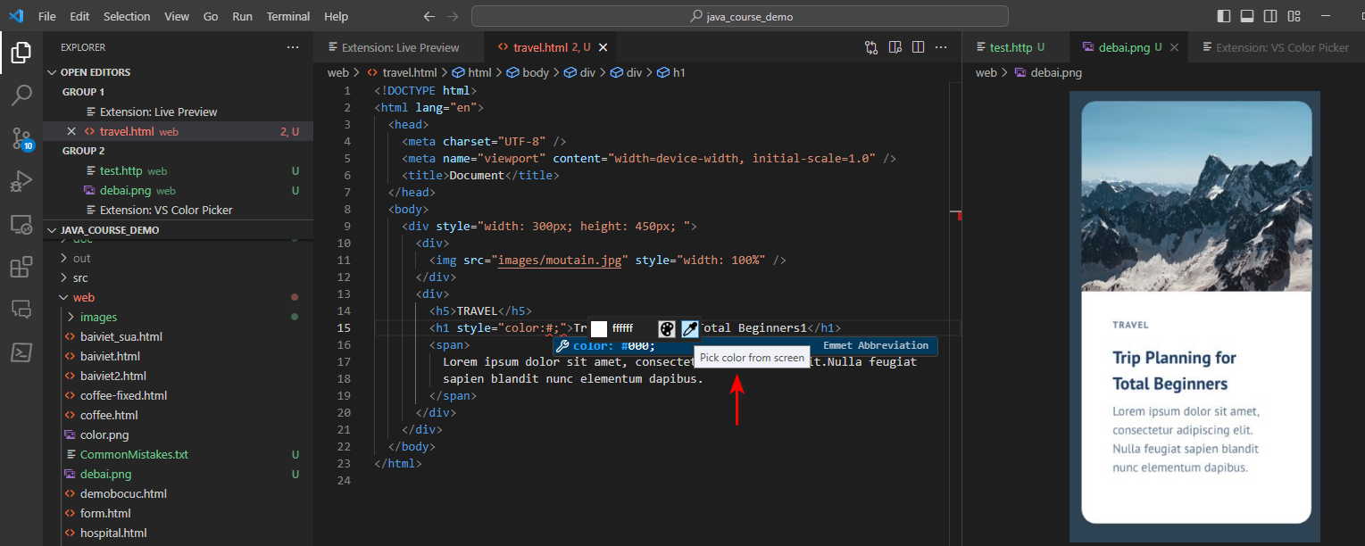

Or pick a color from screen. Move cursor to the pixel and **press Enter to pick,** Esc to cancel:

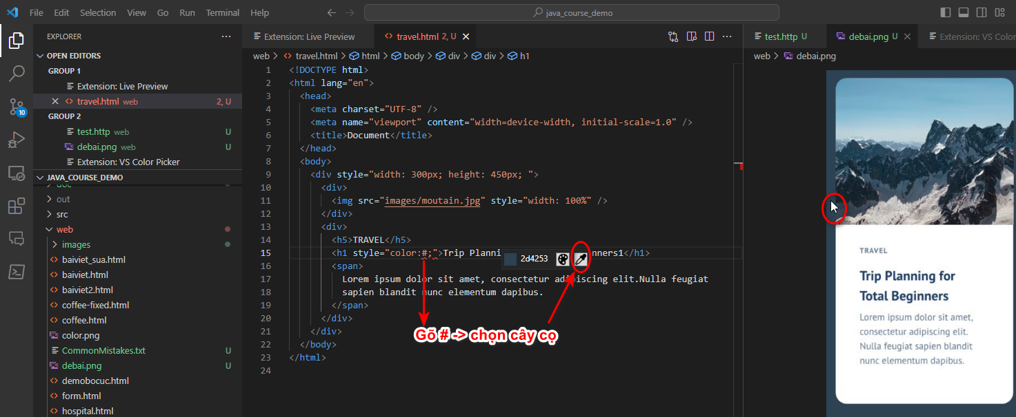

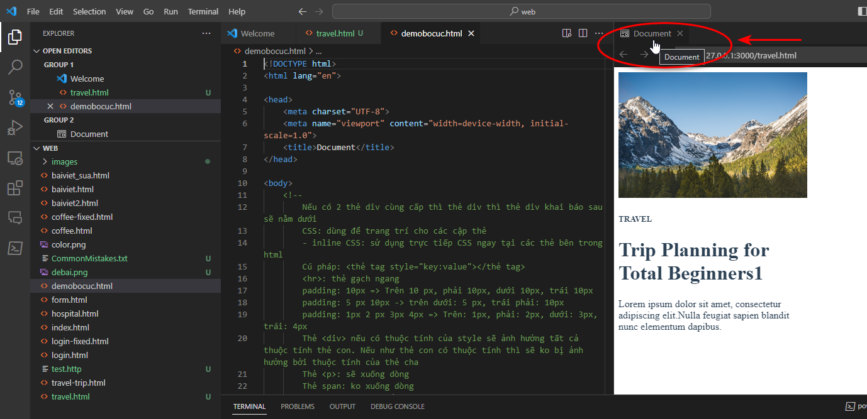

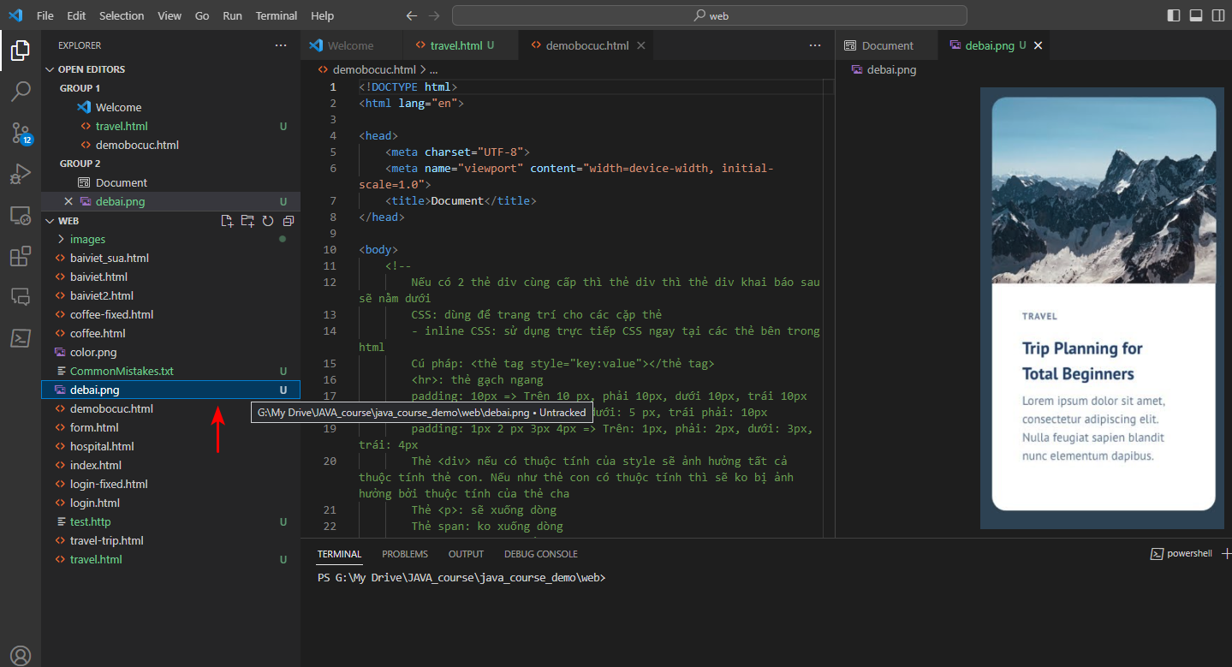

VS Color Picker Visual Studio Code extension icon

* Color Picker Plus: This extension is another good option for picking colors from images. It also allows you to save custom color palettes.

[Opens in a new window[https://encrypted-tbn0.gstatic.com/favicon-tbn?q=tbn:ANd9GcR-luPlDlD1SFs9hRigBPkt8jfeNrQl2lCButRF3S6a8RvvZStncCLDMwsM865Yfv2-I1NEaNUT9CW8qKM2Cq1JYOkgmA](https://medium.com/@fbnlsr/10-essential-extensions-for-vs-code-fdfa17f4f66c)medium.com](https://medium.com/@fbnlsr/10-essential-extensions-for-vs-code-fdfa17f4f66c)

Color Picker Plus Visual Studio Code extension icon

* Image Color Picker: This extension is specifically designed to pick colors from images. It allows you to select a color from an image and get its hex code, RGB value, and HSV value.

[Opens in a new window[https://encrypted-tbn0.gstatic.com/favicon-tbn?q=tbn:ANd9GcR-luPlDlD1SFs9hRigBPkt8jfeNrQl2lCButRF3S6a8RvvZStncCLDMwsM865Yfv2-I1NEaNUT9CW8qKM2Cq1JYOkgmA](https://medium.com/@fbnlsr/10-essential-extensions-for-vs-code-fdfa17f4f66c)medium.com](https://medium.com/@fbnlsr/10-essential-extensions-for-vs-code-fdfa17f4f66c)

Image Color Picker Visual Studio Code extension icon

* Color Thief: This extension is a popular color picking tool that is also available as a standalone application. It allows you to pick colors from images and create color palettes.

[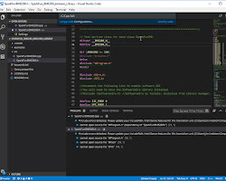Opens in a new window[https://encrypted-tbn2.gstatic.com/favicon-tbn?q=tbn:ANd9GcQ2IIo2vSw8hzc-D60aV1dbn0qKvrLSBo2A4IvfmbDzVq0JdgXbXegrwL2KorwndQlDW7fF8s_eFg7T0Qy41z63t56zP0KbLglg](https://www.digikey.com/en/maker/projects/making-the-programming-of-arduino-easier-with-a-different-ide/33bf0b51eb54464194db70722c68d144)www.digikey.com](https://www.digikey.com/en/maker/projects/making-the-programming-of-arduino-easier-with-a-different-ide/33bf0b51eb54464194db70722c68d144)

Color Thief Visual Studio Code extension icon

The best extension for you will depend on your needs and preferences. If you are looking for an extension that is simple and easy to use, then the VS Color Picker extension is a good option. If you want an extension that allows you to save custom color palettes, then the Color Picker Plus extension is a good choice. If you are looking for an extension that is specifically designed for picking colors from images, then the Image Color Picker extension is a good option. And if you are already familiar with Color Thief, then you can use the Color Thief extension in Visual Studio Code.