Exension

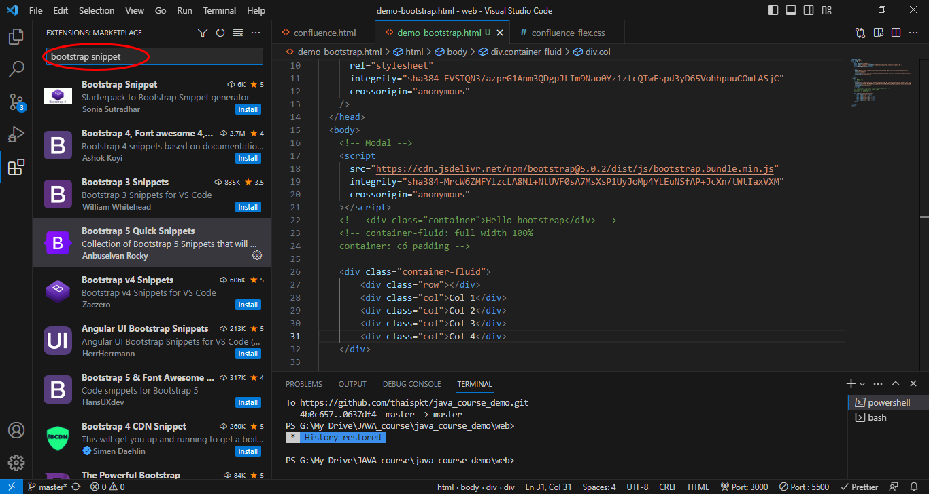

<https://getbootstrap.com/>

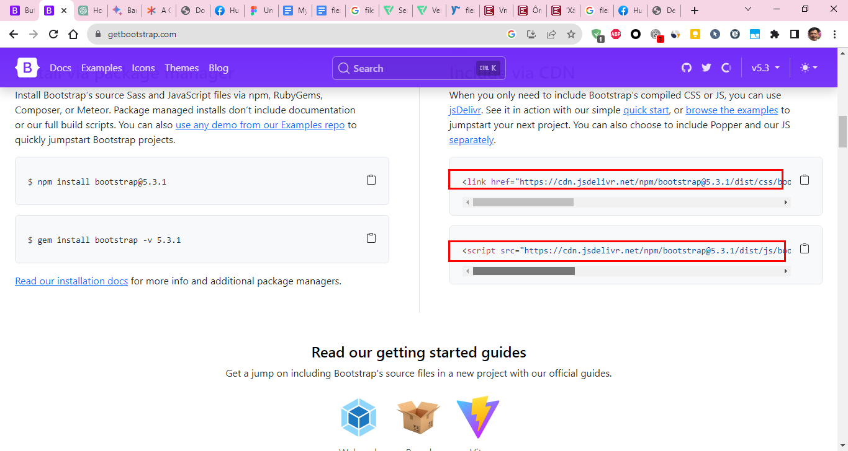

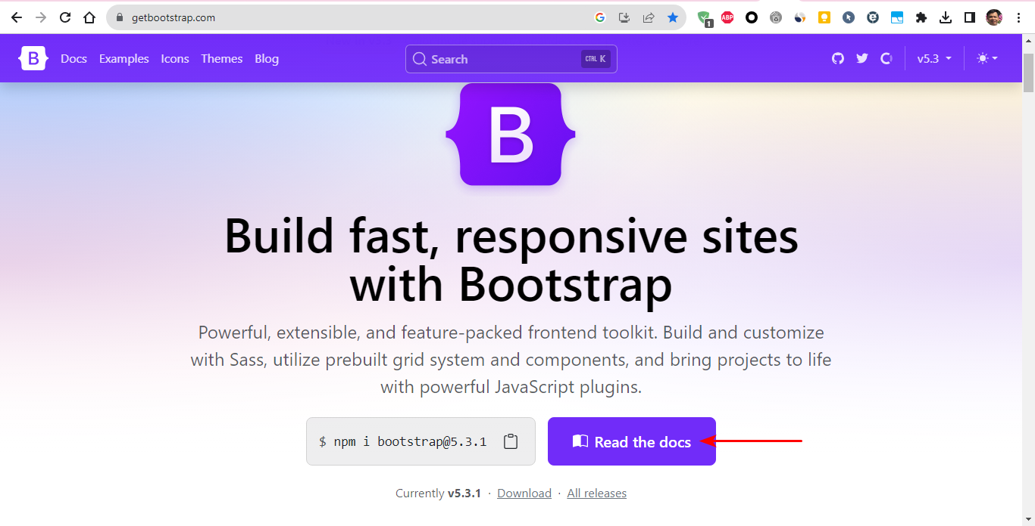

<https://getbootstrap.com/docs/5.3/helpers/color-background/>

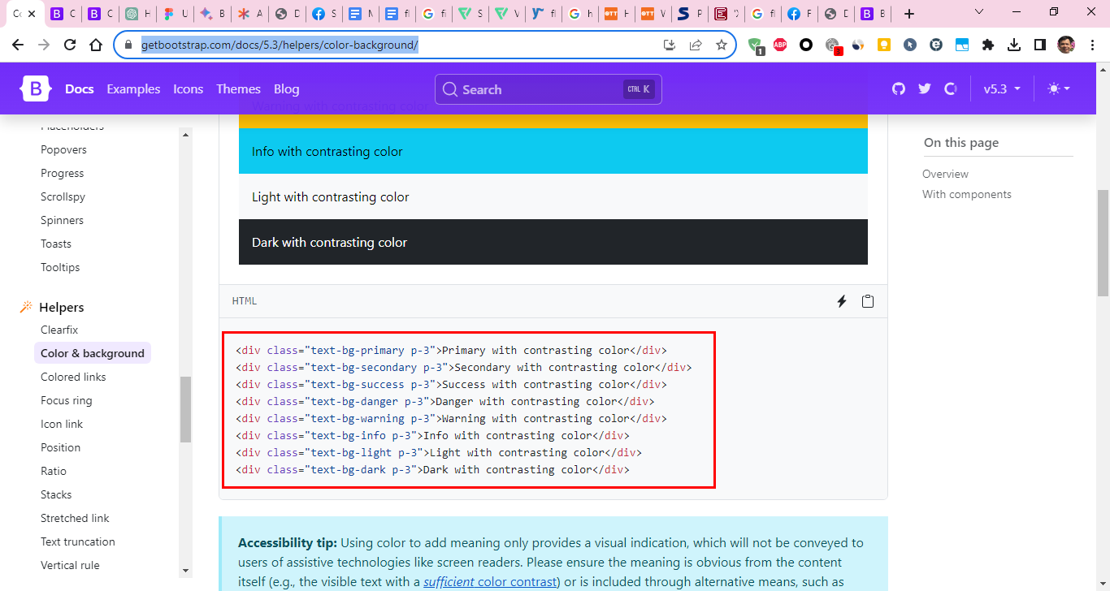

<!DOCTYPE html>

<html lang="en">

<head>

    <meta charset="UTF-8">

    <meta name="viewport" content="width=device-width, initial-scale=1.0">

    <title>DemoBootstrap</title>

    <link href="https://cdn.jsdelivr.net/npm/bootstrap@5.3.1/dist/css/bootstrap.min.css" rel="stylesheet" integrity="sha384-4bw+/aepP/YC94hEpVNVgiZdgIC5+VKNBQNGCHeKRQN+PtmoHDEXuppvnDJzQIu9" crossorigin="anonymous">

</head>

<body>

    <!-- chen script o body -->

    <script src="https://cdn.jsdelivr.net/npm/bootstrap@5.3.1/dist/js/bootstrap.bundle.min.js" integrity="sha384-HwwvtgBNo3bZJJLYd8oVXjrBZt8cqVSpeBNS5n7C8IVInixGAoxmnlMuBnhbgrkm" crossorigin="anonymous"></script>

    <button type="button" class="btn btn-danger">Base class</button>

</body>

</html>

<https://getbootstrap.com/docs/5.3/components/buttons/>

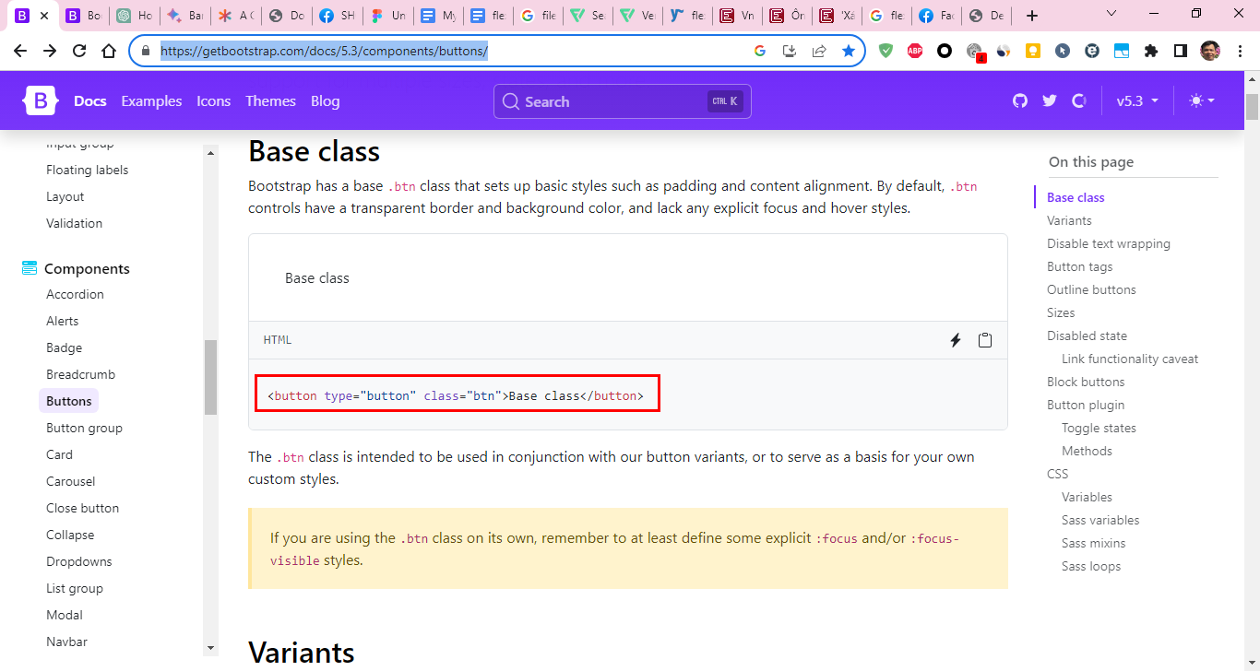

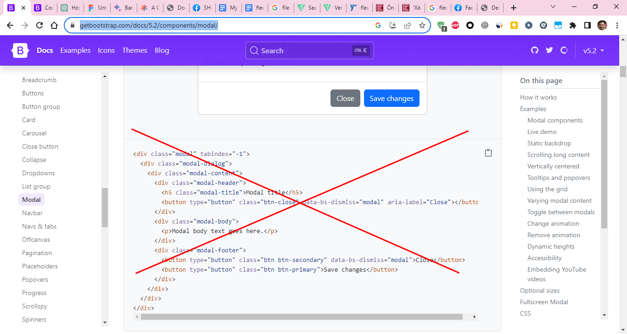

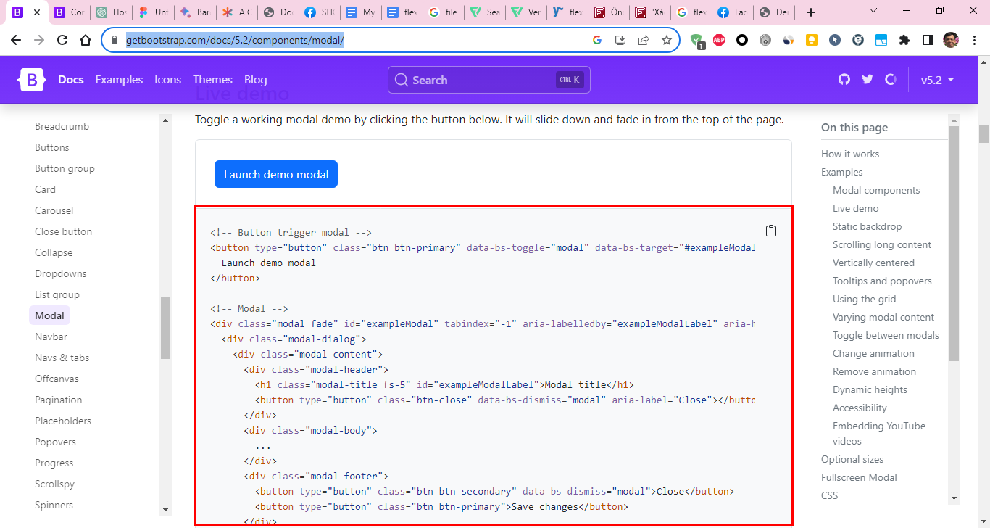

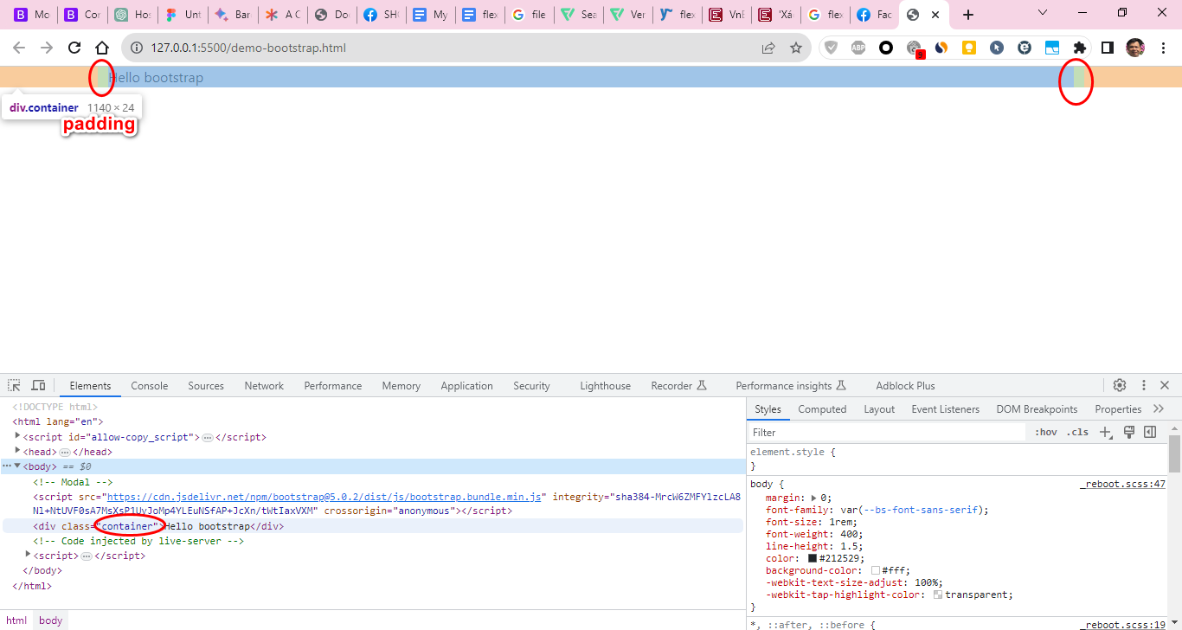

container-fluid: full width 100%

container: có padding

<https://getbootstrap.com/docs/5.3/layout/grid/>

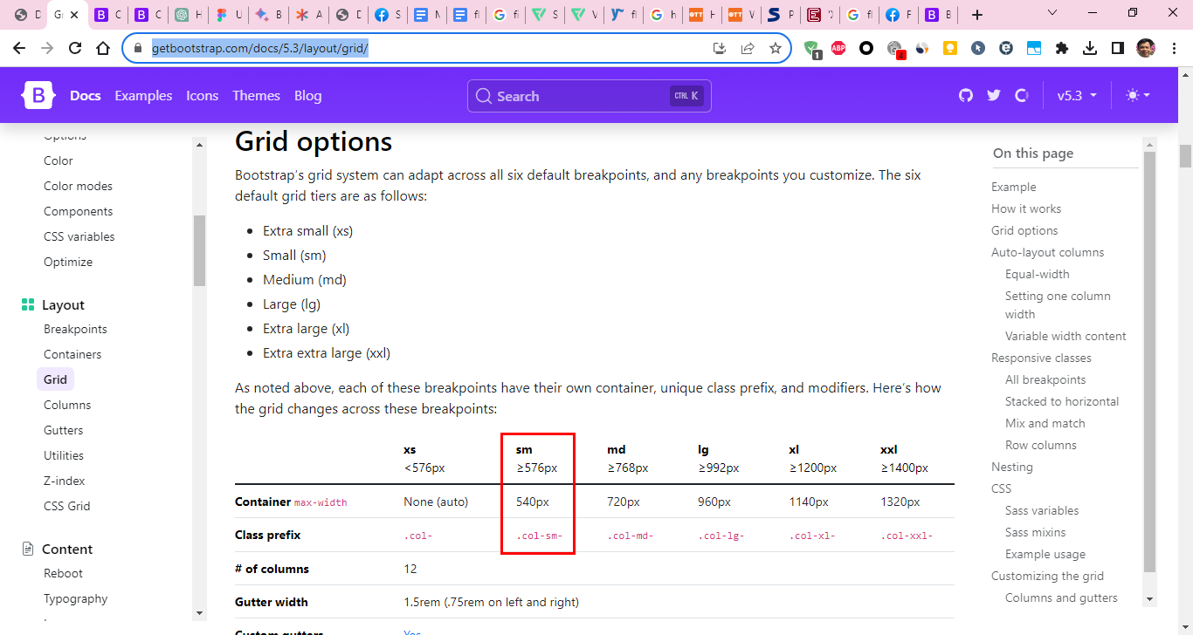

<https://getbootstrap.com/docs/5.3/components/navbar/>

<https://getbootstrap.com/docs/5.3/utilities/flex/>

          <div class="row">

            <div style="background-color: blanchedalmond;" class="col">col</div>

            <div style="background-color: coral;" class="col">col</div>

            <div style="background-color: chartreuse;" class="col">col</div>

            <div style="background-color: darkgoldenrod;" class="col">col</div>

            <div style="background-color:darksalmon;" class="col">col</div>

          </div>

          <div class="row">

            <div style="background-color: aqua;" class="col-8">col-8</div>

            <div style="background-color: chartreuse;" class="col-4">col-4</div>

          </div>

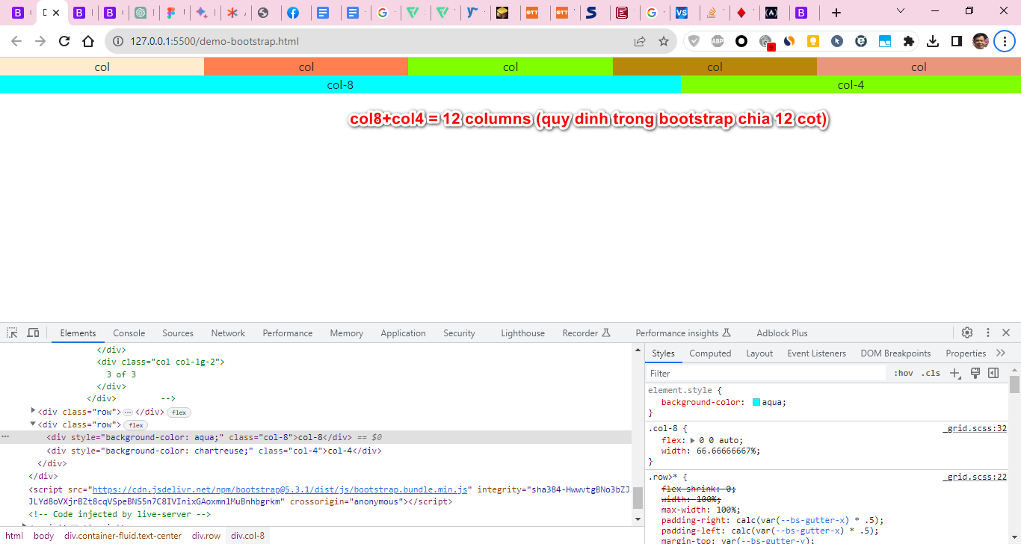

      <div class="row">

        <div class="col-sm-6 text-bg-primary p-3">Col 1</div>

        <div class="col-sm-6 text-bg-secondary p-3">Col 2</div>

        <div class="col-sm-6 text-bg-success p-3">Col 3</div>

        <div class="col-sm-6 text-bg-danger  p-3">Col 4</div>

      </div>

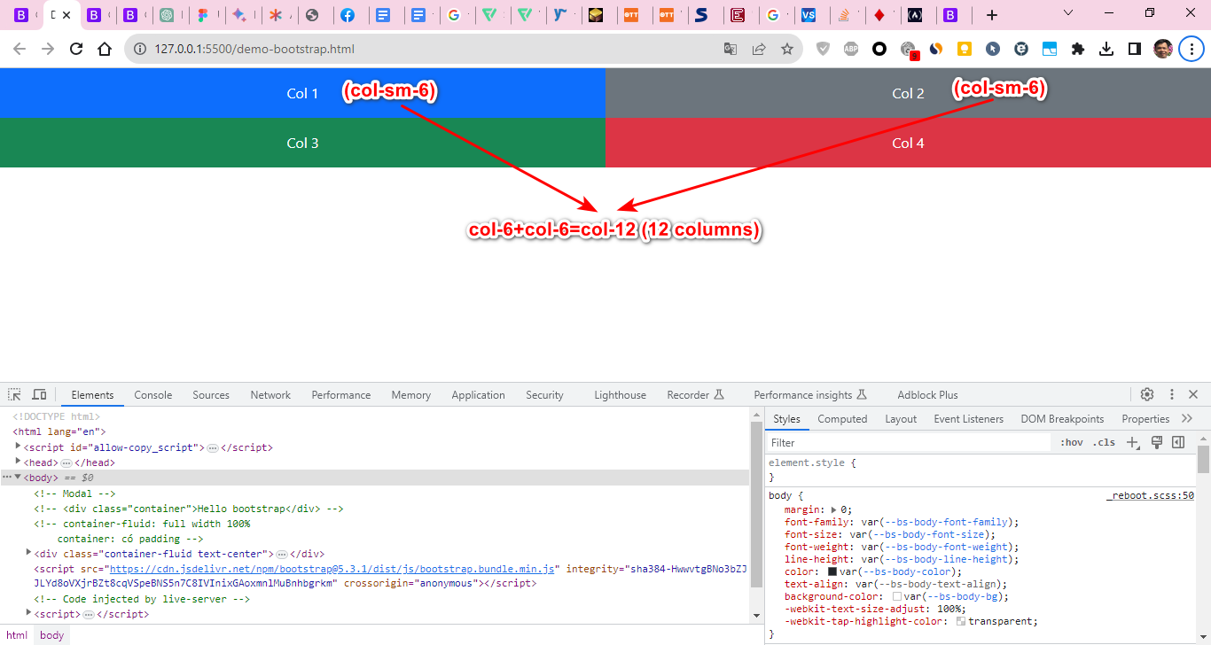

      <div class="row">

        <div class="col-sm-3 text-bg-primary p-3">Col 1</div>

        <div class="col-sm-3 text-bg-secondary p-3">Col 2</div>

        <div class="col-sm-3 text-bg-success p-3">Col 3</div>

        <div class="col-sm-3 text-bg-danger  p-3">Col 4</div>

      </div>

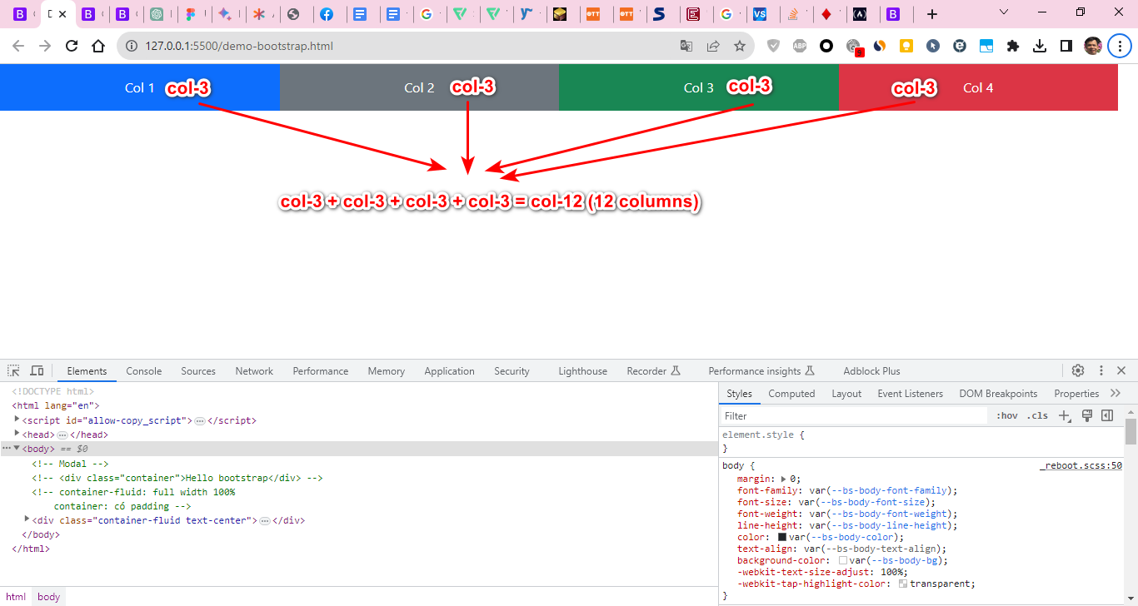

<https://getbootstrap.com/docs/5.2/components/carousel/>

