**Lab 4: Delegate, Event and Linq**

1. Write a program to calculate addition, subtraction, multiplication, and division using delegate generics.

- MultiCast Delegate:

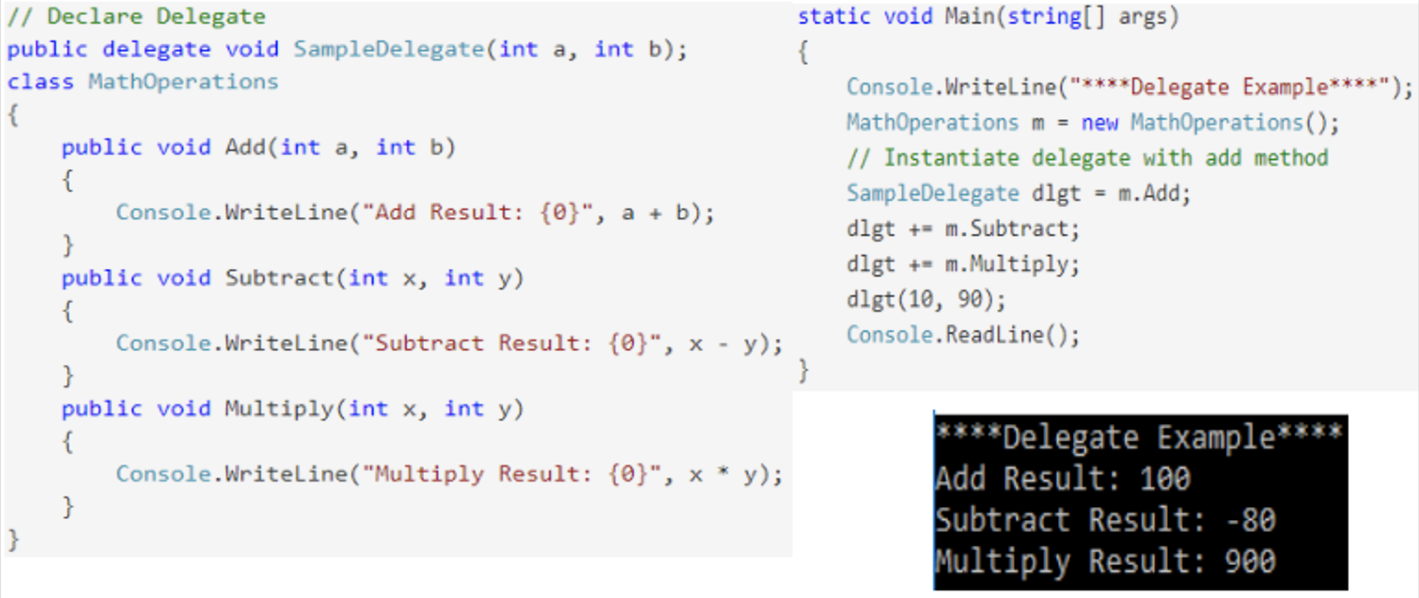

2. Suppose you are writing a banking application and need to update the account balance when the user performs a transaction. You can use a delegate to create an event to notify when the user's account balance changes.

Guild:

Step 1: Create a delegate to create an event.

Step 2: Create an Account class with the BalanceChanged event.

Step 3: Register the event and callback.

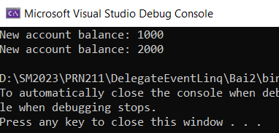

3. Create a data source that is a list (using the List class) of products (which will use a self-built Product class). Build the Product class as follows:

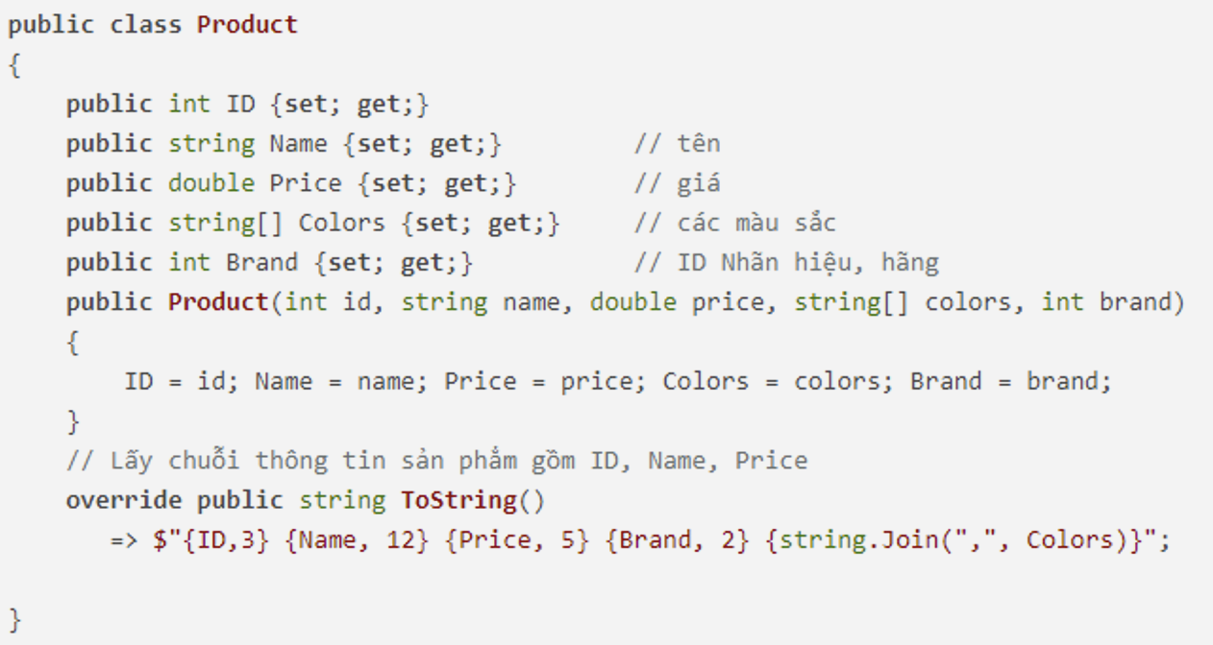

Build the Brand class to represent the brand of goods.

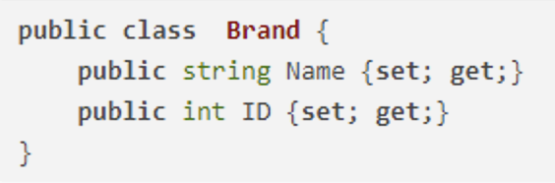

Initialize 2 list objects used to perform LINQ queries: the products list and the brands list.

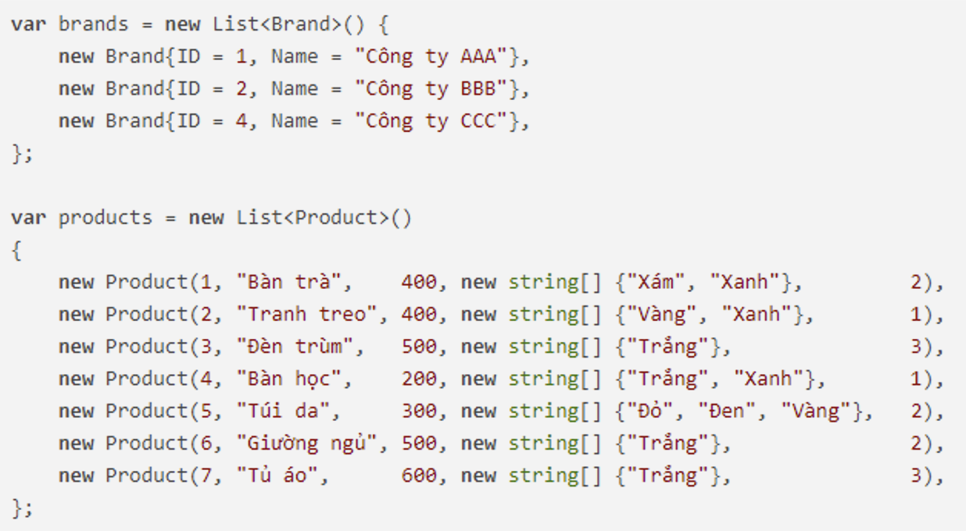

1. Filter out products with a price of 400.
2. Each product name has an array of colors. Filter out products that contain the color yellow.
3. Display the list of products in descending order of price.

