REPORT: DEVELOPER AND PROJECT MANAGEMENT SYSTEM
Name: Trần Xuân Thái
Student ID: SE204097
1. Introduction
The "Developer & Project Management System" is a Console application built using Java. Its primary purpose is to digitalize the human resource management (Developers) and project assignment (Projects) workflows for an IT company.
The system provides 12 core functionalities (CRUD operations), allowing users to read/write data from text files, search records, calculate total experience, sort lists using Lambda Expressions, and notably, handle data integrity (e.g., preventing the deletion of developers who are currently assigned to ongoing projects).
2. Problem Analysis
Based on the system requirements, the problem is analyzed into the following elements:
- Entities: The problem revolves around two main objects: Developer (ID, name, programming languages, salary) and Project (project ID, dev ID, project name, duration, start date).
- Relationships: A 1-N (One-to-Many) relationship. One Developer can participate in multiple Projects. These two entities are linked via the common attribute DevID.
- Constraints:
  - All input data must strictly follow the correct format (validated via Regular Expressions).
  - When creating a new Project (Case 6), the assigned DevID must exist in the Developer list.
  - When deleting a Developer (Case 9), the system must verify if they are involved in any ongoing projects. If so, the deletion process must be blocked to maintain data integrity.
3. Computational Thinking
3.1 Decomposition
Instead of cramming all code into a single Main file, the system is decomposed into specialized packages based on a modular architecture:
- model: Contains core object classes (Developers, Projects).
- manager: Contains business logic and data storage classes (DeveloperManager, ProjectManager).
- tools: Contains shared utility tools like Inputter (for robust input handling) and Acceptable (for Regex validation constants).
- dispatcher: Contains the Main class acting as the Controller/Menu navigator.
3.2 Pattern Recognition
During the coding process, repetitive actions with clear rules were identified:
- Input Validation Pattern: Requesting input, validating against Regex, showing errors, and looping until valid is a recurring pattern. Thus, the inputAndLoop() method in the Inputter class was created for high reusability across all data fields.
- File I/O Pattern: Reading and writing files using BufferedReader and PrintWriter share a similar structure across both Manager classes.
3.3 Abstraction
- By ignoring the real-world complexities of a person or a project, the system abstracts and retains only the most crucial attributes required for software management (ID, Name, Salary, Duration, etc.).
- Hiding the complexity of Regular Expressions by centralizing them in the Acceptable interface makes the code in other classes much cleaner and more readable (e.g., calling Acceptable.isValid(data, Acceptable.DEV_ID_VALID) instead of writing raw regex strings in multiple places).
3.4 Algorithm Design (Holistic Approach)
The system applies consistent algorithm patterns across various features:
- Validation Loop Algorithm: Uses a do-while loop combined with Regex. Process: Receive input string -> remove leading/trailing spaces (trim()) -> Match with Regex -> If invalid, print an error and repeat -> If valid, return the result. This ensures all data is "clean" before entering the system.
- File I/O Processing Algorithm: * Reading: Open stream -> Read lines until null -> Split string by commas -> Instantiate objects -> Add to ArrayList.
  - Writing: Iterate through the list -> Extract attributes -> Concatenate with commas -> Overwrite the file.
- Cross-Constraint Checking Algorithm: Uses Linear Search to check for existence. Before Adding (a project) or Deleting (a developer), the system uses the ID as a key to cross-reference between DeveloperManager and ProjectManager. If data integrity rules are violated, the execution flow is immediately terminated using the return statement.
4. OOP Design (UML)
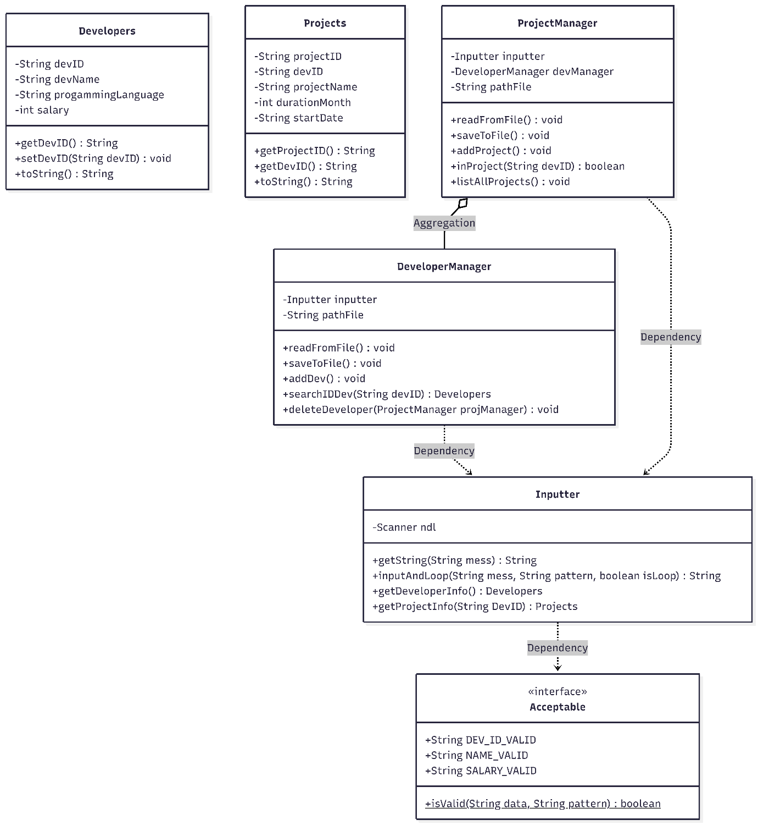
5. Flowchart
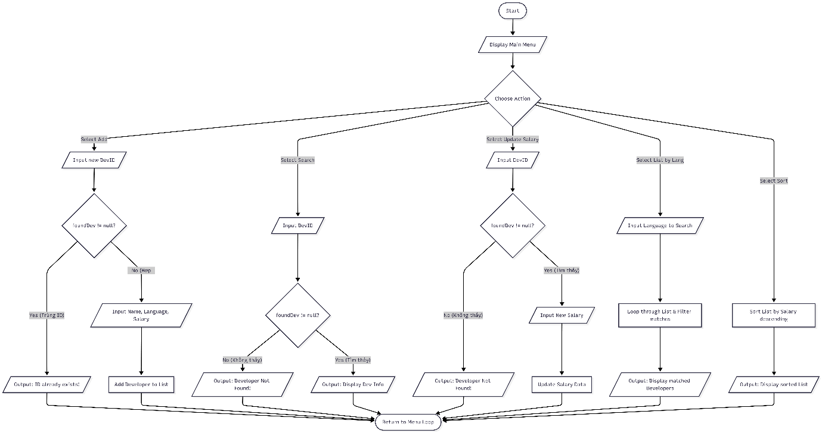
6. Conclusion
The project successfully fulfills all 12 functional requirements. Through this lab, core concepts have been mastered and effectively applied:
- Understanding Decomposition in system design.
- Mastering string manipulation and strict data validation using Regular Expressions.
- Deeply comprehending Memory Allocation and References (Dependency Injection) by passing DeveloperManager to ProjectManager to enable cross-communication and protect data integrity.
- Utilizing Lambda Expressions to optimize sorting operations (Collections.sort), making the code concise and modern.

