**MINISTRY OF EDUCATION AND TRAINING**

**FPT UNIVERSITY**

Software Project Document

**Jewelry Production Order System**

|  |  |
| --- | --- |
|  | |
| **Group Members** | Trịnh Công Thái – Team Leader – SE183743  Phạm Nguyên Vũ – Team Member – SE184101  Lê Vũ Đức Lương – Team Member – SE183775  Chu Phan Nhật Long – Team Member – SE183738 |
| **Supervisor** | Mr. Ton That Hoang Minh |

1

**- Ho Chi Minh, May 2024 -**

# Project Introduction

## Overview

### Project Information

* Project name: Jewelry Production Order System
* Software type: Web Application

### Project Team

1. ***Supervisors***

|  |  |  |  |
| --- | --- | --- | --- |
| **Full Name** | **Role** | **Email** | **Mobile** |
| Ton That Hoang Minh | Lecturer | [minhtth5@fe.edu.vn](mailto:minhtth5@fe.edu.vn) |  |

Table 1 - Supervisors

1. ***Team Members***

|  |  |  |  |
| --- | --- | --- | --- |
| **Full Name** | **Email** | **Mobile** | **Role** |
| Trịnh Công Thái | [thaitcse183743@fpt.edu.vn](mailto:thaitcse183743@fpt.edu.vn) | 0902700316 | Leader |
| Phạm Nguyên Vũ | [vupnse184101@fpt.edu.vn](mailto:vupnse184101@fpt.edu.vn) | 0908705620 | Member |
| Lê Vũ Đức Lương | [luonglvdse183775@fpt.edu.vn](mailto:luonglvdse183775@fpt.edu.vn) | 0368984593 | Member |
| Chu Phan Nhật Long | [longcpnse183738@fpt.edu.vn](mailto:longcpnse183738@fpt.edu.vn) | 034717890 | Member |

Table 2 - Team Members

* 1. Product Background

2

## Project Scope & Limitations

### Major Features

* **Guest:**

+ FE-01: Register account

* **Customer:**

+ FE-02: Sent request

+ FE-03: View order detail

+ FE-04: View order process

+ FE-05: Decide on the order

+ FE-06: Cancel order

* **Sales Staff:**

+ FE-07: View request

+ FE-08: View all order detail

+ FE-09: View order process

+ FE-10: Edit customer order

+ FE-11: Cancel order

+ FE-12: Submit order's price to manager

+ FE-13: Export receipt and warranty

* **Manager:**

+ FE-14: View all order detail

+ FE-15: View order process

+ FE-16: Approve or decline order's price

* **Design Staff:**

+ FE-17: View 'approved' order detail

+ FE-18: Upload 3D design for customer order

+ FE-19: Approve or decline order's price

3

* **Production Staff:**

+ FE-20: View 'approved 3D design' order detail

+ FE-21: Report finished order

* **Admin:**

+ FE-09: View all order detail

+ FE-10: View order process

+ FE-11: View dashboard

# Project Management Plan

## Overview

### Scope & Estimation

|  |  |  |  |
| --- | --- | --- | --- |
| **#** | **WBS Item** | **Complexity** | **Est. Effort (man-days)** |
| ***1*** | ***Requirement analysis*** |  | ***10*** |
| 1.1 | Define background and context of product | Complex | 7 |
| 1.2 | Find problems of users | Medium | 2 |
| 1.3 | Existed system analysis | Simple | 1 |
| ***2*** | ***Technology training*** |  | ***12*** |
| 2.1 | Learn Spring Boot framework | Complex | 6 |
| 2.2 | Learn ReactJS framework | Complex | 6 |
| ***3*** | **Workspace setup** |  | ***3*** |
| 3.1 | Setup resources storage workspace | Medium | 2 |
| 3.2 | Setup resources and version control | Medium | 1 |
| ***4*** | **Document writing** |  | ***17*** |
| 4.1 | Write project introduction | Medium | 2 |
| 4.2 | Write project management plan | Medium | 3 |
| 4.3 | Write software requirement specification | Complex | 6 |
| 4.4 | Write software design description | Complex | 6 |
| ***5*** | **Interface design** |  | ***10*** |
| 5.1 | Design web application interface | Complex | 10 |

23

|  |  |  |  |
| --- | --- | --- | --- |
| ***6*** | ***Implementation*** |  | **14** |
| 6.1 | Implement authentication/authorization  features | Complex | 2 |
| 6.2 | Implement customer features | Complex | 3 |
| 6.3 | Implement sales staff features | Complex | 4 |
| 6.4 | Implement manager features | Medium | 1 |
| 6.5 | Implement design staff features | Medium | 1 |
| 6.6 | Implement production staff features | Medium | 1 |
| 6.7 | Implement admin features | Medium | 2 |
| ***7*** | ***Testing*** |  |  |
| 7.1 | Unit Test | Complex |  |
| 7.2 | Integration Test | Complex |  |
| 7.3 | System Test | Complex |  |
| ***8*** | ***Closing*** |  |  |
| 8.1 | Maintenance | Medium |  |
| 8.2 | Prepare slides for defense | Medium |  |

***Total Estimated Effort (man-days)*** ***xxx***

Table 3 - Scope & Estimation

4

### 1.2 Project Risks

|  |  |  |  |  |
| --- | --- | --- | --- | --- |
| **#** | **Risk Description** | **Impact** | **Possibility** | **Response Plans** |
| 1 | High weight points are skewed to Backend | Critical | Medium | Assign more members and spend more time doing frontend tasks. |

Table 4 - Project Risks

## Management Approach

### A diagram of a team Description automatically generated Project Process

References: [*https://www.scrum.org/*](https://www.scrum.org/)

Figure 1 - Scum process

This project is developed under the Scrum framework of Agile methodology. We choose this process model because of the following reasons:

+ Because customers really don't know what they want their website to look like, changing requirements often take place, we need to develop from part to part to output the most suitable process for our system to satisfy organization.

+ Using Agile for web application testing, teams get feedback almost daily and can act on that feedback immediately.

5

+ Our team does not have any experience in working on the website for patients which is why we need to directly communicate, research and work to deliver to customers as soon as possible so that we can get improvement feedback.

### Quality Management

In this project, to improve the project quality, we use the following approach:

* API convention:
  + Name the API Route that maps to the entity in the system
  + Each API response must return the following general information:
    - Status code: 200, 204, 400, 401, 404, ...
    - Status text: fail, success
    - Total: number of data items have been returned
    - Data: an array that contains all data items
* Coding convention:
  + Set the meaningful names for variables
  + Add comments to code can be confusing
  + Use Camel casing for naming Enum, Class and Interface
* Unit Testing: Each member has the responsibility to write a unit test to ensure a function/method works appropriately.
* Integration Testing: After finishing coding one module/screen both members working on the client-side and server-side need to execute integration testing to ensure the module/screen can work smoothly from client-side to server-side.
* System Testing: After finishing coding for whole systems, all team members need to re-execute all test cases and free tests to ensure the system is working stable.

6

### Training Plan

|  |  |  |  |
| --- | --- | --- | --- |
| **Training Area** | **Participants** | **When, Duration** | **Waiver Criteria** |
| Spring Boot | Thái, Lương | 1 week | Mandatory |
| ReactJS | Vũ, Long | 1 week | Mandatory |
| GitHub | All member | 4 days | Mandatory |

Table 5 - Training plan

## Project Deliverables

|  |  |  |  |
| --- | --- | --- | --- |
| **Sprint #** | **Sprint objective** | **Duration** | **Deliverable** |
| 1 | Project Plan Document, SRS Document | 6 days | Project Planning, Software Requirement |
| 2 | Design Document | 5 days | Architecture Design, Basic Design, Detail Design and Database Design |
| 3 | Authentication Module, User Module, Role Module | 14 days | Code & System test cases |

Table 6 - Project deliverables

7

|  |  |  |  |  |
| --- | --- | --- | --- | --- |
| **Responsibility** | **Trịnh Công Thái** | **Phạm Nguyên Vũ** | **Lê Vũ Đức Lương** | **Chu Phan Nhật Long** |
| Backend for system | x |  | x |  |
| Front end web |  | x |  | x |
| Other | x | x | x | x |

## Responsibility Assignments

Table 7 - Responsibility Assignments

## Project Communications

|  |  |  |  |  |
| --- | --- | --- | --- | --- |
| **Communication Item** | **Who/ Target** | **Purpose** | **When, Frequency** | **Type, Tool, Method(s)** |
| Working with advisor | Supervisor (Ton That Hoang Minh) and team members | * Review documentation * Demonstrate features * Evaluate progress and result | 2 times per week | Face to face |
| Working in team | Team | * Raise opinions, | Always | Face to |

8

|  |  |  |  |  |
| --- | --- | --- | --- | --- |
|  | members | problems   * Ask for help from other members * Report working status to leader |  | Face, Messenger, Discord, Zalo |

Table 8 - Project Communications

### 5.2 External Interface

**a. FU Contacts**

|  |  |  |  |
| --- | --- | --- | --- |
| **Function** | **Contact Person**  **(Name, position)** | **Contact address (Email, telephone)** | **Responsibility** |
| Advisor | Ton That Hoang Minh | minhtth5@fpt.edu.vn | * Provide document template * Give instruction to project team * Review deliverables * Supervise project status |

Table 9 - FU contact

## Configuration Management

### Document Management

Because of the real-time data synchronization, we use Discord to manage documents. Discord allows team members to conveniently collaborate in real-time. We create documents on Discord based on the document template, then divide the document writing work for members based on their predefined responsibilities. Each member can see the results of the other members' work instantly.

9

### Source Code Management

We choose GitHub to manage our source code. The version control system allows members to collaboratively work on a source code efficiently, conveniently, and easily to resolve conflict, especially helpful for looking back in time and quickly identifying changes a collaborator made.

### Tools & Infrastructures

|  |  |
| --- | --- |
| **Category** | **Tools / Infrastructure** |
| **IDEs/Editors** | IntelliJ IDEA, Visual Studio Code |
| **UML tools** | Draw.io, Star UML |
| **Source Version Control** | GitHub |
| **Project Management Tool** | Discord |
| **Framework** | ReactJS (Frontend), Spring Boot (Backend) |
| **Programming Languages** | Java |
| **DBMS** | MySQL |

Table 10 - Tools & Infrastructures

# Software Requirements Specification

## Product Overview

### Guest Requirements

For Guests who want to register an account to place orders. Our system will allow easy account creation, providing a straightforward process for new users to start using our services.

10

### Customer Requirements

For Customers who need a seamless way to manage their orders. The system will enable customers to send requests, view detailed order information, track order progress, make decisions on orders (including price and 3D design), and cancel orders if necessary.

### Sales Staff Requirements

For Sales Staff who require efficient order management tools. The system will provide the ability to view requests, see all order details, track order progress, edit customer orders, cancel orders, submit order prices to the manager, and export receipts and warranties.

* + 1. Manager Requirements

For Managers who need oversight and decision-making capabilities. The system will enable managers to view all order details, track order progress, and approve or decline order prices.

* + 1. Design Staff Requirements

For Design Staff who work on customer orders requiring 3D designs. The system will allow designers to view approved order details and upload 3D designs for customer orders.

* + 1. Production Staff Requirements

For Production Staff who handle the manufacturing of approved orders. The system will provide the ability to view details of orders with approved 3D designs and report finished orders.

* + 1. Admin Requirements

For Admins who need to manage and monitor the entire system. The admin website will provide comprehensive screens to view all order details, track order processes, and view a dashboard for an overview of system performance.

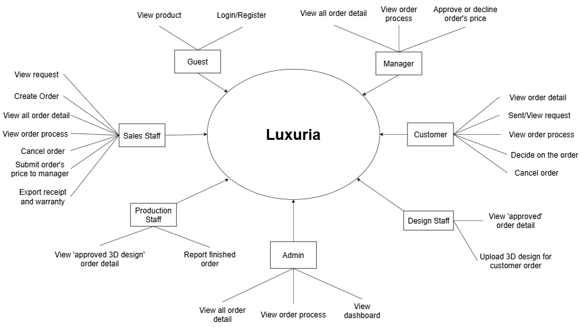

Figure 2 - Context diagram

## System Functions

1. Screen flow

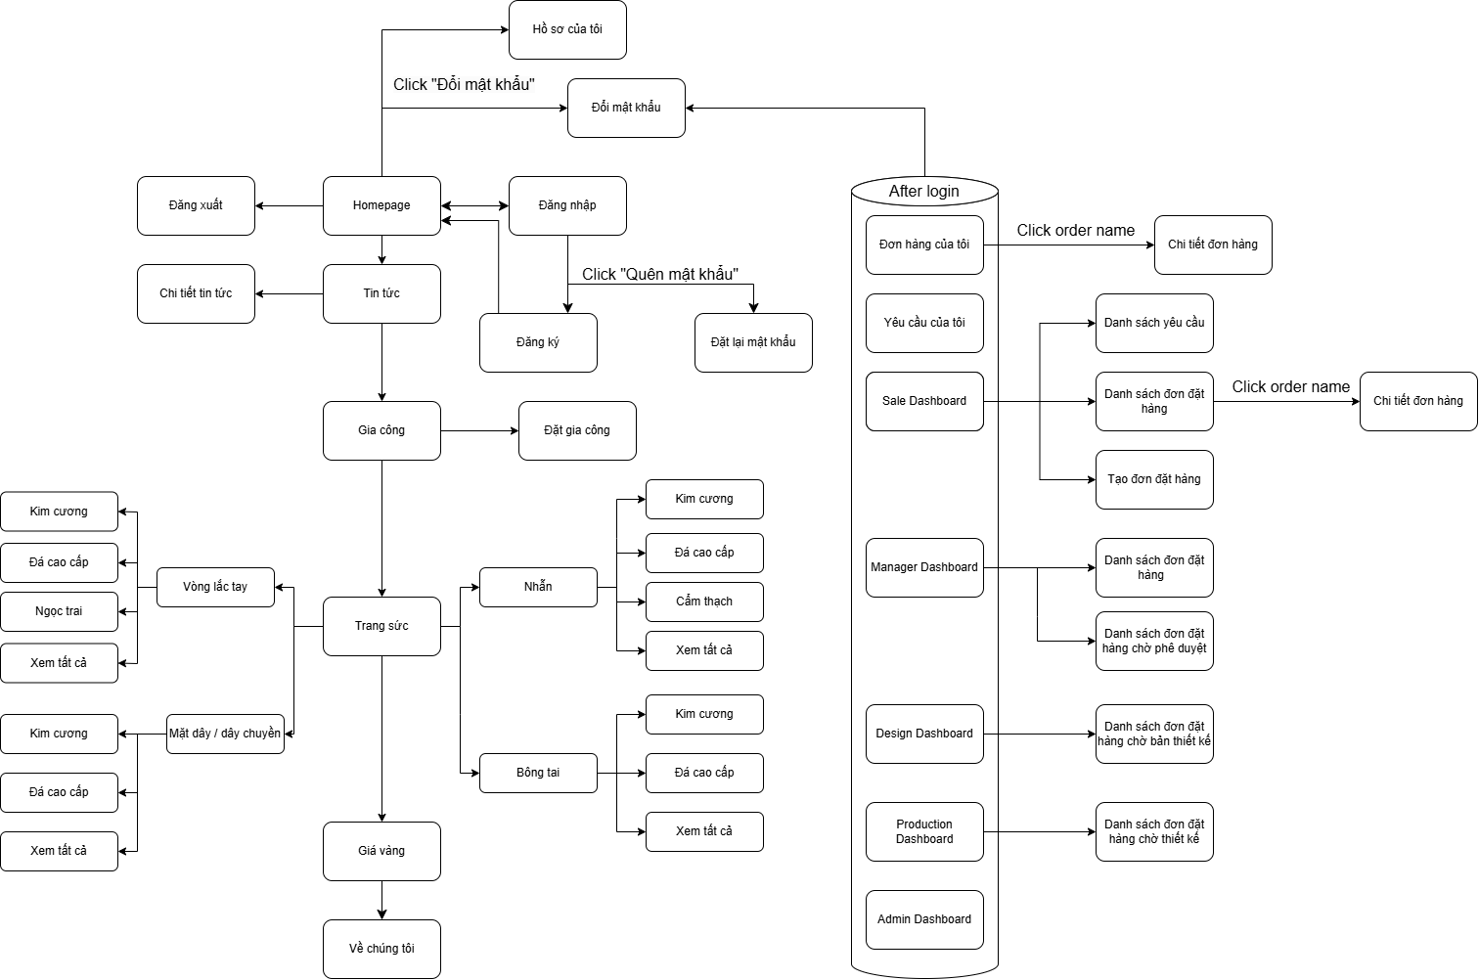

1. Screen detail

|  |  |  |
| --- | --- | --- |
| **Feature** | **Screen** | **Description** |
| Public | Home Page | the starting page of the system |
| Public | Tin tức | list of shared posts |
| Public | Chi tiết tin tức | detail of the shared post |
| Public | Gia công |  |
| Public | Trang sức |  |
| Public | Giá vàng |  |
| Public | Về chúng tôi |  |
| Common | Đăng nhập | authenticate the user to give him/her to access authorised features later on |
| Common | Đăng ký | register a new user into the system, verified by the registered email |
| Common | Đổi mật khẩu | change user’s login password |
| Common | Hồ sơ của tôi | view & edit/update user profile |
| Common | User Authorization | Authorization user into the system functions based on his/her role |
| Customer | Yêu cầu của tôi |  |
| Customer | Đơn hàng của tôi |  |
| Sales Staff, Admin | Danh sách yêu cầu |  |
| Sales Staff, Admin, Manager | Danh sách đơn đặt hàng |  |
| Sales Staff | Tạo đơn đặt hàng |  |
| Sales Staff, Manager, | Chi tiết đơn hàng |  |
|  |  |  |
|  |  |  |
|  |  |  |
|  |  |  |
|  |  |  |
|  |  |  |
|  |  |  |
|  |  |  |
|  |  |  |

## User Requirements



### Actors

|  |  |  |
| --- | --- | --- |
| **#** | **Actor** | **Description** |
| 1 | Administrator | The administrators who can view all request, orders and the admin dashboard |
| 2 | Production Staff | The staff who can view “approved 3D design” order and report finished orders |
| 3 | Design Staff | The staff who can view “approved price” orders from customers and the manager. They can upload pictures of 3D designs to customer orders |
| 4 | Manager | The manager who can view orders, track order processes, and approve or decline prices submitted by sales staff |
| 5 | Sales Staff | The staff who can view and confirm or decline requests, create and view orders and order processes, edit customer orders, and submit order prices to the manager. They can also view and export receipts or warranties |
| 6 | Customer | The customers who can make and cancel requests, view orders, and cancel orders before the price is approved by sales staff. They can also approve prices from sales staff or designs from design staff |
| 7 | Guest | Guests who can visit the web pages |

Table 11 - Actors list and description

12

### Use Cases

* + - 1. ***Diagram***

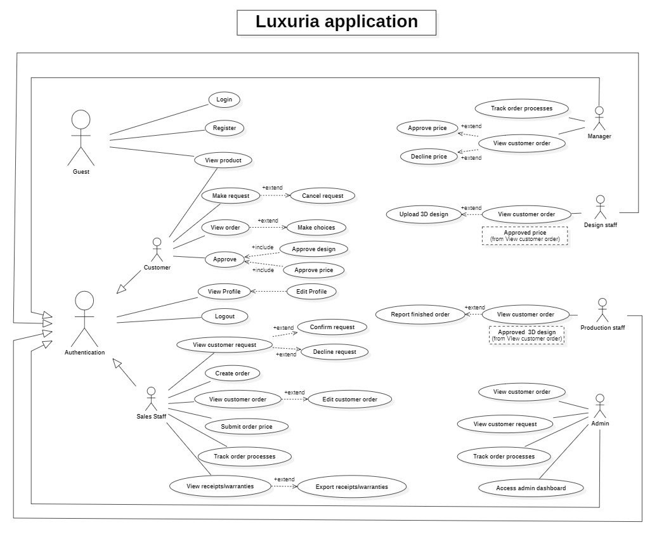

Figure 3 - <Use case overview> Luxuria Application

13

* + - 1. ***Use Case List***

|  |  |  |  |
| --- | --- | --- | --- |
| **ID** | **Use Case** | **Actors** | **Description** |
| UC01 | Register | Guest | Guest register for account |
| UC02 | Login | Guest | Unauthenticated player login to Luxria to verify role, and give them access to more features |
| UC03 | Logout | Customer, Sales Staff, Design Staff, Production Staff, Manager, Admin | This feature allows actors logout the web |