VU MINH THAI

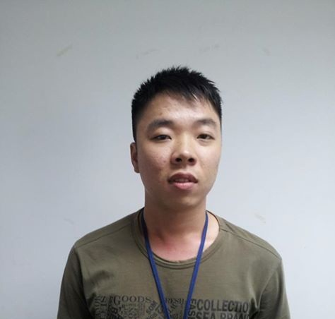

Software Engineer

SUMMARY

* A software engineer with 2 years of experience majored in software development on Windows, experienced in Java J2EE, Struts, Hibernate, Spring, JSP, Apache Tomcat, jQuery, SQL Server, Oracle, My SQL. Especially, experience fluently in Java and J2EE technologies to develop web-based applications.
* **Core Responsibilities**: Serve as a Software Engineer/Project developer. Have experiences in both software development and software testing. Responsible for main tasks and logic for projects.

TECHNICAL SKILLS

* **Programming Languages**: Java (JSP, Servlet, J2EE).
* **Scripting Languages**: HTML, Java Script, CSS, AJAX, jQuery, XML, JSON.
* **Database Management Systems**: SQL Server, Oracle, My SQL.
* **Frameworks/ Platforms**: Java, Spring, Spring MVC, Struts 1.2, Hibernate.
* **IDEs**: Eclipse, IntelliJ IDEA.
* **Application Server**: Apache Tomcat.
* **Operating Systems**: Windows.
* **Others:** Spring MVC RESTful Webservice, Maven.
* **Soft Skills**: Problem solving, communication. Positive attitude, teamwork & self-training skills.

EDUCATION

* **Ho Chi Minh City University Information of Technology** - Diploma in Information systems

PROFESSIONAL EXPERIENCE

06/2013 – Present

Java Web Service Developer/Software Engineer

Project: JIRA Plugin – Organization Chart, Resource Allocation.

* **Description:**
* The add-on for JIRA providing administrators the ability to manage roles of each user in project easily and also support RESTful Web Service.
* **Responsibilities**:
* Developed a RESTful Web Service for plugin.
* Teamwork, collaborate with other developers.
* **Accomplishments**:
* Fulfilled the needs of Software Developer within the defined scope of work.

**Technologies**: Java J2EE platform, XML, JSON, CSS/HTML/JavaScript, jQuery, Apache Velocity.

06/2012 – present (1+ year)

Java Web Service Developer/Software Engineer

Project: SmartTV Cloud Service.

* **Description:**
* Backend RESTful webservice development.
* Modules integration, management.
* Server environment configuration.
* Server architecture maintaining.
* **Responsibilities**:
* Design, create project modules structure.
* Performed configuration management tasks.
* Control deployment, source code versioning process.
* Develop RESTful WebService.
* Integrate with client-server/server-server authentication module using Oxauth.
* Operate backend team.
* Monitor, maintain server stability, scalability.
* **Accomplishments**:
* Fulfilled the needs of backend developer, server maintainer within the defined scope of work.

**Technologies**: Java J2EE platform, Jersey, JPA, Eclipselink, Maven, XML, JSON, CSS/HTML/JavaScript, jQuery.