Bài tập về nhà ngày 24/7

Bài 2.1:

Code:

#include<iostream>

using namespace std;

int main(){

int n;

cout<<"Nhap vao so nguyen n: ";

cin>>n;

int dem=0;

while(n>=10){

n/=10; // hay n = n /10;

dem++;

}

cout<<"So luong chu so cua so nguyen la: "<<dem+1<<endl;

}

Chạy:

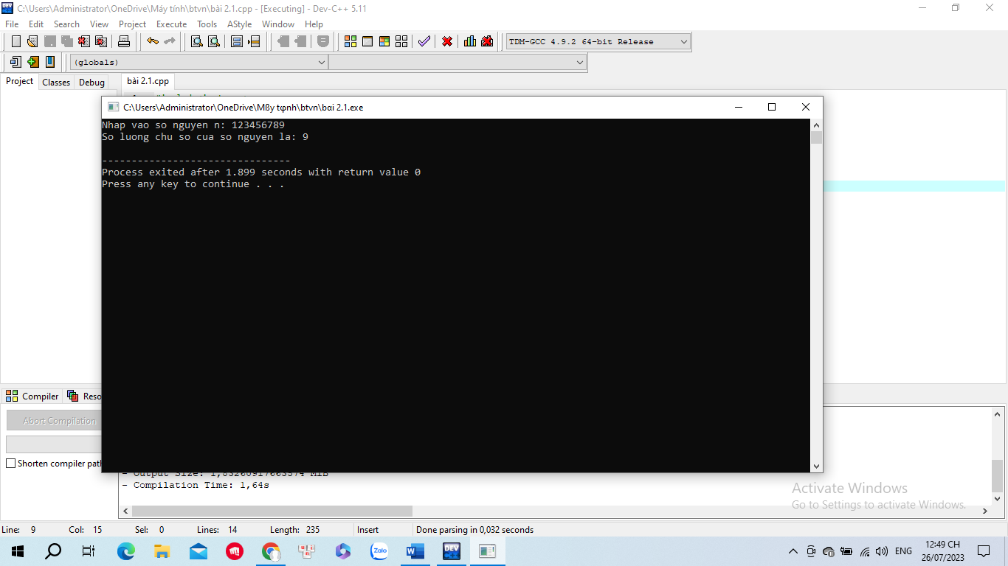

Bài 2.2:

Code:

#include <iostream>

using namespace std;

int main(){

int so;

int soTemp;

int tong = 0;

cout<<"Nhap so: ";

cin>>so;

soTemp= so;

while(soTemp!= 0) {

tong += soTemp % 10;

soTemp /= 10;

}

cout<<"Tong cac chu so cua so "<<so<<" la "<<tong<<endl;

return 0;

}

Chạy:

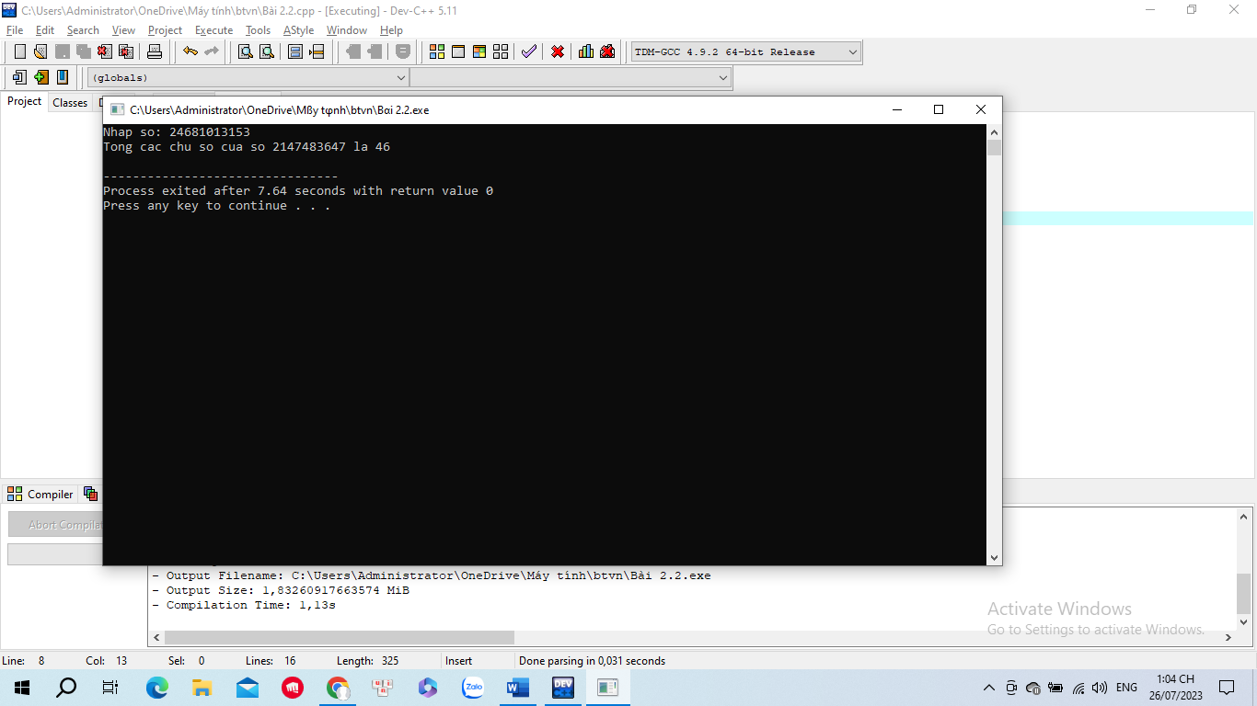

Bài 2.3:

Code:

#include <iostream>

using namespace std;

int main() {

int n, sum = 0;

cout<<"Nhap vao so nguyen duong n: ";

cin>>n;

for(int i=1; i<n; i+=2){

sum= sum+i;

}

cout<<"Tong cac so le tu 1 den "<<n<<" là: "<<sum;

return 0;

}

Chạy:

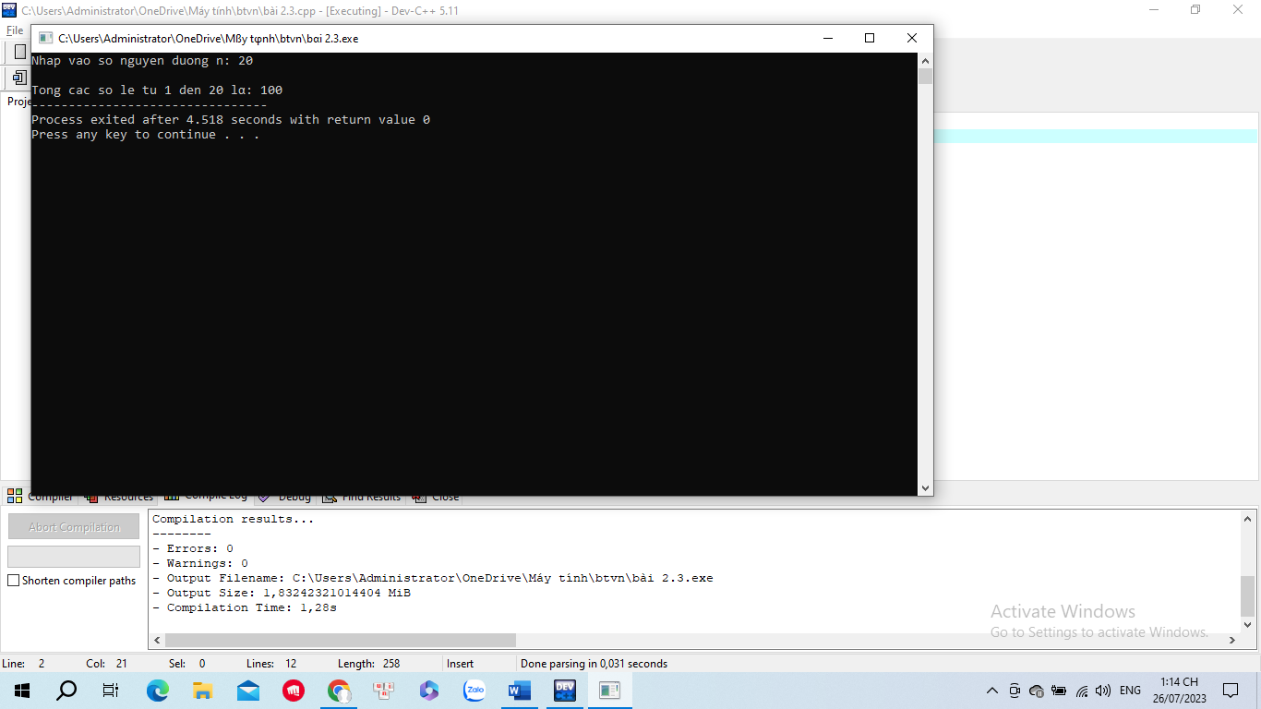

Bài 2.4:

Code:

#include<iostream>

using namespace std;

int main()

{

long temp, n;

int s = 0;

do

{

cout<<"Nhap vao so nguyen n lon hon 0: ";

cin>>n;

if(n <= 0)

{

cout<<"So n phai lon hon 0, nhap lai"<<endl;

}

}while(n <= 0);

temp = n;

while(temp != 0)

{

if(temp % 2 == 0)

{

s = s + temp % 10;

}

temp = temp / 10;

}

cout<<"Tong cac chu so chan cua "<<n<<" la: "<<s;

return 0;

}

Chạy:

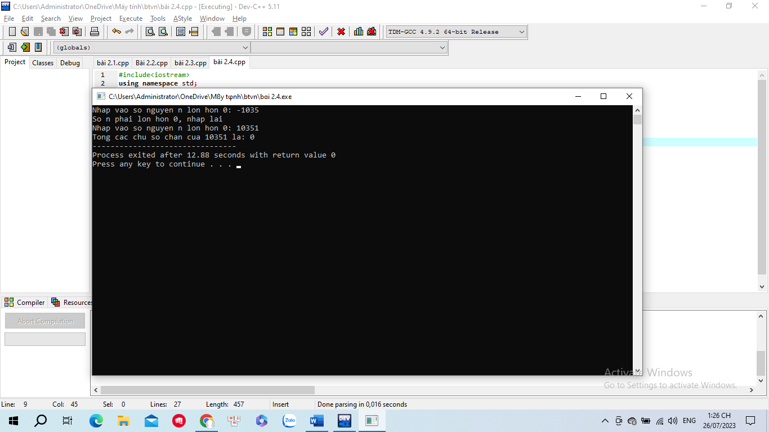

Bài 2.5:

Code:

#include <iostream>

using namespace std;

int main(){

int n, tmp;

cout<<"Nhap n: ";

cin>>n;

int res= 0;

while(n>0){

tmp= n % 10;

res= res \* 10 + tmp;

n= n / 10;

}

cout<<"So dao cua n la: "<<res;

return 0;

}

Chạy:

