Turki Haj Mohamad ME 8204 (Project Proposal) 3/14/2018

**Modeling and Control of LBR iiwa 7 R800**

For this project LBR iiwa 7 R800 from KUKA Laboratories was chosen to be studied. The iiwa 7 is an adaptive manipulator that can work in a collaboration with human environment as shown in fig. 1. This light weight robot can be used for handling, machining, and assembly processing. In fig. 2 (a) the main robot assemblies are shown where (1) in-line wrist, (2) joint module and (3) base frame. The iiwa 7 consists of 7 joints (7 degree of freedom) which means it is a redundant robot. The robot axes are shown in Fig.2 (b).

Figure 2: (a) LBR iiwa 7 R800 assemblies.

(b) LBR iiwa 7 R800 7 axes.

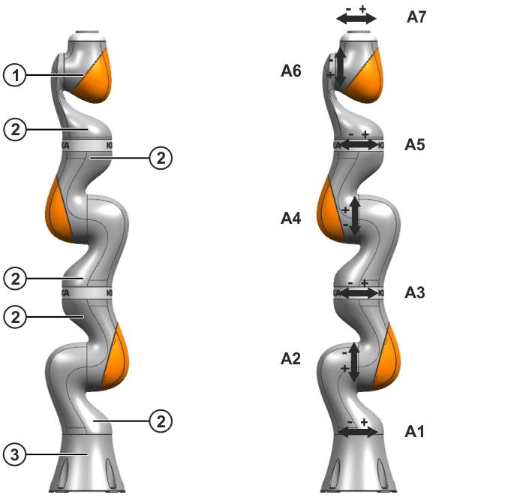

(a)

(b)

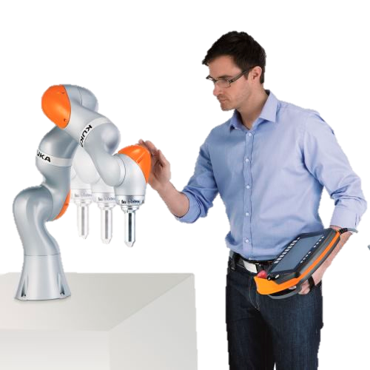

Figure 1: LBR iiwa 7 R800-human

collaboration.

Table 1 shows some basic data of the iiwa 7 such as the number of axes and controlled axes, the total robot weight, the maximum robot reach. The working envelope of iiwa 7 and the allowed angle ranges for each axis are shown in fig. 3.

Table 1: Technical data of LBR iiwa 7 R800

|  |  |
| --- | --- |
|  | **LBR iiwa 7 R800** |
| Number of axes | 7 |
| Number of controlled axes | 7 |
| Volume of working envelope | 1.7 m³ |
| Weight | 23.9 kg |
| Maximum reach | 800 mm |
| Mounting position | Floor, Ceiling, Wall |



Figure 3: The working envelope of LBR iiwa 7 R800

This project is divided into three parts: 1) Kinematic and dynamic modeling 2) Trajectory planning 3) Control. In the first part, the DH table will be constructed then the DH matrices will be determined. The inverse position solution will be derived to determine the unknown joint variables. The Jacobian matrix can be calculated using the position of the end effector and the DH matrices which will be a $(6×7)$ matrix. Because we have a redundant robot (7 degree of freedom) the Jacobian matrix have to be converted to ($6×6$) matrix to be able to solve for the inverse velocity solution. This will give us infinity number of solutions for the same end effector velocity, but the best solution is one with the minimum joint velocity. The kinematic inverse solutions will be determined from the desired trajectory path of the end effector which is the second part of the project.

The equations of motion of the robot will be derived using Euler Lagrangian dynamics. The inertial parameter of the links for the iiwa 7 model obtained from KUKA website. By deriving the equations of motion the kinematic and dynamic modeling part is completed.

In the second part, a trajectory planning will be performed in order to achieve a circular trajectory. Note that, this task should take into consideration the allowed ranges of the joints. [I haven’t put so much thought on the desired trajectory and it can be changed if you have any suggestions.]

The last part is controlling the robot by performing a closed loop control to make the robot follow the desired trajectory.

References:

Hayat, Abdullah Aamir et al. “Dynamic Identification of Manipulator: Comparison between CAD and Actual Parameters.” (2015).

https://www.kuka.com/en-us/services/downloads

https://www.youtube.com/watch?v=q5TiEDbcADM