**Practical no. 1**

**Aim:** Print only the words that start with letter ‘s’ in the following statement.

**String Split():** Python String split() method in Python split a string into a list of strings after breaking the given string by the specified separator.

**For loop:** Python For loop is used for sequential traversal i.e. it is used for iterating over an iterable like String, Tuple, List, Set or Dictionary.

**Program:**

s="print only the word that starts with s in this sentence"

for i in s.split():

if i[0]=='s':

print(i)

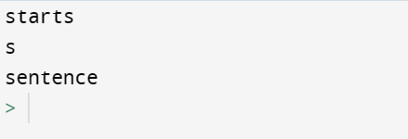**Output:**