Phase 1: Setup
- Fix the configuration. Decide the paths, window size (30), RUL cap (125), number of conditions (6), the dropped sensors, validation fraction, and seeds. Keep these in one place so you can log them later.
- Set up MLflow once. Point the tracking URI at your database, then select or create one experiment (for example cmapss_fd004_hybrid). Do this once at the start, not inside a loop. Calling “create experiment” repeatedly with the same name causes an error on the second pass.

Phase 2: Data preparation
- Load the training file (train_FD004) and compute the capped RUL from each engine’s last cycle. This step applies only to run-to-failure data.
- Choose the sensor columns. Keep all 21 sensors, then drop the near-constant ones.
- Split by engine. Randomly assign whole engines to train and validation. Never split windows, because overlapping windows from one engine would leak into both sets.
- Fit the preprocessor on the training engines only. That means the KMeans model and the per-condition sensor means and standard deviations. Save it to disk.
- Apply the preprocessor to the training engines, the validation engines, and later the benchmark test set. Never refit it on those.
- Build windows. Create stride-1 windows of 30 cycles for train and validation, each paired with the capped RUL at the window’s last cycle.
- Build the tabular features for XGBoost from the same windows: last value, short-term mean, short-term standard deviation, slope, and the cycle number.

Phase 3: Training (one MLflow run per configuration)
Start a new MLflow run for each configuration you want to compare, and give it a descriptive name.
- Log the parameters first: window size, RUL cap, dropped sensors, seeds, validation fraction, XGBoost settings, CNN-GRU settings, ensemble size, and the data file names.
- Train XGBoost with early stopping on the validation engines. Log its best iteration and validation RMSE.
- Train the CNN-GRU ensemble, one network per seed, with early stopping. Log each network’s validation RMSE and the number of epochs it ran.
- Tune the blend weight on the validation predictions. Log the weight, the blend’s validation RMSE, and the correlation between the two models’ errors.

Phase 4: Benchmark evaluation
- Prepare the official test set. Apply the saved preprocessor, take the last 30 cycles of each engine (padding short ones), and cap the true RUL from RUL_FD004.txt.
- Predict with all three models (XGBoost, CNN-GRU, blend) and compute RMSE and the NASA score for each.
- Log these as your main metrics, clearly named as test metrics, separate from the validation ones. This is the number to compare across runs.

Phase 5: Store the artifacts
- Log the saved files to the run: the preprocessor, the XGBoost model, each CNN-GRU network, the config with the blend weight and sensor list, and optionally a plot of predicted vs. true RUL.
- Register the final model (optional) if you want MLflow to keep named versions. Register the best run, not every run.
- Add tags such as dataset (FD004), model family (hybrid), and a short note on what you changed in this run.

Phase 6: Compare and iterate
- Change one thing per run, then compare runs in the MLflow UI by test RMSE and NASA score. Examples: window length, whether per-condition normalization is on, XGBoost depth, ensemble size. This is where your earlier identical-score problem is solved: runs now differ in a logged parameter.
- Repeat the best configuration with a few seeds and look at the mean and spread of test RMSE, so a lucky seed doesn’t mislead you.
- Pick the final run by test RMSE (and NASA score), not by validation RMSE alone.

Phase 7: Serving
- Load the artifacts from the chosen MLflow run in your API, so it uses the exact preprocessor and models that produced the logged scores.
- Check the API against the offline pipeline. Send one test engine’s history through the API and confirm the prediction matches what the offline evaluation gave for that engine. If they differ, there’s a preprocessing mismatch.

Common mistakes to avoid
- Creating the experiment inside the training loop
- Looping over identical settings, which logs the same score repeatedly
- Fitting the preprocessor on all engines or on the test set
- Reporting validation RMSE as if it were the benchmark score
- Logging metrics without the parameters that produced them
If you want, I can turn this into a checklist to track as you restructure your existing scripts, or help you decide which parameters are worth sweeping first.

Here’s the workflow as a flow, followed by what happens at each stage.
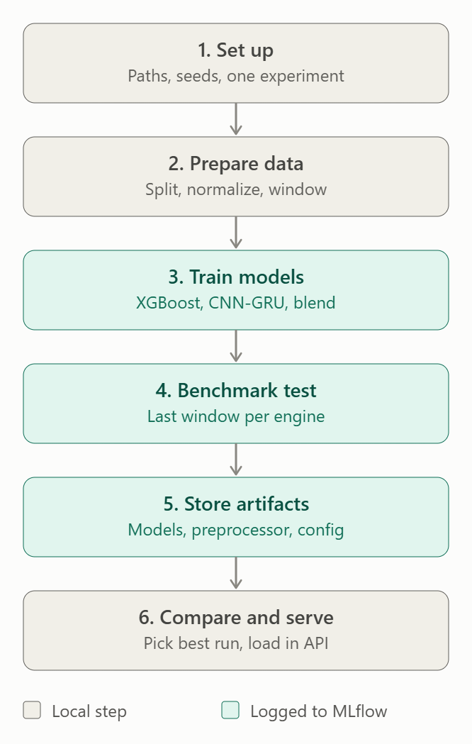
1. Set up
- Decide your paths, window size (30), RUL cap (125), seeds, and validation fraction in one place.
- Create the MLflow experiment once, at the start. Don’t create it inside a loop.
2. Prepare data
- Load train_FD004 and compute the capped RUL.
- Split by engine, not by window.
- Fit the preprocessor (KMeans plus per-condition statistics) on the training engines only, then apply it to everything.
- Build 30-step windows for the neural net and summary features for XGBoost.
3. Train models (start one MLflow run per configuration)
- First log the parameters: window size, seeds, XGBoost settings, CNN-GRU settings.
- Train XGBoost and the CNN-GRU ensemble.
- Tune the blend weight on the validation engines.
- Log the validation RMSE of each model and of the blend.
4. Benchmark test
- Apply the saved preprocessor to test_FD004, take the last 30 cycles per engine, and compare with RUL_FD004.txt.
- Log test RMSE and NASA score, named clearly as test metrics. This is the number to compare across runs.
5. Store artifacts
- Attach the preprocessor, XGBoost model, CNN-GRU models, and config (blend weight, sensor list) to the same run.
- Add tags such as dataset, model type, and what you changed.
6. Compare and serve
- Change one thing per run, then compare runs by test RMSE in the MLflow UI.
- Repeat the best setup with a few seeds to check it isn’t luck.
- Load the winning run’s artifacts in your API and check that one engine’s API prediction matches the offline result.
The teal boxes (3, 4, 5) are where data goes into MLflow. Everything before step 3 is local preparation, and the same prepared data is reused across runs. If your runs start giving identical scores again, check that each run logs a different parameter.

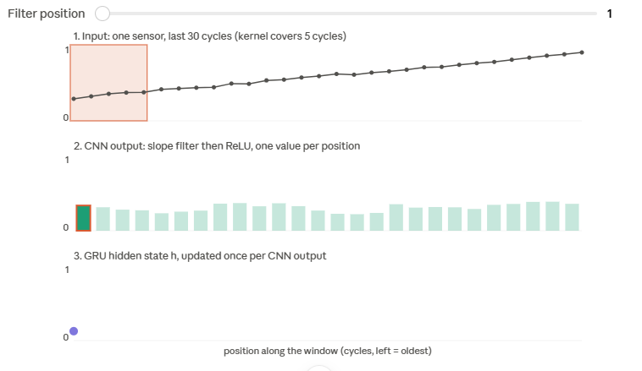
This is a toy version, not your real data. I can't read your X_tr from here, so the engines are made up: one sensor, 30 cycles, with a hand-picked slope filter and hand-set GRU weights. Your trained network learns many filters across all the sensors. The mechanics are the same, though.
How to read it
Drag the slider to move the CNN filter along the window.
- Panel 1: the orange box is the 5 cycles the filter sees at that position.
- Panel 2: the filter measures the local slope in that box and applies ReLU. That gives one number per position, 26 in total for a window of 30 with a kernel of 5.
- Panel 3: the GRU reads those 26 numbers in order. Its hidden state h is the running memory, and it updates once per position.
Try the two engines
- Engine B (steady drift): every CNN output is a small, similar value. h rises slowly and settles at a moderate level.
- Engine A (flat, then spike): the CNN outputs are about 0 for most of the window and jump only in the last 3 positions. h stays low, then jumps at the end.
The two engines end at the same sensor value but have different final h. The final dense layer takes that h and maps it to an RUL, which is how the model separates "slow wear" from "sudden blip".
To see this with your real model, pull one validation window and the CNN output for it:
x = X_val[0:1] # shape (1, window, n_features)
print(x.shape)
for l in net.layers:
print(l.name, l.output.shape) # find the last conv layer's name
conv = tf.keras.Model(net.inputs, net.get_layer("conv1d").output) # use your layer name
feat = conv.predict(x) # shape (1, steps, filters)
Plot x[0, :, k] for one sensor k next to feat[0, :, f] for one filter f, and you'll see the same pattern as panel 2.
What's the output of the print loop? Then I can tell you which layer name to use and what the shapes mean for your model.
what is the use of having z score over standard sensor values
Weighing per-condition normalization for the sensor readings.
Weighing per-condition normalization for the sensor readings.
There are two separate benefits. The second matters most for your data.
1. Putting sensors on the same scale
Raw C-MAPSS sensors have very different ranges. One might sit around 550 and another around 0.03. For the neural net, this causes problems:
- Large-valued sensors dominate the weight updates, so the net learns slowly or unevenly.
- Activations like tanh in the GRU saturate on large inputs.
After a z-score, every sensor has mean 0 and std 1, so each contributes comparably at the start of training. XGB doesn’t care about scale because trees only compare thresholds, so this benefit is for the NN.
2. Removing the operating-condition effect (per-condition z-score)
FD004 has 6 operating conditions (different altitude, Mach and throttle settings). A sensor’s value changes a lot between conditions, far more than the wear signal you want to detect.
Made-up numbers to show the idea:
Condition | Healthy engine | Worn engine
1 | 550 | 552
2 | 520 | 522
The degradation is +2, but the condition difference is 30. If an engine switches between conditions 1 and 2 across cycles, the raw sensor jumps around by 30 and hides the slow +2 drift.
With the per-condition z-score, each value is compared with the mean and std of its own condition. Both conditions now sit around 0, and a worn engine shows up as a small positive shift in both. The condition effect is gone and only the degradation remains.
A global z-score fixes issue 1 but not issue 2, so the per-condition version is what makes the sensors useful for RUL in FD004.

When I take an ensemble model of cnn-gru, a cnn slides a filter of 3 over the data. But my data has conditions intermittently. How does the filter make out that the filter has values for different operating conditions?
Weighing normalization against adding condition inputs
The filter can’t tell. It only sees numbers, so it has no idea which operating condition produced them. The per-condition z-score is what makes this work.
What the filter actually sees
A Conv1D with kernel size 3 covers 3 consecutive cycles and all sensor columns at once, so its weights have shape (3, n_sensors) per filter. It multiplies those numbers by its weights and sums them. Nothing in that operation knows about conditions.
Why it still works after your z-score
Each row was normalised against its own condition’s mean and std. So even if cycle 10 is condition 1 and cycle 11 is condition 4, both rows are now expressed as “how far from normal for this condition”. The jumps from condition switching are gone, and the filter sees a smooth signal that only changes with degradation.
Without this step, a switch from condition 1 to 4 would look like a sudden jump of 30 units. The filter would treat it as a spike or slope and pass it on as a feature, and the GRU would take it as a real event.
Where it can still go wrong
- Imperfect clustering: if a cycle is assigned to the wrong condition, it gets normalised with the wrong mean and std. This produces small jumps the filter can’t distinguish from real change.
- Condition-dependent behaviour: a degraded engine may respond differently in each condition, not just shift by a constant. Mean and std only remove the constant shift, so some leftover condition effect can remain.

Approach | Matrix Size for XGBoost | Pros | Cons
Raw Flattened (Your Idea) | (100, 61) | • Doesn't lose any raw data details.  • Simplest code. | • Treates time step 1 and time step 2 as totally unrelated columns (XGBoost loses sequential awareness).  • Vulnerable to overfitting if the data is noisy.
Engineered Features (Original Code) | (100, 9) | • Summarizes trends explicitly for the model.  • Highly resilient to random noise.  • Trains much faster. | • Permanently throws away fine-grained, step-by-step details.

