Dataset: FD004
Columns
Columns | Description | Ignored Status
OP_Setting1 | Altitude
OP_Setting2 | Mach Number
OP_Setting3 | Throttle
Sensor_1 |  | IGNORED
Sensor_2
Sensor_3
Sensor_4
Sensor_5 |  | IGNORED
Sensor_6 |  | IGNORED
Sensor_7
Sensor_8
Sensor_9
Sensor_10 |  | IGNORED
Sensor_11
Sensor_12
Sensor_13
Sensor_14
Sensor_15
Sensor_16 |  | IGNORED
Sensor_17
Sensor_18 |  | IGNORED
Sensor_19 |  | IGNORED
Sensor_20
Sensor_21

Columns OP_Settings_1,2 and 3 represent operation settings. There are 6 such settings options:
Condition / Profile | Setting 1 (Altitude / Input) | Setting 2 (Mach Number) | Setting 3 (Throttle / Power)
Profile 1 | 0.0 | 0.0005 | 100.0
Profile 2 | 10.0 | 0.2500 | 20.0
Profile 3 | 20.0 | 0.7000 | 40.0
Profile 4 | 35.0 | 0.8400 | 60.0
Profile 5 | 42.0 | 0.8400 | 40.0
Profile 6 | 25.0 | 0.6200 | 60.0

Steps that were used to build the models:
- Read CSV values from the table and drop columns that are not required. Refer to table above.
- Find the six operating profiles/clusters from the dataset using K-Means clustering.
- Why is this important? The sensor readings vary widely between each operational profile. The sensor readings are affected by various environmental and operational factors and vary accordingly with operational profiles.
- Output of this operation will give an array that denotes operational profile for each row in the table.
- Perform pre-processing on data:
- This is important because wide jump in sensor readings across adjacent profiles can throw the learning process off.
- Hence we use Z-Score during preprocessing.
Z=(value-mean)/std
- Z-score is calculated for each sensor reading/row based on operating profile and mean and std for that profile.
- FD004 has 6 operating conditions (different altitude, Mach and throttle settings). A sensor’s value changes a lot between conditions, far more than the wear signal you want to detect.
- Made-up numbers to show the idea:
Condition | Healthy engine | Worn engine
1 | 550 | 552
2 | 520 | 522
- The degradation is +2, but the condition difference is 30. If an engine switches between conditions 1 and 2 across cycles, the raw sensor jumps around by 30 and hides the slow +2 drift.
- With the per-condition z-score, each value is compared with the mean and std of its own condition. Both conditions now sit around 0, and a worn engine shows up as a small positive shift in both. The condition effect is gone and only the degradation remains.

Model Selection:
- Two models were evaluated to provide better performance:
XGBoost
CNN-GRU

- XGBoost:
- Can contain a maximum of 1500 tress with a max depth of 5 nodes.
- From previous evaluation cycles, XGBoost was found to have the lowest RMSE and MAE.
- CNN-GRU:
- Contains two Convolution Layers with 64 filters/kernels of size 3 each, Bidirectional GRU layer with 64 neurons, GRU layer with 32 neurons and 32 dense layers.

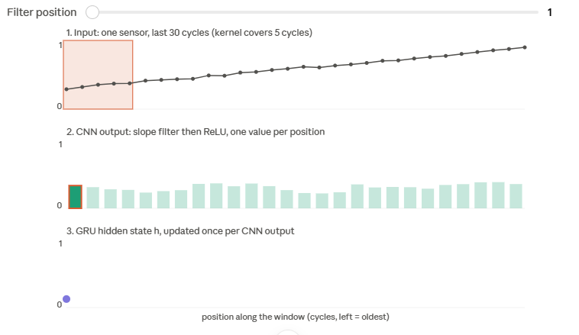
- CNN uses a filter of size 3 moving over 3 rows at a time. This helps capture dependencies over short term of 3 rows. GRU can use a consolidation of n windows of size 3 to capture long term dependencies.

- The below images show two engines where one has gradual degradation and other has a sudden spike.

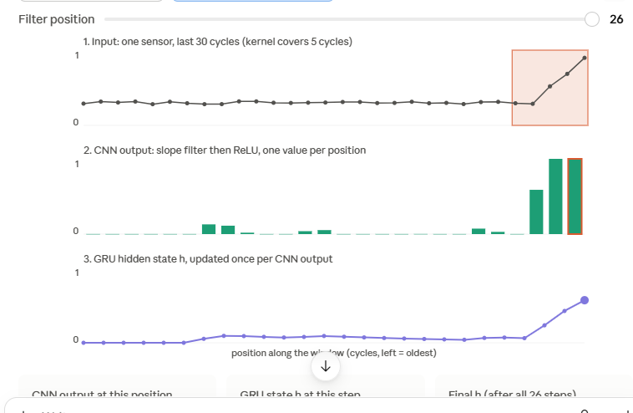

- Blended Model Selection:
Formula = 0.45*(Prediction from CNN-GRU) + (1-0.45)*(Prediction from XGBoost)

- Model Selection Results:
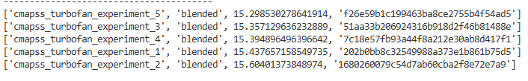

- Results on Test_004 Dataset
- 11 engines had less than 30 readings. These were padded to give us 30 readings.
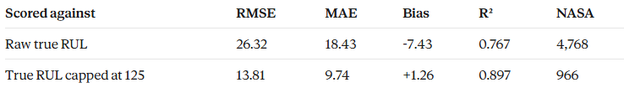
- Error in various RUL Ranges can be found below:

- 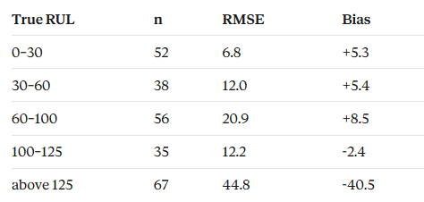The 67 engines with true RUL above 125 can’t be predicted correctly: true
195 is predicted as 115, 192 as 124, and so on. Against the capped truth, RMSE drops from 26.32 to 13.81.
- For true RUL under 30, 50 of 52 predictions are above the true value. The error is small (RMSE 6.8)

