RAJALAKSHMI ENGINEERING COLLEGE
(An Autonomous Institution)
THANDALAM, CHENNAI

PROJECT REPORT
ON
JUSTALITRE – EMERGENCY FUEL DELIVERY SYSTEM
Integrated Object Oriented Programming and Database Management Systems Project

Submitted by
THAMIZHSELVAN V – 250701780
THAKSHES K – 250701779
VENMATHI I – 250701820
SUVANITHA SRI S - 250701766
of
BACHELOR OF ENGINEERING
in
COMPUTER SCIENCE AND ENGINEERING

Project Guide
Dr. G. Dharani Devi
Associate Professor
Department of Computer Science and Engineering



November 2026
RAJALAKSHMI ENGINEERING COLLEGE
BONAFIDE CERTIFICATE

Certified that this project report titled “JUSTALITRE – EMERGENCY FUEL DELIVERY SYSTEM” is the bonafide work of the following students of the Department of Computer Science and Engineering, who carried out the project work under my supervision.
Name | Register Number
Thamizhselvan V | 250701780
Thakshes K | 250701779
Venmathi I | 250701820
Suvanitha Sri S | 250701766

The project is submitted in partial fulfilment of the requirements for the integrated Object Oriented Programming and Database Management Systems project during the academic year 2026–2027.

PROJECT GUIDE
Dr. G. Dharani Devi
Associate Professor
Department of Computer Science and Engineering

INTERNAL EXAMINER | EXTERNAL EXAMINER

DECLARATION
We hereby declare that the project report entitled “JUSTALITRE – EMERGENCY FUEL DELIVERY SYSTEM” is the work carried out by us under the guidance of Dr. G. Dharani Devi, Associate Professor, Department of Computer Science and Engineering, Rajalakshmi Engineering College.
We further declare that this work has not been submitted, either in full or in part, for the award of any other degree or diploma.

Student Name | Register Number | Signature
Thamizhselvan V | 250701780
Thakshes K | 250701779
Venmathi I | 250701820

ACKNOWLEDGEMENT
We express our sincere gratitude to the management of Rajalakshmi Engineering College for providing the facilities and support required to complete this project.
We thank the Head of the Department and the faculty members of the Department of Computer Science and Engineering for their encouragement and academic support.
We convey our special thanks to our project guide, Dr. G. Dharani Devi, Associate Professor, for her guidance, suggestions and valuable feedback throughout the development of this project.
Finally, we thank our parents and friends for their support and encouragement during the completion of this work.

ABSTRACT
JustALitre is an emergency fuel delivery web application designed to help vehicle users who run out of fuel while travelling. The application allows a customer to request a limited quantity of petrol or diesel and provide the vehicle type, contact details, payment preference and delivery location. The system calculates the fuel cost, delivery fee and applicable night surcharge, then stores the order in a MySQL database.
The application is developed using Java 17, Spring Boot, Thymeleaf and MySQL. Spring Data JPA is used for database persistence. The dispatch module allows an administrator to log in, add delivery partners, view orders, assign available partners, update delivery status, verify a four-digit OTP and cancel orders. A customer can view the order status, assigned partner and order cost details.
The project demonstrates object-oriented programming concepts through entity classes, service classes, repositories and a controller-based application structure. Database concepts are demonstrated through the partners and orders tables and their relationship. The implementation provides a simple web-based workflow for emergency fuel ordering and dispatch management.

3TABLE OF CONTENTS
CHAPTER | CONTENTS
1 | INTRODUCTION
1.1 | Problem Statement
1.2 | Project Overview
1.3 | Purpose
1.4 | Scope
2 | FUNCTIONALITIES PROVIDED
3 | SYSTEM DESIGN
3.1 | System Flow Diagram
3.2 | Data Flow Description
3.3 | Use Case Description
3.4 | Entity Relationship Diagram
4 | MODULE DESCRIPTION
5 | IMPLEMENTATION
5.1 | Customer Home and Order Form
5.2 | Order Processing and Pricing
5.3 | Partner and Dispatch Management
5.4 | Order Tracking and OTP Verification
5.5 | Database Implementation
6 | TESTING
7 | CONCLUSION AND FUTURE ENHANCEMENTS
8 | REFERENCES
APPENDIX A | JAVA SOURCE CODE
APPENDIX B | OUTPUT SCREENSHOTS

1. INTRODUCTION

1.1 PROBLEM STATEMENT
A vehicle running out of fuel on a road can cause inconvenience, delay and safety concerns. The user may have difficulty reaching a fuel station, especially when stranded away from a familiar location. Conventional solutions may require the user to arrange assistance independently. A simple system is therefore needed to submit an emergency fuel request and coordinate its fulfilment through registered delivery partners.

1.2 PROJECT OVERVIEW
JustALitre is a web-based emergency fuel delivery and dispatch management system. Customers can select a vehicle, choose petrol or diesel, specify a quantity from 2 to 5 litres, enter their contact information and provide a delivery location. The application records the order and calculates the amount payable.
An administrator uses the dispatch interface to manage delivery partners and orders. Available partners are assigned to waiting orders in order sequence. The customer tracking page displays the current status, partner details when assigned, OTP and cost breakdown.

1.3 PURPOSE
- To provide a simple web interface for requesting a small quantity of emergency fuel.
- To record customer, vehicle, fuel, quantity, location and payment information.
- To calculate fuel cost, delivery fee and night surcharge consistently on the server.
- To maintain partner availability and assign available partners to pending orders.
- To support delivery status updates and OTP-based confirmation.
- To store order and partner information in a relational database.

1.4 SCOPE
The implemented scope includes customer order placement, server-side input validation, price calculation, database storage, partner registration, automatic assignment of the first available partner, dispatch status updates, order cancellation and OTP verification during delivery. The customer provides the location as text. The supplied Java implementation does not implement GPS-based location capture or nearest-partner distance calculation. Payment options are recorded as UPI or cash; the source code does not include a payment gateway integration.

2. FUNCTIONALITIES PROVIDED
- Customer order form for bike or car, petrol or diesel, and 2–5 litres.
- Customer details validation, including a 10-digit phone number and mandatory location.
- Server-side calculation of fuel cost, delivery fee, night surcharge and total amount.
- Generation of a four-digit delivery OTP.
- Storage of orders and partner details in MySQL.
- Administrator login using a configurable admin key stored in application settings.
- Partner registration and availability display.
- Automatic assignment of pending orders to the first available partner by partner ID.
- Order status progression through NEW, ASSIGNED, ON_THE_WAY and DELIVERED, with CANCELLED as a terminal status.
- OTP validation before marking an order as delivered.
- Automatic refresh of the dispatch page every 30 seconds and active tracking page every 10 seconds.

3. SYSTEM DESIGN

3.1 SYSTEM FLOW DIAGRAM
The following flow represents the implemented application sequence.
CUSTOMER
|
v
Open JustALitre home page
|
v
Enter vehicle, fuel, litres, contact and location
|
v
Server-side validation
| invalid
+--------------------> Display error and return to form
|
valid
v
Calculate price and generate OTP
|
v
Save order in MySQL (status: NEW)
|
v
Assign first available partner, if available
|
v
Customer tracking page
|
v
ADMIN DISPATCH: update status / cancel / verify OTP
|
v
DELIVERED or CANCELLED

3.2 DATA FLOW DESCRIPTION
The customer submits order details through the Thymeleaf form. The WebController receives the request and calls OrderService. OrderService validates the fields, calculates the charges, generates the OTP and saves the FuelOrder through OrderRepository. It then attempts to assign a free Partner through PartnerRepository. The tracking page retrieves the saved order and displays its details. The administrator uses the dispatch controller routes to manage partners and update order status.

3.3 USE CASE DESCRIPTION
Actor | Use Case | Description
Customer | Place fuel order | Submits vehicle, fuel, quantity, contact, location and payment details.
Customer | Track order | Views order status, assigned partner, OTP and cost details.
Administrator | Login / Logout | Accesses or exits the dispatch dashboard using the configured admin key.
Administrator | Manage partners | Adds partners and views whether each partner is free or busy.
Administrator | Manage orders | Views orders, marks assigned orders as on the way, cancels orders and confirms delivery.
Administrator | Verify OTP | Enters the customer OTP before completing delivery.

3.4 ENTITY RELATIONSHIP DIAGRAM
PARTNERS
-------------------------
id PK
name
phone
available
1
|
| one partner may be linked to multiple orders over time
|
M
ORDERS
-------------------------
id PK
customer_name
phone
vehicle
fuel_type
litres
location
payment
fuel_cost
delivery_fee
night_fee
total
status
otp
partner_id FK -> partners.id
created_at
The partners table stores delivery partner information and availability. The orders table stores customer order details and contains partner_id as a foreign key referencing partners.id. An order can remain without a partner while its status is NEW. Once assigned, partner_id identifies the allocated partner.

4. MODULE DESCRIPTION

4.1 CUSTOMER MODULE
The customer module presents the home page and fuel request form. It accepts the vehicle category, fuel type, quantity, customer name, phone number, location and payment preference. The form restricts the available quantity choices to 2, 3, 4 or 5 litres.

4.2 ORDER PROCESSING MODULE
The OrderService class validates the submitted values. It accepts PETROL or DIESEL, BIKE or CAR, UPI or CASH, a 10-digit phone number, a non-empty name and location, and a quantity between 2 and 5 litres. It calculates the fuel cost using the configured per-litre rate. A night surcharge is applied between 10:00 PM and 6:00 AM.

4.3 PARTNER MANAGEMENT MODULE
The administrator can add a delivery partner by entering a name and a valid 10-digit phone number. Each partner has an availability flag. A partner is marked busy when assigned an order and becomes available again when the associated order is delivered or cancelled.

4.4 DISPATCH MODULE
The dispatch dashboard lists partners and orders. An administrator can move an ASSIGNED order to ON_THE_WAY, submit the OTP to complete delivery, or cancel an open order. The page refreshes automatically every 30 seconds.

4.5 TRACKING MODULE
The tracking page displays the order number, status, assigned partner information, order details and price breakdown. The page refreshes every 10 seconds while the order is active. The OTP is shown only to the browser session that placed the order.

4.6 DATABASE MODULE
The database module uses MySQL. Spring Data JPA repositories provide persistence operations for FuelOrder and Partner entities. Hibernate is configured with ddl-auto=update, and a schema.sql file is also supplied to describe the partners and orders tables.

5. IMPLEMENTATION

5.1 TECHNOLOGIES USED
Technology | Purpose
Java 17 | Application programming language and object-oriented implementation.
Spring Boot 3.3.4 | Application framework and embedded web server.
Spring Web | HTTP request mapping and controller handling.
Thymeleaf | Server-side HTML template rendering.
Spring Data JPA / Hibernate | Object-relational mapping and database access.
MySQL | Relational database for orders and partners.
Maven | Dependency management and project build.

5.2 CUSTOMER HOME AND ORDER FORM
The home page presents the emergency fuel service and the order form. The user selects the vehicle, fuel type, quantity and payment mode, then enters name, phone number and a text location. The implementation in the supplied source code uses a manually entered location; GPS-based location retrieval is not implemented in the Java source.
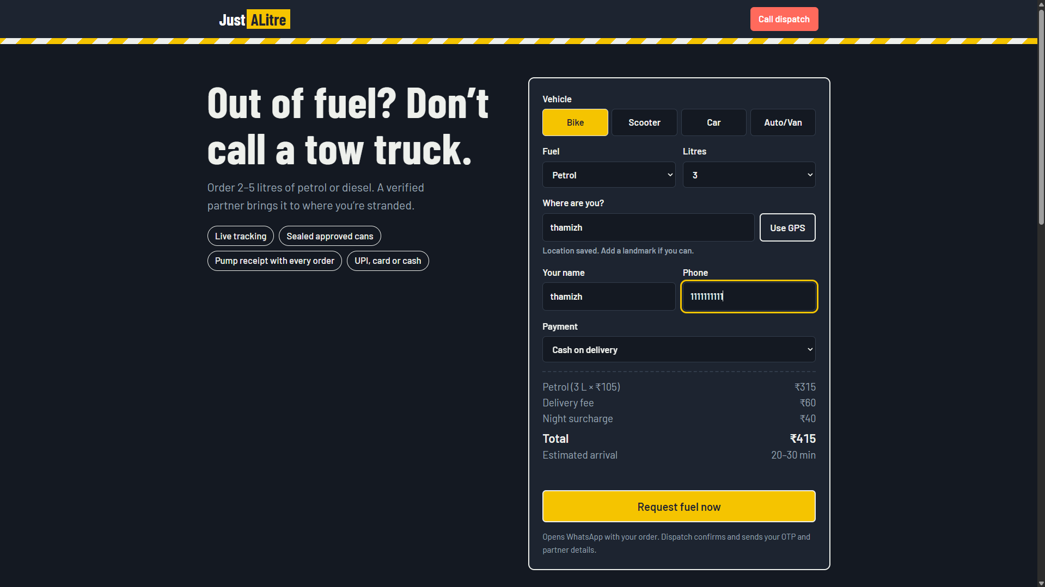
Figure 5.1: JustALitre customer home page and fuel request form

5.3 ORDER PROCESSING AND PRICING
The configured default rates in application.properties are ₹105.00 per litre for petrol, ₹94.00 per litre for diesel, ₹60.00 delivery fee and ₹40.00 night fee. The night fee is applied when the server time is from 10:00 PM to before 6:00 AM. The final amount is calculated on the server as fuel cost plus delivery fee plus night fee.
For example, a three-litre petrol order at the configured petrol rate has a fuel cost of ₹315.00. With a ₹60.00 delivery fee and no night surcharge, the total is ₹375.00.
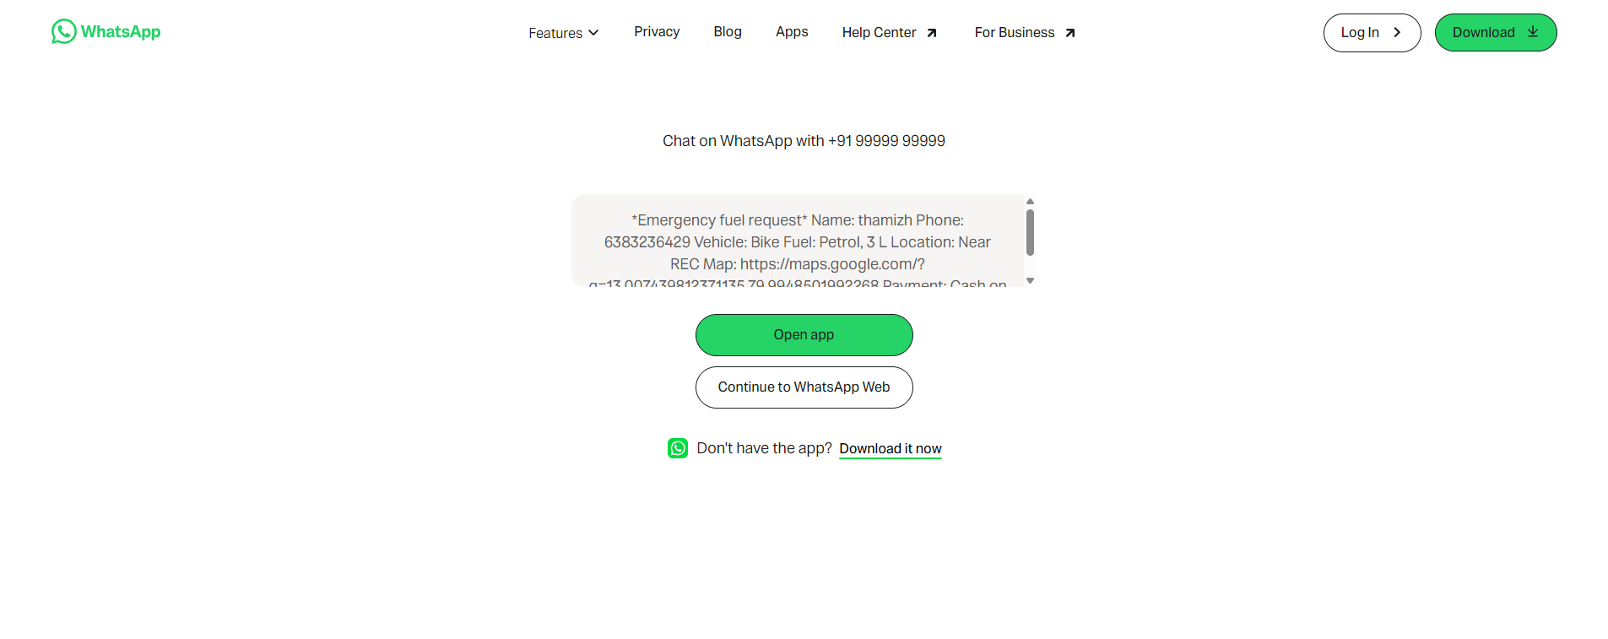
Figure 5.2: Order submission interface / order confirmation view supplied for the project

5.4 WHATSAPP HANDOFF SCREENSHOT
A WhatsApp handoff screen was included among the supplied project screenshots. It illustrates an order message prepared for dispatch communication. The submitted source code archive, however, does not contain a WhatsApp API integration or WhatsApp message-sending implementation. The implemented Java flow saves the order and redirects the customer to the tracking page.
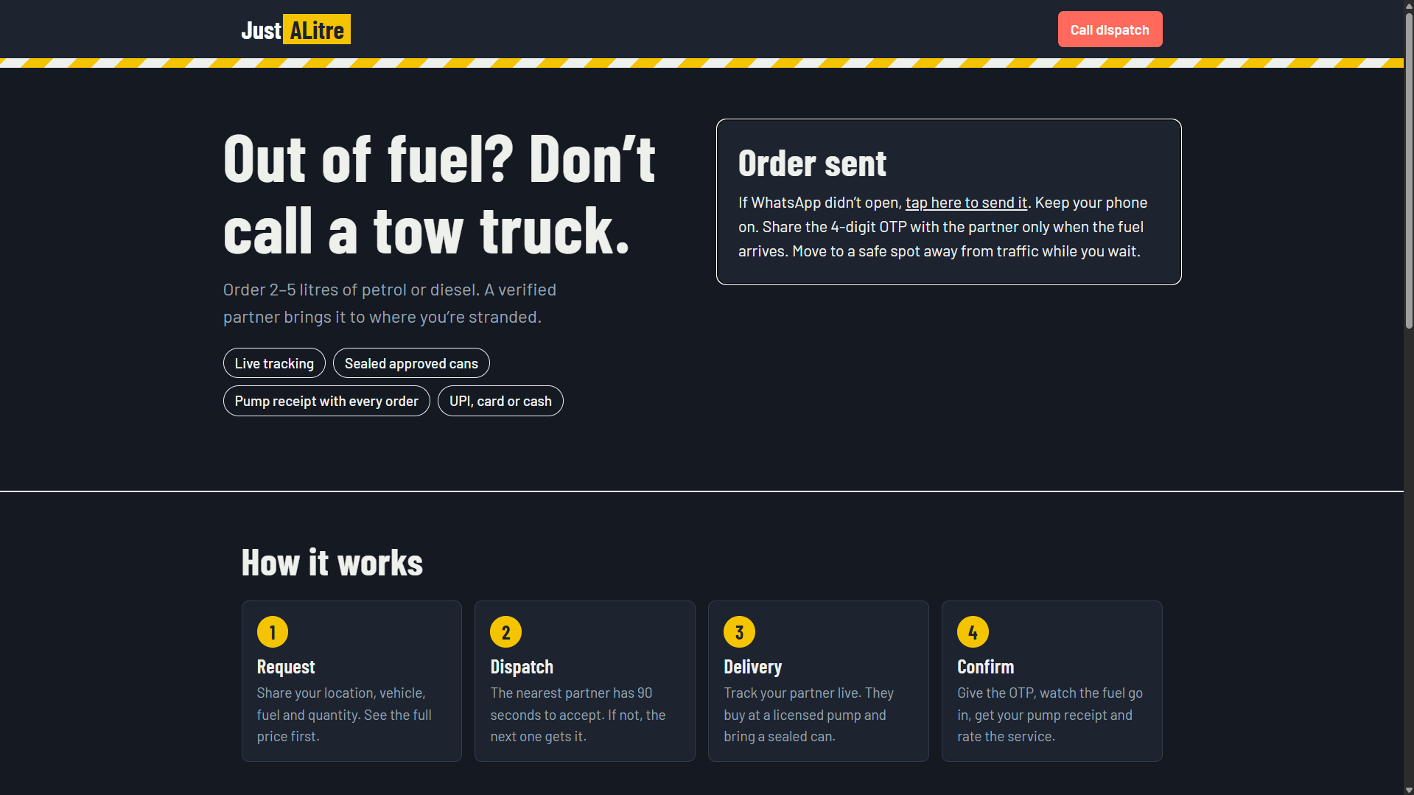
Figure 5.3: Supplied WhatsApp order handoff screen

5.5 PARTNER AND DISPATCH MANAGEMENT
The administrator accesses the dispatch dashboard after successful login. The dashboard displays partner records, their phone numbers and availability, together with the order list. An administrator can add partners, update order progress, verify delivery OTPs and cancel orders. The dispatch page refreshes every 30 seconds.
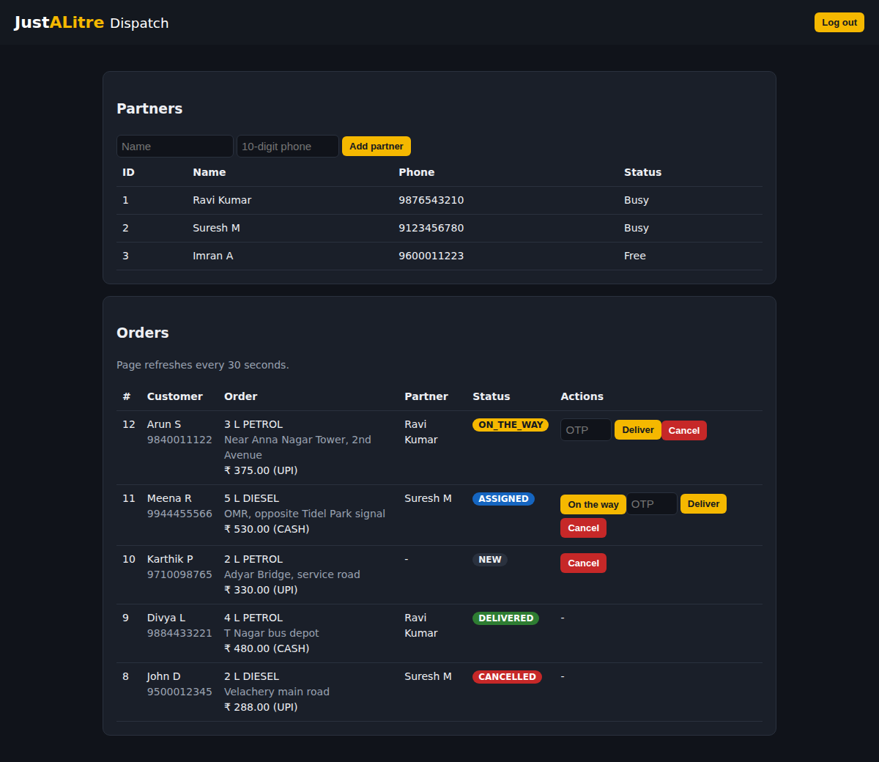
Figure 5.4: Administrator dispatch dashboard

5.6 ORDER TRACKING AND OTP VERIFICATION
When an order is created, the application generates a four-digit OTP using SecureRandom. The tracking page displays the OTP to the browser session that placed the order. The administrator must enter the matching OTP to mark an order as DELIVERED. A wrong OTP is rejected. Once delivery or cancellation is completed, the partner is marked available and pending orders are considered for assignment.
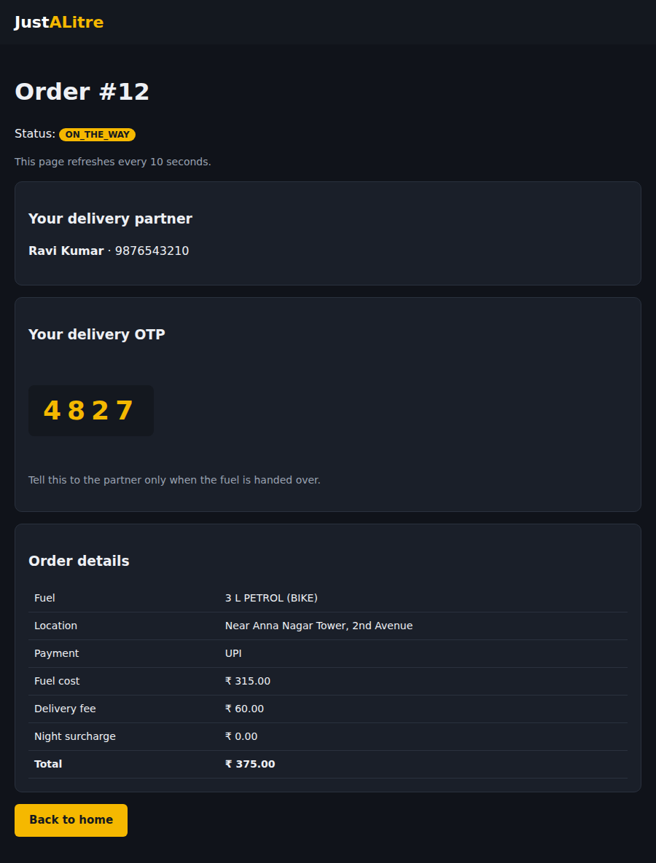
Figure 5.5: Customer order tracking page showing partner, OTP and price details

5.7 DATABASE IMPLEMENTATION
The supplied schema defines two tables: partners and orders. The partners table contains the partner ID, name, phone and availability. The orders table contains customer details, vehicle and fuel information, quantity, location, payment mode, individual charges, total, status, OTP, partner foreign key and creation timestamp.
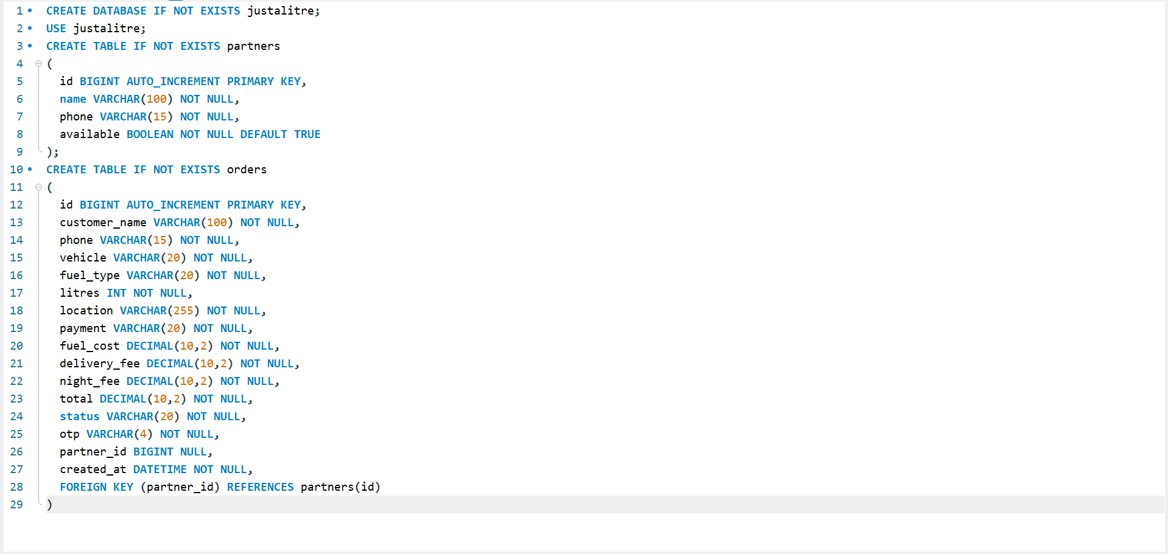
Figure 5.6: MySQL schema for the partners and orders tables

6. TESTING
The following test cases are derived from the validations and business rules present in the supplied source code. They describe expected application behaviour. No automated test report or execution log was included in the supplied ZIP, so these cases are not represented as independently executed test results.
Test Case | Input / Action | Expected Result
Valid order | Valid name, 10-digit phone, BIKE/CAR, PETROL/DIESEL, 2–5 litres, location and UPI/CASH | Order is saved and tracking page is opened.
Invalid phone | Phone number not containing exactly 10 digits | Validation error is displayed.
Invalid fuel | Fuel value other than PETROL or DIESEL | Order is rejected.
Invalid vehicle | Vehicle value other than BIKE or CAR | Order is rejected.
Invalid quantity | Quantity below 2 or above 5 litres | Order is rejected.
Missing location | Blank location | Order is rejected.
Partner assignment | At least one available partner and a NEW order | First available partner by ID is assigned.
Wrong OTP | Administrator enters an OTP that does not match | Delivery is not completed and an error is displayed.
Correct OTP | Administrator enters the matching OTP | Order status becomes DELIVERED and partner becomes available.
Cancel order | Administrator cancels an open order | Order status becomes CANCELLED and assigned partner is released.

6.1 TESTING LIMITATIONS
The project archive does not include automated unit or integration test classes. Therefore, the test cases above are specification-based checks inferred directly from the implementation. They should be executed in the configured Java and MySQL environment before being recorded as passed.

7. CONCLUSION AND FUTURE ENHANCEMENTS

7.1 CONCLUSION
JustALitre demonstrates a web-based workflow for requesting and dispatching emergency fuel. The system collects customer and order details, validates input, calculates charges, generates an OTP and stores information in MySQL. The administrator dashboard supports partner registration, partner allocation, order status updates, cancellation and OTP-based delivery confirmation. The project combines Java object-oriented design, Spring Boot web development, Thymeleaf templates and relational database persistence.
The project provided practical experience in developing a multi-layer application using entity classes, repositories, service logic and web controllers. It also demonstrated the use of primary keys, foreign keys and entity relationships in database design.

7.2 FUTURE ENHANCEMENTS
- Integrate a secure payment gateway for online UPI and card payments.
- Add GPS-based location capture and map-based delivery visibility.
- Implement distance-based partner selection rather than first-available assignment.
- Integrate a verified messaging service for order notifications.
- Add role-based access control and stronger credential management.
- Provide detailed order history, reporting and analytics for administrators.
- Add automated unit and integration tests.

8. REFERENCES
- Oracle. Java Documentation. https://docs.oracle.com/en/java/
- Spring. Spring Boot Reference Documentation. https://docs.spring.io/spring-boot/
- Spring. Spring Data JPA Reference Documentation. https://docs.spring.io/spring-data/jpa/
- Thymeleaf Documentation. https://www.thymeleaf.org/documentation.html
- MySQL Documentation. https://dev.mysql.com/doc/
- Project source code and database schema supplied for JustALitre.

APPENDIX A – JAVA SOURCE CODE
The following source files are reproduced from the submitted JustALitre ZIP archive. The listing is included as project documentation.

JustALitreApplication.java
package com.justalitre;
import org.springframework.boot.SpringApplication;
import org.springframework.boot.autoconfigure.SpringBootApplication;
@SpringBootApplication
public class JustALitreApplication {
public static void main(String[] args) {
SpringApplication.run(JustALitreApplication.class, args);
}
}

Partner.java
package com.justalitre;
import jakarta.persistence.*;
@Entity
@Table(name = "partners")
public class Partner {
@Id @GeneratedValue(strategy = GenerationType.IDENTITY)
private Long id;
private String name;
private String phone;
private boolean available = true;
public Long getId() { return id; }
public void setId(Long id) { this.id = id; }
public String getName() { return name; }
public void setName(String name) { this.name = name; }
public String getPhone() { return phone; }
public void setPhone(String phone) { this.phone = phone; }
public boolean isAvailable() { return available; }
public void setAvailable(boolean available) { this.available = available; }
}

FuelOrder.java
package com.justalitre;
import jakarta.persistence.*;
import java.math.BigDecimal;
import java.time.LocalDateTime;
@Entity
@Table(name = "orders")
public class FuelOrder {
@Id @GeneratedValue(strategy = GenerationType.IDENTITY)
private Long id;
private String customerName;
private String phone;
private String vehicle;
private String fuelType;
private int litres;
private String location;
private String payment;
private BigDecimal fuelCost;
private BigDecimal deliveryFee;
private BigDecimal nightFee;
private BigDecimal total;
private String status; // NEW, ASSIGNED, ON_THE_WAY, DELIVERED, CANCELLED
private String otp;
@ManyToOne
@JoinColumn(name = "partner_id")
private Partner partner;
private LocalDateTime createdAt;
public Long getId() { return id; }
public void setId(Long id) { this.id = id; }
public String getCustomerName() { return customerName; }
public void setCustomerName(String v) { this.customerName = v; }
public String getPhone() { return phone; }
public void setPhone(String v) { this.phone = v; }
public String getVehicle() { return vehicle; }
public void setVehicle(String v) { this.vehicle = v; }
public String getFuelType() { return fuelType; }
public void setFuelType(String v) { this.fuelType = v; }
public int getLitres() { return litres; }
public void setLitres(int v) { this.litres = v; }
public String getLocation() { return location; }
public void setLocation(String v) { this.location = v; }
public String getPayment() { return payment; }
public void setPayment(String v) { this.payment = v; }
public BigDecimal getFuelCost() { return fuelCost; }
public void setFuelCost(BigDecimal v) { this.fuelCost = v; }
public BigDecimal getDeliveryFee() { return deliveryFee; }
public void setDeliveryFee(BigDecimal v) { this.deliveryFee = v; }
public BigDecimal getNightFee() { return nightFee; }
public void setNightFee(BigDecimal v) { this.nightFee = v; }
public BigDecimal getTotal() { return total; }
public void setTotal(BigDecimal v) { this.total = v; }
public String getStatus() { return status; }
public void setStatus(String v) { this.status = v; }
public String getOtp() { return otp; }
public void setOtp(String v) { this.otp = v; }
public Partner getPartner() { return partner; }
public void setPartner(Partner v) { this.partner = v; }
public LocalDateTime getCreatedAt() { return createdAt; }
public void setCreatedAt(LocalDateTime v) { this.createdAt = v; }
}

PartnerRepository.java
package com.justalitre;
import org.springframework.data.jpa.repository.JpaRepository;
import java.util.Optional;
public interface PartnerRepository extends JpaRepository<Partner, Long> {
Optional<Partner> findFirstByAvailableTrueOrderByIdAsc();
}

OrderRepository.java
package com.justalitre;
import org.springframework.data.jpa.repository.JpaRepository;
import java.util.List;
public interface OrderRepository extends JpaRepository<FuelOrder, Long> {
List<FuelOrder> findAllByOrderByIdDesc();
List<FuelOrder> findByStatusOrderByIdAsc(String status);
}

OrderService.java
package com.justalitre;
import org.springframework.beans.factory.annotation.Value;
import org.springframework.stereotype.Service;
import org.springframework.transaction.annotation.Transactional;
import java.math.BigDecimal;
import java.security.SecureRandom;
import java.time.LocalDateTime;
import java.util.List;
@Service
public class OrderService {
private final OrderRepository orders;
private final PartnerRepository partners;
private final SecureRandom random = new SecureRandom();
@Value("${fuel.petrol}") private BigDecimal petrolRate;
@Value("${fuel.diesel}") private BigDecimal dieselRate;
@Value("${fee.delivery}") private BigDecimal deliveryFee;
@Value("${fee.night}") private BigDecimal nightFee;
public OrderService(OrderRepository orders, PartnerRepository partners) {
this.orders = orders;
this.partners = partners;
}
public BigDecimal getPetrolRate() { return petrolRate; }
public BigDecimal getDieselRate() { return dieselRate; }
public BigDecimal getDeliveryFee() { return deliveryFee; }
public BigDecimal getNightFee() { return nightFee; }
@Transactional
public FuelOrder placeOrder(String name, String phone, String vehicle, String fuel,
int litres, String location, String payment) {
if (name == null || name.isBlank()) throw new IllegalArgumentException("Name is required.");
if (phone == null || !phone.matches("\\d{10}")) throw new IllegalArgumentException("Enter a valid 10-digit phone number.");
if (!fuel.equals("PETROL") && !fuel.equals("DIESEL")) throw new IllegalArgumentException("Choose petrol or diesel.");
if (!vehicle.equals("BIKE") && !vehicle.equals("CAR")) throw new IllegalArgumentException("Choose bike or car.");
if (!payment.equals("UPI") && !payment.equals("CASH")) throw new IllegalArgumentException("Choose a payment method.");
if (litres < 2 || litres > 5) throw new IllegalArgumentException("Quantity must be between 2 and 5 litres.");
if (location == null || location.isBlank()) throw new IllegalArgumentException("Location is required.");
BigDecimal rate = fuel.equals("PETROL") ? petrolRate : dieselRate;
int hour = LocalDateTime.now().getHour();
boolean night = hour >= 22 || hour < 6;
FuelOrder o = new FuelOrder();
o.setCustomerName(name.trim());
o.setPhone(phone);
o.setVehicle(vehicle);
o.setFuelType(fuel);
o.setLitres(litres);
o.setLocation(location.trim());
o.setPayment(payment);
o.setFuelCost(rate.multiply(BigDecimal.valueOf(litres))); // price is calculated on the server
o.setDeliveryFee(deliveryFee);
o.setNightFee(night ? nightFee : BigDecimal.ZERO);
o.setTotal(o.getFuelCost().add(o.getDeliveryFee()).add(o.getNightFee()));
o.setOtp(String.format("%04d", random.nextInt(10000)));
o.setStatus("NEW");
o.setCreatedAt(LocalDateTime.now());
o = orders.save(o);
assignPending();
return orders.findById(o.getId()).orElse(o);
}
/** Gives waiting (NEW) orders to free partners, oldest order first. */
@Transactional
public void assignPending() {
for (FuelOrder o : orders.findByStatusOrderByIdAsc("NEW")) {
var p = partners.findFirstByAvailableTrueOrderByIdAsc();
if (p.isEmpty()) return;
Partner partner = p.get();
partner.setAvailable(false);
partners.save(partner);
o.setPartner(partner);
o.setStatus("ASSIGNED");
orders.save(o);
}
}
public FuelOrder find(Long id) { return orders.findById(id).orElse(null); }
public List<FuelOrder> allOrders() { return orders.findAllByOrderByIdDesc(); }
public List<Partner> allPartners() { return partners.findAll(); }
@Transactional
public void addPartner(String name, String phone) {
if (name == null || name.isBlank() || phone == null || !phone.matches("\\d{10}"))
throw new IllegalArgumentException("Partner needs a name and a 10-digit phone.");
Partner p = new Partner();
p.setName(name.trim());
p.setPhone(phone);
partners.save(p);
assignPending();
}
@Transactional
public void markOnTheWay(Long id) {
FuelOrder o = find(id);
if (o != null && o.getStatus().equals("ASSIGNED")) {
o.setStatus("ON_THE_WAY");
orders.save(o);
}
}
@Transactional
public void deliver(Long id, String otp) {
FuelOrder o = find(id);
if (o == null || o.getPartner() == null) throw new IllegalArgumentException("Order has no partner yet.");
if (o.getStatus().equals("DELIVERED") || o.getStatus().equals("CANCELLED"))
throw new IllegalArgumentException("Order is already closed.");
if (otp == null || !o.getOtp().equals(otp.trim())) throw new IllegalArgumentException("Wrong OTP.");
o.setStatus("DELIVERED");
orders.save(o);
freePartner(o);
}
@Transactional
public void cancel(Long id) {
FuelOrder o = find(id);
if (o == null || o.getStatus().equals("DELIVERED") || o.getStatus().equals("CANCELLED")) return;
o.setStatus("CANCELLED");
orders.save(o);
freePartner(o);
}
private void freePartner(FuelOrder o) {
if (o.getPartner() != null) {
Partner p = o.getPartner();
p.setAvailable(true);
partners.save(p);
}
assignPending();
}
}

WebController.java
package com.justalitre;
import jakarta.servlet.http.HttpSession;
import org.springframework.beans.factory.annotation.Value;
import org.springframework.stereotype.Controller;
import org.springframework.ui.Model;
import org.springframework.web.bind.annotation.*;
import org.springframework.web.servlet.mvc.support.RedirectAttributes;
import java.util.HashSet;
import java.util.Set;
@Controller
public class WebController {
private final OrderService service;
@Value("${admin.key}") private String adminKey;
public WebController(OrderService service) { this.service = service; }
// ---------- Customer ----------
@GetMapping("/")
public String home(Model m) {
m.addAttribute("petrol", service.getPetrolRate());
m.addAttribute("diesel", service.getDieselRate());
m.addAttribute("delivery", service.getDeliveryFee());
m.addAttribute("night", service.getNightFee());
return "index";
}
@PostMapping("/order")
public String order(@RequestParam String name, @RequestParam String phone,
@RequestParam String vehicle, @RequestParam String fuel,
@RequestParam int litres, @RequestParam String location,
@RequestParam String payment,
HttpSession session, RedirectAttributes ra) {
try {
FuelOrder o = service.placeOrder(name, phone, vehicle, fuel, litres, location, payment);
Set<Long> mine = mineOf(session);
mine.add(o.getId()); // only this browser may see the OTP
session.setAttribute("myOrders", mine);
return "redirect:/track/" + o.getId();
} catch (IllegalArgumentException e) {
ra.addFlashAttribute("error", e.getMessage());
return "redirect:/#order";
}
}
@GetMapping("/track/{id}")
public String track(@PathVariable Long id, HttpSession session, Model m) {
FuelOrder o = service.find(id);
if (o == null) return "redirect:/";
m.addAttribute("o", o);
m.addAttribute("showOtp", mineOf(session).contains(id));
return "track";
}
@SuppressWarnings("unchecked")
private Set<Long> mineOf(HttpSession s) {
Object v = s.getAttribute("myOrders");
return v == null ? new HashSet<>() : (Set<Long>) v;
}
// ---------- Admin / dispatch ----------
private boolean isAdmin(HttpSession s) { return Boolean.TRUE.equals(s.getAttribute("admin")); }
@GetMapping("/admin")
public String admin(HttpSession s, Model m) {
if (!isAdmin(s)) return "admin-login";
m.addAttribute("orders", service.allOrders());
m.addAttribute("partners", service.allPartners());
return "admin";
}
@PostMapping("/admin/login")
public String login(@RequestParam String key, HttpSession s, RedirectAttributes ra) {
if (adminKey.equals(key)) s.setAttribute("admin", true);
else ra.addFlashAttribute("error", "Wrong admin key.");
return "redirect:/admin";
}
@PostMapping("/admin/logout")
public String logout(HttpSession s) { s.invalidate(); return "redirect:/admin"; }
@PostMapping("/admin/partner")
public String addPartner(@RequestParam String name, @RequestParam String phone,
HttpSession s, RedirectAttributes ra) {
if (!isAdmin(s)) return "redirect:/admin";
try { service.addPartner(name, phone); }
catch (IllegalArgumentException e) { ra.addFlashAttribute("error", e.getMessage()); }
return "redirect:/admin";
}
@PostMapping("/admin/order/{id}/ontheway")
public String onTheWay(@PathVariable Long id, HttpSession s) {
if (isAdmin(s)) service.markOnTheWay(id);
return "redirect:/admin";
}
@PostMapping("/admin/order/{id}/deliver")
public String deliver(@PathVariable Long id, @RequestParam String otp,
HttpSession s, RedirectAttributes ra) {
if (!isAdmin(s)) return "redirect:/admin";
try { service.deliver(id, otp); }
catch (IllegalArgumentException e) { ra.addFlashAttribute("error", "Order #" + id + ": " + e.getMessage()); }
return "redirect:/admin";
}
@PostMapping("/admin/order/{id}/cancel")
public String cancel(@PathVariable Long id, HttpSession s) {
if (isAdmin(s)) service.cancel(id);
return "redirect:/admin";
}
}

APPENDIX A.2 – DATABASE SCHEMA
CREATE DATABASE IF NOT EXISTS justalitre;
USE justalitre;
CREATE TABLE IF NOT EXISTS partners (
id BIGINT AUTO_INCREMENT PRIMARY KEY,
name VARCHAR(100) NOT NULL,
phone VARCHAR(15) NOT NULL,
available BOOLEAN NOT NULL DEFAULT TRUE
);
CREATE TABLE IF NOT EXISTS orders (
id BIGINT AUTO_INCREMENT PRIMARY KEY,
customer_name VARCHAR(100) NOT NULL,
phone VARCHAR(15) NOT NULL,
vehicle VARCHAR(20) NOT NULL,
fuel_type VARCHAR(20) NOT NULL,
litres INT NOT NULL,
location VARCHAR(255) NOT NULL,
payment VARCHAR(20) NOT NULL,
fuel_cost DECIMAL(10,2) NOT NULL,
delivery_fee DECIMAL(10,2) NOT NULL,
night_fee DECIMAL(10,2) NOT NULL,
total DECIMAL(10,2) NOT NULL,
status VARCHAR(20) NOT NULL,
otp VARCHAR(4) NOT NULL,
partner_id BIGINT NULL,
created_at DATETIME NOT NULL,
FOREIGN KEY (partner_id) REFERENCES partners(id)
);
-- Tables are also created automatically by Hibernate (ddl-auto=update).

APPENDIX B – OUTPUT SCREENSHOTS
The screenshots below were supplied as evidence of the JustALitre interface and database design.
B.1 Customer home page
B.2 Order confirmation / order form output
B.3 WhatsApp handoff screenshot
B.4 Admin dispatch dashboard
B.5 Order tracking and OTP display
B.6 Database schema

